**CST8921 – Cloud Industry Trends**

**Lab 6 – Hosting static web app on blob storage**

## Introduction

In this lab, I will explore and understand cloud storage accounts and their new capabilities. The cloud storage account can store Blob files, Azure files and tables. In the lab, one of the capabilities I am looking over is hosting a static HTML website and assets to host the website. It is useful to create a front page for the organization. The HTML website is deployed using Visual Studio Code with the storage extension

## Objective

The goal of this lab activity is to familiarize with Azure storage and deploying a static web app using visual studio code.

**Screenshots:**

**Host a static web app on Blob Storage Account**

1. Launch Visual Studio code

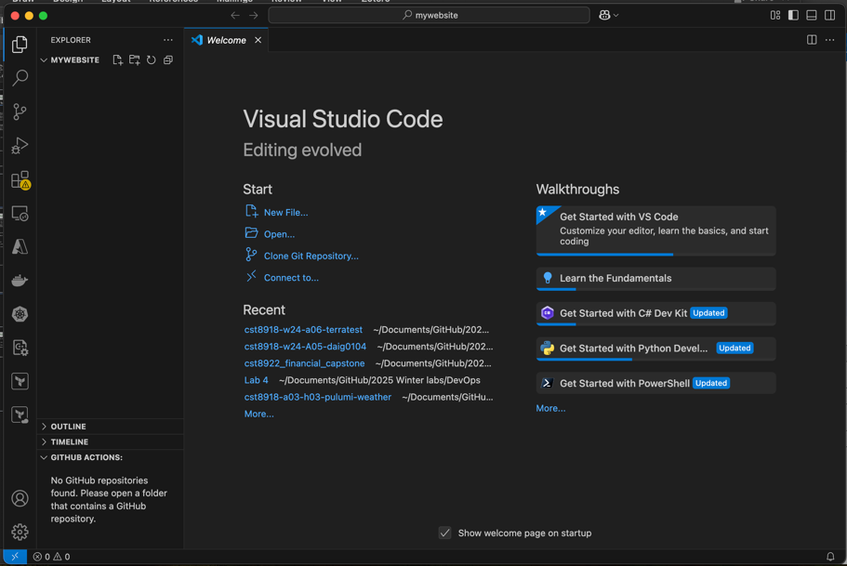

1. In extensions install azure storage



1. Creating a storage account

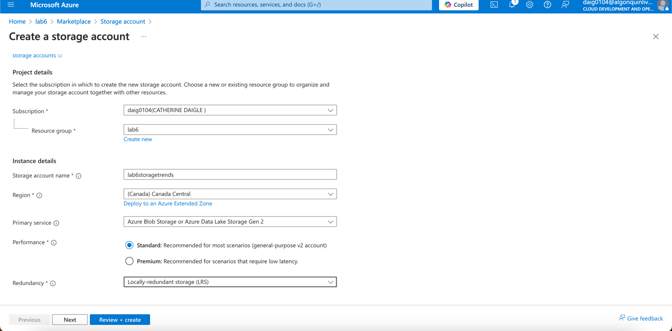

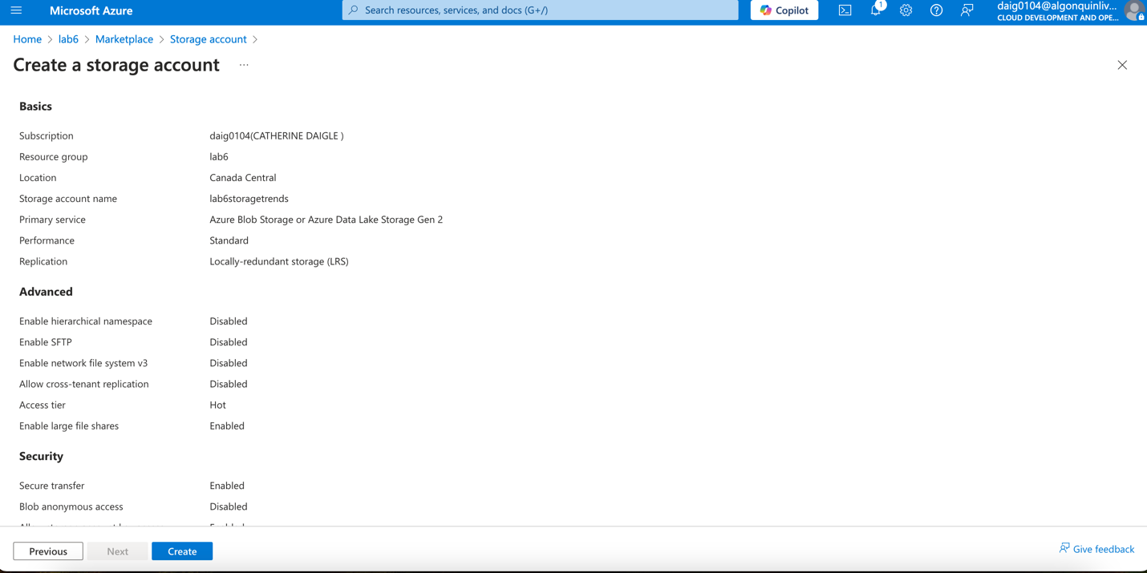

1. Select Static website to display the configuration page for static websites.

Selecting Enabled to enable static. In the Index document name field, specify a default index page of index.html. In the Error document path field, specify a default error page of 404.html.

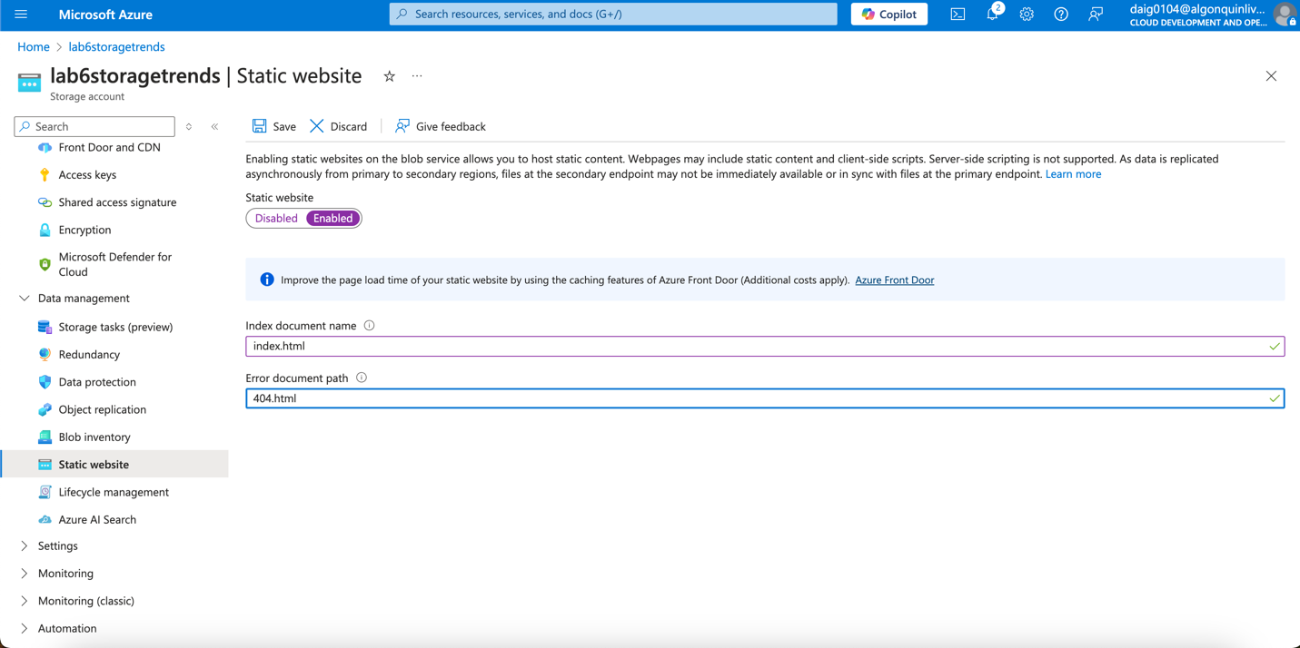

**Deploy hello world website -** create a Hello World web page with Visual Studio Code and deploy it to the static website hosted in your Azure Storage account.

1. Create an empty folder named mywebsite on your local file system.

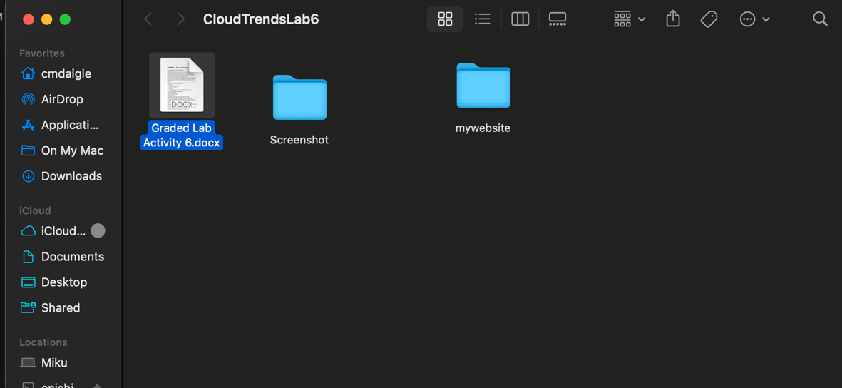

1. Launch Visual Studio Code, and open the folder that you just created from the Explorer panel.
2. Creating the default index file in the mywebsite folder and name it index.html.

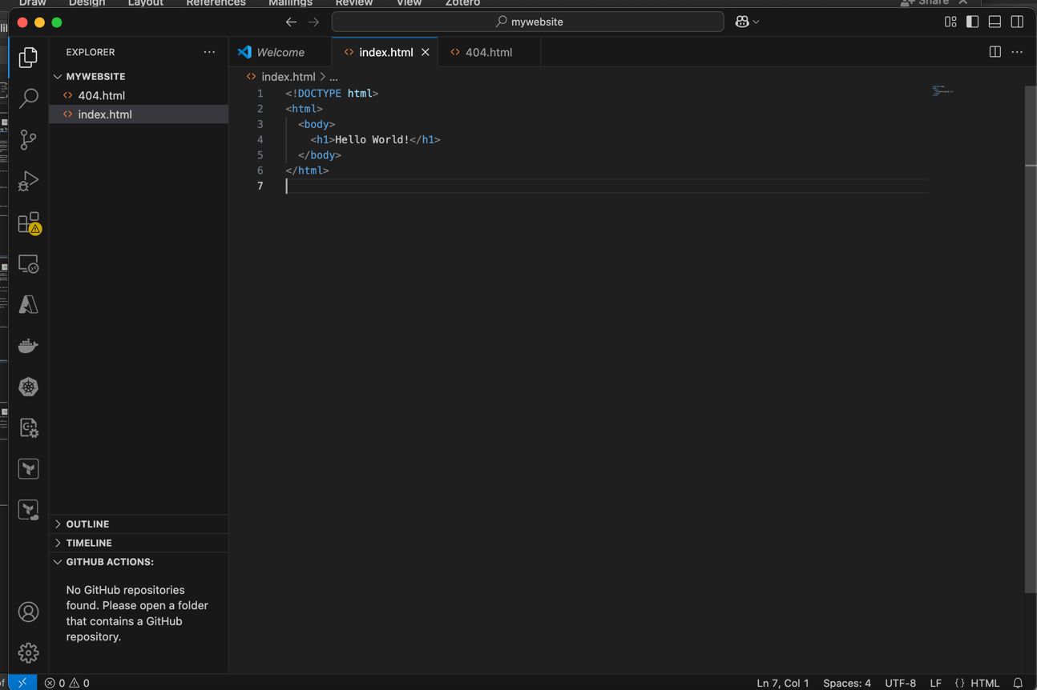

1. Creating another file named 404.html and paste the following code and save the file:

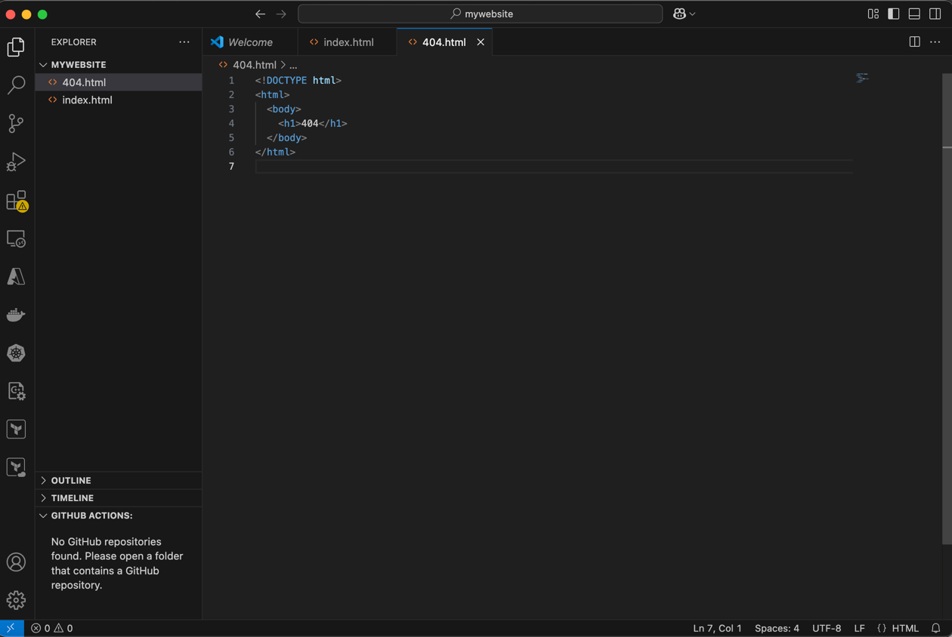

1. Right click on the mywebsite folder and selecting deploy to static website to deploy your website.

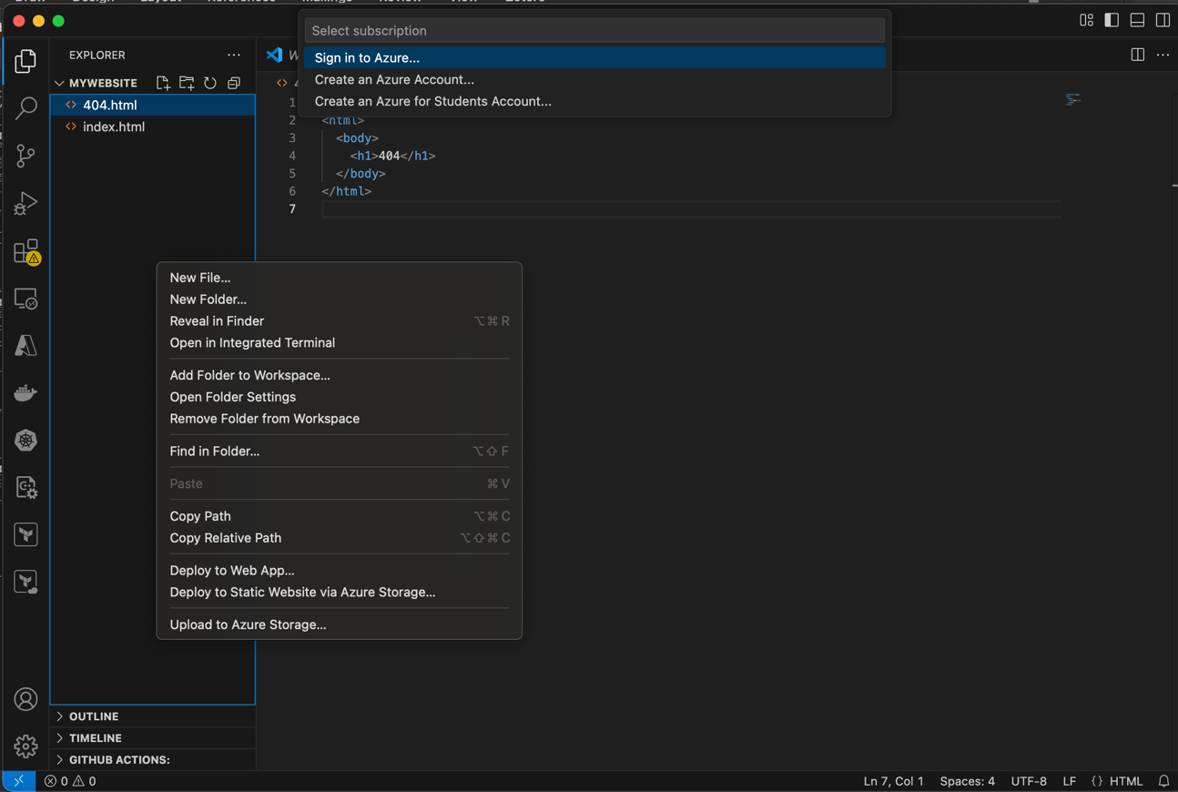

1. Select the subscription containing the storage account for which you enabled static website hosting. Next, select the storage account when prompted. And Deploying to the storage account

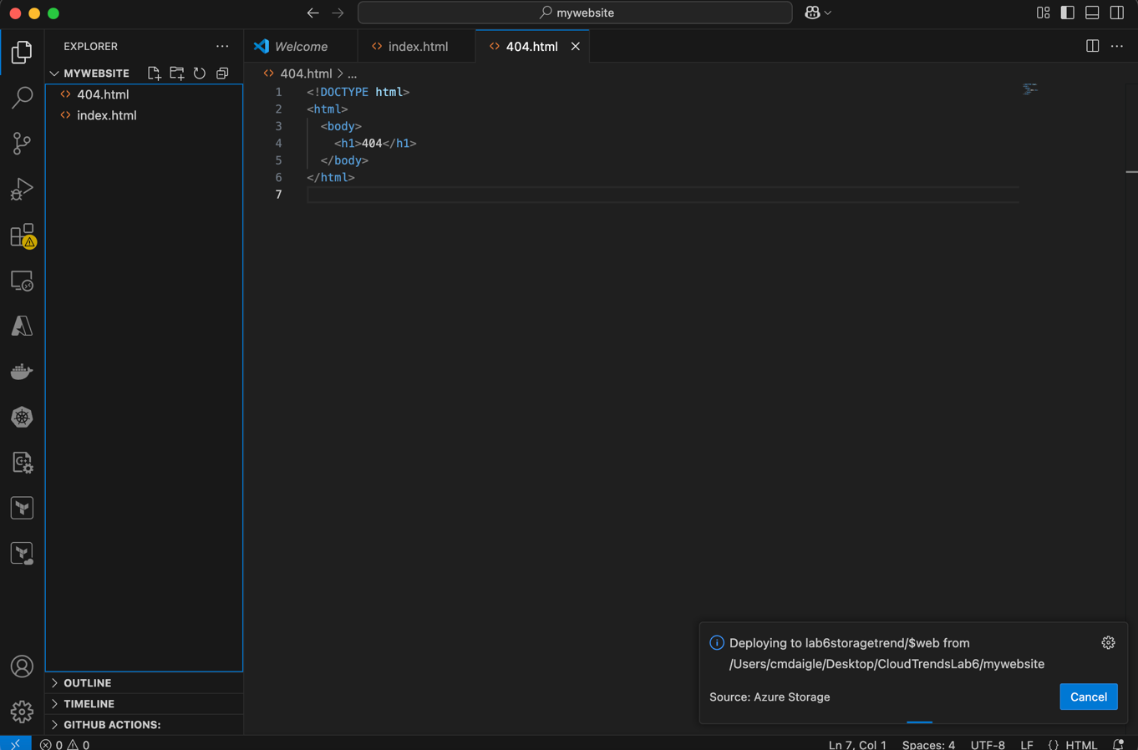

1. VS code will upload the files to web endpoint and you can review the website in azure.



1. Delete all the resources once the lab is completed and document all the steps in a lab report. Before:

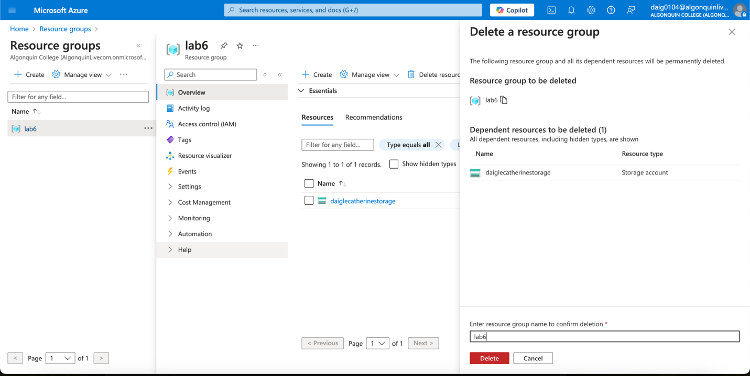

After:

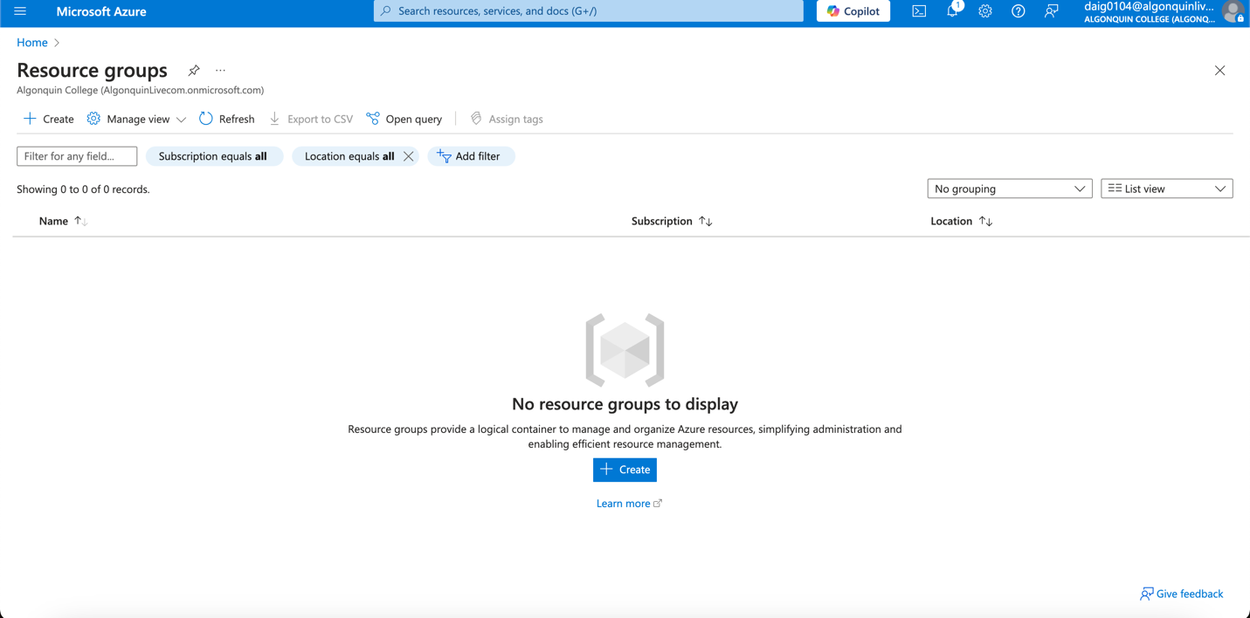

## Results:

As a result, I have successfully deployed a simple Hello World! Webpage using Azure storage and Visual Studio code.

## Conclusion:

In conclusion, azure storage allows you to implement a simple webpage by linking the HTML files to the static website of the Azure storage page. It seems very useful for companies who want to deploy a simple web page without many interactions. The static website can also be linked to a 404 page in case the main web page was to go down. My assumption is that Azure decided to move Azure Static web apps as a more complex method to build larger web pages.