**CCP6114**

**PROGRAMMING FUNDAMENTALS**

**ASSIGNMENT DOCUMENTATION**

|  |  |  |
| --- | --- | --- |
| Lecture Section | : | TC7L |
| Tutorial Section | : | T13L |
| Group Number/Group Name | : | G03 |
| Submitted to | : | Dr. Lee Fong Yee |

|  |  |  |
| --- | --- | --- |
| **ID** | **Name** | **Email Address** |
| **243UC247BR** | **LIM PEI SHAN** | **LIM.PEI.SHAN@student.mmu.edu.my** |
| **243UC247D6** | **CHAN KER JING** | **CHAN.KER.JING@student.mmu.edu.my** |
| **243UC247C1** | **BERNICE GAN XINYI** | **BERNICE.GAN.XINYI@student.mmu.edu.my** |
| **243UC247CB** | **TEOW YAN PING** | **TEOW.YAN.PING @student.mmu.edu.my** |

Table of Contents

Pseudocodes 3

Program 1: TC7L_G03_main1.cpp 3

Pseudocode Explanation of Program 1 6

Program 2: TC7L_G03_main2.cpp 7

Pseudocode Explanation of Program 2 9

Structure diagrams 10

Program 1: TC7L_G03_main1.cpp 10

Explanation of Program 1 Structure Diagram 11

Program 2: TC7L_G03_main2.cpp 12

Explanation of Program 2 Structure Diagram 13

Input 14

Sample 1 and 2 14

Sample 3 14

Output 15

Sample 1 and 2 15

Explanation of fileOutput1.txt 15

fileOutput1.csv 16

Explanation of fileOutput2.txt 17

fileOutput2.csv 18

Sample 3 19

Explanation of fileOutput3.txt 19

fileOutput3.csv 19

Code segments explanation 20

Program 1: TC7L_G03_main1.cpp 20

Program 2: TC7L_G03_main2.cpp 23

Task Distribution 28

Student 1 28

Student 2 28

Student 3 28

Student 4 28

# Pseudocodes

## Program 1: TC7L_G03_main1.cpp

**START**

**OPEN the input file**

**IF the input file opened successfully**

**IF the file is empty**

**Display the message “The file is empty.”**

**ELSE**

**WHILE the file containing lines**

**IF found a semicolon in the line**

**IF the file contains the line “CREATE TABLE”**

**Call the function createTable**

**IF filename is equal to "fileInput1.mdb"**

**Open "fileOutput1.csv"**

**ELSE**

**Open "fileOutput2.csv"**

**ELSE IF the file contains the line “INSERT INTO”**

**Call the function insertIntoTable**

**ELSE IF the file contains the line “SELECT”**

**Call the function selectFromTable**

**ELSE IF the file contains the line “UPDATE”**

**Call the function updateIntoTable**

**ELSE IF the file contains the line “DELETE”**

**Call the function deleteIntoTable**

**ELSE IF the file contains the line “COUNT”**

**Call the function countIntoTable**

**Clear the command buffer**

**ENDIF**

**END WHILE**

**CLOSE the input file after reading it**

**ELSE**

**Display message: “Error opening the file.”**

**ENDIF**

**IF there is no customer to display after reading the file**

**Display message “No customer available in the 'customer' table to view in CSV format.”**

**ELSE**

**IF the input file read is equal to “fileInput1.mdb”**

**OPEN the output file 1 to write data read from input file into it**

**ELSE**

**OPEN the output file 2 to write data read from input file into it**

**ENDIF**

**Display the header of the table**

**WRITE the header of the table to output file**

**FOR counter start from 0 TO customer_count STEP customer_count - 1 DO**

**Display the columns including the customer_id, customer_name, customer_city, customer_state, customer_country, customer_phone, customer_email, each separated with a comma in the terminal**

**WRITE the columns to the output files and csv files including the customer_id, customer_name, customer_city, customer_state, customer_country, customer_phone, customer_email each separated with a comma in a csv file**

**ENDFOR**

**CLOSE the output file after writing data into it**

**CLOSE the csv file after writing data into it**

**ENDIF**

**END**

### Pseudocode Explanation of Program 1

**Purpose of the program:** This program will request an input file from user and read from the file to write it into an output file int txt and csv format.

**Explanation:**

1. If the file opens successfully, it checks whether the file is empty. If the file is empty, it will output “The file is empty.” Otherwise, it will enter a while loop. The while loop checks if the file contains any line to read. If find a semicolon in the line, continue to check if the file has a SQL command such as:
   1. “CREATE TABLE”: It will call the function createTable() and open csv files based on the input file.
   2. “INSERT INTO”: It will call the function insertIntoTable()
   3. “SELECT”: Call the function selectFromTable()
   4. “UPDATE”: Call the function updateIntoTable()
   5. “DELETE”: Call the function deleteIntoTable()
   6. “COUNT”: Call the function countIntoTable()

After that, clear command buffer to avoid program error. After no more lines to read from the input file, close the input file. If the file does not open successfully, output “Error opening the file.”

1. After reading the file, another if statement checks if there is any information to be written into output files: txt and csv file. If no information, output “No customer available in the ‘customer’ table to view in CSV format. If there is information, check which input files that user wishes to read. If input file 1 is read, write header and the columns read from input file 1 to output file 1 and so forth. After writing into an output file, close the output files and csv files.
2. Explanation about the function:
   1. createTable(): This function with parameter line passed by reference will process the “CREATE TABLE” command. It will output to inform user that the table structure is been initiated to store customer data.
   2. selectFromTable(): This function with parameter line passed by reference will output to user that the program is processing the “SELECT” command.
   3. insertIntoTable(): This function has 9 parameters, containing the line of the input files and 8 vectors to store the customer data passed by reference. It has a regex library to detect the characters like space, ( , ) and ‘ .It will search a string for a match to the regex and push the data into vector.
   4. updateIntoTable()
   5. deleteIntoTable()
   6. countIntoTable()

## Program 2: TC7L_G03_main2.cpp

**START**

**OPEN the input file**

**IF the input file opened successfully**

**IF the file is empty**

**Display the message “The file is empty.”**

**ELSE**

**WHILE the file containing lines**

**IF found a semicolon in the line**

**IF the file contains the line “CREATE TABLE”**

**Call the function createTable**

**Open "fileOutput3.csv"**

**ELSE IF the file contains the line “SELECT”**

**Call the function selectFromTable**

**ELSE IF the file contains the line “INSERT INTO”**

**Call the function insertIntoTable**

**ELSE IF the file contains the line “UPDATE”**

**Call the function updateIntoTable**

**ELSE IF the file contains the line “DELETE”**

**Call the function deleteIntoTable**

**ELSE IF the file contains the line “COUNT”**

**Call the function countIntoTable**

**END WHILE**

**ENDIF**

**CLOSE the input file after reading it**

**ELSE**

**Display message: “Error opening the file.”**

**ENDIF**

**IF there is no book to display after reading the file**

**Display message “No books available in the 'books' table to view in CSV format.”**

**ELSE**

**Display the header of the table**

**WRITE the header of the table to output file**

**FOR counter start from 0 TO book_count STEP book_count - 1 DO**

**Display the columns including the book_id, book_name, book_author, book_year, book_category, book_status, book_quantity, book_pricing, each separated with a comma**

**WRITE the columns to the output files including the book_id, book_name, book_author, book_year, book_category, book_status, book_quantity, book_pricing, each separated with a comma**

**ENDFOR**

**CLOSE the output file after writing data into it**

**ENDIF**

**END**

### Pseudocode Explanation of Program 2

**Purpose:** This program will request an input file from user and read from the file to write it into an output file int txt and csv format.

**Explanation:**

1. If the file opens successfully, it checks whether the file is empty. If the file is empty, it will output “The file is empty.” Otherwise, it will enter a while loop. The while loop checks if the file contains any line to read. If find a semicolon in the line, continue to check if the file has a SQL command such as:
   1. “CREATE TABLE”: It will call the function createTable() and open csv files based on the input file.
   2. “INSERT INTO”: It will call the function insertIntoTable()
   3. “SELECT”: Call the function selectFromTable()
   4. “UPDATE”: Call the function updateIntoTable()
   5. “DELETE”: Call the function deleteIntoTable()
   6. “COUNT”: Call the function countIntoTable()

After that, clear command buffer to avoid program error. After no more lines to read from the input file, close the input file. If the file does not open successfully, output “Error opening the file.”

1. After reading the file, another if statement checks if there is any information to be written into output files: txt and csv file. If no information, output “No books available in the ‘book’ table to view in CSV format. If there is information, check which input files that user wishes to read. If input file 1 is read, write header and the columns read from input file 1 to output file 1 and so forth. After writing into an output file, close the output files and csv files.
2. Explanation about the function:
   1. createTable(): This function with parameter line passed by reference will process the “CREATE TABLE” command. It will output to inform user that the table structure is been initiated to store book data.
   2. selectFromTable(): This function with parameter line passed by reference will output to user that the program is processing the “SELECT” command.
   3. insertIntoTable(): This function has 9 parameters, containing the line of the input files and 8 vectors to store the book data passed by reference. It has a regex library to detect the characters like space, ( , ) and ‘ .It will search a string for a match to the regex and push the data into vector.
   4. updateIntoTable()
   5. deleteIntoTable()
   6. countIntoTable()

# Structure diagrams

### Program 1: TC7L_G03_main1.cpp

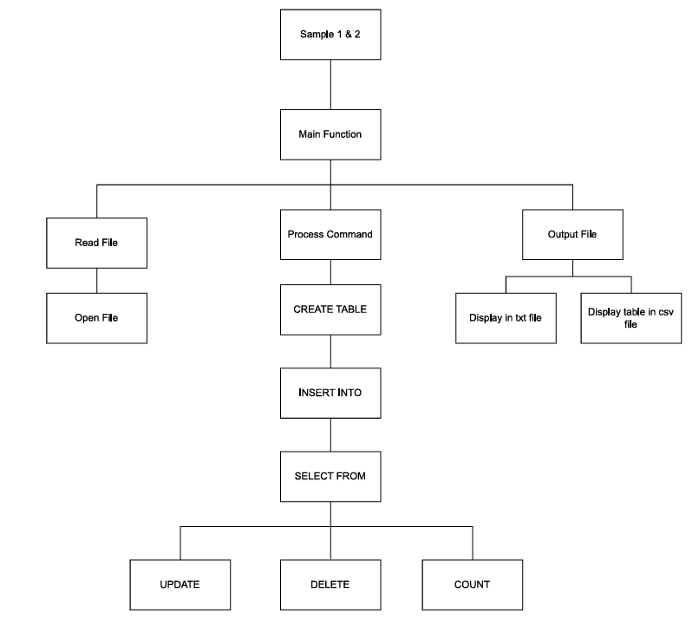

Explanation of Program 1 Structure Diagram

**Overall Representation**

* **Title**: The diagram is labelled "Sample 1 & 2," indicating that it represents a specific example focused on managing customer data

**Main Function**

* **Main Function Block:** This is the central controller of the program, which manages the flow of operations.

**Key Components**

* **Read File:** This block handles the file input operation. It ensures that the program accesses the user-provided file.
* **Open File:** 
  1. Ensures that the input file is opened successfully.
  2. Includes error handling for cases like "The file is empty" or "Error opening the file."
* **Process Command:**

1. This block processes each line of the file and determines the type of SQL operation (like CREATE, INSERT, SELECT, etc.) to execute:
2. **CREATE TABLE:** Handles the creation of database tables based on the provided SQL command. It is called the createTable() function.
3. **INSERT INTO:** Inserts new customer’s data into the table. This is the insertIntoTable() function.
4. **SELECT FROM:** Queries data from the table and retrieves it using the selectFromTable() function.
5. **UPDATE:** Updates existing customers’ records in the table with the updateIntoTable() function.
6. **DELETE:** Deletes the records from the table connected to the deleteIntoTable() function.
7. **COUNT:** Counts the number of rows in a table or performs aggregations. This is the countIntoTable() function.

* **Output File:**

1. This block writes the results of the processed commands into output files in both TXT and CSV formats.
2. **Display in txt file:** Writes the data to a text file format.
3. **Display table in csv file:** Exports the table data in a CSV format for easy readability and compatibility with spreadsheet applications.

### Program 2: TC7L_G03_main2.cpp

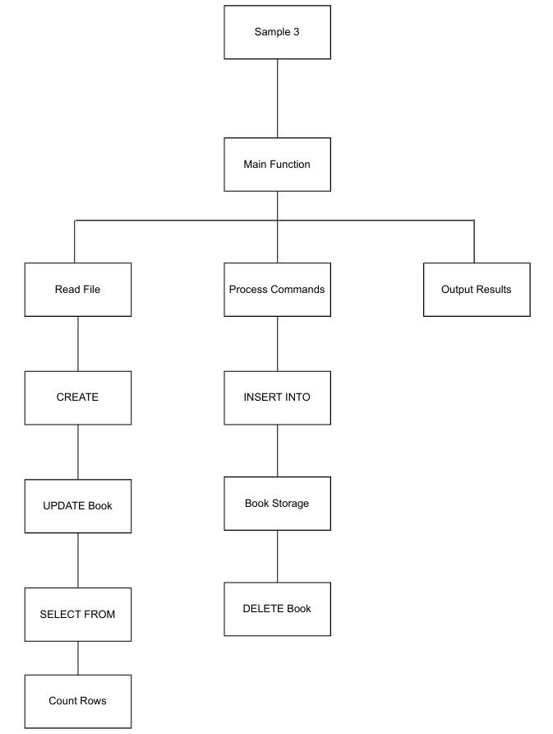

### Explanation of Program 2 Structure Diagram

**Overall Representation**

* **Title**: The diagram is labelled "Sample 3," indicating that it represents a specific example focused on managing book data.

**Main Function**

* **Main Function Block**: This is where everything starts. It starts the program, handling file operations and processing commands.

**Key Components**

1. **Read File**:
   1. This part shows that the program is set to open and read a file that the user specifies. The file contains SQL commands for managing book records.
   2. If the file opens correctly and isn’t empty, the program gets to work interpreting the SQL commands inside.
2. **Process Commands**:
   1. The program looks at the commands it just read and sorts them based on their type:
      1. **CREATE**: This command indicates that a new table structure is being created to hold book data. It calls the createTable() function.
      2. **INSERT INTO**: This is all about adding new books to the collection and triggers the insertIntoTable() function.
      3. **SELECT FROM**: This prepares to fetch book data using the selectFromTable() function.
      4. **UPDATE**: This is a future feature for updating book records, linked to the updateIntoTable() function.
      5. **DELETE**: Similarly, this one will handle removing books, connected to deleteIntoTable().
      6. **COUNT**: This is for counting how many records are present, planned for the countIntoTable() function.
3. **Book Storage**:
   1. **Books Vector**: This is where the program keeps track of the book data while it’s running. It uses a vector to store all the book objects that are added.
4. **Output Results**:
   1. After processing the commands, the program prepares to display results. If there’s any data, it writes it out to files in a format, like CSV, that’s easy to read.

# Input

## Sample 1 and 2

## Sample 3

# Output

## Sample 1 and 2

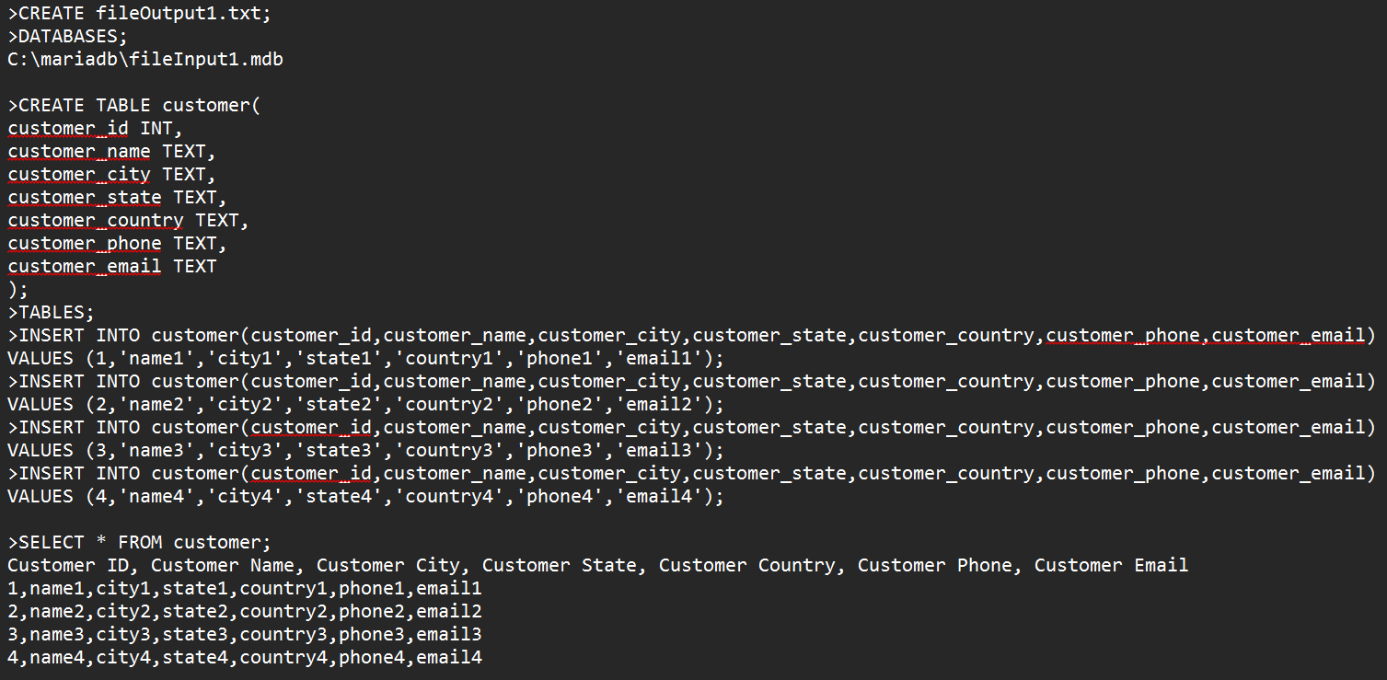

### Explanation of fileOutput1.txt

The commands in fileOutput1.txt represent a simple database operation for managing customer data.

**Command Breakdown**

1. **CREATE fileOutput1.txt;**
   1. This command indicates the intention to create a new output file named fileOutput1.txt. This is where results from the subsequent operations will be stored.
2. **DATABASES;**
   1. This statement suggests a command to switch or reference a database. It indicates the program is targeting a specific database located at C:\mariadb\fileInput1.mdb.
3. **CREATE TABLE customer(...);**
   1. This command creates a new table named customer in the database. The table structure includes several fields to store information about customers:
      1. customer_id INT: An integer field for the customer's ID.
      2. customer_name TEXT: A text field for the customer's name.
      3. customer_city TEXT: A text field for the customer's city.
      4. customer_state TEXT: A text field for the customer's state.
      5. customer_country TEXT: A text field for the customer's country.
      6. customer_phone TEXT: A text field for the customer's phone number.
      7. customer_email TEXT: A text field for the customer's email address.
4. **TABLES;**
   1. This command is possibly intended to list existing tables in the current database. It signifies an action related to the database structure.
5. **INSERT INTO customer(...);**
   1. These commands add new customer records into the customer table. Each INSERT statement includes the customer ID and related information for each customer:
      1. Customers 1 through 4 are added with corresponding details like names, cities, states, countries, phone numbers, and email addresses.
6. **SELECT * FROM customer;**
   1. This command retrieves all records from the customer table. It selects every column for each customer entry available in the table.

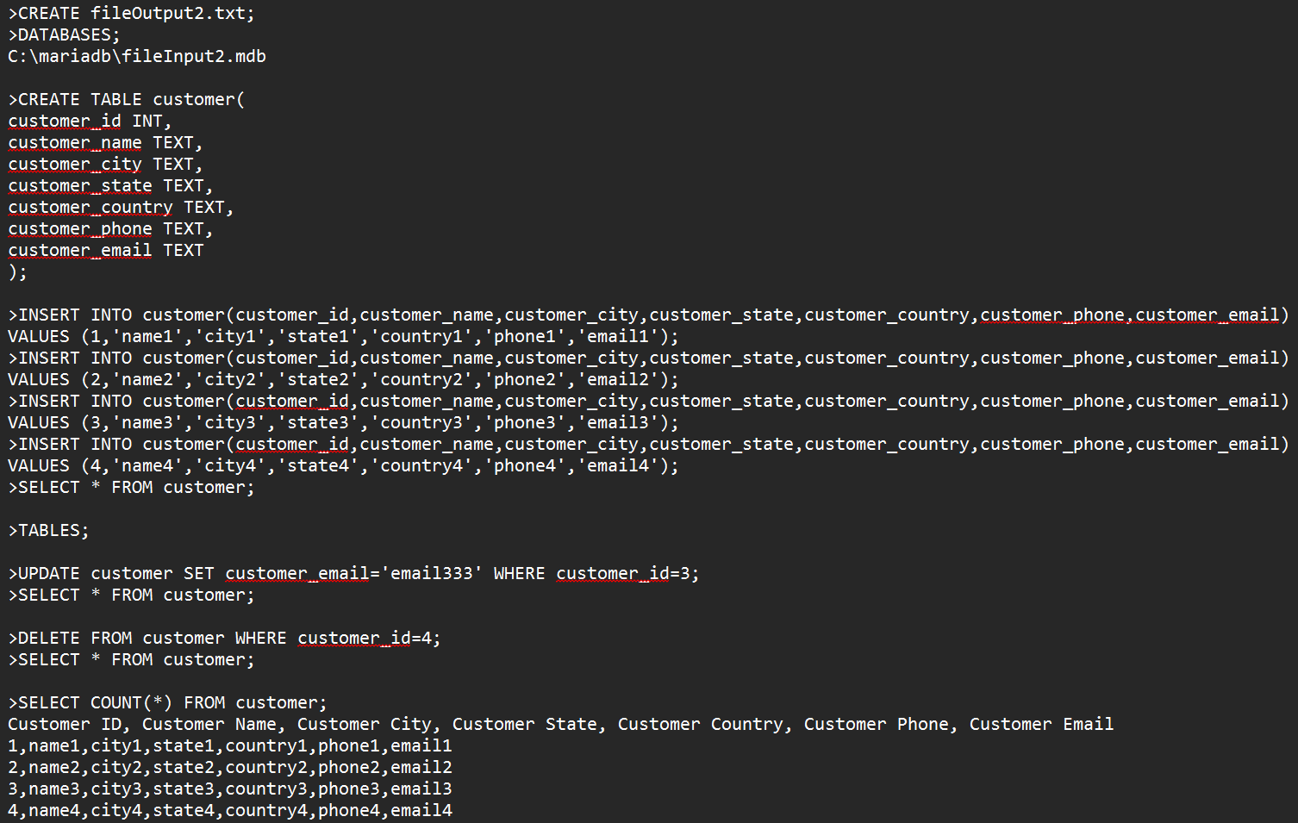

### fileOutput1.csv

The final database will also be output as a csv file.

### Explanation of fileOutput2.txt

The commands in fileOutput2.txt illustrate a more complex set of operations for managing customer data. This file not only creates records but also updates and deletes them while demonstrating how to gather data from the customer table

**Command Breakdown**

1. **CREATE fileOutput2.txt;**
   1. This command signals the creation of a new output file called fileOutput2.txt, where results of the subsequent operations will be stored.
2. **DATABASES;**
   1. Similar to the previous file, this command indicates a context switch to a specific database located at C:\mariadb\fileInput2.mdb, setting the stage for table management.
3. **CREATE TABLE customer(...);**
   1. The creation of a new table named customer is defined here. It has the same structure as in the previous file, including fields for:
      1. customer_id INT
      2. customer_name TEXT
      3. customer_city TEXT
      4. customer_state TEXT
      5. customer_country TEXT
      6. customer_phone TEXT
      7. customer_email TEXT
4. **INSERT INTO customer(...);**
   1. Multiple INSERT statements are used to add new customer records to the table. Each record is populated with details for customers 1 through 4, just like in the previous operations.
5. **SELECT * FROM customer;**
   1. This command fetches all records from the customer table, displaying them. The output would look like this:
6. Customer ID, Customer Name, Customer City, Customer State, Customer Country, Customer Phone, Customer Email
7. 1,name1,city1,state1,country1,phone1,email1
8. 2,name2,city2,state2,country2,phone2,email2
9. 3,name3,city3,state3,country3,phone3,email3
10. 4,name4,city4,state4,country4,phone4,email4
11. **TABLES;**
    1. This command is presumably intended to list existing tables in the database.
12. **UPDATE customer SET customer_email='email333' WHERE customer_id=3;**
    1. This command updates the email address of the customer with customer_id 3 to 'email333'. This demonstrates how to modify existing records in the database.
13. **SELECT * FROM customer;**
    1. After the update, this command retrieves all records from the customer table again, allowing us to see the changes made. The output would reflect that customer 3 now has the updated email.
14. **DELETE FROM customer WHERE customer_id=4;**
    1. This command deletes the record of the customer with customer_id 4 from the table, demonstrating how to remove entries.
15. **SELECT * FROM customer;**
    1. This retrieves all remaining records, showing the updated list of customers after the deletion.
16. **SELECT COUNT(*) FROM customer;**
    1. This command counts the total number of records currently in the customer table. The output provides a simple integer indicating how many customers remain after the previous operations.

### fileOutput2.csv

The final database will be output as a csv file.

## Sample 3

### Explanation of fileOutput3.txt

### fileOutput3.csv

# Code segments explanation

In this assignment, we have created two programs.

Program 1 named TC7L_G03_main1.cpp is to read the input files from sample 1 and 2 and write to output files.

Program 2 name TC7L_G03_main2.cpp is to read the input files from sample 3 and write to output files.

## Program 1: TC7L_G03_main1.cpp

1. **Header files**

|  |
| --- |
|  |
| Explanation: |

1. **Function prototype**

|  |
| --- |
|  |
| Explanation: |

1. **Main function**

|  |
| --- |
|  |
| Explanation: Vector that stores the data of the customers like customer id, customer name, customer city, customer state, customer country, customer phone and customer email. Initialized customer count to 0. |
|  |
| Explanation: **ifstream** is a class used to read file with the variable named **inputFile**; **ofstream** is a class used to write data to a file, **outputCsvFile** representing a file stream to write the file to a CSV file and **outputTxtFile** is to write it to a TXT file; **string** is a class to handle text and **filename** is a variable to hold the name of the file (e.g. “fileInput1.mdb”) to be opened and processed; **line** is a varibale to use for finding the keywords to process command and **fullCommand** used to complete command built from other strings or input. |

1. **createTable function**

|  |
| --- |
|  |
| Explanation: |

1. **selectFromTable function**

|  |
| --- |
|  |
| Explanation: |

1. **insertIntoTable function**

|  |
| --- |
|  |
| **Explanation:**  **Parameter:** All arguments are passed by reference.  **Idea:** Used the library <regex> to extract the data from the command “VALUES” in the input file, and then write into output files.  **Functions template used in regex:**   1. **regex pattern:** R(...) = raw string literals, it helps to ignore all special characters like \n \t   **Format:** R(“(), ' () '”)   * put () around the regex, to create a capturing group(grouped them together). * having open and close brackets () to store vector * if have single quotation (' '), means the vector stored is a string * Inside the (), we use a series of pattern to detect spaces, open and closed bracket(), quotation(‘) and to capture INT and TEXT to be stored in vector: * \( : to detect the open bracket '(' * \d : to detect digit number 0-9. In code, now we have \d+ because we need to capture one or more digit like customer id. * [^']+ : to capture TEXT inside a single quotation. In this program, we do not need to output single quotation, so we put ^' to detect and ignore it. The plus sign (+) here means one or more character(string) * \s*: to detect space  1. **smatch:** string match  * create an object called match and then use store the result of the matched regex above.  1. **regex_search:** Searches a string for a match to the regex  * **Format:** (first, second, third) * first = to go through the line in database * second = hold the results of the matched value * third = the pattern that you want to match with * After detecting characters, extract the data needed, and push it into a vector. |

1. **updateIntoTable function**

|  |
| --- |
|  |
| Explanation: |

1. **deleteIntoTable function**

|  |
| --- |
|  |
| Explanation: |

1. **countIntoTable function**

|  |
| --- |
|  |
| Explanation: |

## Program 2: TC7L_G03_main2.cpp

1. **Header files**

|  |
| --- |
|  |
| Explanation: The header files included at the beginning of the program are essential for accessing various functionalities required throughout the code. |

1. **Function prototype**

|  |
| --- |
|  |
| Explanation: Function prototypes declare the functions that will be defined later in the code. This allows the main function and other parts of the code to be aware of the functions' signatures (names, return types, and parameters) before they are actually implemented, ensuring proper functioning and preventing conflicts. |

1. **Main function**

|  |
| --- |
|  |
| Explanation: The program starts by prompting the user to enter the filename of the input file containing SQL-like commands. It opens the file for reading and checks if it is empty. This allows for immediate feedback to the user if there are issues with file accessibility or content. |
|  |
| Explanation: The main function reads lines from the input file, concatenating them until a complete command (indicated by a ;) is detected. Depending on the command type (CREATE TABLE, INSERT INTO, or SELECT), it calls the appropriate functions (createTable, insertIntoTable, selectFromTable) to execute the required operations. This design allows for dynamic command handling and modularized code. |
|  |
| Explanation: After processing the commands, the program checks if any books were successfully inserted into the vector. It then outputs the book details to both the console and a CSV file (fileOutput3.csv). Lastly, it ensures that the output file is properly closed, maintaining good resource management practices and preparing the program to exit. |

1. **createTable function**

|  |
| --- |
|  |
| Explanation: The createTable function is responsible for creating a new table in memory or the database based on the defined structure provided through the input command. This function typically sets up the necessary data structures to store the table’s data, ensuring that the specified schema (fields and their types) is respected. |

1. **selectFromTable function**

|  |
| --- |
|  |
| Explanation: This function retrieves and displays data from the specified table. It processes select queries, extracts the requested data based on any filters or conditions provided, and formats the output to reflect the current contents of the table. |

1. **insertIntoTable function**

|  |
| --- |
|  |
| **Explanation:**  **Parameter:** All arguments are passed by reference.  **Idea:** Used the library <regex> to extract the data from the command “VALUES” in the input file, and then write into output files.  **Functions template used in regex:**   * + - 1. **regex pattern:** R(...) = raw string literals, it helps to ignore all special characters like \n \t   **Format:** R(“(), ' () '”)   * put () around the regex, to create a capturing group(grouped them together). * having open and close brackets () to store vector * if have single quotation (' '), means the vector stored is a string * Inside the (), we use a series of pattern to detect spaces, open and closed bracket(), quotation(‘) and to capture INT and TEXT to be stored in vector: * \( : to detect the open bracket '(' * \d : to detect digit number 0-9. In code, now we have \d+ because we need to capture one or more digit like customer id. * [^']+ : to capture TEXT inside a single quotation. In this program, we do not need to output single quotation, so we put ^' to detect and ignore it. The plus sign (+) here means one or more character(string) * \s*: to detect space   + - 1. **smatch:** string match * create an object called match and then use store the result of the matched regex above.   + - 1. **regex_search:** Searches a string for a match to the regex * **Format:** (first, second, third) * first = to go through the line in database * second = hold the results of the matched value * third = the pattern that you want to match with * After detecting characters, extract the data needed, and push it into a vector. |

1. **updateIntoTable function**

|  |
| --- |
|  |
| Explanation: |

1. **deleteIntoTable function**

|  |
| --- |
|  |
| Explanation: |

1. **countIntoTable function**

|  |
| --- |
|  |
| Explanation: |

# Task Distribution

## Student 1

|  |  |
| --- | --- |
| Student ID | 243UC247BR |
| Student name | LIM PEI SHAN |
| Task percentage | 25% |
| Task descriptions | 1. Structure Diagram for sample 1 and 2 2. Create the input files 3. Output the TXT files in the same format as the sample given for sample 1 and 2 4. Create the update function |
| Total score (30m) |  |

## Student 2

|  |  |
| --- | --- |
| Student ID | 243UC247D6 |
| Student name | CHAN KER JING |
| Task percentage | 25% |
| Task descriptions | 1. Pseudocode for program 1 and 2 2. Insert rows to the table 3. View table in csv mode 4. Create vector to store the data for sample 1 and 2 |
| Total score (30m) |  |

## Student 3

|  |  |
| --- | --- |
| Student ID | 243UC247C1 |
| Student name | BERNICE GAN XINYI |
| Task percentage | 25% |
| Task descriptions | 1. Structure Diagram for Sample 3 2. Create the delete function |
| Total score (30m) |  |

## Student 4

|  |  |
| --- | --- |
| Student ID | 243UC247CB |
| Student name | TEOW YAN PING |
| Task percentage | 25% |
| Task descriptions | 1. Create vector to store the data for sample 1 2. Output the full path of the input file using file system library 3. Create the count function |
| Total score (30m) |  |