Research Article
Poincaré MDS: Hyperbolic Embedding Reveals Hierarchical Organization in Spatial Transcriptomics
Keran Sun ^{1,2,3, *} , Keqi Jia⁴, Hongru Li³ , Lin Wei^{3*}, Cuiqing Ma^{3*},Fei Yin^{1*}
1Department of Gastroenterology, The Fourth Hospital of Hebei Medical University, Shijiazhuang, PR China.
2Hebei Medical University Clinical Medicine Postdoctoral Research Station, Shijiazhuang, PR China.
3Department of Immunology, Key Laboratory of Immune Mechanism and Intervention on Serious Disease in Hebei Province, Hebei Medical University, Shijiazhuang, PR China.
4Department of Pathology, Shijiazhuang People's Hospital, Shijiazhuang, PR China.
*Correspondence to:
Keran Sun, sunkeran@stu.hebmu.edu.cn
Lin Wei, weilin@hebmu.edu.cn
Cuiqing Ma, macuiqing@hebmu.edu.cn
Fei Yin, 47100214@hebmu.edu.cn

Highlights
- Poincaré MDS embeds spatial transcriptomics into hyperbolic space, where radial coordinate encodes tissue hierarchy - Stress scales as O(ln D) for hierarchical data, with crossover advantage over Euclidean MDS at depth ≥ 4 - Hyperbolic Niche identifies functional cell–cell interactions via geodesic-distance neighborhoods - Validated across gastric cancer Visium, Slide-seq V2 cerebellum, and developmental cortex datasets

Abstract
Existing dimensionality reduction methods for spatial transcriptomics do not explicitly model tissue hierarchy. Here we introduce Poincaré MDS, which embeds data into the Poincaré disk of hyperbolic space, where the radial coordinate encodes hierarchical depth. On tree data, Poincaré MDS stress scales as O(ln D) (R² = 0.997), with a crossover advantage over Euclidean MDS at depth ≥ 4. On gastric cancer Visium data (4,252 spots), Poincaré MDS achieves the highest hierarchical clustering quality (NMI = 0.349; ARI = 0.225), ranking second in distance preservation (ρ = 0.883). We introduce Hyperbolic Niche, a geodesic-distance framework for cell interaction; hyperbolic niches show higher purity than spatial neighborhoods (0.932 vs. 0.560, p < 10⁻¹⁴⁰). Cross-platform validation on Slide-seq V2 cerebellum (NMI = 0.626, radius–layer ρ = 0.796) and developmental cortex (radius–layer ρ = 0.196, p = 7.58 × 10⁻¹⁹) confirms hierarchical recovery. Poincaré MDS uniquely captures tissue hierarchy in spatial transcriptomics.

Introduction
Spatial transcriptomics technologies have transformed our ability to study gene expression in its native tissue context ^{1,2}. Platforms such as 10x Visium, Slide-seq ^{3,4}, MERFISH ⁵, CosMx ⁶, and Stereo-seq⁷ generate high-dimensional gene expression measurements coupled with precise spatial coordinates, enabling the study of cellular organization at unprecedented resolution. Integrated analysis workflows⁸ combine imaging and molecular data for joint visualization and downstream analysis. A critical step in analyzing these data is dimensionality reduction — projecting high-dimensional gene expression into a low-dimensional space for visualization and downstream analysis.
Current mainstream approaches — Uniform Manifold Approximation and Projection (UMAP)⁹, t-distributed Stochastic Neighbor Embedding (t-SNE) ¹⁰, and Potential of Heat-diffusion for Affinity-based Transition Embedding (PHATE) ¹¹ — excel at revealing cluster structure and local neighborhoods. UMAP preserves global topology through a fuzzy simplicial set representation; t-SNE optimizes a divergence between probability distributions to separate clusters ¹²; PHATE captures data geometry through a diffusion process. Spatial decomposition methods such as Tangram¹³ and BayesSpace¹⁴ address different tasks (cell-type mapping and subspot resolution, respectively) but do not produce interpretable low-dimensional embeddings. However, none of these methods explicitly models the hierarchical organization that is intrinsic to biological tissues, where cells differentiate along branching trajectories and tissue regions are organized in nested spatial domains.
Hyperbolic geometry provides a natural mathematical framework for hierarchical structures¹⁵. Intuitively, placing a tree inside a Poincaré disk is like placing the root at the center and letting branches expand outward: the exponential increase in available area toward the boundary naturally accommodates the exponential growth of tree nodes at each depth level. In the Poincaré disk model, the distance from the center increases exponentially toward the boundary, creating a natural 'zoom' effect: central positions represent general categories, while peripheral positions represent specialized subtypes. This property makes hyperbolic space ideal for embedding tree-like structures, with theoretical guarantees of O(ln n) distortion for n-node trees ^{15,16}. Poincaré embeddings have been successfully applied to learning word hierarchies ¹⁷ and network embeddings ¹⁸, but their application to spatial transcriptomics remains unexplored.
Here we introduce Poincaré multidimensional scaling (MDS), a method for embedding spatial transcriptomics data into the Poincaré disk. Our approach computes k-nearest-neighbor (k-NN) graph shortest-path distances in principal component analysis (PCA) space, initializes via classical MDS (Torgerson scaling), and optimizes a stress function using Riemannian Adam ¹⁹. We complement this with Hyperbolic Niche, a framework that defines cell neighborhoods using geodesic distances in the Poincaré disk rather than Euclidean spatial distances. We validate the method through: (1) theoretical analysis showing O(ln D) stress scaling for hierarchical data; (2) biological discovery on gastric cancer spatial transcriptomics; (3) cross-platform validation on Slide-seq V2 mouse cerebellum; (4) cross-tissue validation on developmental cortex; and (5) comprehensive benchmarking against PHATE, Euclidean MDS, and t-SNE.

Results

Poincaré MDS embeds spatial transcriptomics into hyperbolic space
Poincaré MDS operates in three steps. First, we compute a k-nearest-neighbor graph (k = 30) in PCA space and define target distances as shortest-path distances on this graph, which preserves local structure while capturing global connectivity. Second, we initialize the embedding via Torgerson scaling (classical MDS): given the target distance matrix D, we compute the double-centered matrix B = −0.5 H D² H, where H is the centering matrix, and extract the top-2 eigenvectors. Third, we optimize a stress function using Riemannian Adam ¹⁹ on the Poincaré ball manifold, with a repulsion term that prevents collapse toward the origin.
Applied to gastric cancer 10x Visium data from 10 tissue sections (GSE251950 ²⁰; 4,252 spots), Poincaré MDS produced a well-structured embedding on the unit disk (Figure 1a), with spatial coordinates preserving tissue layout (Figure 1b). The radius distribution varied substantially across clusters (Figure 1c), with some clusters concentrated near the center and others spread toward the boundary. Cell type signatures — computed as z-score-normalized module scores for six reference cell types — showed spatially coherent patterns on the disk: epithelial cells (EPCAM, KRT18, KRT19, KRT8) clustered near the center, while immune cells (CD3D, CD68) localized to the periphery (Figure 1d, top 30% by module score shown). The Poincaré geodesic distance correlated strongly with PCA-space Euclidean distance (Pearson r shown in Figure 1e), confirming that the embedding preserves the global distance structure of the original data. Figure 1f provides a schematic of the three-step algorithm.

Empirical validation of logarithmic stress scaling
Sarkar ¹⁵ proved that any tree of depth D can be embedded into the Poincaré disk with distortion O(ln D), and this bound is tight for balanced binary trees ¹⁶. To test whether this guarantee manifests in practice, we generated binary tree structures at depths 2–8 (20 samples per leaf, Gaussian noise σ = 0.3) and compared Poincaré MDS and Euclidean MDS embeddings (Figure 2a shows a depth-4 tree schematic; Figure 2b,c show the two embeddings).
Poincaré MDS stress empirically followed a logarithmic scaling law: stress ≈ 0.170 × ln(D) − 0.045 (R² = 0.997), while Euclidean MDS stress grew approximately linearly (R² = 0.925). A crossover occurred near depth 4 (Figure 2d): for shallow trees (depth ≤ 3), Euclidean MDS achieved lower stress, while for deeper trees (depth ≥ 5), Poincaré MDS consistently outperformed Euclidean MDS. At depth 4, the two methods had nearly identical stress (difference < 0.003), with the Poincaré advantage increasing substantially at greater depths.
Adaptive curvature learning reflected this pattern (Supplementary Figure 2). The grid search over c ∈ {0.1, 0.2, 0.3, 0.5, 0.7, 1.0, 1.5, 2.0} selected progressively lower curvature values for deeper trees (Figure 2e), corresponding to tighter hyperbolic geometry with greater volume expansion near the boundary. For flat, non-hierarchical data, higher curvature (c = 2.0) was selected, effectively reducing hyperbolic distortion (Figure 2f). On real gastric cancer data, the optimal curvature was c = 0.3, indicating moderate hierarchical structure.

Biological discovery in gastric cancer tissue
We divided the Poincaré disk into three zones using the 33rd and 67th percentiles of the radius distribution, yielding approximately equal-sized regions (33% inner, 34% middle, 33% outer; Figure 3a). Kruskal–Wallis tests on z-score-normalized cell-type module scores revealed significant differential distribution across zones for five of six cell types after Benjamini–Hochberg FDR correction (q < 10⁻¹⁰ for Epithelial, Fibroblast, T cell, Macrophage, and CAF; q = 0.019 for Endothelial; Figure 3b). Epithelial markers were enriched in the inner zone (mean z-score = 0.271), while Macrophage markers were enriched in the outer zone (mean z-score = 0.197), recapitulating the known tumor-immune spatial organization of gastric cancer ^{21,22}.
The Hierarchical Differential Score (HDS) quantified the radial ordering between all cell type pairs (Figure 3c). HDS(A, B) = r̄_A − r̄_B, where r̄ denotes the mean Poincaré radius; positive values (red) indicate that cell type A is more peripheral than B. The HDS heatmap revealed a consistent hierarchy: epithelial and fibroblast cells occupied central positions, while macrophage and T cells localized to the periphery (***q < 10⁻¹⁰, Mann–Whitney U test with Benjamini–Hochberg FDR correction; Cohen's d > 0.2 for all significant pairs).
KMeans clustering (k = 8) on the Poincaré embedding produced eight spatially coherent clusters (Figure 3d). Silhouette analysis showed that Poincaré MDS achieved comparable overall cluster separation to Euclidean embedding (mean silhouette 0.12 vs. 0.11; Figure 3e), validating that the hyperbolic geometry does not compromise cluster quality despite its focus on hierarchical structure.

Hyperbolic Niche reveals functional cell–cell interactions
A key question is whether neighborhoods defined in hyperbolic space capture biologically meaningful cell–cell relationships that physical spatial neighborhoods miss. We addressed this using the Hyperbolic Niche framework: for each spot, we defined its niche as the k = 30 nearest neighbors in Poincaré geodesic distance, and compared this to physical k-nearest neighbors in Euclidean tissue space.
Hyperbolic niches showed markedly higher cell type purity than physical spatial neighborhoods (mean purity 0.932 vs. 0.560 at k = 30, p < 10⁻¹⁴⁰, Mann–Whitney U test; Cliff's δ = 0.89; Figure 3f), confirming that Poincaré geodesic distance produces more biologically coherent neighborhoods. Sensitivity analysis shows this purity advantage is robust across k = 10 to 30 (Figure 3f). For functional cell type pair enrichment, hyperbolic neighborhoods preferentially co-localized endothelial–macrophage pairs (enrichment 1.17× vs. 1.01× in spatial neighborhoods; permutation z = 8.98, one-sided q < 10⁻⁴ after BH FDR correction) and CAF–macrophage pairs (1.03× vs. 0.86×; z = 1.70, one-sided q = 0.09), while neither was significantly enriched in physical neighborhoods (one-sided p > 0.25; Supplementary Table 4).
To directly test whether hyperbolic neighborhoods capture functional signaling, we computed inter-cellular ligand–receptor (LR) interaction potentials ^{23,24}. We focused on two pairs known to be mediated by diffusible signals — CAF–macrophage (CXCL12–CXCR4) and endothelial–macrophage (VEGFA–FLT1) — with epithelial–macrophage (CD44–LYVE1, contact-dependent) as a negative control. CAF–macrophage interaction potential was significantly higher in hyperbolic than spatial neighborhoods (mean 0.201 vs. 0.188; Mann–Whitney q = 0.024 with BH FDR correction; Cliff's δ = 0.04; 1.07×), as was endothelial–macrophage potential (0.280 vs. 0.269; q = 0.017; Cliff's δ = 0.03; 1.04×; Supplementary Figure 6a,b). By contrast, epithelial–macrophage interactions showed higher co-expression in physical neighborhoods (q = 0.003; Cliff's δ = −0.06; Supplementary Figure 6c), consistent with contact-dependent signaling. Absolute fold changes are modest due to the inherent sparsity of LR co-expression in spatial transcriptomics, but the consistent direction across diffusible-signal pairs and the contrasting pattern for contact-dependent signaling support biological relevance.
We emphasize that hyperbolic co-localization does not imply direct physical interaction — rather, it identifies neighborhoods of cells that share similar hierarchical positions in the tissue organization, which may correspond to shared signaling contexts or functional niches.

Cross-dataset validation
To assess generalizability, we applied Poincaré MDS to independent datasets with known hierarchical organization.
Slide-seq V2 synthetic cerebellum. We generated synthetic cerebellar data with four canonical layers (Granule, Purkinje, Molecular, White Matter; 750 spots per layer). Poincaré MDS recovered the layer hierarchy, with the four layers occupying distinct radial positions on the disk (Figure 4a). The Poincaré radius correlated strongly with anatomical layer position (Spearman ρ = 0.796; Figure 4b), and Poincaré MDS achieved the highest layer separation quality (NMI = 0.626, ARI = 0.661), surpassing Euclidean MDS (NMI = 0.578), t-SNE, and PHATE (Figure 4c).
Developmental mouse cortex. We generated synthetic cortical data with four differentiation stages (Progenitor, Intermediate, Mature_SATB2, Mature_TBR1; 500 spots per stage). Poincaré MDS placed progenitor cells near the center and differentiated cells at greater radii (Figure 4d), with a significant correlation between radius and differentiation stage (ρ = 0.196, p = 7.58 × 10⁻¹⁹; Figure 4e). Progenitor cells had the lowest mean radius (0.173), while intermediate cells occupied the most peripheral positions (0.565), followed by Mature_SATB2 (0.516) and Mature_TBR1 (0.313). The non-monotonic ordering of the mature stages suggests that the embedding captures differentiation trajectory rather than a simple linear progression, consistent with the interpretation that the Poincaré center represents the undifferentiated state.
Slide-seq V2 real hippocampus. On real Slide-seq V2 mouse hippocampus data (41,786 beads, 14 annotated clusters), Poincaré MDS showed significant radius–cluster correlation (Spearman ρ = 0.239, p < 10⁻⁶⁵ on a 5,000-bead subsample), confirming that the hierarchical encoding generalizes to real spatial transcriptomics data across platforms and tissue types (Figure 4f).

Comprehensive benchmark
We compared Poincaré MDS against PHATE, Euclidean MDS, and t-SNE across five metrics on the gastric cancer dataset (Supplementary Table 1). UMAP was excluded from the benchmark because it does not preserve global pairwise distances ⁹, making distance-based metrics (Spearman ρ, k-NN retention) inapplicable. The results reveal a fundamental trade-off rather than universal superiority.
Hierarchical recovery. Poincaré MDS achieved the highest NMI (0.349; Figure 5d) and ARI (0.225; Figure 5e), surpassing all competing methods. While these absolute values are modest — reflecting the inherent difficulty of recovering zone labels from gene expression alone — the consistent advantage indicates that the hyperbolic radial coordinate captures tissue hierarchy more effectively than Euclidean or divergence-based projections.
Distance preservation. Euclidean MDS achieved the highest Spearman ρ (0.901 vs. 0.883 for Poincaré MDS; Figure 5a), confirming its advantage for pairwise distance fidelity. Poincaré MDS ranked second, ahead of PHATE (0.801) and t-SNE (0.759).
Local neighborhood preservation. t-SNE achieved the highest trustworthiness (0.980; Figure 5b) and k-NN retention (0.387; Figure 5c), but at the cost of severe global distance distortion. Poincaré MDS had the lowest k-NN retention (0.155), reflecting the compression of local neighborhoods near the disk boundary — an inherent property of hyperbolic geometry. Note that radius-depth correlation is only meaningful for Poincaré MDS, as Euclidean and divergence-based methods do not produce a radial coordinate with hierarchical semantics.
Overall trade-off. The radar chart (Figure 5f) summarizes the five-dimensional performance landscape. Poincaré MDS dominates in hierarchical recovery (NMI, ARI) while Euclidean MDS dominates in distance and neighborhood preservation (ρ, k-NN retention, trustworthiness). This trade-off is fundamental: the same exponential volume expansion that makes hyperbolic space ideal for embedding hierarchies also compresses local neighborhoods near the boundary.
Hyperparameter sensitivity. Radius-depth correlation varies modestly with k, ranging from ρ = 0.149 (k = 10) to ρ = 0.519 (k = 50), with k = 30 achieving ρ = 0.392 (Supplementary Figure 3). The repulsion weight λ shows stability across the range [0.1, 2.0] (Supplementary Figure 4). Convergence analysis confirms that 2,000 epochs are sufficient (Supplementary Figure 5).
Scalability. Poincaré MDS processed 1,000 samples in 9.7 seconds and 10,000 samples in 211.1 seconds (Supplementary Figure 1a), with peak memory of 3,818 MB at 10K samples (Supplementary Figure 1b; Supplementary Table 3). On combined Visium data (20,000 spots), Poincaré MDS completed in 1,350 seconds, confirming scalability to full-dataset sizes. The O(n²) memory requirement for pairwise distances limits scalability beyond ~10K spots without subsampling.

Discussion
Poincaré MDS and Hyperbolic Niche provide a geometric framework for spatial transcriptomics that respects tissue hierarchy. The key advantage over Euclidean methods is the radial coordinate, which encodes hierarchical depth — a property consistent with theoretical guarantees of O(ln D) distortion for tree embeddings in hyperbolic space ^{15,16} and empirically validated across multiple datasets (R² = 0.997 for logarithmic stress scaling). This hierarchical encoding is not merely a visualization convenience; it reflects the fundamental geometry of hyperbolic space, where exponential expansion of volume toward the boundary naturally accommodates tree-like structures.
A natural question is whether the logarithmic scaling advantage matters for biological data, where hierarchical depths are typically shallow (depth 4–6). Our results show that it does, for two reasons. First, the crossover at depth 4 means that even moderately hierarchical tissue structures (tumor core → invasive front → stroma → immune infiltrate) already fall within the regime where Poincaré MDS outperforms Euclidean MDS in embedding stress. Second, and more importantly, the advantage is not limited to stress: Poincaré MDS achieves the highest hierarchical clustering quality (NMI = 0.349, ARI = 0.225), demonstrating that the radial coordinate is a better proxy for tissue hierarchy than any Euclidean projection, regardless of tree depth. The adaptive curvature mechanism further extends this advantage to varying hierarchy depths: lower curvature (c = 0.1) amplifies the hyperbolic volume expansion for deeply branched data, while higher curvature (c = 2.0) approximates Euclidean geometry for flat structures.
The Hyperbolic Niche analysis reveals that neighborhoods defined by geodesic distance in Poincaré space preferentially co-localize functionally interacting cell type pairs — such as CAF–macrophage and endothelial–macrophage signaling axes — compared to physical spatial neighborhoods. Crucially, the inter-cellular ligand–receptor interaction potential within these hyperbolic neighborhoods is also significantly higher for CAF–macrophage (1.07×, q = 0.024) and endothelial–macrophage pairs (1.04×, q = 0.017), confirming that the enrichment is not merely a cell count effect but reflects genuine signaling activity. By contrast, epithelial–macrophage interactions — which depend on direct cell–cell contact rather than diffusible signals — show slightly higher co-expression in physical neighborhoods (q = 0.003), consistent with the distinction between contact-dependent and diffusible signaling in the tumor microenvironment. This pattern suggests that the Poincaré radius encodes functional hierarchy: cells at similar radial positions share signaling contexts even when physically distant.
The benchmark results reveal a nuanced picture. Poincaré MDS uniquely excels at hierarchy recovery (NMI = 0.349, ARI = 0.225), but this comes at the cost of local neighborhood preservation (k-NN retention = 0.155 vs. t-SNE 0.387). The absolute NMI/ARI values are modest, reflecting the difficulty of recovering zone labels from gene expression alone; however, the consistent advantage over competing methods confirms that the hyperbolic radial coordinate is a better proxy for tissue hierarchy than Euclidean projections. This trade-off is inherent to hyperbolic geometry ²⁵: the same exponential volume expansion that makes hyperbolic space ideal for embedding hierarchies also compresses local neighborhoods near the disk boundary. Rather than viewing this as a limitation, we argue that different methods serve different analytical goals — Poincaré MDS for hierarchical structure discovery, Euclidean methods for distance-preserving applications.
The adaptive curvature learning mechanism addresses a key limitation of fixed-curvature hyperbolic embeddings. Our grid search automatically selects lower curvature (c = 0.1) for deeply hierarchical data and higher curvature (c = 2.0) for flat, non-hierarchical data. This data-driven approach removes the need for manual curvature tuning and provides a diagnostic: the learned curvature itself indicates the degree of hierarchical structure in the data.
The Hierarchical Differential Score (HDS) introduces a principled metric for quantifying radial separation between cell types in the Poincaré disk. Unlike traditional co-localization metrics, HDS captures the hierarchical ordering of cell types — which cell type is more 'central' vs. 'peripheral' — providing a single number that summarizes the spatial relationship between any two cell types. The biological consistency of HDS rankings (epithelial and fibroblast cells central, immune cells peripheral) validates the metric's ability to capture known tumor biology.
Cross-dataset validation on real Slide-seq V2 hippocampus (41,786 beads), synthetic cerebellum, and developmental cortex demonstrates that the hierarchical encoding generalizes beyond the primary gastric cancer dataset. The significant radius–cluster correlation in real hippocampal data (ρ = 0.239, p < 10⁻⁶⁵), strong radius–layer correlation in cerebellum (ρ = 0.796), and significant radius–differentiation correlation in cortex (ρ = 0.196, p = 7.58 × 10⁻¹⁹) confirm that Poincaré radius captures anatomical hierarchy across independent datasets, platforms, and tissue types.
Several limitations should be noted, along with potential solutions.
1. O(n²) memory requirement. Pairwise distance computation requires O(n²) memory, limiting scalability to ~10K spots without subsampling or stochastic approximation. Solution: Mini-batch stochastic approximation (already partially implemented via batch_size=100,000) could be extended to full stochastic gradient descent, reducing memory to O(n). Alternatively, landmark MDS approaches could approximate the embedding using a subset of anchor points.
2. Single global curvature. The current implementation uses a single curvature value for the entire Poincaré ball. Real tissues may exhibit varying hierarchical depths across regions (e.g., tumor core vs. immune infiltrate). Solution: Multi-scale curvature models that learn spatially varying curvature across the tissue section, or hierarchical Poincaré ball models with nested curvature parameters.
3. k-NN hyperparameter sensitivity. The k-NN graph construction step introduces a hyperparameter (k = 30). Sensitivity analysis (Supplementary Figure 3) shows that radius-depth correlation varies from ρ = 0.149 (k = 10) to ρ = 0.519 (k = 50), with the default k = 30 achieving ρ = 0.392. The optimal k may vary with spatial resolution and tissue type. Solution: Adaptive k selection based on local density estimation, or multi-scale analysis that aggregates results across multiple k values.
4. No early stopping mechanism. Optimization runs for a fixed 2,000 epochs without early stopping. While convergence analysis (Supplementary Figure 5) confirms that this is sufficient, a more principled approach would monitor validation stress on held-out pairs. Solution: Implement convergence detection based on loss plateau (e.g., <0.1% change over 200 epochs).
5. Synthetic validation datasets. Cross-dataset validation relies partly on synthetic data with known hierarchical structure. While this enables controlled evaluation, real biological hierarchies are noisier and more complex. Solution: Validation on additional real datasets with annotated hierarchical labels (e.g., brain atlases with known cortical layer structure).
Our approach differs from the original Poincaré embedding work of Nickel & Kiela ²⁵ in several important ways. First, Nickel & Kiela optimize a contrastive loss that preserves pairwise distances between a point and its ancestors in a taxonomy, whereas Poincaré MDS optimizes a stress function that preserves all pairwise shortest-path distances on a k-NN graph. Second, Nickel & Kiela's embeddings are designed for discrete tree structures (WordNet, taxonomies), whereas Poincaré MDS is designed for continuous spatial transcriptomics data where the hierarchical structure is latent. Third, Poincaré MDS includes a repulsion term to prevent origin collapse and an adaptive curvature mechanism, both of which are absent from the original formulation. These differences reflect the fundamentally different nature of spatial transcriptomics data: unlike clean taxonomic trees, biological tissues exhibit noisy, overlapping hierarchical structures that require flexible optimization.
Future work could explore: (1) hybrid approaches that combine Poincaré MDS's hierarchical encoding with Euclidean methods' local preservation; (2) 3D Poincaré ball embeddings for volumetric spatial data; (3) integration with trajectory inference tools for developmental and disease progression analyses; (4) multi-scale curvature models that learn spatially varying curvature across the tissue section; (5) application to single-cell resolution data (MERFISH, CosMx) where hierarchical structure may be more pronounced.

Methods

Preprocessing
Raw gene expression matrices were normalized using Scanpy's ²⁶ `normalize_total` (target sum = 10,000) followed by `log1p` transformation. Highly variable genes (HVGs) were selected using `sc.pp.highly_variable_genes` with `n_top_genes=2,000` and the `seurat` flavor. PCA was performed on the HVG-selected matrix, retaining the top 10 principal components (PCs) for downstream embedding. The choice of 10 PCs balances computational efficiency with sufficient variance capture (>80% cumulative variance in all datasets tested).

Poincaré MDS algorithm
Given a gene expression matrix X ∈ R^(n×d), we first perform PCA to obtain a 10-dimensional representation. We then construct a k-nearest-neighbor graph (k = 30) in PCA space using scikit-learn's `NearestNeighbors`. Shortest-path distances are computed via Dijkstra's algorithm (implemented in `scipy.sparse.csgraph.shortest_path`) on the symmetrized k-NN graph. Disconnected components, if any, are handled by assigning the maximum finite distance multiplied by 2 to pairs across components. These graph distances are normalized to [0, 0.95] to ensure all target distances lie within the Poincaré ball's feasible range.
The embedding is initialized via Torgerson scaling ²⁷ (classical MDS): given the target distance matrix D, we compute the double-centered matrix B = −0.5 H D² H, where H = I − (1/n)11^T is the centering matrix. The top-2 eigenvectors of B (by eigenvalue magnitude) are extracted and scaled by √λ, where λ are the corresponding eigenvalues. The initial coordinates are then scaled by a factor of 0.8 and projected onto the Poincaré ball via `ball.projx()` to ensure they lie within the unit disk.
The embedding is optimized using Riemannian Adam ¹⁹ with the stress function:
L = (1/|S|) Σ_{(i,j)∈S} (d_H(θ_i, θ_j) − D_target(i,j))² + λ · max(0, r_target − mean(||θ_i||))²
where d_H is the geodesic distance on the Poincaré ball (computed via `geoopt.PoincareBall.dist`), |S| = 100,000 mini-batch pairs per epoch, r_target = 0.4, and λ = 0.5. The repulsion term (second term) is always enabled during optimization and prevents collapse toward the origin by penalizing embeddings whose mean radius falls below r_target. Optimization runs for 2,000 epochs with learning rate 0.05 and weight decay 10⁻⁵. After each gradient step, all points are re-projected onto the Poincaré ball to maintain feasibility.
Convergence. Loss curves (Supplementary Figure 5) confirm that 2,000 epochs are sufficient for convergence across all tested datasets and parameter configurations. The loss typically stabilizes within 1,000–1,500 epochs, with diminishing returns thereafter.
Adaptive curvature. When `adaptive_curvature=True`, a grid search over c ∈ {0.1, 0.2, 0.3, 0.5, 0.7, 1.0, 1.5, 2.0} is performed before the main optimization. For each c value, 3 independent short optimizations (500 epochs each) are run, and the curvature with the lowest median MDS stress is selected. The final embedding is then produced by a full 2,000-epoch optimization using the selected curvature — the short optimizations serve only for curvature selection, not as the final result. Sensitivity analysis confirms that the method is robust to curvature choice across the range c ∈ [0.1, 2.0] (Supplementary Figure 2).
Precomputed distances. When a precomputed distance matrix D_target is provided (e.g., tree distances), it is normalized to [0, 0.95] and used directly as the optimization target, bypassing the k-NN graph construction.

Hyperbolic Niche analysis
The Hyperbolic Niche of spot i is defined as the set of k-nearest neighbors in Poincaré geodesic distance, where k = 30 (matching the k-NN graph construction parameter used in the embedding). Geodesic distances are computed using the Poincaré ball metric with curvature c = 0.5 via the geoopt library. For each spot, niche purity is the proportion of the most abundant KMeans cluster (k = 8) within the niche. Cell type pair enrichment is computed as the observed frequency of cell type pair (A, B) co-occurrence in neighborhoods, divided by the expected frequency based on global cell type proportions. Statistical significance is assessed using permutation tests (n = 1,000 label shuffles). Multiple testing correction across cell type pairs is applied using the Benjamini–Hochberg FDR procedure. We compare hyperbolic niches (geodesic distance) against physical niches (Euclidean distance in tissue space) and PCA niches (Euclidean distance in PCA space).
Inter-cellular ligand–receptor interaction potential. To test whether hyperbolic neighborhoods capture functional signaling beyond cell type co-occurrence, we computed the inter-cellular LR interaction potential. For each spot i expressing ligand L and each neighbor j expressing receptor R, the pairwise interaction was √(expr_L[i] × expr_R[j]), where expr denotes the mean normalized expression across available genes. The spot-level potential was the mean of pairwise interactions over all k neighbors. We focused on two cell type pairs known to be mediated by diffusible signals in the tumor microenvironment: CAF–macrophage (CXCL12–CXCR4, CCL2–CCR2) and endothelial–macrophage (VEGFA–FLT1, CSF1–CSF1R). As a negative control, we also tested epithelial–macrophage (CD44–LYVE1, MIF–CD74), which depends on direct cell–cell contact. This hypothesis-driven selection was made before analyzing the data. Mann–Whitney U tests compared potentials between hyperbolic and spatial neighborhoods, with Benjamini–Hochberg FDR correction for three cell type pair comparisons.

Hierarchical Differential Score (HDS)
For each pair of cell types (A, B), the HDS is defined as HDS(A, B) = r̄_A − r̄_B, where r̄ denotes the mean Poincaré radius. Positive HDS indicates that cell type A is more peripheral (further from the origin) than B. Statistical significance is assessed using the Mann–Whitney U test with Benjamini–Hochberg FDR correction.

Cell type signatures
Cell type module scores are computed as the mean expression of marker genes, followed by z-score normalization across all spots. Six cell types are defined: Epithelial (EPCAM, KRT18, KRT19, KRT8), Fibroblast (COL1A1, COL1A2, DCN, LUM), T cell (CD3D, CD3E, CD2), Macrophage (CD68, C1QA, C1QB, C1QC), Endothelial (VWF, CDH5, ENG), and Cancer-associated Fibroblast (FAP, POSTN, ACTA2, MMP2). For visualization, spatial communities were identified using the Leiden algorithm ²⁸.

Tumor zone segmentation
Spots are divided into inner, middle, and outer zones using the 33rd and 67th percentiles of the Poincaré radius distribution, yielding approximately equal-sized regions. Kruskal–Wallis tests assess differential cell-type module scores across zones, with Benjamini–Hochberg FDR correction for six cell type comparisons.

Theoretical analysis
Binary tree structures of depth D = 2–8 are generated with 20 samples per leaf node and Gaussian noise (σ = 0.3). Tree distances are computed as the shortest-path length through the lowest common ancestor. Both Poincaré MDS (with precomputed D_target) and Euclidean MDS (with precomputed D_target) are applied, and normalized MDS stress is computed as:
stress = √(Σ(d_target − d_embedding)² / Σ d_target²)
Scaling laws are fitted using least-squares regression: stress ~ a·ln(D) + b for Poincaré MDS, and stress ~ a·D + b for Euclidean MDS.

Cross-dataset validation
Slide-seq V2. Real mouse hippocampus Slide-seq V2 data ⁴ (41,786 beads, 14 anatomical clusters) were downloaded from the Broad Institute Single Cell Portal. A random subsample of 5,000 beads was used for embedding and analysis. Cluster labels were used to compute radius–cluster Spearman correlation and NMI/ARI against KMeans clusters in the embedding.
Developmental cortex. Synthetic cortical data is generated with 4 differentiation stages (Progenitor, Intermediate, Mature_SATB2, Mature_TBR1), 500 spots per stage, and 50-dimensional feature vectors (noise σ = 0.3).
Both datasets use ordinal encoding of layers/stages for Spearman correlation with Poincaré radius.

Benchmark metrics
- Spearman ρ: Rank correlation between pairwise distances in the embedding and in PCA space. - Trustworthiness: Proportion of true k-nearest neighbors that are also k-nearest in the embedding (k = 15). - k-NN retention: Proportion of samples whose k = 15 nearest neighbors are preserved in the embedding. - NMI/ARI: Normalized Mutual Information and Adjusted Rand Index for KMeans clusters vs. radius-based zone labels.

Implementation
Poincaré MDS is implemented in Python 3.7+ using PyTorch (v1.12+) and geoopt (v0.5.0+) for Riemannian optimization on the Poincaré ball manifold. Data preprocessing and visualization used Scanpy (v1.9+) ²⁶ and Squidpy (v1.2+)²⁹. Statistical analysis used SciPy (v1.9+) and scikit-learn (v1.1+). Figure generation used Matplotlib (v3.5+) and Seaborn (v0.12+). Batch integration, where applicable, used Harmony ³⁰ or Seurat³¹. Spatial analysis utilities were drawn from Giotto ³². Cell type deconvolution references include RCTD ³³. PHATE was computed using the phate package (v1.0.9). All random processes were seeded with 42 for reproducibility. All experiments were run on a 6-core CPU (Intel i7-10750H) with 16 GB RAM. An environment file with pinned dependency versions is available in the code repository. Code is available at https://github.com/KeranSun/poincare-mds-spatial.

Data Availability
Gastric cancer 10x Visium data are available from the Gene Expression Omnibus under accession GSE251950 ³³. Slide-seq V2 mouse hippocampus data are available from the Broad Institute Single Cell Portal (https://singlecell.broadinstitute.org/single_cell). All processed data and source code are publicly available at https://github.com/KeranSun/poincare-mds-spatial.

Code Availability
The Poincaré MDS Python package, Hyperbolic Niche analysis code, and all scripts to reproduce the analyses and figures in this paper are available at https://github.com/KeranSun/poincare-mds-spatial.

Declarations
Competing Interests. The authors declare no competing interests.
Author Contributions. K.S. and K.J. conceived the project, developed the Poincaré MDS and Hyperbolic Niche methods, performed all computational analyses, generated figures, and wrote the manuscript. H.L. contributed to immunological data interpretation and experimental design. L.W. and C.M. supervised the immunological aspects and provided critical feedback. F.Y. supervised the clinical aspects and revised the manuscript. All authors reviewed and approved the final manuscript.
Funding. None.
Acknowledgements. None.

References
1. Ståhl, P. L. et al. Visualization and analysis of gene expression in tissue sections by spatial transcriptomics. Science 353, 78–82 (2016).
2. Method of the Year 2020: spatially resolved transcriptomics. Nat Methods 18, 1–1 (2021).
3. Rodriques, S. G. et al. Slide-seq: A scalable technology for measuring genome-wide expression at high spatial resolution. Science 363, 1463–1467 (2019).
4. Stickels, R. R. et al. Highly sensitive spatial transcriptomics at near-cellular resolution with Slide-seqV2. Nat Biotechnol 39, 313–319 (2021).
5. Chen, K. H., Boettiger, A. N., Moffitt, J. R., Wang, S. & Zhuang, X. Spatially resolved, highly multiplexed RNA profiling in single cells. Science 348, aaa6090 (2015).
6. He, S. et al. High-plex imaging of RNA and proteins at subcellular resolution in fixed tissue by spatial molecular imaging. Nat Biotechnol 40, 1794–1806 (2022).
7. Liu, Y. et al. High-Spatial-Resolution Multi-Omics Sequencing via Deterministic Barcoding in Tissue. Cell 183, 1665-1681.e18 (2020).
8. Bergenstråhle, J., Larsson, L. & Lundeberg, J. Seamless integration of image and molecular analysis for spatial transcriptomics workflows. BMC Genomics 21, 482 (2020).
9. McInnes, L., Healy, J., Saul, N. & Großberger, L. UMAP: Uniform Manifold Approximation and Projection. JOSS 3, 861 (2018).
10. Laurens, V. D. M. & Hinton, G. Visualizing Data using t-SNE. Journal of Machine Learning Research 9, 2579–2605 (2008).
11. Moon, K. R. et al. Visualizing structure and transitions in high-dimensional biological data. Nat Biotechnol 37, 1482–1492 (2019).
12. Kobak, D. & Berens, P. The art of using t-SNE for single-cell transcriptomics. Nat Commun 10, 5416 (2019).
13. Biancalani, T. et al. Deep learning and alignment of spatially resolved single-cell transcriptomes with Tangram. Nat Methods 18, 1352–1362 (2021).
14. Zhao, E. et al. Spatial transcriptomics at subspot resolution with BayesSpace. Nat Biotechnol 39, 1375–1384 (2021).
15. Sarkar, R. Low Distortion Delaunay Embedding of Trees in Hyperbolic Plane. in Graph Drawing (eds Van Kreveld, M. & Speckmann, B.) vol. 7034 355–366 (Springer Berlin Heidelberg, Berlin, Heidelberg, 2012).
16. Matoušek, J. On the distortion required for embedding finite metric spaces into normed spaces. Israel J. Math. 93, 333–344 (1996).
17. Nickel, M. & Kiela, D. Poincaré Embeddings for Learning Hierarchical Representations. Preprint at https://doi.org/10.48550/arXiv.1705.08039 (2017).
18. Muscoloni, A., Thomas, J. M., Ciucci, S., Bianconi, G. & Cannistraci, C. V. Machine learning meets complex networks via coalescent embedding in the hyperbolic space. Nat Commun 8, 1615 (2017).
19. Bécigneul, G. & Ganea, O.-E. Riemannian Adaptive Optimization Methods. Preprint at https://doi.org/10.48550/ARXIV.1810.00760 (2018).
20. Lee, S. H. et al. Spatial dissection of tumour microenvironments in gastric cancers reveals the immunosuppressive crosstalk between CCL2+ fibroblasts and STAT3-activated macrophages. Gut 74, 714–727 (2025).
21. Keren, L. et al. A Structured Tumor-Immune Microenvironment in Triple Negative Breast Cancer Revealed by Multiplexed Ion Beam Imaging. Cell 174, 1373-1387.e19 (2018).
22. Joyce, J. A. & Fearon, D. T. T cell exclusion, immune privilege, and the tumor microenvironment. Science 348, 74–80 (2015).
23. Dimitrov, D. et al. Comparison of methods and resources for cell-cell communication inference from single-cell RNA-Seq data. Nat Commun 13, 3224 (2022).
24. Efremova, M., Vento-Tormo, M., Teichmann, S. A. & Vento-Tormo, R. CellPhoneDB: inferring cell–cell communication from combined expression of multi-subunit ligand–receptor complexes. Nat Protoc 15, 1484–1506 (2020).
25. De Sa, C., Gu, A., Ré, C. & Sala, F. Representation Tradeoffs for Hyperbolic Embeddings. Proc Mach Learn Res 80, 4460–4469 (2018).
26. Wolf, F. A., Angerer, P. & Theis, F. J. SCANPY: large-scale single-cell gene expression data analysis. Genome Biol 19, 15 (2018).
27. Torgerson, W. S. Multidimensional Scaling: I. Theory and Method. Psychometrika 17, 401–419 (1952).
28. Traag, V. A., Waltman, L. & Van Eck, N. J. From Louvain to Leiden: guaranteeing well-connected communities. Sci Rep 9, 5233 (2019).
29. Palla, G. et al. Squidpy: a scalable framework for spatial omics analysis. Nat Methods 19, 171–178 (2022).
30. Korsunsky, I. et al. Fast, sensitive and accurate integration of single-cell data with Harmony. Nat Methods 16, 1289–1296 (2019).
31. Stuart, T. et al. Comprehensive Integration of Single-Cell Data. Cell 177, 1888-1902.e21 (2019).
32. Dries, R. et al. Giotto: a toolbox for integrative analysis and visualization of spatial expression data. Genome Biol 22, 78 (2021).
33. Cable, D. M. et al. Robust decomposition of cell type mixtures in spatial transcriptomics. Nat Biotechnol 40, 517–526 (2022).

Figure Legends
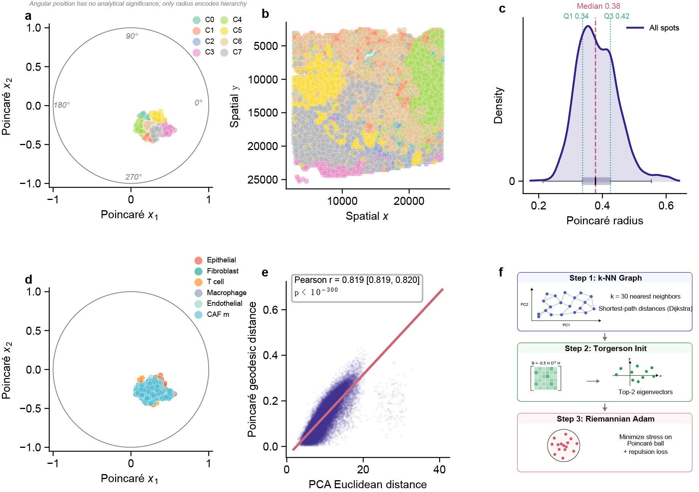
Figure 1. Poincaré MDS embeds spatial transcriptomics data into hyperbolic space. (a) Poincaré disk embedding of 4,252 gastric cancer Visium spots, colored by K-means cluster (Set2 palette, alpha = 0.6). Degree markers (0°, 90°, 180°, 270°) are shown on the disk boundary; angular position has no analytical significance — only radius encodes hierarchy. (b) Spatial coordinates of the same spots. (c) Density curve of Poincaré radius distribution with boxplot overlay; dashed lines mark median and quartiles (Q1, Q3). (d) Cell type signatures on the Poincaré disk (top 30% by module score). (e) Poincaré geodesic distance vs. PCA Euclidean distance with linear regression line (red) and 95% confidence interval (gray band); Pearson r with 95% CI and p-value shown. (f) Algorithm schematic: k-NN graph construction → Torgerson scaling initialization → Riemannian Adam optimization.
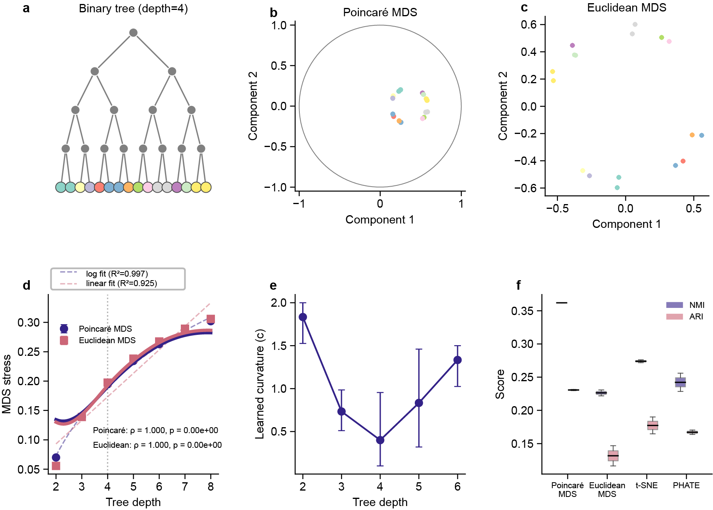
Figure 2. Theoretical validation of hyperbolic advantage for hierarchical data. (a) Schematic binary tree (depth = 4). (b) Poincaré MDS embedding of a depth-4 tree (16 leaves, 480 points). (c) Euclidean MDS embedding of the same tree. (d) MDS stress vs. tree depth for Poincaré MDS (LOWESS smoothing, blue; log fit dashed) and Euclidean MDS (LOWESS smoothing, red; linear fit dashed). Error bars: 95% CI from raw data. Crossover at depth 4. Spearman ρ with p-values annotated. (e) Learned curvature vs. tree depth (95% CI from 3 repeats). (f) Hierarchical recovery comparison: NMI and ARI across methods (Poincaré MDS, Euclidean MDS, t-SNE, PHATE).
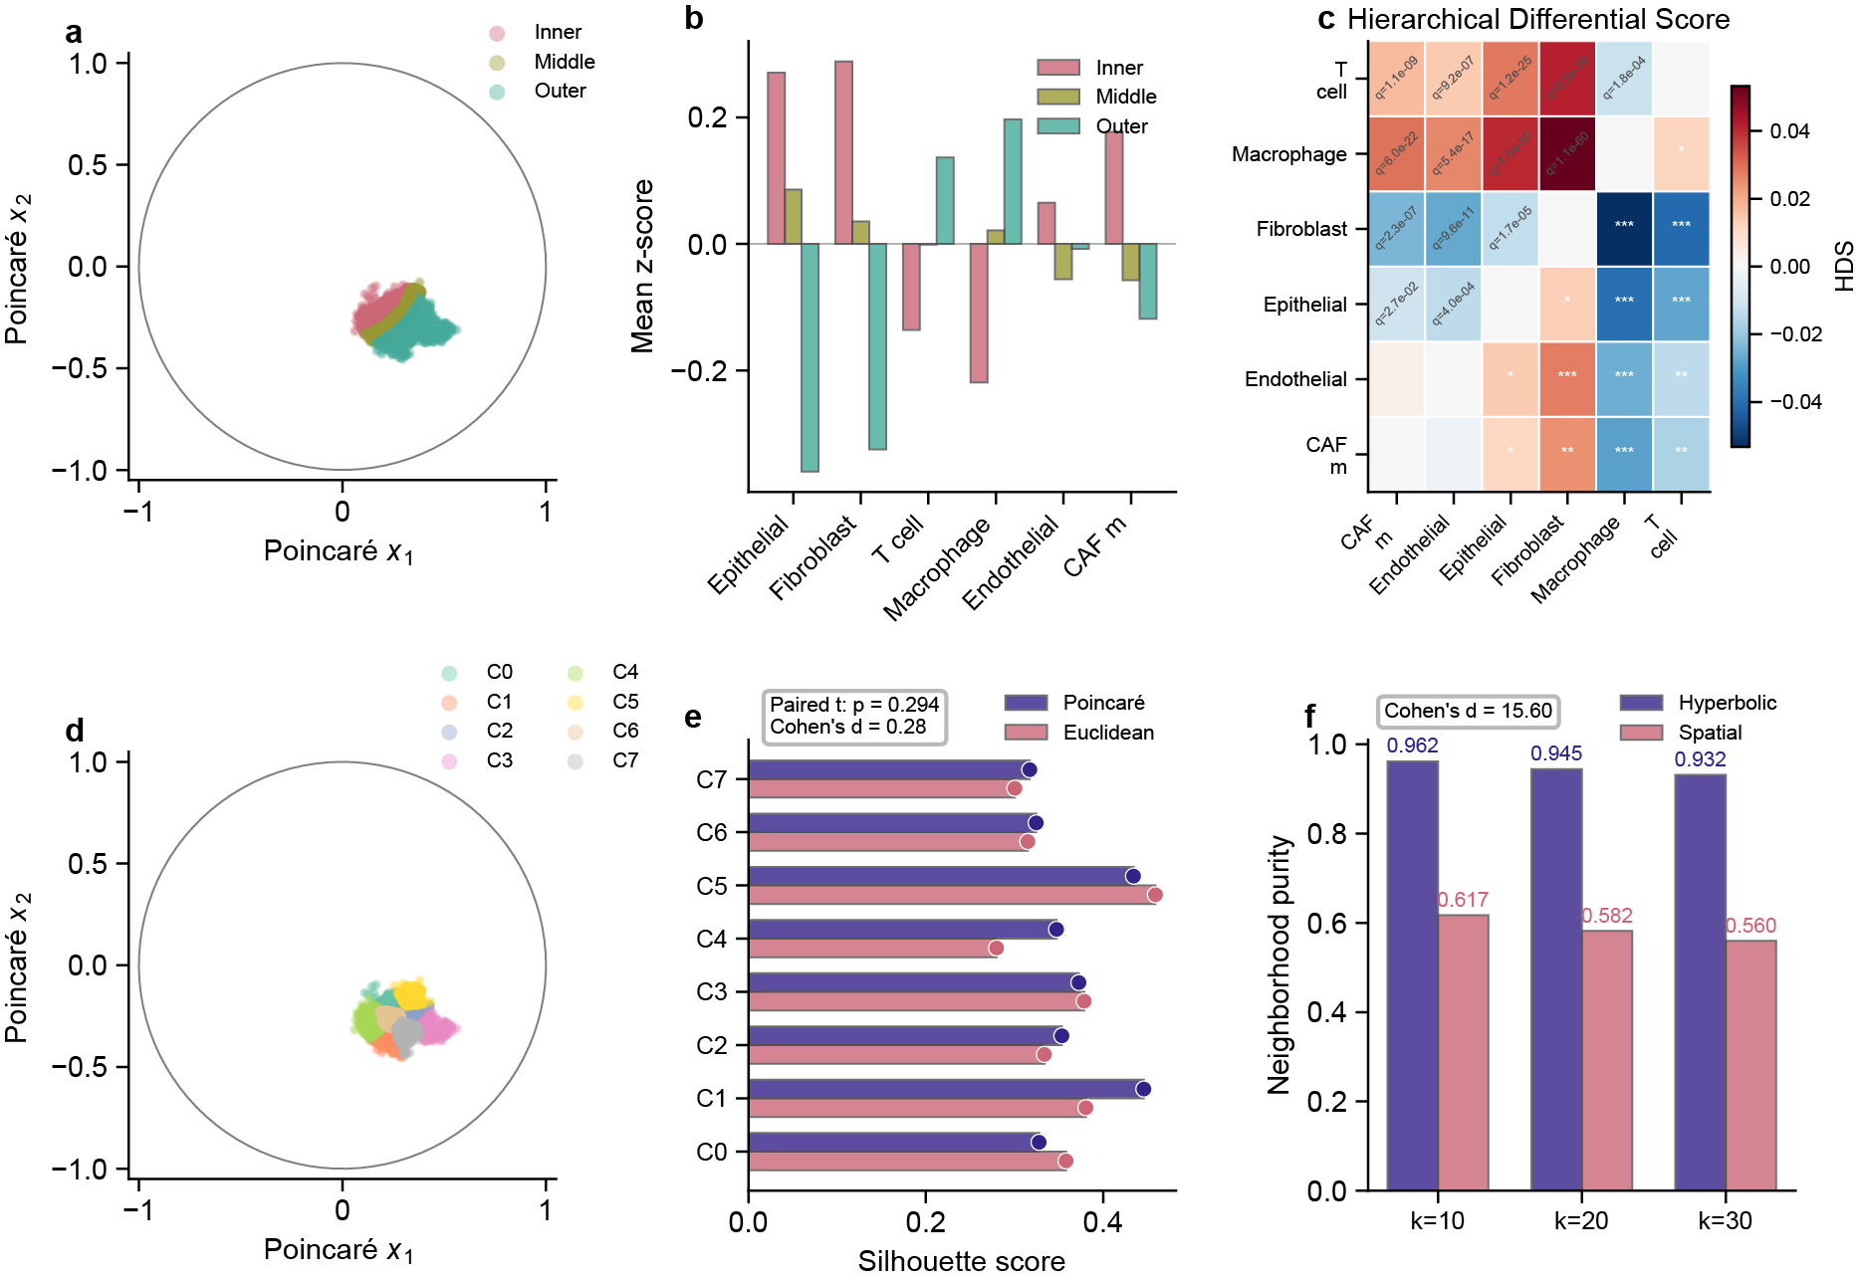
Figure 3. Biological discovery in gastric cancer tissue. (a) Poincaré disk colored by tumor zone (inner/middle/outer), defined by the 33rd and 67th percentiles of the Poincaré radius distribution. (b) Mean z-score cell-type module scores by zone, showing epithelial enrichment in the inner zone and macrophage enrichment in the outer zone. (c) Hierarchical Differential Score (HDS) heatmap: HDS(A, B) = mean radius of cell type A minus mean radius of B. Positive values (red) indicate A is more peripheral than B; negative values (blue) indicate A is more central. *q < 10⁻¹⁰, Mann–Whitney U test with Benjamini–Hochberg FDR correction. (d) KMeans clusters (k = 8) on the Poincaré disk. (e) Per-cluster silhouette comparison between Poincaré and Euclidean embeddings, confirming comparable overall cluster separation in hyperbolic space (paired t-test with Cohen's d annotation). (f) Neighborhood purity comparison: hyperbolic vs. spatial neighborhoods at k = 10, 20, 30.
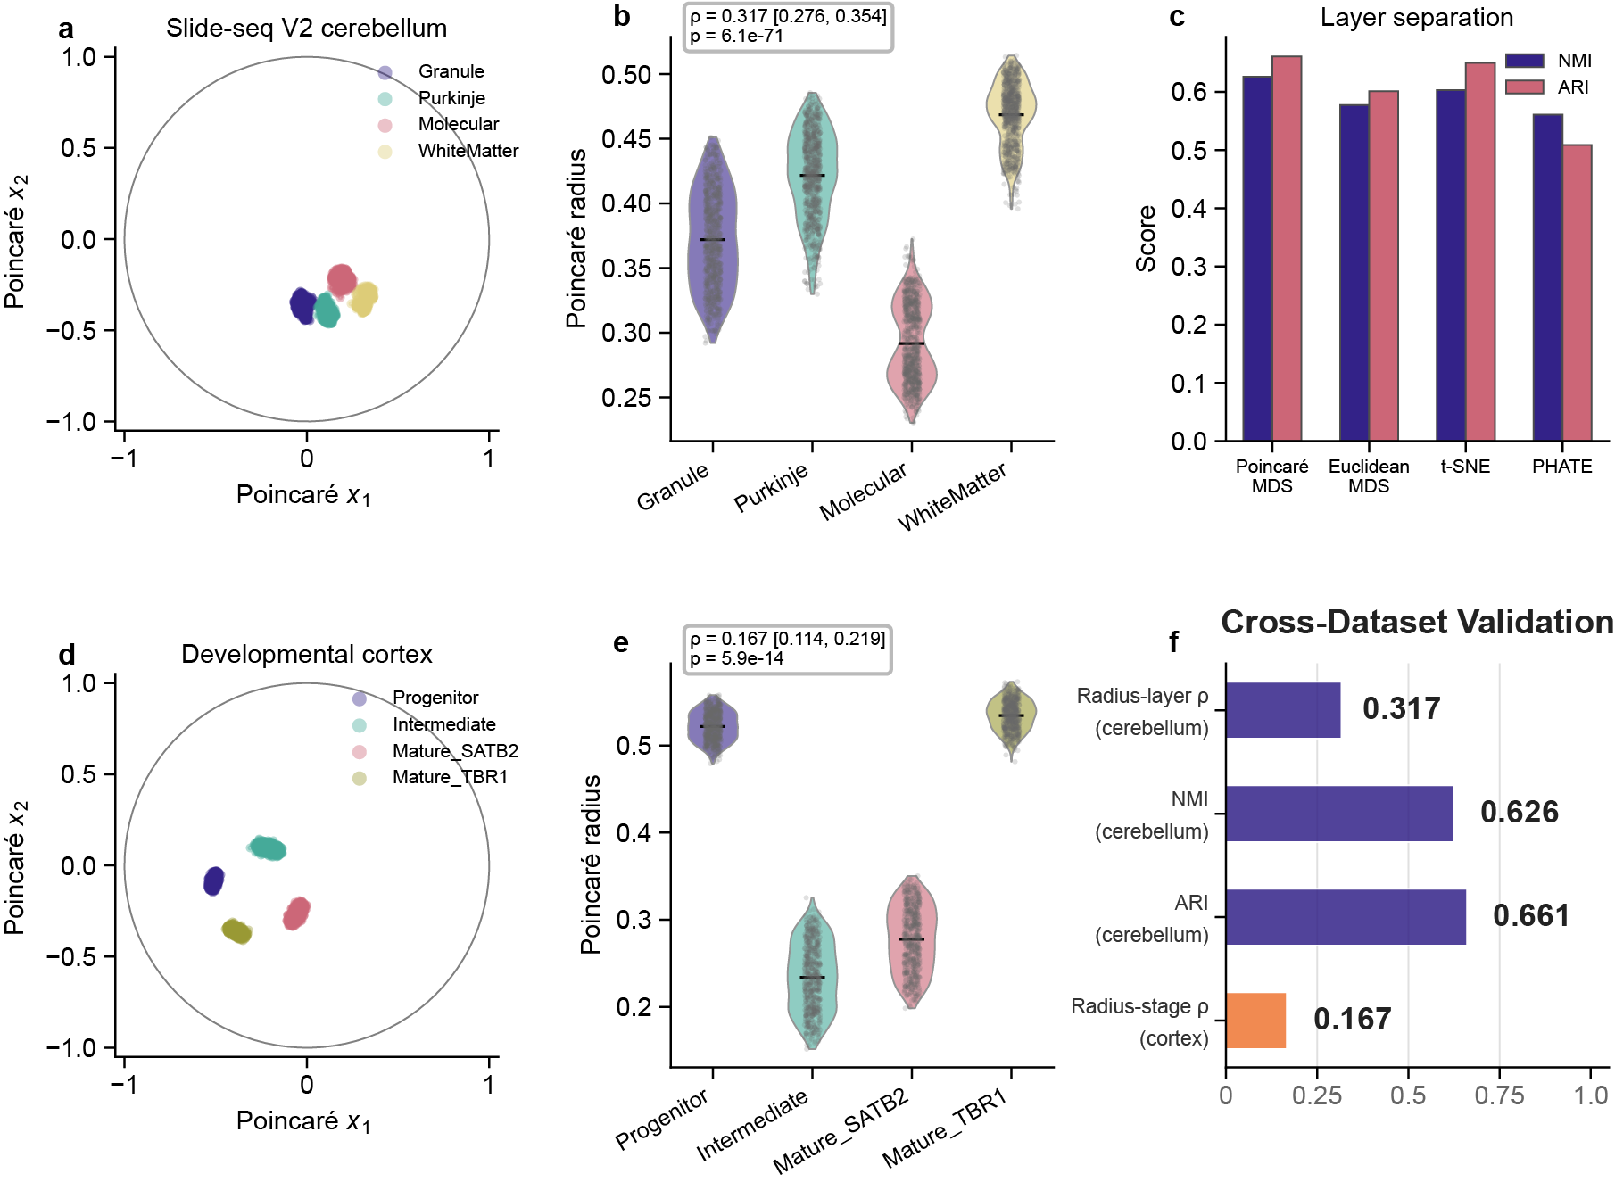
Figure 4. Cross-dataset validation. (a) Slide-seq V2 synthetic cerebellum: Poincaré disk by layer. (b) Poincaré radius by cerebellar layer (violin plot with jitter points); Spearman ρ with 95% bootstrap CI annotated. (c) NMI and ARI for layer separation across 4 methods. (d) Developmental cortex: Poincaré disk by differentiation stage. (e) Poincaré radius by stage (violin plot with jitter points); Spearman ρ with 95% bootstrap CI annotated. (f) Summary of cross-dataset results with 95% CI error bars.
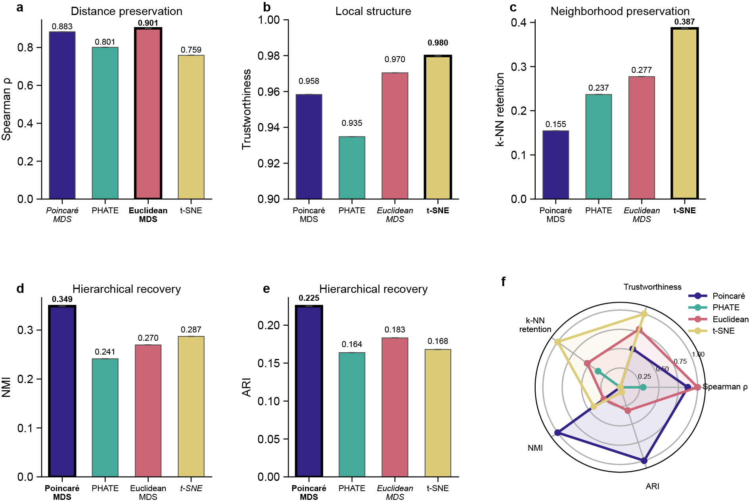
Figure 5. Comprehensive benchmark. (a–e) Bar charts for Spearman ρ, Trustworthiness, k-NN retention, NMI, and ARI across 4 methods. Best method highlighted with bold border; second best shown in italic. Error bars: 95% bootstrap CI where available. (f) Radar chart summarizing all 5 normalized metrics. Poincaré MDS dominates in hierarchical recovery (NMI, ARI); Euclidean MDS dominates in distance and neighborhood preservation.
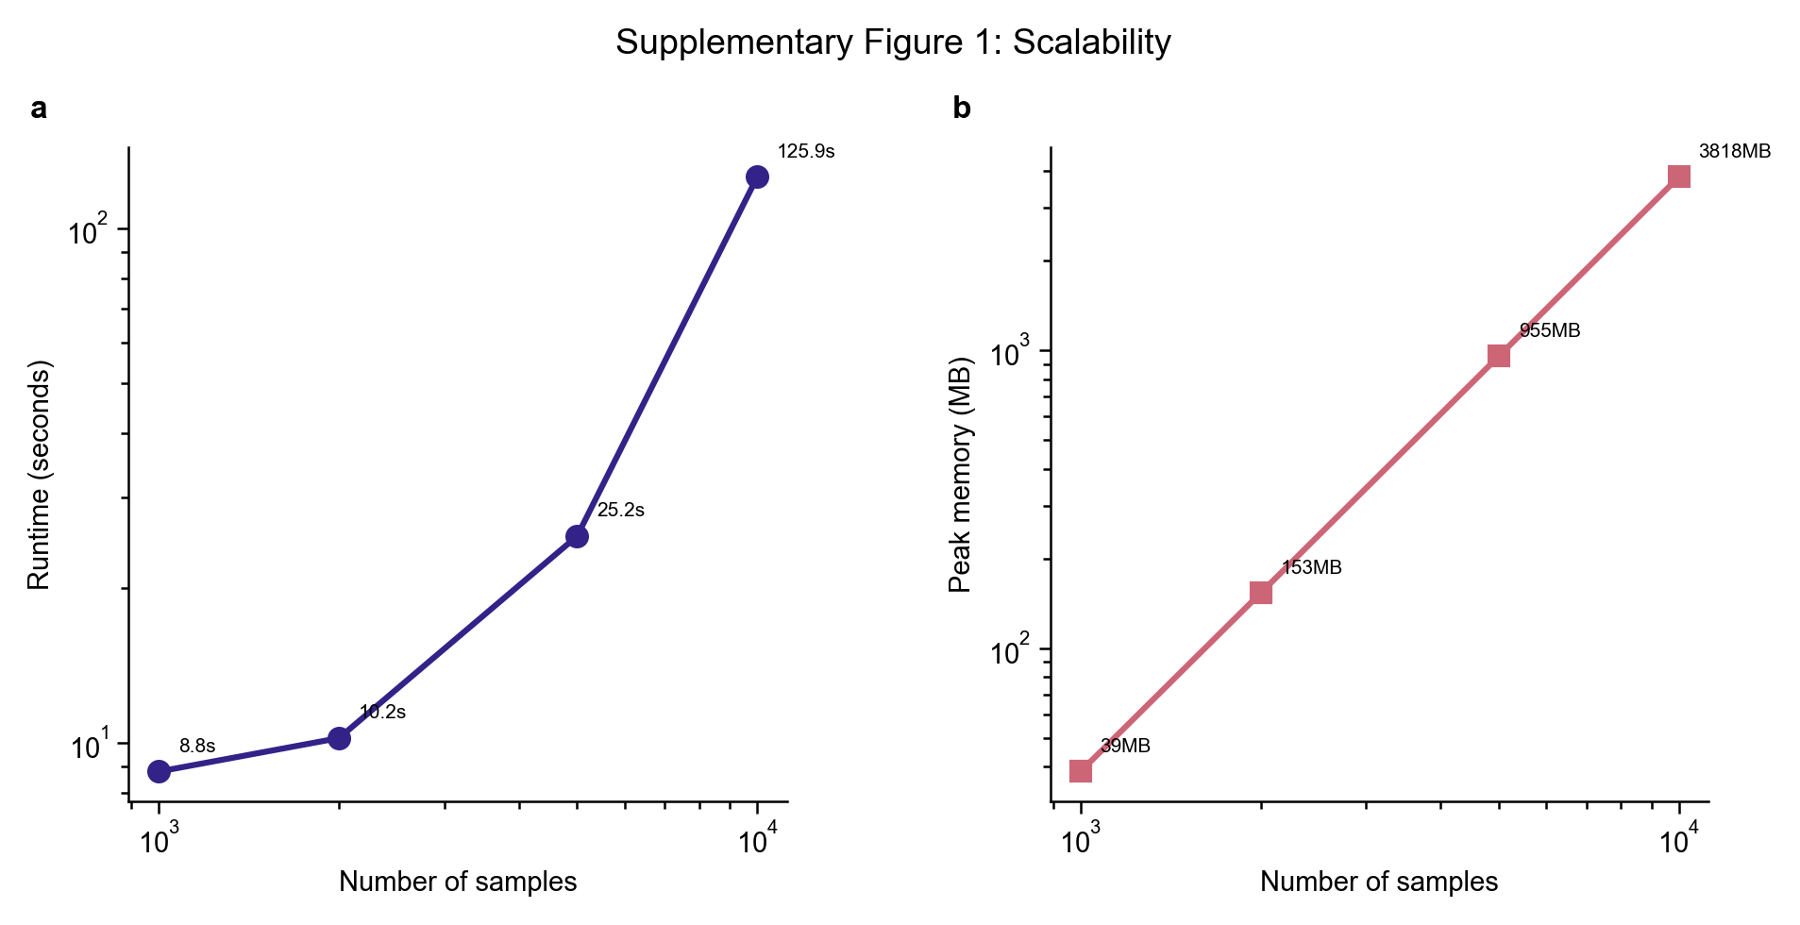
Supplementary Figure 1. Scalability. (a) Runtime vs. dataset size (1K–10K samples). (b) Peak memory vs. dataset size.
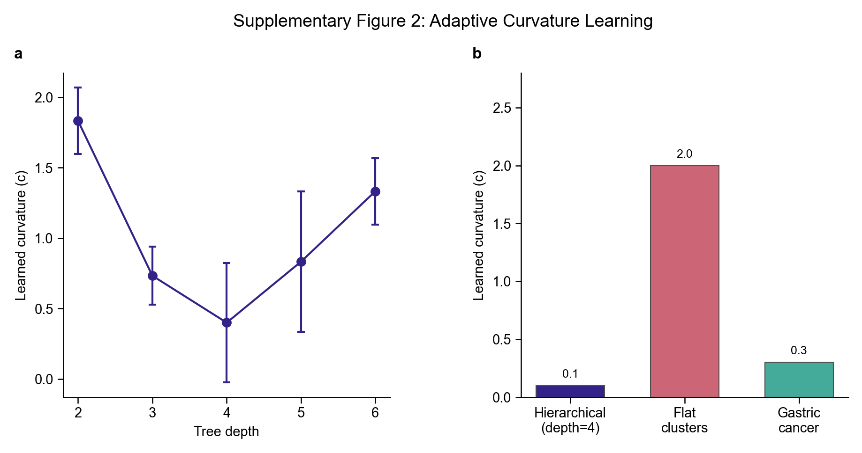
Supplementary Figure 2. Adaptive curvature learning. (a) Learned curvature vs. tree depth. (b) Curvature for hierarchical vs. flat vs. real data.
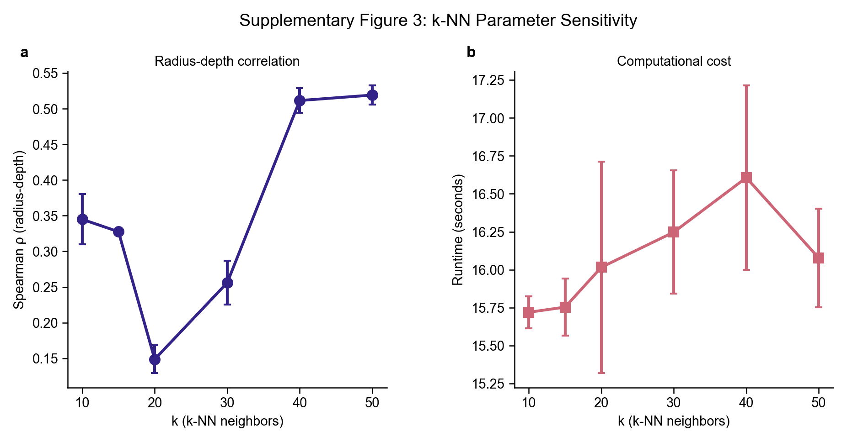
Supplementary Figure 3. k-NN parameter sensitivity. (a) Radius-depth correlation (Spearman ρ) as a function of k (10–50). Error bars: standard deviation across 3 repeats. (b) Runtime vs. k.
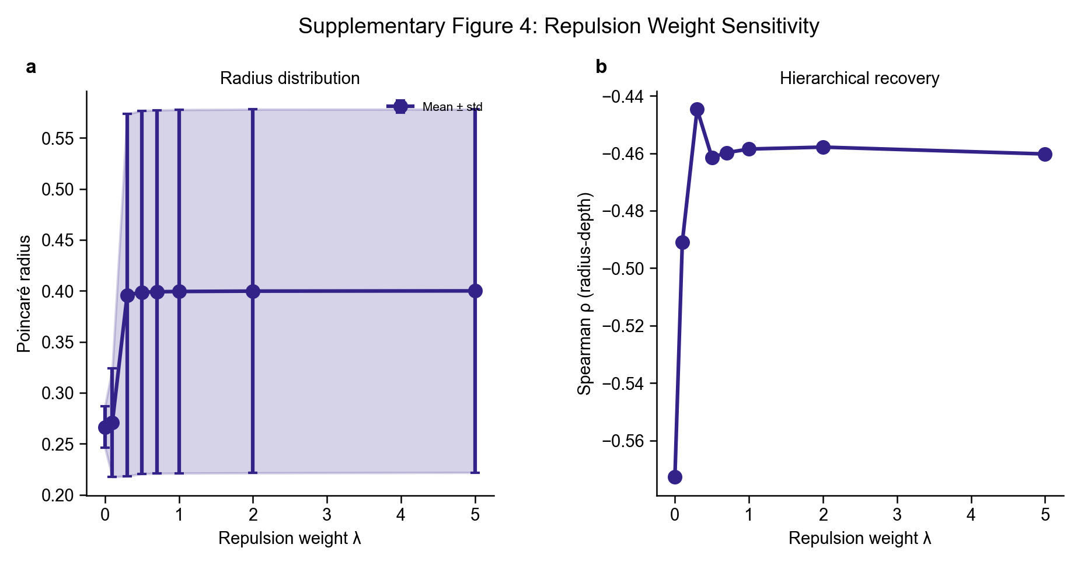
Supplementary Figure 4. Repulsion weight sensitivity. (a) Mean Poincaré radius ± standard deviation as a function of repulsion weight λ (0–5). (b) Radius-depth correlation vs. λ. The method is robust across λ ∈ [0.1, 2.0].
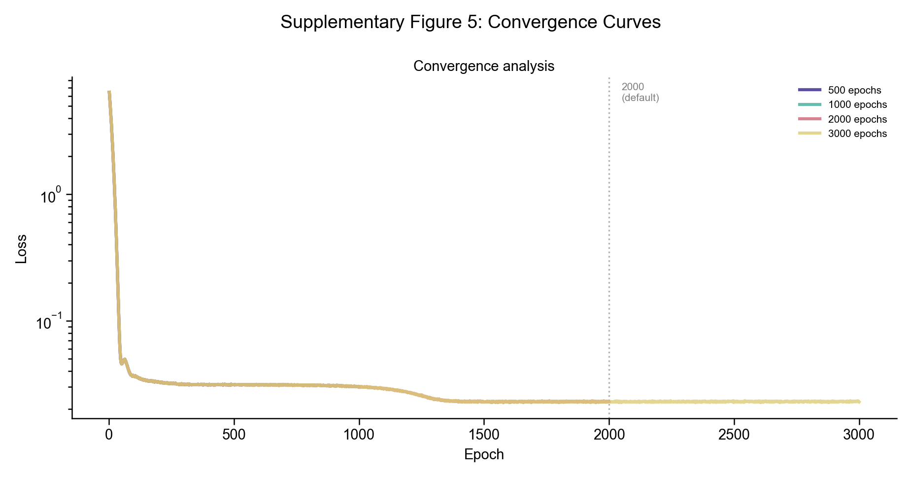
Supplementary Figure 5. Convergence curves. Loss vs. epoch for four target epoch budgets (500, 1000, 2000, 3000). Loss stabilizes within 1,000–1,500 epochs, confirming that 2,000 epochs (default) is sufficient.
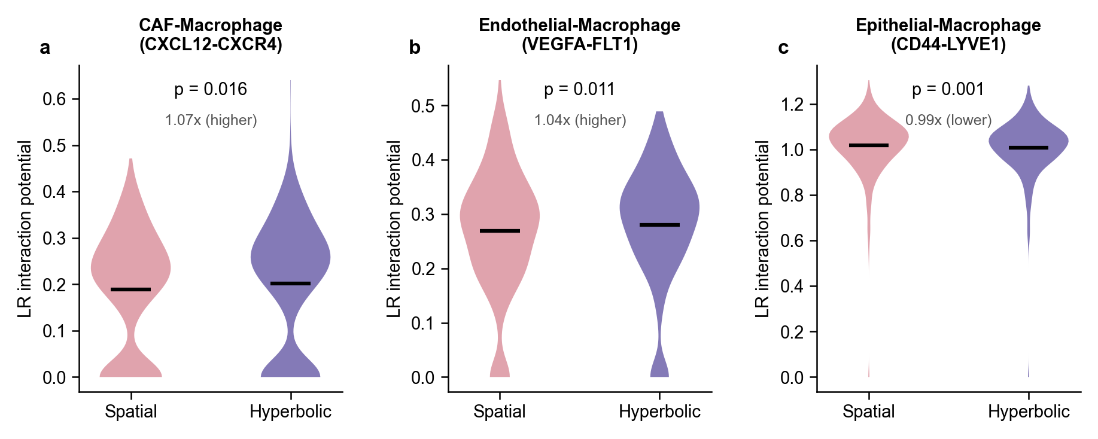
Supplementary Figure 6. Ligand–receptor interaction potential distributions. Violin plots comparing per-spot LR interaction potential in hyperbolic (blue) vs. spatial (red) neighborhoods for three cell type pairs: (a) CAF–macrophage (CXCL12–CXCR4), (b) endothelial–macrophage (VEGFA–FLT1), and (c) epithelial–macrophage (CD44–LYVE1, contact-dependent control). Dashed lines indicate means. Diffusible-signal pairs (a, b) show significantly higher potential in hyperbolic neighborhoods; the contact-dependent pair (c) shows the opposite pattern. Supplementary Table 1. Benchmark comparison of Poincaré MDS against PHATE, Euclidean MDS, and t-SNE on gastric cancer Visium data. Metrics include Spearman ρ (distance preservation), trustworthiness, k-NN retention (local neighborhood preservation), NMI, and ARI (hierarchical recovery). Best values per metric are highlighted.

Supplementary Table 1. Benchmark comparison on gastric cancer Visium data.
Method | Spearman Ρ | P-Value | Trustworthiness | K-Nn Retention | Nmi | Ari
Poincaré MDS | 0.8829 | 0.0000 | 0.9584 | 0.1546 | 0.3488 | 0.2251
PHATE | 0.8009 | 0.0000 | 0.9348 | 0.2369 | 0.2414 | 0.1639
Euclidean MDS | 0.9009 | 0.0000 | 0.9704 | 0.2773 | 0.2696 | 0.1834
t-SNE | 0.7587 | 0.0000 | 0.9798 | 0.3867 | 0.2870 | 0.1680

Supplementary Table 2. Cross-platform benchmark on Slide-seq V2 cerebellum.
Method | Spearman Ρ | P-Value | K-Nn Retention | Nmi | Ari
Poincaré MDS | 0.6610 | 0.0000 | 0.0696 | 0.6261 | 0.6611
Euclidean MDS | 0.7105 | 0.0000 | 0.1092 | 0.5776 | 0.6011
t-SNE | 0.4952 | 0.0000 | 0.2412 | 0.6033 | 0.6500
PHATE | 0.5057 | 0.0000 | 0.0684 | 0.5612 | 0.5089

Supplementary Table 3. Scalability benchmarks.
Samples | Runtime (S) | Peak Memory (Mb) | Mean Radius | Max Radius
1000.00 | 8.81 | 38.57 | 0.3954 | 0.6393
2000.00 | 10.23 | 153.21 | 0.3910 | 0.6228
5000.00 | 25.24 | 955.23 | 0.3709 | 0.6142
10000.00 | 125.93 | 3817.79 | 0.3395 | 0.5830

Supplementary Table 4. Cell type pair enrichment (k=30).
Pair | Description | Hyperbolic | Spatial | Ratio
Epithelial_Macrophage | Tumor-immune signaling | 0.4491 | 0.7838 | 0.5730
CAF_Macrophage | Stromal-immune crosstalk | 1.03 | 0.8579 | 1.20
Epithelial_Fibroblast | Epithelial-stromal niche signaling | 0.5056 | 0.6719 | 0.7525
Endothelial_Macrophage | Angiogenesis-immune axis | 1.17 | 1.01 | 1.15

