The System of Life Cycle

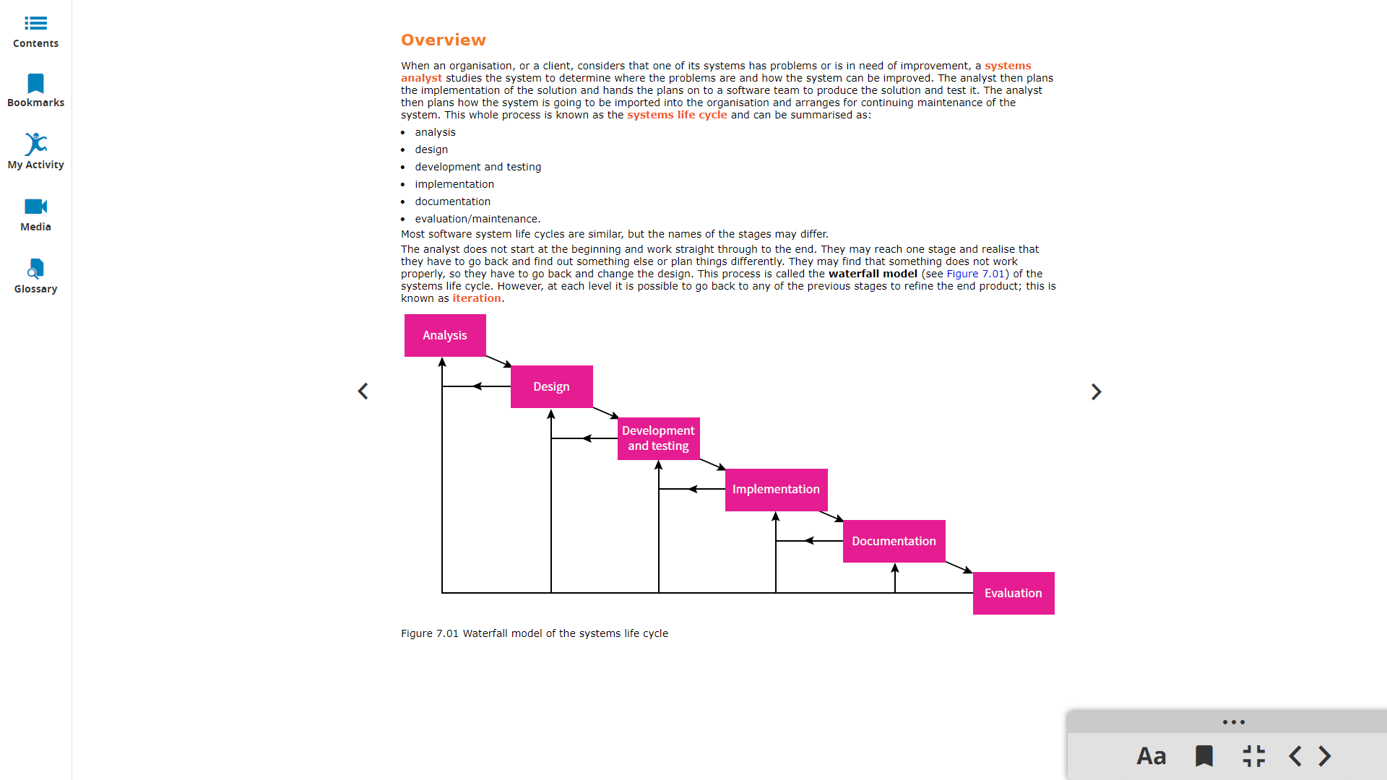

Architectural Design

For your project, architectural Design and Menu Description should be completed in a word document (it shouldn't have any python code at all). Refer to the last two pages of the project outline.

Use a flow chart for the design and specify your menu with details (What do you want to include for the

animation, lesson, test and result etc).

Here are some websites where you can find more information and examples about flow charts:

1. Flow chart symbols: <https://www.lucidchart.com/pages/flowchart-symbols-meaning-explained>

*please note the parallelogram which was used for input/output is outdated.*

1. <https://www.edrawsoft.com/flowchart-examples-for-students.html>
2. Here are some online tools to draw flow charts:

* <https://www.smartdraw.com/flowchart/flowchart-maker.htm?id=264563&msclkid=009516ff1ede10f690c749750dc0b4ba> (7-day trial)
* <https://online.visual-paradigm.com/app/diagrams/#diagram:proj=0&type=BlankDiagram>

1. More Guide:

<https://medium.com/@warren2lynch/a-comprehensive-guide-for-flowchart-over-50-examples-785d6dfdc380>