The System of Life Cycle

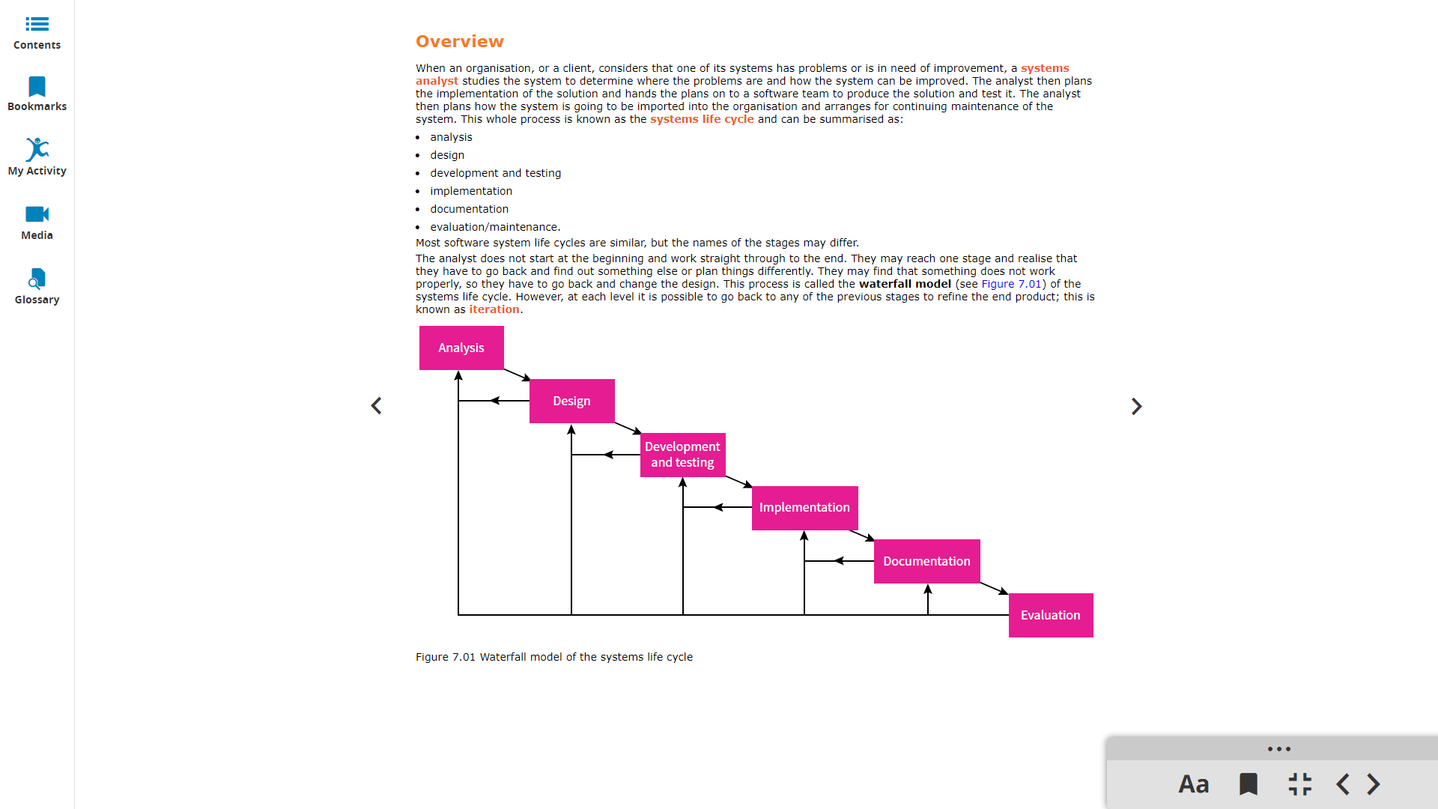

Flow chart:

Architectural Design and Menu Description should be completed in a word document (it shouldn't have any python code). Use flow chart for the design and specify your menu with details (What do you want to include for the animation, lesson, test and result etc).

Here are some websites where you can find more information about flow charts:

1. Flow chart symbols: https://www.lucidchart.com/pages/flowchart-symbols-meaning-explained

*please note the parallelogram which was used for input/output is outdated.*

1. https://www.edrawsoft.com/flowchart-examples-for-students.html
2. https://medium.com/@warren2lynch/a-comprehensive-guide-for-flowchart-over-50-examples-785d6dfdc380