**How to package and import Python files of your own:**

1. Make sure save your Python files in the same folder so that they are considered to be packaged. For example, in the following example, we have four Python files in the same folder:

* main.py
* variable.py
* function.py
* classes.py

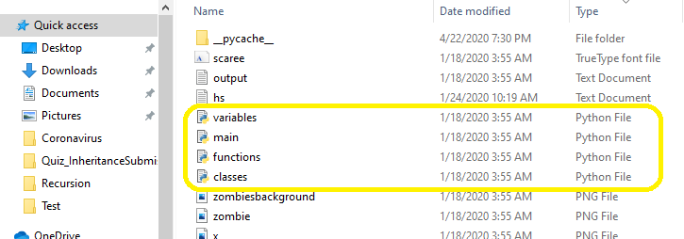

1. If we need to import three supporting Python files in Main.py, we will have statements

from variables import *

from functions import *

from classes import *

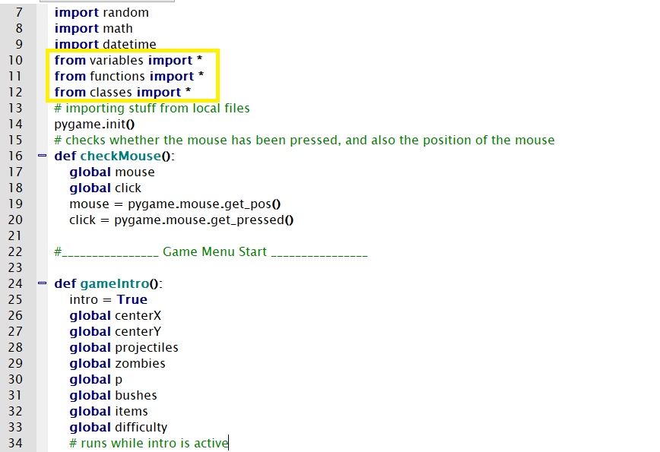

**Differences between Turtle and Pygame**

“Turtle” is a Python feature like a drawing board, which lets us command a turtle to draw all over it! We can use functions like turtle.forward(…) and turtle.right(…) which can move the turtle around.

To make use of the turtle methods and functionalities, we need to import turtle.”turtle” comes packed with the standard Python package and need not be installed externally.The roadmap for executing a turtle program follows 4 steps:

1. Import the turtle module
2. Create a turtle to control.
3. Draw around using the turtle methods.
4. Run turtle.done().

Turtle Python is a simple drawing program designed for children or beginning programmers. You can make simple games like tic-tac-toe with it. However, it isn't designed for advanced games.

If you wish to build much more complex and bigger games, Pygame is a much better option. Pygame,  compared to Turtle Python, it is more advanced and is designed for game development. However, it's still simple enough that you can program games by yourself.