[I've uploaded my own MOL lab texture to Dropbox](https://www.dropbox.com/s/olux0tcauvs2yju/bluedog_MOL_Lab.psd?dl=0" \t "_blank). The layers to look at are the 'PanelGaps' for the rounded corners, and the various layers of 'scratches' and 'smudges' for the weathering / frayed edges. One thing I've noticed is Porkjet will go along edges and hit them hard here and there with a straight-up white brush. Personally speaking, I feel like your textures are about 90% there, I just think that at the moment they're a little too 'stockalike' and not enough 'porkalike'. I know there's only so much you can do with the mk1 pod style but in regards to everything else there are two big things:

[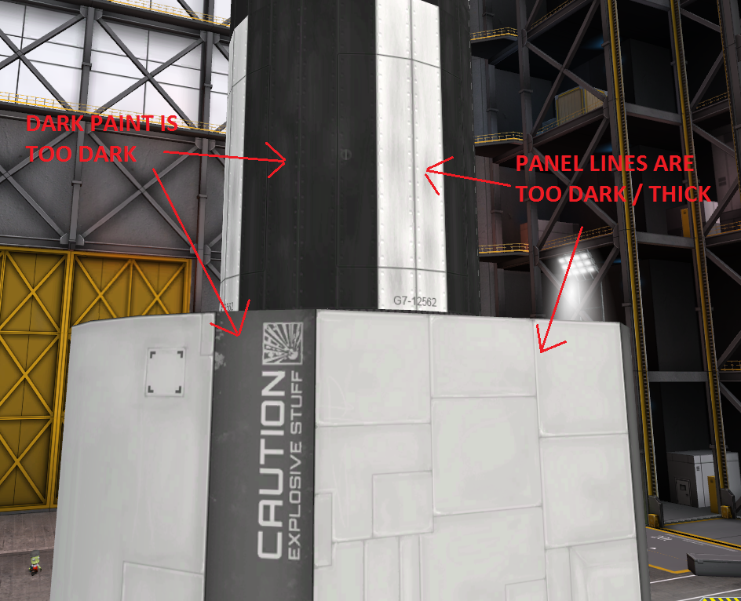](http://i.imgur.com/BObNFYF.png)

As I type this I'm still in game so I found some more things that I think could be improved. These ones I'll just write out here:

[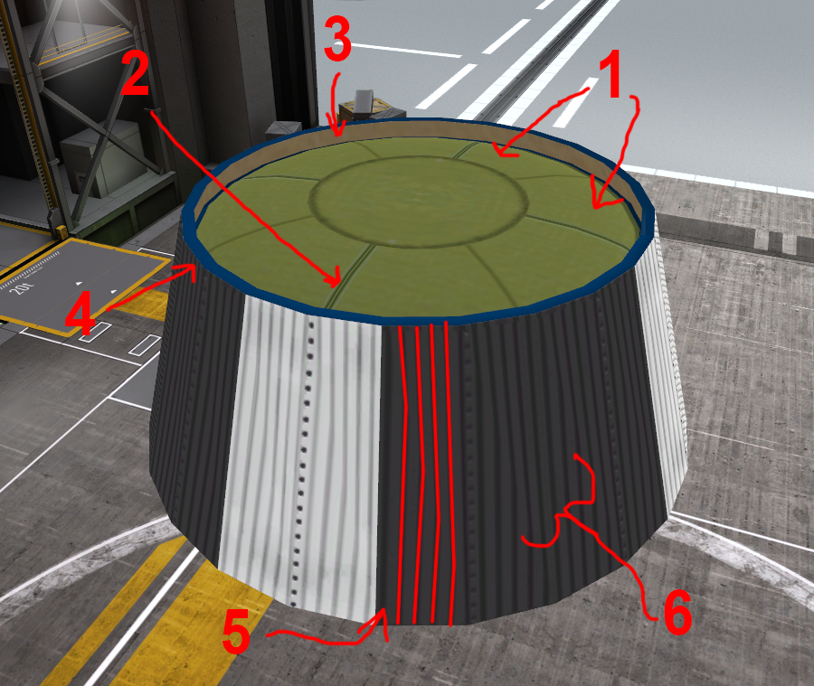](http://i.imgur.com/Zq7qcCX.png)

1) The wedges of the tank are too uniform. Add more shading (See the edgeSmudges layers in the file I posted above) to break them up.

2) Your UVs don't line up perfectly with the lines on the texture. This happens to me too, just go in and move them by hand so they line up with the edges.

3) This is too solid. Personally I would add in an AO gradient on the bottom, and lighter scuff marks along the top.

4) The blue rim is the same thing. Solid blocks of color really give away that it's a texture wrapped onto a part and not a 3d object, doubly so with the flat lighting in the VAB. Adding in lightening scuff marks along the edges will help. As a side note, I'm not a huge fan of really dark / saturated colors in stockalike stuff but that's me.

5) You're getting distortion from your UV mapping. You drew the stripes as a normal rectangle on the texture and then pinned your UV corners to it right? I get that too, I'm not sure how to fix it. [@Beale](http://forum.kerbalspaceprogram.com/index.php?/profile/70533-beale/) you seem to have gotten around this maybe? I feel like I've seen you do that.

6) And more generally, the stripes are too thick, this part is a little too uniform. You only have two distinct tones in the dark section, same for the white: Dark and darker. Adding in, for example, subtle highlighting inbetween the lines may help bring them out a bit and make them feel more 3D.

In regards to the Brumby, I think it would benefit from the sections being bigger. It's too divided up at the moment. And it's just the same detail everywhere. IMO breaking it up with some smooth sections here or there, in particular inside the window indents, would make it a much nicer part. Right now it's visually exhausting. An example of what I mean would be something like [@Beale](http://forum.kerbalspaceprogram.com/index.php?/profile/70533-beale/)'s Gemini in TRAILS. The part isn't uniform the whole way around. It has some parts that are smooth, the size of the sections isn't the same for every part. The window glass is a solid light blue, try and add some variation to it like the windows on the Mk1 lander can to break them up. And again, the dark is far too dark.

Anyways, I know you kind of didn't ask for all that but I think you could really easily make the parts look way more awesome with some of those small fixes. Sorry if all that is unwanted / doesn't interest you, but if you want to I could try and help further with more feedback / possibly taking one of your textures and making some changes as an example. :)