Arnaud Harmange U13657431

EC605 Lab 7

**TASK 1**

1.What kind of protocol is used when performing a ping command?

1) The protocol being used is ICMP

2.What information is transferred in this protocol?

2) ICMP or Internet Control Message Protocol transmits a message that is

wrapped in IP packets, in this particular case with the Ping command it sends

an echo request from the host machine to the target (www.bu.edu)

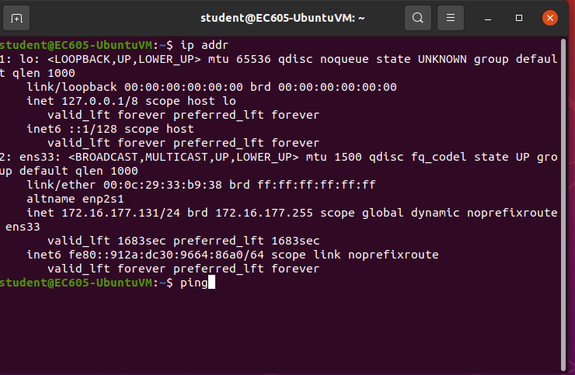

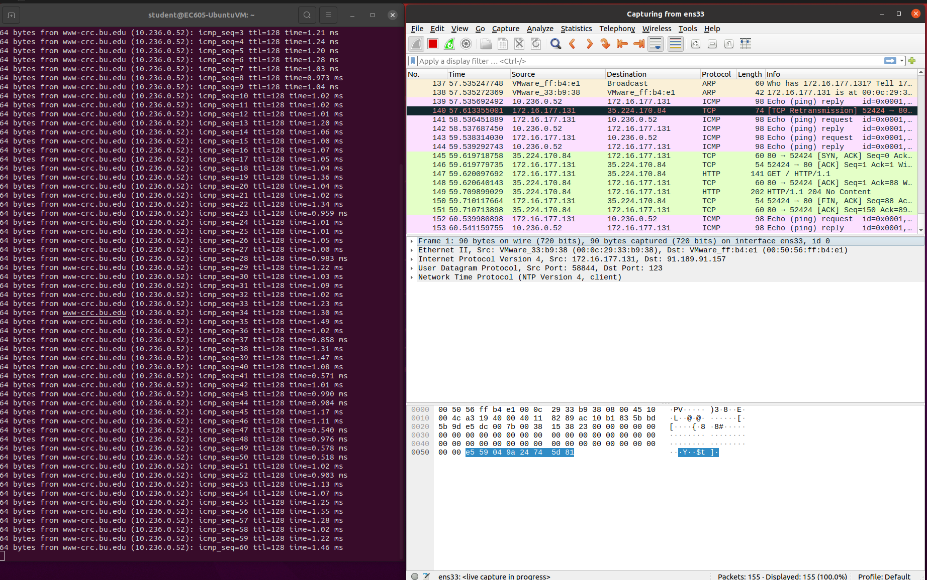

**TASK 2**

1.Specify the destination IP address

142.250.65.196

2.Specify the destination MAC address

00:50:56:ff:b4:e1

3.Specify the Internet Protocol version

IPV4 (Internet protocol Version 4)

4.Specify the Source and Destination Port

Source: 56106

Destination: 80

5.Specify the version of wget

wget 1.20.3

6.Specify the TCP Flags

0x018 (PSH, ACK)

000. .... .... = Reserved: Not set

...0 .... .... = Nonce: Not set

.... 0... .... = Congestion Window Reduced (CWR): Not set

.... .0.. .... = ECN-Echo: Not Set

.... ..0. .... = Urgent: Not set

.... ...1 .... = Acknowledgement: Set

.... .... 1... = Push :set

.... .... .0.. = Reset: Not set

.... .... ..0. = Syn: Not set

.... .... ...0 = Fin: Not set

Acknowledgement and Push flags are the only set flags

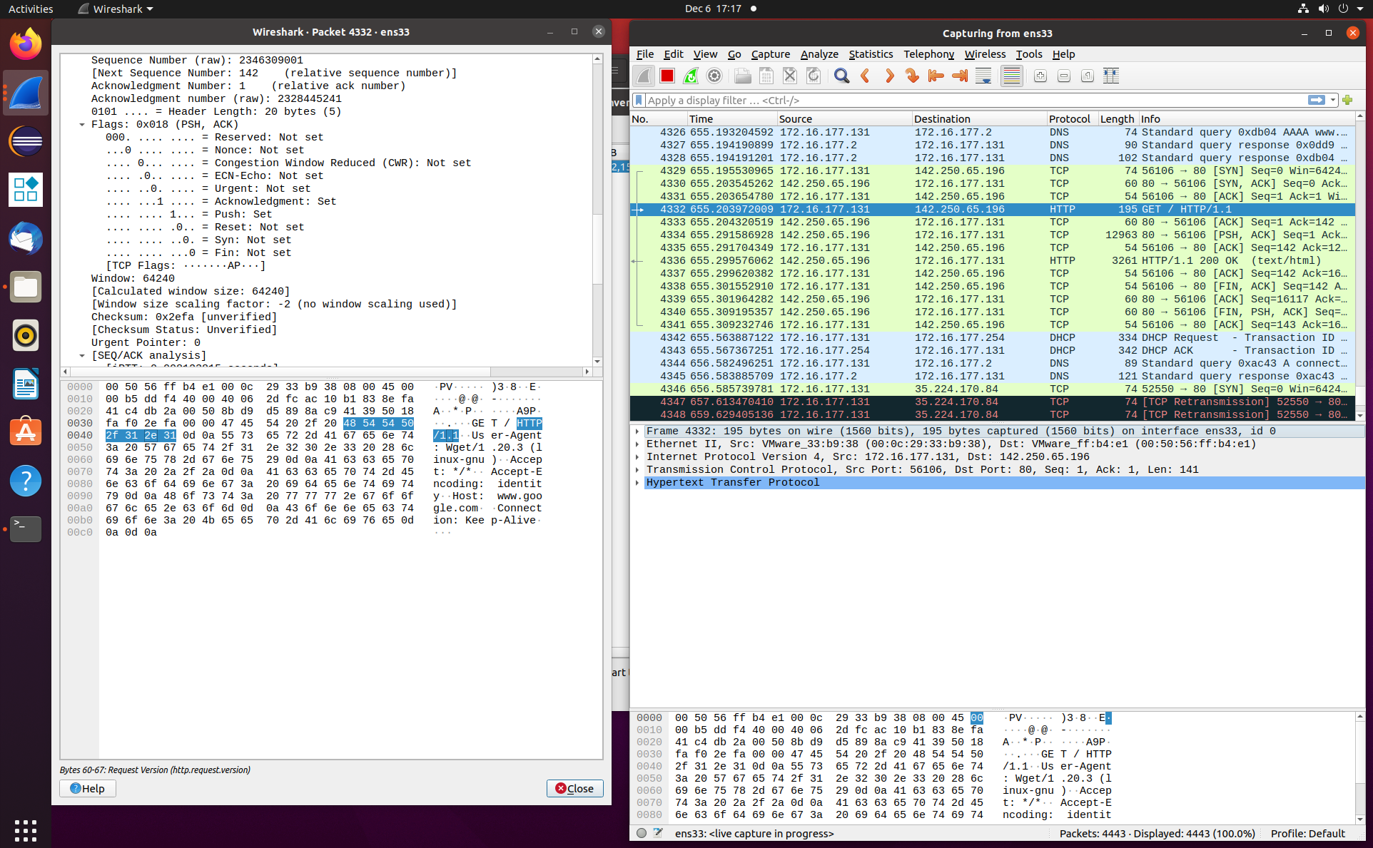

**TASK 3**

1.Specify the destination IP address

142.250.65.196

2.Specify the destination MAC address

00:56:ff:b4:e1

3.Specify the Internet Protocol version

IPV4 (Internet protocol Version 4)

4.Specify the Source and Destination Port

Source: 52976

Destination: 80

5.Specify the version of wget

wget version 1.20.3

6.Specify the TCP Flags

0x018 (PSH, ACK)

000. .... .... = Reserved: Not set

...0 .... .... = Nonce: Not set

.... 0... .... = Congestion Window Reduced (CWR): Not set

.... .0.. .... = ECN-Echo: Not Set

.... ..0. .... = Urgent: Not set

.... ...1 .... = Acknowledgement: Set

.... .... 1... = Push :Not set

.... .... .0.. = Reset: Not setEC605Student

.... .... ..0. = Syn: Not set

.... .... ...0 = Fin: Not set

The ACK (acknowledge) and PSH (push) flags are set

Differences- There is a client/server handshake in the secure protocol but not in the unsecure protocol. The Unsecure protocol only uses TCP, but the secure protocol uses TCP and TLSv1.3, or Transport Layer Security which encrypts the information being sent between the server and the client.

List the packets sent between two machines and the purpose of each packet

Client Hello- source sends hello request to the destination (server)

Server Hello - Server has received Client hello, acknowledges it and sends acknowledgement back to the Client

Application data- information exchange between the client and the server

FIN, ACK - client is done, send FIN to server to end connection

FIN, PSH, ACK - Server acknowledges the FIN from the client, ends connection and sends acknowledgement back to client to confirm end of connection

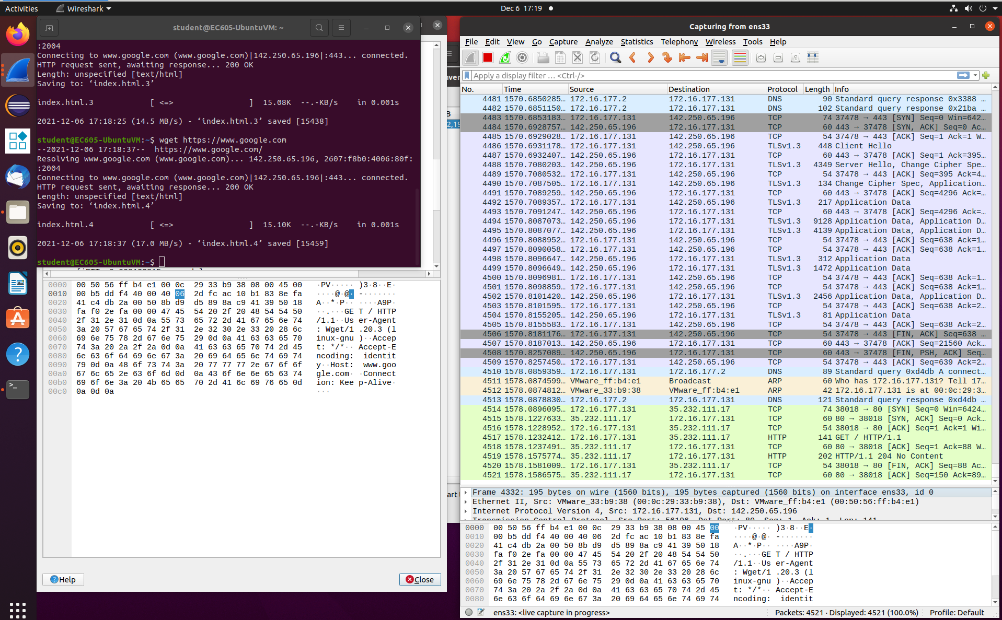ACK - Client send acknowledgement that it received server FIN

**TASK 4**

IP Addresses:

74.125.29.189 -> Google

128.197.26.34 -> Boston University

192.168.1.17 -> Internet Assigned Numbers Authority (IANA)

192.168.1.1 -> Internet Assigned Numbers Authority (IANA)

216.58.219.238 -> Google

Client IP:

192.168.1.17

Domains Being Accessed:

Google

Boston University

Internet Assigned Numbers Authority

Image:

