Software Design
Specification

for

Library Management System

Version 1.0 approved

Prepared by

Kerem Erkut Çiftlikçi
Esra Gürbüz

Fırat University Faculty of Technology Software Engineering Department(UOLP)

05.22.2025

Revision History

Name | Date | Reason for Changes | Version
Esra Gürbüz  K. Erkut Çiftlikçi | 22/05/2025 | Initial Commit | 1.0

Table of Contents
- Introduction
  - Purpose of This Document
  - Scope of the Development Project
  - Definitions, acronyms, and abbreviations
  - References
  - Overview of Document
- System Architecture Description
  - System Architecture
    - High Level Architecture Design
    - Architecture Narrative
  - Database Components
    - Entity Relationship Diagram (ERD)
    - Database Table Definitions
  - GUI Components with Layouts and Navigation
    - User Interface Issues
    - List of User Interface Screens and Reports
    - User Interface Screens or Reports (Layouts)
- Detailed Description of System Components
  - Class Diagram
  - Use Case 1
- Design Decisions and Tradeoffs
- Appendices
  - Appendix A: Use Case Diagram
  - Appendix B: Data Dictionary
    - B1: Use Case Descriptions
    - B2 : Actor Descriptions
    - B3: Class Descriptions
  - Appendix C: List of inputs and outputs(labeled and numbered.)

- Introduction
  - Purpose
This document outlines the software design for Personal Library Management Application The purpose of the document is to provide a technical basis for the software development process by describing in detail the architecture of the system, its components, modules and the interaction between them.
This application is a system that allows users to easily catalog, organize and manage the books they own.The system defines two different user roles, 'user' and 'library admin', each with access to specific functionalities. This document describes how these functions are realized within the system, together with interfaces, data flows and module relationships.The goal is to deliver a user-friendly, maintainable software architecture.

  - Scope
The Library Management System is a standalone Java application designed for personal use, supporting two roles: Library Admin (full access to manage books) and User (read-only access to view and search books). It uses Java Swing for the GUI and MySQL for data storage. The system includes a login page for user authentication and a main page for book management operations, such as adding, updating, deleting, searching, and viewing books.

Key features within the scope of this design include:
- A responsive and intuitive user interface
- User authentication and role-based access control
- CRUD operations (Create, Read, Update, Delete) for books
- Search and filtering functionality
- Basic analytics and summaries (e.g., total books, categories)
- Scalable architecture to allow for future feature expansion
This SDS focuses on the internal structure, design decisions, and module interactions that will support these functionalities. Integration with external services (e.g., ISBN lookup APIs or cloud storage) is out of scope for version 1.0 but may be considered in future releases.

  - Definitions, acronyms, and abbreviations

Acronyms | Definition
SDS | Software Design Specification - a document that describes the architecture and design of a software system.
CRUD | Create, Read, Update, Delete – the four basic operations for persistent storage in software systems
GUI | Graphical User Interface – the visual part of the application through which users interact with the system.
MySQL | An open-source relational database management system based on SQL (Structured Query Language), used for storing and managing data.
API | Application Programming Interface – a set of rules and protocols for building and interacting with software applications.
ISBN | International Standard Book Number – A unique numeric identifier for books, typically used to retrieve book metadata.
User | A standard user of the system who can manage their personal library.
Library Admin | A user with full access rights to manage books and categories.  A privileged user who can manage other users and oversee system-level data.
DAO | Data Access Object, an interface for data operations
JDBC | Java Database Connectivity, used to connect Java to MySQL.

  - References
- Java Swing Documentation, Oracle
- MySQL Connector/J Documentation.
- Intellij IDEA Documentation

  - Overview of this Document
This Software Design Specification (SDS) provides a detailed technical plan for the development of the Personal Library Management Application v1.0 release. It serves as a guide for developers, testers and other stakeholders by defining the system architecture, design patterns, modules, data structures and interactions between components.
This document assumes that the reader has a basic understanding of software engineering concepts, object-oriented design principles, and database technologies.
- System Architecture Description
  - System Architecture
The system follows a layered architecture, separating the GUI, business logic and data storage layers.
    - High Level Architecture Diagram
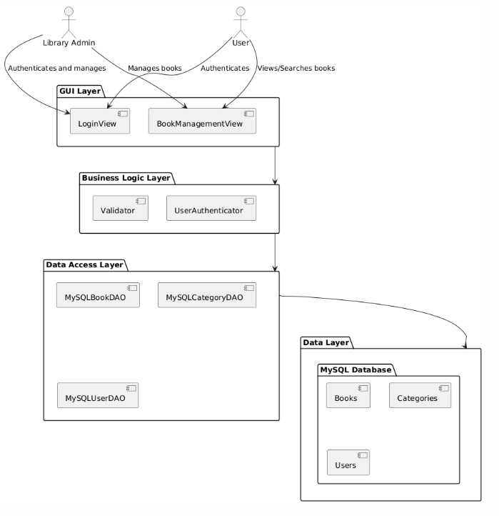

The overall system architecture involves interactions between the Library Admin and the User, with data persistence handled through a MySQL database. The core functionalities revolve around managing book data. The system's boundary is defined by its user interface interactions with these two actor types.
    - Architecture Narrative
The Library Management System is built upon a simple, standalone
architecture, primarily due to the specified constraints.
- Database: MySQL, accessed via JDBC (MySQL Connector/J).
- GUI: Java Swing, providing user interaction with login and main pages.
- Implementation Language: Java (JDK 11+).
- Tools: IntelliJ IDEA for development.
- The system uses DAO implementations for data access and includes a UserAuthenticator class for login validation.
  - Database Components
    - Entity Relationship Diagram (ERD)
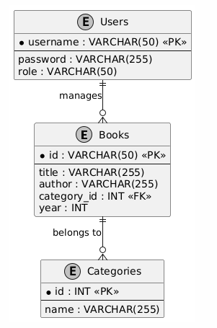
    - Database Table Definitions
The data will be stored in traditional relational database tables in MySQL. The definitions below outline the structure of these tables:
- Books Table: This table will store information about each book.
book_id: INT, PRIMARY KEY, AUTO_INCREMENT (unique identifier).
title: VARCHAR(255), NOT NULL.
author: VARCHAR(255), NOT NULL.
category_id: INT, FOREIGN KEY references Categories(category_id).
publication_year: INT.
- Categories Table: This table will store a list of available categories.
category_id: INT, PRIMARY KEY, AUTO_INCREMENT.
category_name: VARCHAR(100), NOT NULL, UNIQUE.
- User Table: This table will store a list of users.
CREATE TABLE Users (
username VARCHAR(50) PRIMARY KEY,
password VARCHAR(255) NOT NULL,
role VARCHAR(50) NOT NULL CHECK (role IN ('ADMIN', 'USER'))
);

  - GUI Components with Layouts and Navigation
    - User Interface Issues
This section describes the considerations made for the types of users of the system and their needs.
- Roles: Admins manage books; Users view/search only.
- Usability: Simple, intuitive design with validation feedback.
- Navigation: The login page is the entry point; upon successful login, the main page is displayed.

    - List of User Interface Screens and Reports

ID | Name | Use Case Involved
UI-1 | Login Screen | User Authentication
UI-2 | Main View | All book management use cases
UI-3 | Book List Report | Search Results, Analytics

    - List of User Interface Screens and Reports
- UI-1 : Login Screen
  - Fields: “Username”, “Password” .
  - Button: "Log In" .
- UI-2 Main View
  - Buttons: View All Books, Add Book, Delete Selected Book, Update Selected Book.
  - Search Fields: Title, Author, Category (dropdown), Year.
  - Table: Displays book list with sortable columns.

Detailed Description of System Components
  - Class Diagram
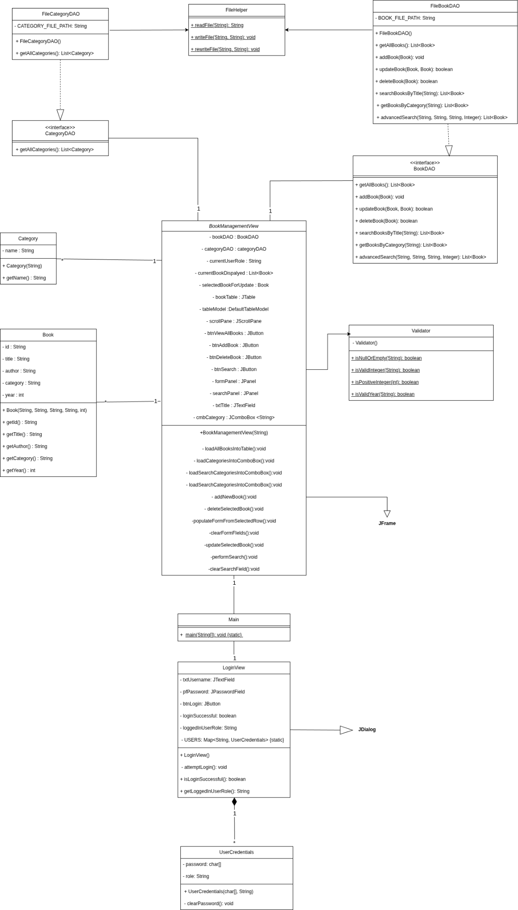

Use Case 1: User Login
- Actor: Library Admin, User
- Description: Authenticates the user and grants access to the main page based on their role.

Sequence Diagram for User Login
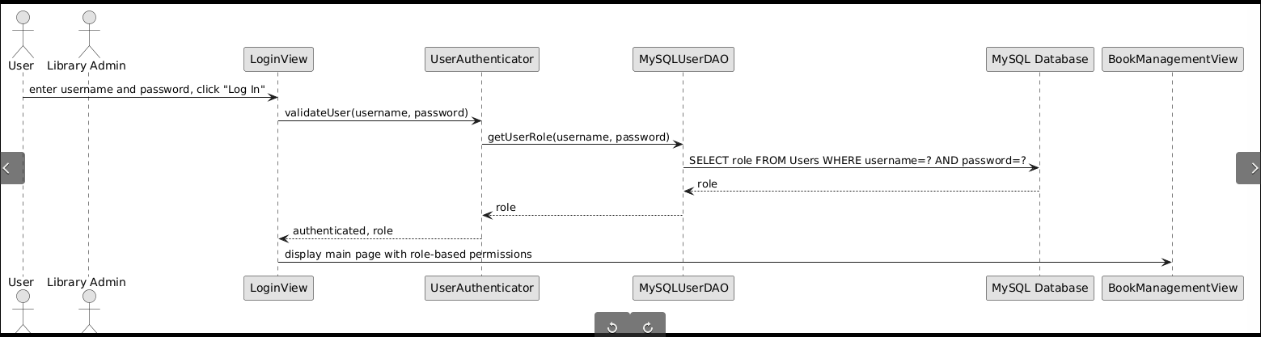

  - Use Case 2 : Add New Book
- Actor : Library Admin
- Description : Adds new book to database.

Sequence Diagram for Add New Book
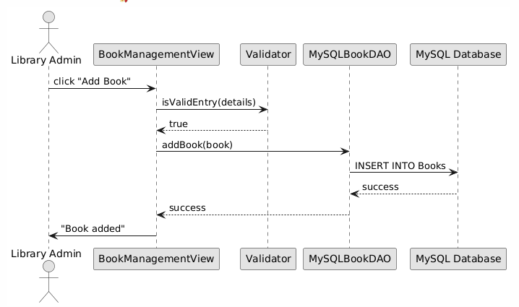

Use Case 3: Search Book by Title
- Actor: User/Admin
- Description: Searches books by title keyword.

Sequence Diagram for Search Book by Title
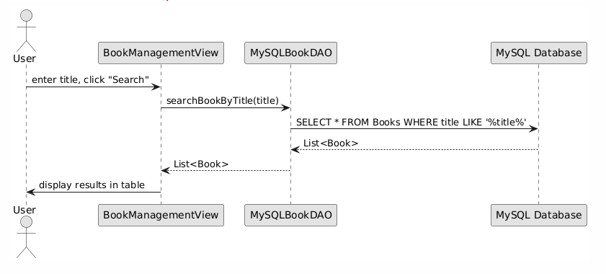

Design Decisions and Tradeoffs
- MySQL over Files:
  - Pros: Scalability, data integrity, powerful queries.
  - Cons: Increased setup complexity.
- DAO Pattern:
  - Pros: Flexible data access abstraction.
  - Cons: Adds development overhead.
- Login Functionality:
  - Pros: Role-based access control.
  - Cons: Additional complexity in user management.
- Switch to IntelliJ IDEA:
  - Pros: IntelliJ IDEA provides superior code navigation, refactoring tools, and debugging capabilities compared to NetBeans, enhancing developer productivity.
  - Cons: Need time to adapt to IntelliJ IDEA's interface and features, potentially requiring initial training.

Appendices

Appendix A: Use Case Diagram
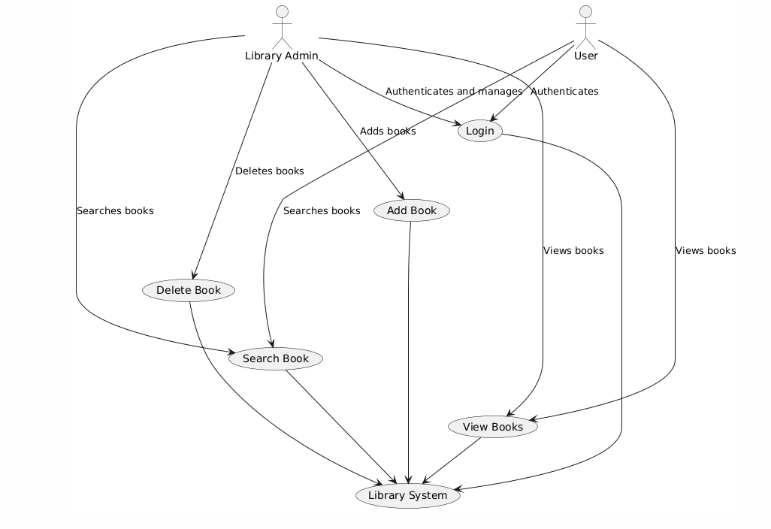
  - Appendix B: Data Dictionary

Use Case Descriptions
- User Login: Authenticates the user and determines their role.
- Add New Book: Admin adds a book.
- Search Book by Title: Search by title keyword.

Actor Descriptions
- Library Admin: Manages books and has full access.
- User: Views and searches books.

Class Descriptions
- LoginView: Handles user login.
- BookManagementView: Manages book operations.
- UserAuthenticator: Validates user credentials.

  - Appendix C: List of Inputs & Outputs
Below is a detailed list of inputs and outputs for each use case in the Library Management System. Inputs are user-provided data or system triggers, while outputs are the system's responses, such as messages, displayed data, or updated states.

    - Inputs

ID | Label | Description
1.1 | Username | String (50 chars max) on Login Screen, validated against Users table for authentication (User Login use case).
1.2 | Password | String (255 chars max) on Login Screen, compared with Users table for authentication (User Login use case).
1.3 | Book ID | Unique string (50 chars max) for book, entered by Admin on Main View (Add/Update Book use case).
1.4 | Book Title | String (255 chars max), mandatory, entered by Admin on Main View (Add/Update Book use case).
1.5 | Book Author | String (255 chars max), mandatory, entered by Admin on Main View (Add/Update Book use case).
1.6 | Book Category ID | Integer, links to Categories, selected by Admin via dropdown on Main View (Add/Update Book use case).
1.7 | Book Year | Integer (1000-current year), entered by Admin on Main View (Add/Update Book use case).
1.8 | Search Title | String (255 chars max) for title search, entered on Main View (Search Book use case).
1.9 | Search Author | String (255 chars max) for author search, entered on Main View (Advanced Search use case).
1.10 | Search Category | Dropdown of category names (category_id), selected on Main View (Advanced Search use case).
1.11 | Search Year | Integer for year filter, entered on Main View (Advanced Search use case).

    - Output

ID | Label | Description
2.1 | User Role | Role ('ADMIN' or 'USER') from Users table, sets Main View permissions (User Login use case).
2.2 | Book List | Table on Main View with title, author, category, year from Books and Categories (Search/View use case).
2.3 | Confirmation | Messages like "Book added", shown on Main View via dialog/status bar (Add/Update/Delete use case).

(“javax.swing (Java Platform SE 8 )”)
(“MySQL :: Download Connector/J”)
(“Intellij IDEA Documetation Page”)

