Software Requirements Specification

for

TaxEngine
Version 0.2.0 approved
Prepared by K. Erkut Çiftlikçi

February 15, 2026

Table of Contents
Table of Contents ii
Revision History iii
1. Introduction 1
1.1 Purpose 1
1.2 Document Conventions 1
1.3 Project Scope 1
1.4 References 1
2. Overall Description 2
2.1 Product Perspective 2
2.2 User Classes and Characteristics 2
2.3 Operating Environment 2
2.4 Design and Implementation Constraints 2
2.5 Assumptions and Dependencies 2
3. System Features 3
3.1 Transaction Data Ingestion and Normalization 3
3.1.1 Description 3
3.1.2 Stimulus/Response Sequences 3
3.1.3 Functional Requirements 3
3.2 Core Tax Calculation Engine 3
3.2.1 Description 3
3.2.2 Stimulus/Response Sequences 3
3.2.3 Functional Requirements 3
3.3 Annual Tax Summary and Reporting 4
3.3.1 Description 4
3.3.2 Stimulus/Response Sequences 4
3.3.3 Functional Requirements 4
4. Data Requirements 4
4.1 Logical Data Model 4
4.2 Data Dictionary 4
4.3 Reports 4
4.4 Data Acquisition, Integrity, Retention, and Disposal 5
5. External Interface Requirements 5
5.1 User Interfaces 5
5.2 Software Interfaces 5
5.3 Hardware Interfaces 5
5.4 Communications Interfaces 5
6. Quality Attributes 6
6.1 Usability 6
6.2 Performance 6
6.3 Security 6
6.4 Safety 6
6.5 [Others as relevant] 6
7. Internationalization and Localization Requirements 6
8. Other Requirements 7
Appendix A: Glossary 7
Appendix B: Analysis Models 7

Revision History
Name | Date | Reason For Changes | Version
K. Erkut Çiftlikçi | Feb 12, 2026 | Initial Draft | 0.1.0
K. Erkut Çiftlikçi | Feb 15,2026 | Added ERD, Feature Tree, and Sequence Diagrams | 0.2.0

Introduction
This section provides a functional overview, strategic objectives, and the organizational structure of this document for the TaxEngine project. Beyond being a technical application, the project is designed as a Proof of Concept (PoC) value proposition for brokerage firms

Purpose
This document specifies the software requirements for TaxEngine Version 1.0. The primary objective of the software is to present a Proof of Concept (PoC) developed to enhance the competitive edge of brokerage firms in Turkey regarding foreign stock market transactions. The intended audience for this document includes:
- Corporate Stakeholders and Decision Makers: Executives evaluating the project’s contribution to the business model and its ability to close the “feature gap” compared the competitors
- Software Development Teams: Engineers reviewing the system’s compatibility with micro services architecture and its technical requirements.
- Tax and Compliance Departments: Specialists auditing the alignment of the calculation logic with legal regulations.

Document Conventions
The following standards are followed in this document:
- Strategic Highlights: Portions indicating business goals are emphasized in italics.
- Technical Terms: Terms such as FIFO, WPI(Yİ-ÜFE), and Capital Increase Gain are used consistently in capital letters or within their specific definitions throughout the document.
- Prioritization: Requirements are classified as “Critical” (Legal necessity), “High” (Core Function), and “Optional” (User Experience).

Project Scope
TaxEngine is a calculation engine that automatically transforms raw transaction history (CSV/Excel) provided by brokerage firms into a tax declaration summary.
- Business Objective (PoC Goal): To prove that the “Foreign Stock Tax Reporting” feature –currently offered as a standard service by competitors (e.g., Midas Menkul Degerler) but not yet available in the target institution- can be implemented internally quickly and cost-effectively.
- Functional Scope: Standardization of raw transaction data from various brokerage firms
  - FIFO-based TL cost and gain analysis using CBRT(TCMB) exchange rates and TURKSTAT (TÜİK) indices.
  - Calculation of the final taxable base within the scope of Income Tax Law (GVK) Articles 80-81.
- Out of Scope: The system does not have direct e-government/Revenue Administration (GİB) integration; outputs are intended as an “advisory report”.

References
The following legal and technical resources were used as a references during the development of this document and the software:
- Income Tax Law(GVK): Duplicate Article 80 (Capital Increase Gains) and Article 81 (Cost Indexing)
- CBRT(TCMB): “Indicative Foreign Exchange Buying Rate” according to transaction dates.
- TURKSTAT(TÜİK): Monthly Domestic Producer Price Index (Yİ-ÜFE) tables.
- Corporate Competitor Analysis: Tax reporting interfaces and report formats offered by other brokerage firms in the market.

Overall Description
This section provides a high-level overview of the product’s environment, its intended users, and the constraints under which it must operate.

Product Perspective
TaxEngine is a standalone Proof of Concept (PoC) designed to bridge the functional gap between existing brokerage services and investor needs. It is envisioned as a modular component that can eventually be integrated into a larger fintech ecosystem as a micro service. The engine acts as a processing layer that consumes raw financial data and produces regulatory-compliant tax outputs.

User Classes and Characteristics
- Individual Investors (Full Taxpayers): Residents in Turkey who trade in foreign markets. These users require a simplified interface to understand their tax liabilities without needing deep expertise in tax law.
- Corporate Analysis & Support Teams: Employees of the brokerage firm who use the tool to provide value-added services to clients or to generate internal reports on customer activity for compliance purposes.

Operating Environment
- Platform Independence: The software shall run on any system supporting Python 3.10+ (Windows, Linux, macOS).
- Data Dependencies: The system operates by processing local data files (CSV/Excel) and requires access to historical datasets for CBRT (TCMB) exchange rates and TURKSTAT (TÜİK) Yİ-ÜFE indicies.

Design and Implementation Constraints
- Regulatory Alignment: The calculation logic is strictly constrained by Income Tax Law (GVK) Duplicate Article 80 and 81.
- Algorithmic Requirement: The engine must use FIFO (First-In, First-Out) method for matching sell orders with purchase lots.
- Language & Tools: The prototype must be developed in Python to ensure rapid iteration and transparency in financial calculations.
- Data Integrity: Since its PoC, the system will prioritize calculation accuracy over UI/UX in the first place.
- Decimal Precision: All monetary calculations shall use at least 2 decimal places to comply with tax reporting standarts.

Assumptions and Dependencies
- Accuracy of Input: It is assumed that the transaction history provided by the brokerage firm is complete and follows a consistent format.
- Availability of Indices: The project depends on the continued availability of monthly Yİ-ÜFE data from TURKSTAT (TÜİK)
- Historical Rates: It assumed that CBRT(TCMB) historical buying rates are accessible for all transaction dates within the reporting year.

System Features

Transaction Data Ingestion and Normalization

Description
The system must be able to import raw transaction history from various brokerage formats (CSV/Excel) and convert them into a standardized data format for processing. This feature is of High priority.

Stimulus/Response Sequences
- Stimulus: User provides a CSV/Excel file containing transaction history.
- Response: System validates the file structure, identifies mandatory fields (Ticker, Date, Quantity, Price), and maps them internal Trade objects.

Functional Requirements
- REQ-1.1: The system shall support CSV and Excel file formats for data input.
- REQ-1.2: The system shall validate that all required transaction fields are present and correctly formatted.
- REQ-1.3: The system shall handle different data formats (e.g., DD/MM/YYYY vs. MM/DD/YYYY) to ensure global compability.

Core Tax Calculation Engine

Description
This is the central logic of the PoC, responsible for applying FIFO matching, currency conversion, and WPI (Yİ-ÜFE) indexing as per Turkish tax law. This feature is Critical priority.

Stimulus/Response Sequences
- Stimulus: A valid set of normalized transaction data is fed into the engine
- Response: The system calculates the TL-equivalent cost and proceeds for every transaction, matches sells with purchase lots using FIFO, and applies where WPI (Yİ-ÜFE) increase exceeds 10%

Functional Requirements
- REQ-2.1: The system shall match sell orders with purchase lots using FIFO (First-In, First-Out) method.
- REQ-2.2: For every transaction, the system shall fetch or use the provided CBRT (TCMB) Buying Rate for that specific date to convert foreign currency to TL.
- REQ-2.3: The system shall check the WPİ(Yİ-ÜFE) increase between the month of purchase and the month of preceding sale. If the increase is >= 10%, it shall apply the indexing formula to adjust the cost basis.
- REQ-2.4: The system shall calculate the net taxable gain or loss for the entire fiscal year.

Annual Tax Summary and Reporting

Description
The system generates a comprehensive summary report that outlines the calculated tax base and estimated tax liability for the user’s annual declaration. This feature is of High priority.

Stimulus/Response Sequences
- Stimulus: User requests a summary report after calculations are complete.
- Response: The system produces a detailed report (CLI output, Excel or PDF) showing total gains, losses and the final estimated tax based on current brackets.

Functional Requirements
- REQ-3.1: The system shall produce an annual summary including “Total Gain”, “Total Loss” and “Next Taxable Base”
- REQ-3.2: The system shall provide a detailed transaction-level breakdown (Lot Matching Table) for audit purposes.
- REQ-3.3: The system shall apply the relevant Income Tax Brackets for the selected fiscal year to estimate the total tax payable.

Data Requirements
This section defines the data structures the system will consume, process, and generate to ensure accurate tax calculations in compliance with Turkish regulations.

Logical Data Model
The TaxEngine operates on a structured logic where raw transaction data is transformed into matched lots and realized gain records. The relationships between the core entities—User, Trade, FifoLot, GainRecord, and ReferenceData—are visualized in the diagram below.

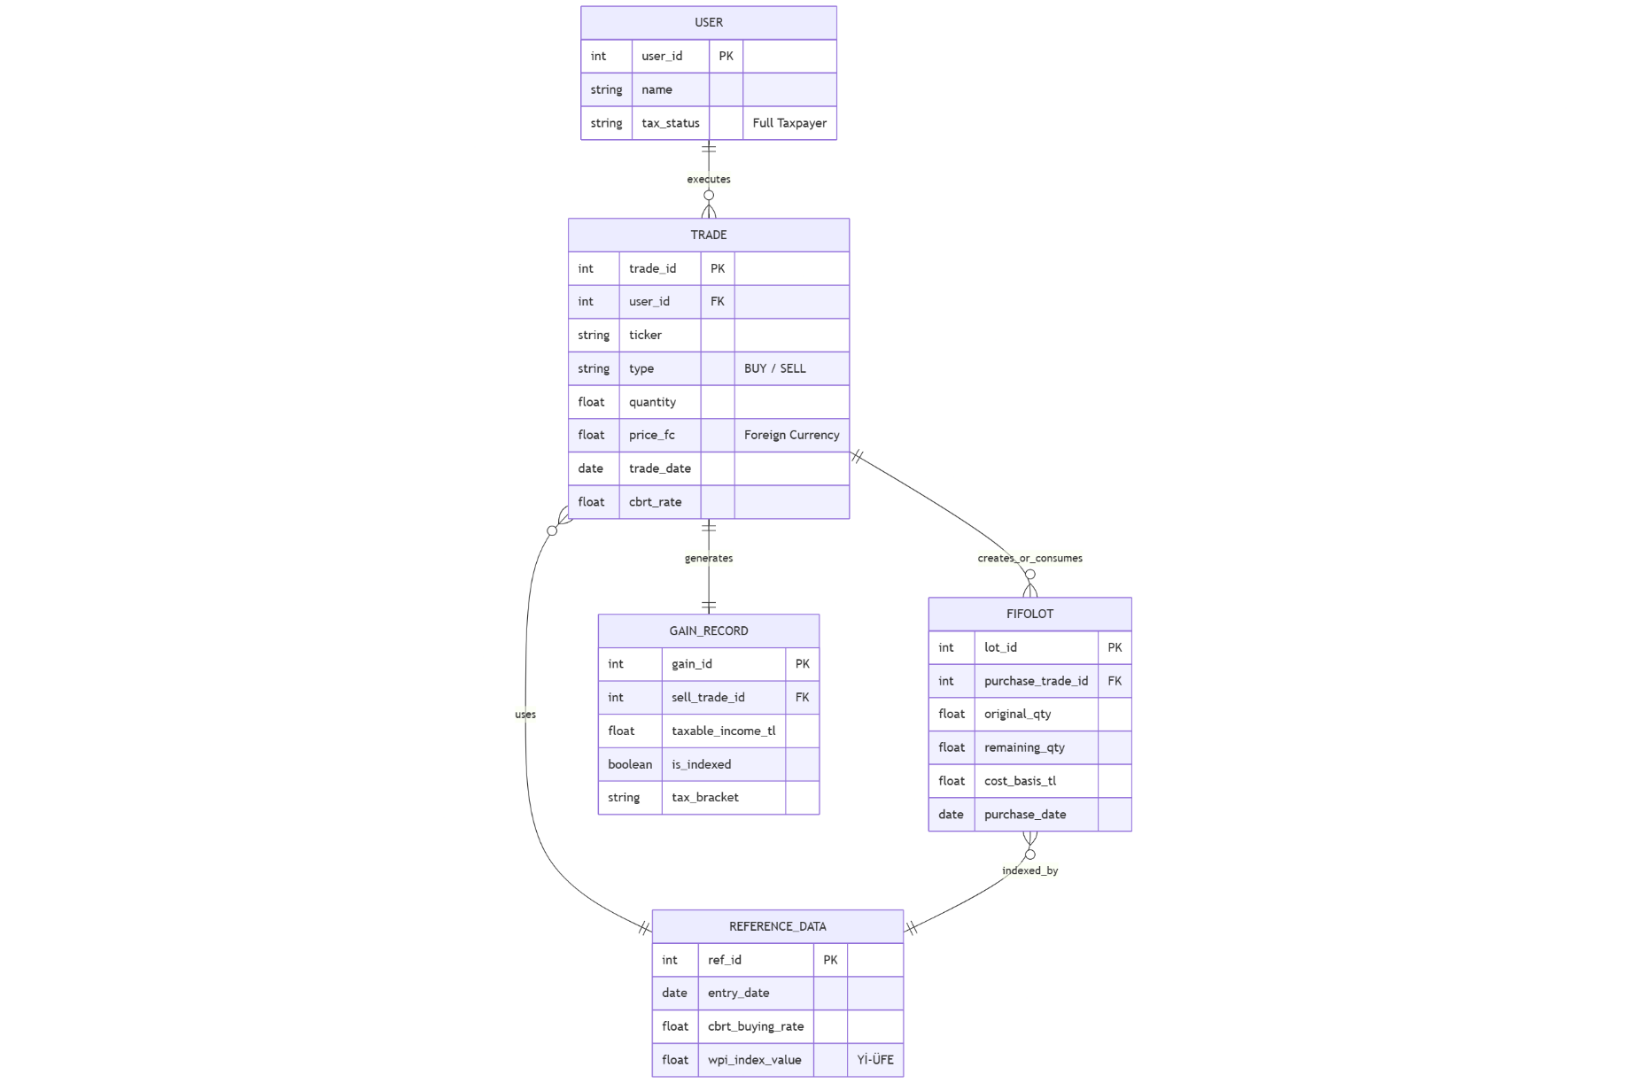

The model ensures that every sell transaction is strictly tied to a specific purchase lot (FIFO) and validated against historical CBRT (TCMB) and TURKSTAT (TÜİK) data.

Data Dictionary
Data Element | Data Type | Description
trade_id | Integer | A unique identifier for each imported transaction
transaction_date | Date | The exact day of the trade, used for fetching daily exchange rates
unit_price_fc | Decimal | Share price in foreign currency at the time of the trade date
exchange_rate | Decimal | The CBRT(TCMB) Foreign Exchange Buying Rate applicable on the trade date.
index_facto | Decimal | The ratio used to adjust costs if the WPI(Yİ- ÜFE) increase is >= 10%
taxable_gain | Decimal | The final profit or loss amount in TL after all regulatory adjusments.

Reports
The system generates the following outputs to provide a comprehensive tax overview for the user and the brokerage firm:
- Annual Tax Summary Report: A high-level overview of total taxable gains, deductible losses, and the estimated final tax liability for the fiscal year.
- Transaction Audit Breakdown: A granular list showing specific matching of sell orders to purchase lots, including the indexing calculations and currency conversion details for each entry.

Data Acquisition, Integrity, Retention, and Disposal
- Data Acquisition: Users manually provide transaction history via CSV or Excel files. (Data entry is limited in the PoC version for rapid prototyping)
- Data Integrity: The system implements strict validation to ensure dates, quantities, and prices are within logical ranges and formats before processing.
- Retention and Disposal: As a Proof of Concept (PoC), the system processes data in volatile memory (RAM) only. No personal financial data is retained on the disk after the session is terminated or the report is generated.

External Interface Requirements

User Interfaces
The PoC version of the TaxEngine will prioritize functional logic over a graphical user interface.
- Interface Type: The system shall provide a Command Line Interface (CLI) for user interactions.
- Interaction Flow: User will interact by specifying file paths for input data (CSV/Excel) and receiving console-based progress updates and calculation results.
- Error Displat: Standardized error messages will be displayed in the console for invalid file formats or missing data fields to ensure usability and ease of correction.

Software Interfaces
The TaxEngine connects with various software components and external data sources to perform its primary functions.
- Runtime Environment: The software requires a Python 3.10+ execution environment and utilizes libraries such as Pandas for high-performance data manipulation and Pydantic for rigorous data validation.
- Data Sources: The system interfaces with local or external data files containing historical CBRT (TCMB) exchange rates and TURKSTAT (TÜİK) WPI (Yİ-ÜFE) indices.
- Exporting Tools: The engine shall interface with file system libraries to generate output reports in Excel (.xlsx) or PDF formats.

Hardware Interfaces
As a software-based calculation engine, the TaxEngine has minimal direct hardware dependencies.
- Standard Workstation: The system operates on standard personal computers or server environments without requiring specialized hardware peripherals.
- Input/Output Devices: Standard input (keyboard) and output (monitor) are used for CLI interaction and report viewing.

Communications Interfaces
The current PoC version focuses on local data processing.
- Local I/O: All communications between the user and the system occur via local file system inputs and outputs.
- Future Considerations: While the PoC uses local files, the architecture is designed to support future REST API communication for cloud-based or web-integrated brokerage services.

Quality Attributes

Usability
- CLI Interaction: The system shall provide a clear and intuitive Command Line Interface (CLI) tailored for technical analysts and developers.

- Error Messaging: The engine must display descriptive error messages when encountering invalid data formats (e.g., incorrect date strings or non-numeric prices) to facilitate quick user correction.

- Ease of Learning: The software should be designed so that a user familiar with brokerage CSV exports can run a full tax report within minutes of setup.

Performance
- Processing Speed: The engine shall be capable of processing a typical annual transaction history (up to 1,000 trades) in under five seconds.

- Resource Efficiency: The system shall utilize optimized data structures like Pandas DataFrames to ensure minimal CPU and memory overhead during large-scale FIFO matching.

Security
- Data Privacy: To ensure the security of sensitive financial information, the PoC will not store any user-uploaded transaction data on a permanent disk or database.

- Volatile Processing: All calculations shall occur within the system's volatile memory (RAM), and all data must be disposed of immediately upon the termination of the session.

Safety
- Regulatory Compliance: The system's primary "safety" measure is its strict adherence to the calculation formulas defined in Income Tax Law (GVK) Articles 80 and 81.

- Calculation Precision: All currency conversions and indexing operations must use high-precision decimal math (rather than standard floating-point) to avoid rounding errors in tax liability.

Verifiability
- Audit Trails: The system shall generate a Transaction Detail List that allows users to manually verify how each sell order was matched to a purchase lot.

- Transparency: The logic for WPI (Yİ-ÜFE) indexing (the 10% threshold) must be explicitly shown in the output report to confirm that the tax base was adjusted correctly according to law.

Internationalization and Localization Requirements

Currency Handling
- Primary Reporting Currency: The system shall use the Turkish Lira (TRY) as the primary currency for all final tax liability calculations and reporting, as required by Turkish tax law.

- Foreign Currency Support: The engine must support the ingestion of transactions in foreign currencies (primarily USD and EUR) and provide a mechanism to convert these amounts to TRY using historical CBRT (TCMB) rates.

Language and Terminology
- Bilingual Support: The system’s documentation and report headers shall be available in both English and Turkish to accommodate the developer's academic background and the local regulatory environment.

- Legal Terminology: Localization shall ensure that specific Turkish tax terms (e.g., "Değer Artış Kazancı," "Yİ-ÜFE Endekslemesi") are used accurately in reports to ensure compliance and clarity for local tax authorities.

Date Formatting
- Date Formats: The system shall support common international date formats (e.g., YYYY-MM-DD) for data processing while allowing localized formats (e.g., DD.MM.YYYY) for generated reports.

Other Requirements

Legal and Regulatory Compliance
The primary requirement of the TaxEngine is strict adherence to the Turkish Income Tax Law (GVK).
- Statutory Compliance: All calculation logic must be updated annually to reflect the latest thresholds (e.g., the 18,000 TL dividend exemption for 2025) and tax brackets issued by the Revenue Administration (GİB).
- Financial Standards: The engine must follow the Tax Procedure Law (VUK) regarding cost basis adjustments and the utilization of official TCMB exchange rates.

Logging and Audit Trail
To ensure transparency in financial reporting, the system must maintain detailed logs of its operations.
- Execution Logs: The system shall log the start time, end time, and status of every calculation run.
- Traceability: Every matched FIFO lot must be logged with its original transaction ID and the specific indexing factor applied, providing a clear audit trail for tax verification.
- Error Logging: All data validation failures, such as missing exchange rates for specific dates, must be recorded in a dedicated error log for troubleshooting.

Product Installation and Configuration
The TaxEngine is designed for easy deployment within a development or analyst environment.
- Configuration Management: Tax brackets, WPI (Yİ-ÜFE) indices, and other variable parameters must be stored in external configuration files (e.g., .yaml or .json) to allow updates without recompiling the source code.
- Startup Procedure: The software shall include a startup check to verify that all required reference data files (TCMB and TÜİK datasets) are present and readable.

Maintainability and Standards
As a PoC intended for potential corporate integration, the codebase must meet professional standards.
- Code Quality: The Python source code shall follow PEP 8 style guidelines to ensure readability for the brokerage firm’s engineering teams.
- Modularity: The system must be structured into independent modules (e.g., TaxEngine, DataLoader, Reporter) to facilitate future migration from a CLI tool to a cloud-based microservice.
Appendix A: Glossary
Term / Acronym | Definition
CBRT (TCMB) | Central Bank of the Republic of Türkiye. The source for the official "Indicative Foreign Exchange Buying Rates" used for currency conversion.
Capital Gain | The profit realized from the sale of a foreign stock, calculated as the difference between the sale price and the adjusted cost basis.
FIFO | First-In, First-Out. An inventory valuation method where the first shares purchased are assumed to be the first ones sold for tax matching purposes.
GVK | Gelir Vergisi Kanunu (Income Tax Law). Specifically referring to Duplicate Articles 80 and 81 which govern capital gains for full taxpayers in Türkiye.
Indexing | The process of adjusting the cost basis of a stock to account for inflation, permitted under Turkish law if the WPI increase exceeds 10%.
MVP / PoC | Minimum Viable Product / Proof of Concept. A version of the software with just enough features to satisfy early customers and prove the feasibility of the technical solution.
PEP 8 | Python Enhancement Proposal 8. The official style guide for Python code, ensuring the project meets professional engineering standards.
Taxable Base | The net amount of income (Matrah) upon which the income tax is calculated after all deductions, indexing, and offsets are applied.
TURKSTAT (TÜİK) | Turkish Statistical Institute. The authority that provides the monthly Domestic Producer Price Index (Yİ-ÜFE) data.
WPI (Yİ-ÜFE) | Wholesale Price Index (Yurt İçi Üretici Fiyat Endeksi). The inflation metric used to determine if cost indexing is legally applicable to a transaction.

Appendix B: Analysis Models

Feature Tree Diagram
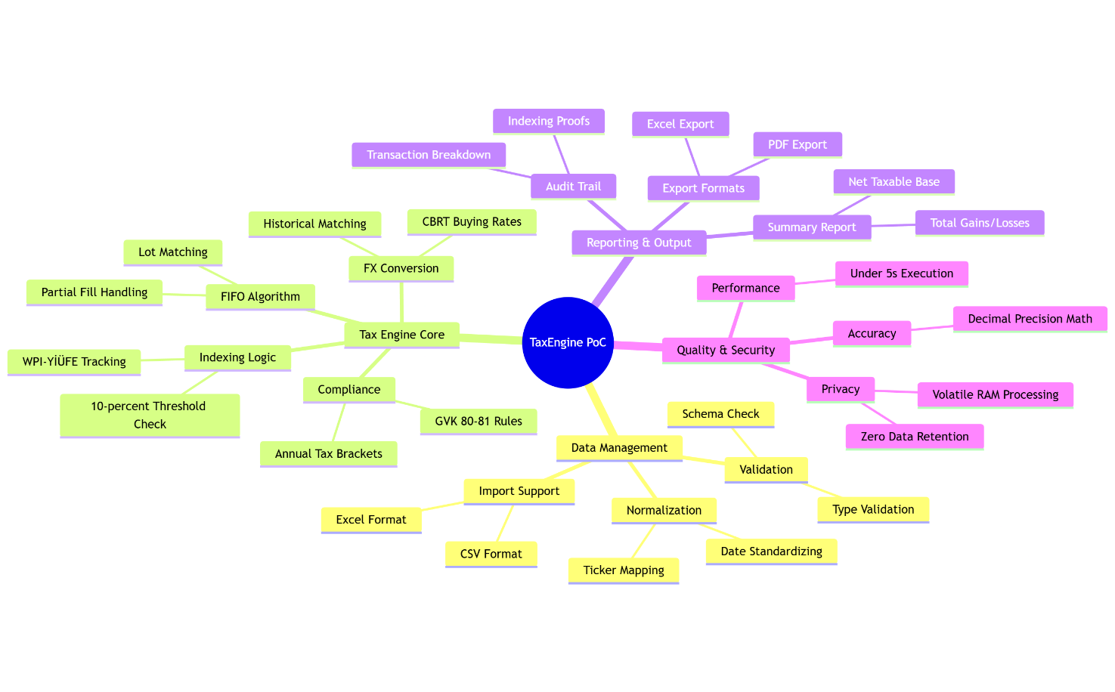
- Sequence Diagram