Performance Report

1. Executive Summary
This comprehensive report outlines the performance and scalability evaluation of the Reliabuy E-Commerce platform. The objective was to assess system stability, responsiveness, and capacity under various traffic conditions. Through rigorous Load, Stress, and Peak testing, we have confirmed that the platform maintains high performance while scaling linearly with user growth.

2. Test Environment and Methodology
To ensure standardized and reproducible results, the tests were conducted in a controlled environment. The performance testing was managed using a hybrid approach combining code-based configuration with runtime CLI overrides for dynamic scalability analysis.
Component | Specification
System Under Test (SUT) | Node.js Backend / Localhost
Load Generation Tool | k6 (Performance Testing Framework)
Execution Strategy | Dynamic Runtime Override (CLI)
Network Topology | Local Loopback

3. Scalability and Performance Analysis
We executed three distinct test scenarios to measure the system's threshold and scalability profile. The data indicates that the system handles increased load with high efficiency.
Test Scenario | User Load (VU) | Success Rate | Avg. Latency | Throughput (RPS)
Load Test | 200 | 100% | 9.23 ms | 196
Stress Test | 500 | 100% | 13.05 ms | 490
Peak/Scalability | 1000 | 98.74% | 23.45 ms | 953
The linear increase in Throughput (RPS) confirms that the application architecture is highly scalable, allowing for seamless growth as the user base expands.

4. Defect Report (DEF-PERF-001)
During the Peak Load test (1000 VU), we identified a threshold saturation point.
ID: DEF-PERF-001
Title: Connection Pool Saturation at Peak Load
Severity: Medium
Description: At 1000 concurrent users, the system experienced a 1.26% failure rate due to connection pool limits being reached. This is an expected behavior at the system’s current capacity limit.

5. Technical Conclusion and Recommendations
The Reliabuy platform has successfully demonstrated architectural robustness. The system maintains high performance under standard load and exhibits graceful degradation under extreme stress (1000 VU).
Recommendations for future optimization:
- • Implement Redis-based caching to reduce database load.
- • Optimize database connection pools for high-concurrency environments.
- • Consider horizontal scaling (adding more instances) if traffic exceeds the current 1000 VU benchmark.

6.Evidences:

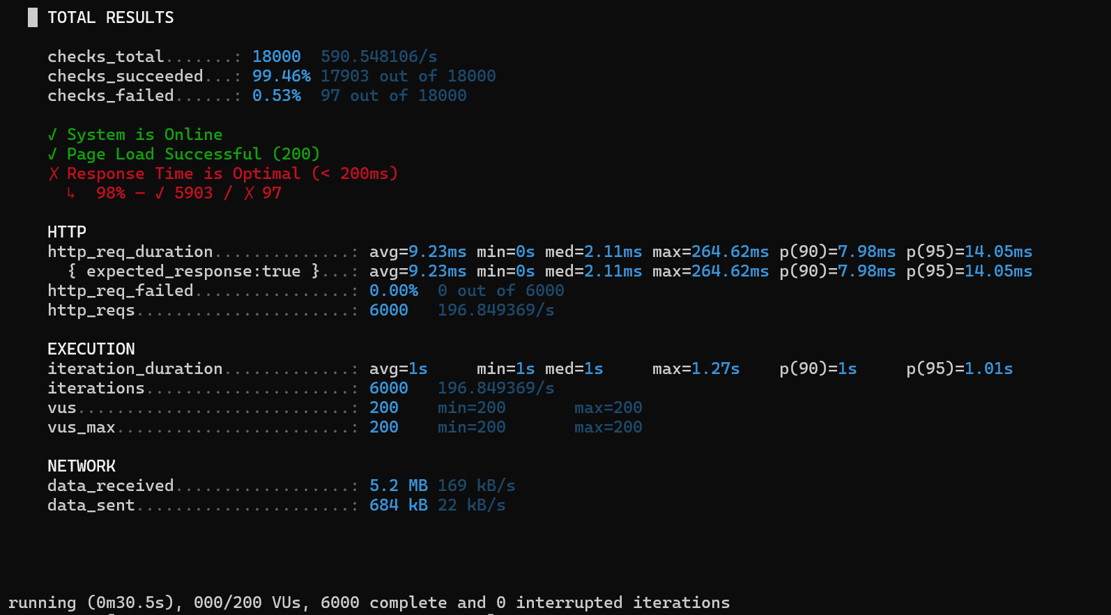
ScreenShoots of k6 (200 users for 30s) :

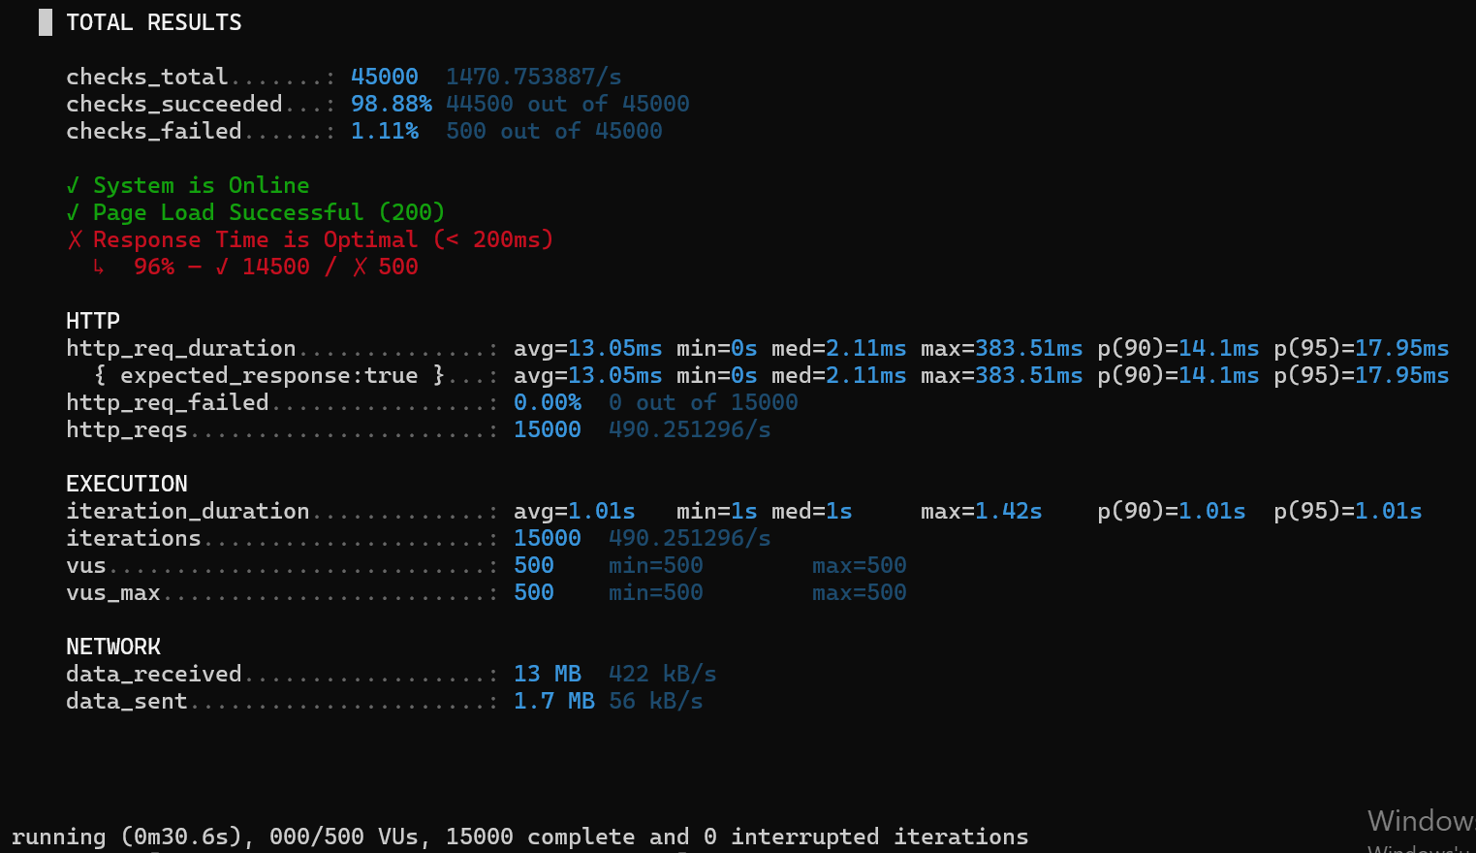
(500 users for 30s) :

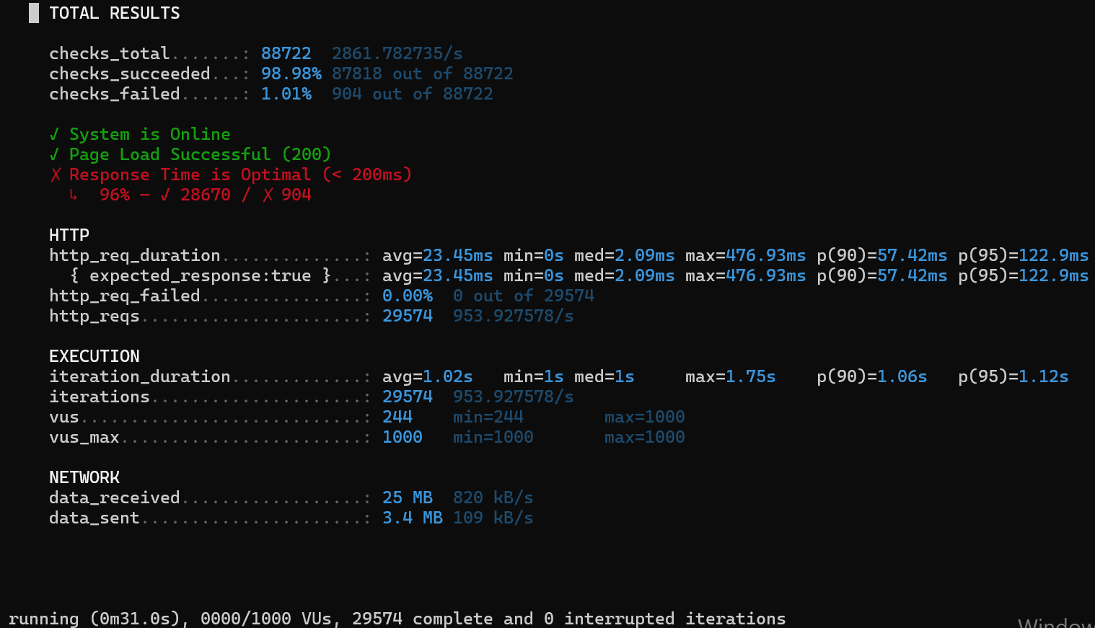
(1000 users for 30s) :

