Security Testing Report

Project: Reliabuy E-Commerce |

1. Executive Summary
This report documents the security assessment of the web application. The testing combined automated scanning and manual penetration testing to identify vulnerabilities.
Test Case  ID | Scenario | Result | Status
TC-SEC-001 | SQL Injection (admin' OR 1=1  --) | Input validation successful. | PASS
TC-SEC-002 | XSS Injection | Script not executed. | PASS
TC-SEC-003 | Weak Password Policy | Weak password rejected. | PASS

2. Automated Scanner Findings (OWASP ZAP / Tool Scan)
Vulnerability | Risk Level | Description
Content Security Policy  (CSP) Not Set | Medium | Lack of CSP header allows potential XSS attacks.
Anti-Clickjacking Header  Missing | Medium | Missing X-Frame-Options allows clickjacking.
X-Content-Type-Options  Header Missing | Low | Browser may sniff content type incorrectly.
Modern Web Application Info | Informational | General application architecture scan.

3. Manual Security Testing Findings
TC-SEC-004 | Invalid Operations Check | No sensitive error leakage. | PASS

4. Recommendations
- CSP Implementation: Add a strong Content-Security-Policy header to the server response to restrict resource loading.
- Clickjacking Defense: Implement X-Frame-Options: DENY or SAMEORIGIN.
- Security Headers: Enable X-Content-Type-Options: nosniff globally.

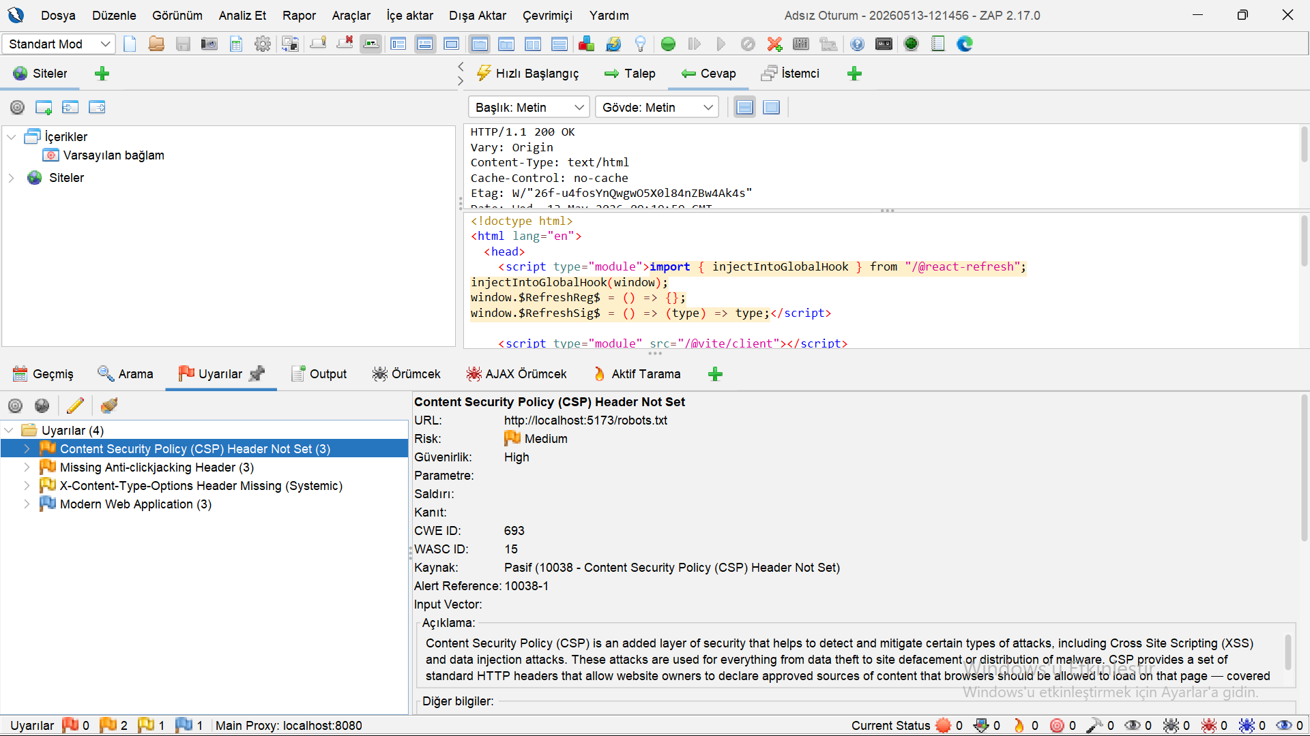
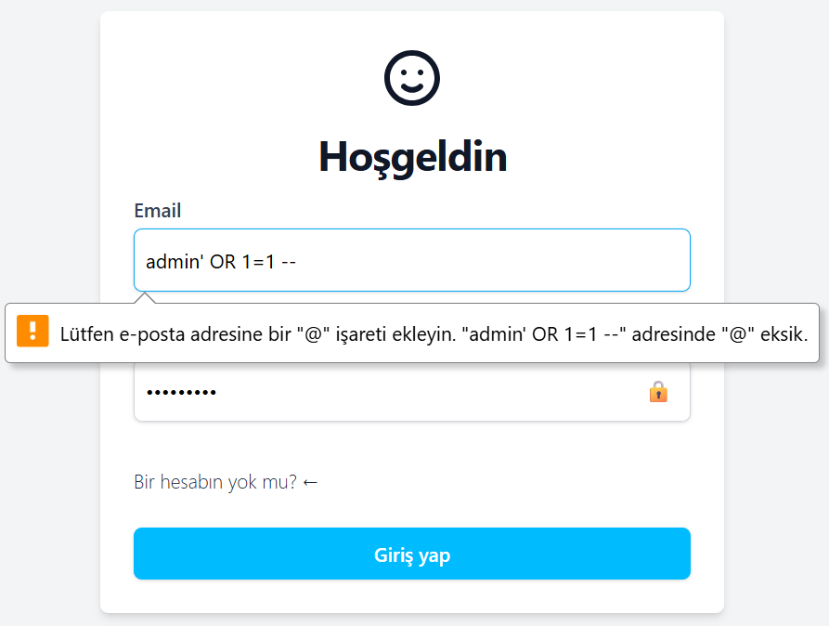
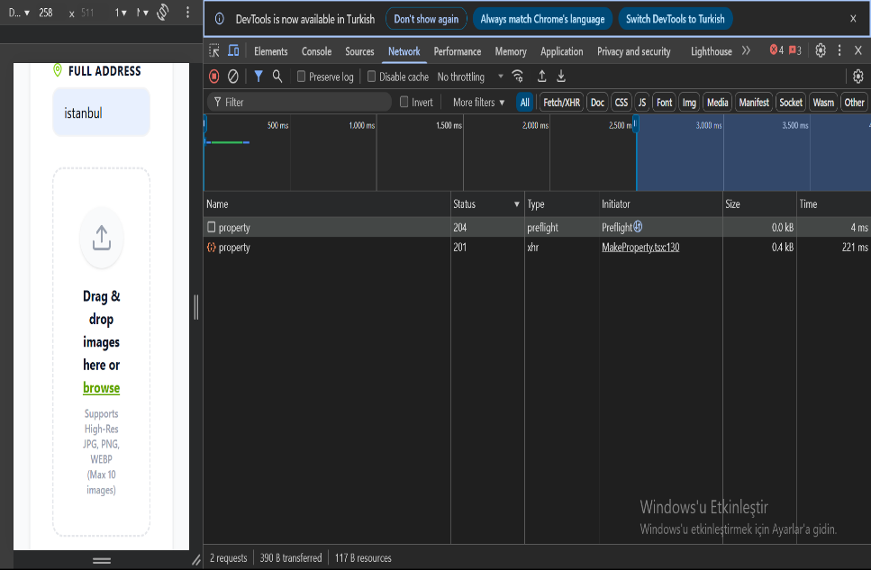
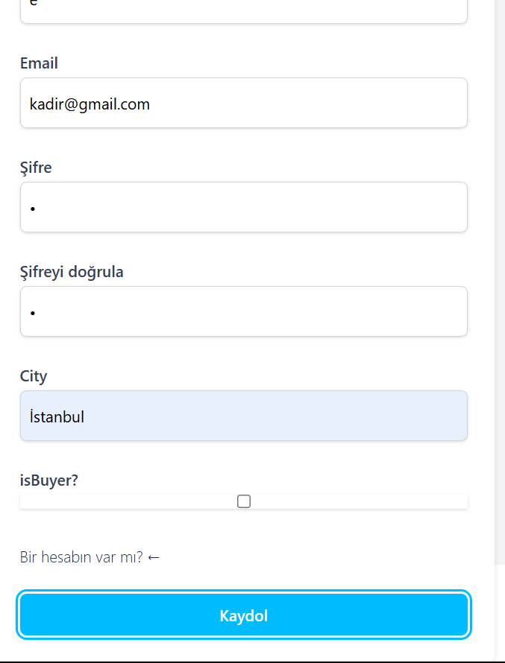
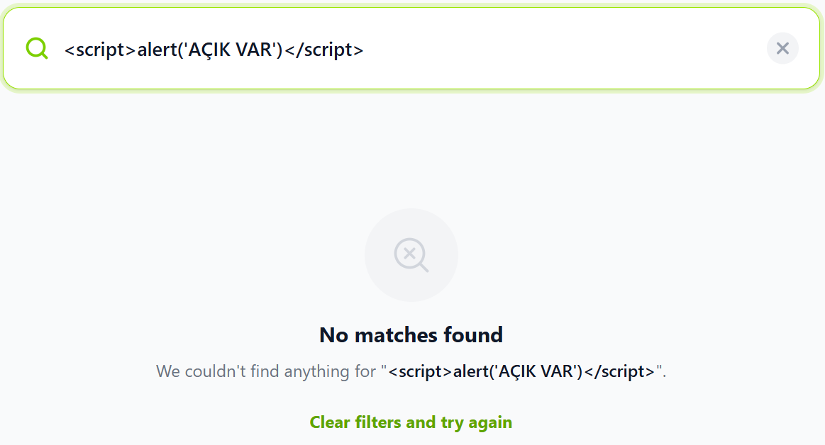
The screenshoots:
