* **GloriousMOISDK** - Communicate with the Model I dll file
* **Hiddevice** - get device info and communicate with hid device
* **LaunchWinSocket** – Use winsocket to communicate with FW Update Application
* **AudioSession** – Get Information and Control Volume of the application
* **thirdparty** – Third party library. It is a library which allows an application to interface with USB and Bluetooth HID-Class devices on Windows

**Environment**

1. Visual Studio 2015/2017
2. Windows 10 WDK ([WDK download for Windows 10 (microsoft.com)](https://support.microsoft.com/zh-tw/windows/wdk-download-for-windows-10-d1bf01fe-4aa7-497b-5fec-a904db8a40bc))

**How to build c++ addons**

1. create nodedriver batch file in node source code
2. set OS=x64
3. set ELECTRON_VERSION=13.1.7
4. cd hiddevice
5. call node-gyp rebuild -target=%ELECTRON_VERSION% -arch=%OS% --dist-url=https://atom.io/download/atom-shell
6. click batch file, if success you can see the hiddevice.node in hiddevice\build\Release\hiddevice.node

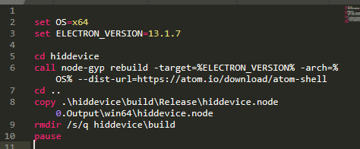

The others are the same way

1. Copy .node file to src/backend/protocol/nodeDriver/x64