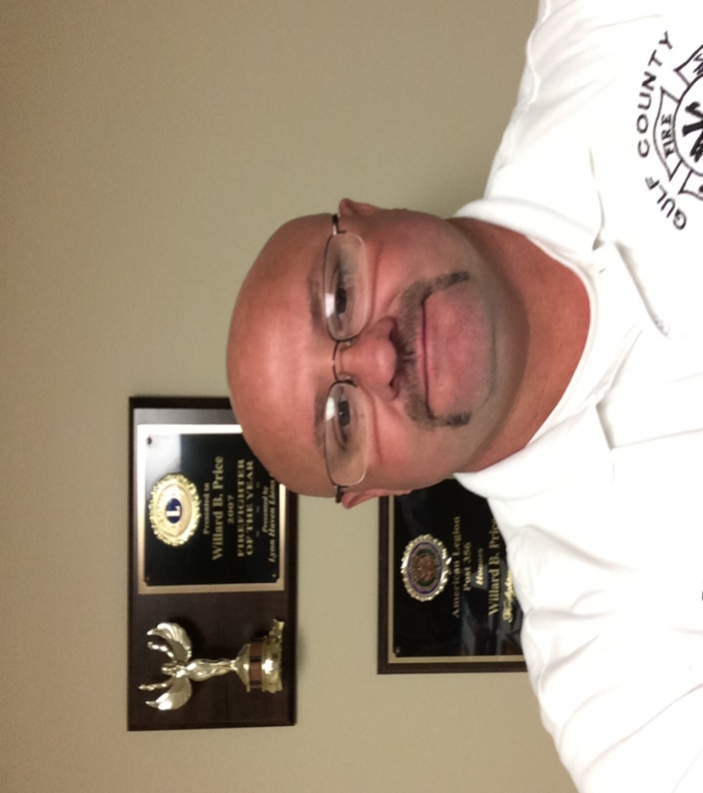

Dear Sir:

I would like to nominate my husband Brad Price for the free LASER LASIK surgery for heroes that Dr. Bret Fisher, The Eye Center, and Gulf Coast Medical Center so graciously offer. First, I would like to give a little background information on why my husband chose his career field and why he is my hero.

We both have lived in Gulf County all our lives. In 1997, tragedy hit Brad’s family, his sister’s three boys, were killed in a mobile home fire. This devastated Brad and his entire family, and he wanted to do more for the people of his community to prevent and protect other people from tragedies like his family experienced. Following his nephews’ death Brad became a volunteer firefighter for the City of Wewahitchka and began driving the ambulance for Wewahitchka Emergency Medical Services. Brad was working at Port St. Joe Paper Mill at the time, and he worked shift work so being able to volunteer for hours others could not work was an asset to Gulf County. However, the paper mill eventually shut down and Brad was able to focus on his dream of becoming a full time firefighter and EMT. This was no easy task with a wife and two children, but he did it! Since Gulf County does not have paid firefighters Brad looked to Bay County for employment. Brad started with Lynn Haven Fire Department in 2006 and stayed until 2012. Brad was chosen by the City of Lynn Haven for Firefighter of the Year in 2007. During his time with Lynn Haven, Brad completed his courses and became a fulltime paramedic. In 2012, Brad went to work for Bay County Fire Department and also became Gulf County Fire Coordinator, as well as earning a degree in Fire Science from Gulf Coast Community College. As the Gulf County Fire Coordinator, Brad has fulfilled his dream of giving back to the community he loves so much.

In between working at 3-4 different jobs, Brad has still managed to Coach our son Brandon in football and baseball, and to Coach our daughter Ashleigh in softball, attend as many games and events as humanly possible, drag fields, and grill in the concession stand. Not an easy thing to do, with his busy schedule.

Brad has always worked like this so he can show our children love and support. Brad has donated his time and his own money to help children who are not so fortunate. For one child he donated the money for a young girl to be able to attend a softball camp, he did this because he knew her mother worked three jobs, and still could not afford to send her. For another child he donated what he could for a football player’s class ring. If there is a parade in Wewahitchka, he will go pick up a mentally challenged man to ride in the fire truck or ambulance with him, just because he knows how much he loves to be in the parade and see all the people. This year he has taken Gulf County School’s Bus driver course, so he can volunteer to drive the bus for the teams, so it will not cost the teams added costs to hire a bus driver to take the kids to out of town games.

Brad has always had perfect vision till the age of 40. Now he has to wear glasses all the time for up close vision. I worry that in his line of duty that this could be a safety hazard, and would appreciate your consideration for MY hero to have this wonderful opportunity not to wear glasses.

Brad Price’s heart is as big as they come, and for all that he has accomplished and for being the daddy he is to my children, he is my hero! So I will make this request on his behalf.

Sincerely,

LaDonna Price

850-819-0138