**NJIT Student’s Perspectives Towards Purchasing Electric Vehicles**

Kerim Sever

Miguel Romero

Denzel Tovar

Milan Tailor

New Jersey Institute of Technology

May 10th, 2022

**Abstract**

Electric vehicles are becoming the smart alternative to traditional vehicles. These cars allow for sustainability and social responsibility practices. The largest group of the population that is more likely to purchase an electric vehicle are recent graduates. The research paper’s main objective is to study the likelihood of a NJIT graduate purchasing an electric vehicle within a five year timeframe upon graduating. In order to conduct the research a survey was distributed amongst NJIT students. The survey was devised to test the hypotheses of which NJIT college (ex. Newark College of Engineering), personal income, work experience, and commute time will influence a person’s decision in buying an electric vehicle. The data collected was analyzed using linear regression and One Way ANOVA analysis. The results concluded that the Ying Wu College of Computing is significantly more likely to purchase an electric vehicle. Income and work experience had no direct correlation in whether an individual would purchase an electric vehicle. Commute time did not have an influence, but the method of transportation did have an influence on the possibility of an individual purchasing an electric vehicle. Overall, while noting the limitations of the research, the results did support that a NJIT student is likely to purchase an electric vehicle given certain lifestyle factors, such as career and methods of transportation.

## Table Of Contents:

Cover Page: ________________________________________________________________ 0

Abstract: ___________________________________________________________________ 1

Introduction: ________________________________________________________________ 3

Research Objective: __________________________________________________________ 4

Research Questions: __________________________________________________________5

Hypothesis: _________________________________________________________________ 9

List of Variables: ____________________________________________________________ 13

Research Method: ___________________________________________________________ 13

Data Collection Procedures: ___________________________________________________ 14

Statistics: __________________________________________________________________ 14

Results: ___________________________________________________________________ 15

Discussion: ________________________________________________________________ 22

References: _________________________________________________________________24

Appendix. __________________________________________________________________25

## Introduction

The research project will discuss the effects of sustainability and social responsibility through the availability of electric cars in the market. Sustainability is the idea of how companies, people, and countries are trying to develop new technologies to prevent further contamination of the planet. Global warming is one of the most significant issues threatening the planet's livelihood and its effect on everyday life. The goal is to encourage companies to perform their civic duty actively and become more socially responsible for their actions. The younger generations have become more socially conscious, thus influencing them to consider purchasing an electric car when becoming financially independent or after graduating from college.

As individuals who have graduated from college represent the most significant population likely to purchase electric vehicles, we decided to use NJIT students to further examine to what extent the variables examined in our report affect the likelihood of college students purchasing an electric vehicle. Furthermore, we have decided to examine the likelihood of purchasing an electric vehicle within a five-year timeframe upon graduation. It provides a realistic timeframe for a recently graduated student to purchase a new vehicle, assuming they have established a lifestyle within this timeframe. In addition, the report will take into consideration the extent of a student's college at NJIT, income, work experiences, and commute. We examine each variable individually throughout the report and see how they impact a student's perspective on purchasing an electric vehicle and the recent graduate's decision to purchase an electric car. By no means an exhaustive list, but it details the most relevant characteristics in a young individual's life that will enable him or her to invest in an electric car.

## Research Objective:

*To observe the likelihood of NJIT students purchasing an electric car within five years of graduating.*

Our report examines consumer sustainability regarding what companies have allocated their resources to in response to consumers' rising interest in the environment and welfare. Environmental issues such as air pollution, destruction of natural habitats, and global warming are consequences of gas emissions. In response, electric vehicles introduced an alternative that strays away from the environmental issues presented by gas emission vehicles. The rise in popularity of electric vehicles is not solely due to the ecological benefits but many variables that partake in a consumer's decision, which we will be examining in our report.

Our research objective is to observe the likelihood of NJIT students purchasing an electric car within five years of graduating. We have decided to use a five-year mark as our understanding of the job market for college graduates is complex and uncertain. Our team made this our focus to follow the various variables that possibly influence the decision of NJIT students to purchase an electric vehicle. Other research studies have found that college-educated individuals are one of the main contributing factors in those who purchase electric cars. Our report will allow us to have a more in-depth look at other contributing variables that could influence consumers' decisions.

## Research Questions:

1. **To which extent does a student's college at NJIT affect the likelihood of purchasing an electric vehicle within five years of graduation?**

The research objective is to observe the likelihood of NJIT students purchasing an electric car within five years of graduation. Many variables can affect a consumer’s sustainability behavior regarding purchasing an electric vehicle. Albeit one variable we think influences the consumer’s likeness of purchasing an electric car would be the college the student is part of at NJIT. As different colleges have a diverse curriculum dependent on the major, we would want to examine if any colleges are more likely to purchase electric vehicles than others.

Fuels Institute conducted a study, EV Consumer Behavior, which observed the majority of consumers of electric vehicles as of 2021. In their research, some of the most notable influences regarding purchasing an electric vehicle were income and level of education (“EV Consumer Behavior”,2021). Individuals with a college degree or higher were more likely to purchase an electric car. Our research question would give us a more comprehensive analysis of the college of individuals who graduated with a college degree are more likely to purchase an electric vehicle.

1. **To what degree does income affect the likelihood of purchasing an electric vehicle?**

As a college graduate of NJIT, it is to be said that the possibility of earning above the average income is high. This is important because one of the key aspects seen when you are trying to purchase a car, in general, is if you can afford it. As the research emphasizes the likelihood of NJIT students to purchase an electric vehicle after they graduate in five years, we cannot ignore that income is one of the variables that will be considered when they are thinking about purchasing an electric vehicle.

According to the NJIT SALARY REPORT OF MAY 2020 GRADUATES by NJIT, the article shows the difference between salaries in all colleges and majors across the university. As the population varies in every college, we get an average of 84k according to PayScale, the company in charge of generating the data for this particular analysis. The importance of this information is emphasized by research from MIT, where the group studies the factors of Americans in purchasing an electric vehicle. In their article, one of the factors is income and how this affects the purchaser when buying an electric car. According to the article and their studies, "PEV buyers, stated preference studies with the general population, and studies analyzing PEV sales all show that incentives are important in encouraging buyers to purchase PEVs [29]. However, high-income buyers would purchase PEVs regardless of incentive availability [11], while lower-income buyers' purchase decisions depend more on incentives [30,31]. Despite this, recipients of incentives are predominantly high-income buyers in predominantly white communities [32]." The article also explains, "The majority of PEV buyers are high-income, home-owning, highly educated, predominantly white households. While some research shows change toward lower-income buyers, the change is slow." These two quotes give the research question a better understanding of how income can be related to a high level of education, as education and income are mostly correlated in terms of wealth in the United States. There can be different variables, but income remains a key factor.

1. **To which extent does your college work experience have an impact on the likelihood of purchasing an electric vehicle?**

Within the first five years of graduating from NJIT, many students will be well into the beginning of their careers. Some NJIT students work while attending classes, which can give them a vast selection in choosing what field a student would want to pursue. It can provide opportunities to lead students to know about purchasing an electric vehicle. When a student goes into the technology field, it allows them to understand the way electric cars are manufactured. Technology has changed the way vehicles are manufactured and taken the car-making business to another level. Elon Musk started off the trend of creating a brand, Tesla, with all-electric vehicles. Technology enthusiasts would be intrigued to work for Tesla. They would learn more about the technology of how an electric car can run.

A student's work experience during college can influence their purchasing behavior. Background does not only rely on a student's major, but it relies on what a student has done with their information. Understanding the technology around a gas vehicle versus an electric car can change how a student decides on purchasing a vehicle. The mindset of a student and what they know does not just rely on what their major is at NJIT, but when a student has had work experience outside of NJIT, it would most likely influence their purchase decision. A student working in the engineering field while attending NJIT may understand how a car engine works along with how pollution of gas vehicles can cause. Certain students would take this information and lean towards purchasing an electric vehicle over a gas-powered car.

1. **To which extent does a NJIT student commute affect the likelihood of purchasing an electric vehicle within five years of graduation.**

An important variable that individuals consider when purchasing a vehicle is their commute. Distance, time, accessibility, and mode of transportation are considered when purchasing a vehicle. An example of this would be an individual who lives in the suburbs but works in the city. Public transportation is not as accessible in the suburbs. Instead, owning a personal vehicle would be more desired, and having an electric vehicle can save them time on their commutes to work and/or school. In our report, we would like to evaluate how a commute affects the likelihood of NJIT students purchasing an electric vehicle within five years of graduation. We will examine the extent of commute time on students' future purchasing decisions.

Examining the variables above will allow us to examine how a current student's commute time will affect their future purchase decision. Distance time will be measured for vehicle transportation to determine how likely people may want an electric vehicle. Location may also affect a user's answer because people who dorm or live near their work may not need an electric vehicle to commute. Electric vehicles would be beneficial for people who are typical commuters to work because of the efficient distance over time. Time may influence the purchaser if the electric vehicle can bring the users to their location faster than other modes of transportation. The standard Tesla Model 3 can go between 250 miles on one single charge (Tesla), this is great for the typical daily commute to work

## Hypothesis for Research Questions

**Hypothesis for RQ1:**

Our hypothesis for research question one is that the College of Engineering at NJIT will have a stronger likelihood of purchasing an electric vehicle in comparison to other NJIT colleges.

**Hypothesis Explanation:**

As mentioned previously in research question one, an individual with a college education is one of the most influential variables regarding purchasing an electric vehicle. Albeit, in our report, we decided to narrow the scope to analyze if an NJIT students' college will impact their likelihood of purchasing an electric vehicle. Our team hypothesized that colleges such as the Newark College of Engineering & Ying Wu College of Computing would represent the demographic most likely to purchase an electric vehicle. To the fact that both are heavily tied to a technology-rich environment and curriculum. We believe that those who are most exposed to technology and have an understanding of them are more likely to purchase an electric vehicle.

**Control Variables:**

* On-Campuses Experience: As NJIT commuters make up 75% of the student population, each student will not have the same opportunity to take advantage of the technology-rich environment at NJIT, choose their instructors, or have the time available for extracurricular activities/clubs. - **Negative Variable**
* Technological Exposure: Since NJIT is a technological school with of students being in STEM we are more likely to utilize technological products/services. - **Positive Variable**

**Hypothesis for RQ2:**

This question is designed to assess the hypothesis that income will have a positive impact on the purchase of an electric vehicle.

**Hypothesis Explanation:**

This hypothesis is designed to explain why income impacts purchasing an electric car, more specifically in college students five years from their graduation. The hypothesis will be tested using a survey of the students of NJIT in specific, as our general population is directly related to NJIT students. The research question will define the hypothesis as its independent and dependent variables are income (IV) and the likelihood of purchasing an electric vehicle(DV), this hypothesis can be explained as if income is involved with college students, then the likelihood of purchasing an electric car is slightly higher. This hypothesis will focus on the analysis of these questions and possible solutions.

**Control variables:**

**These are the control variables this question will be considered:**

* A natural disaster: The main reason we determine this is one of the control variables is that a natural disaster can affect employment in a way that an individual may lose their job and can control also lead to losing a house or workplace. This variable has a negative impact on income.
* A Pandemic: In the past two years, the world has seen how a pandemic can affect income in such a way that we cannot control it. This is the reason why we choose this control variable. This variable has a negative effect on income.
* Economic effects: This variable negatively affects income, as we talk about recessions, inflation, and depreciation in the market. We picked this variable as a control variable due to the fact that the world has suffered different recessions in the past two decades, that we have seen how people have lost or minimized their income because of these events.
* A World War: In the past, and nowadays, where we live, a War can start anytime. This control variable is associated with much loss in human capital and income for the people. That is why we believe it can be considered a control variable for income. This control variable will have a negative effect on income.

**Hypothesis for RQ3:**

This question is designed to assess the hypothesis that a student's work experience will have an impact in purchasing an electric vehicle.

**Hypothesis Explanation:**

This question is designed to assess the hypothesis that a student's work experience will have an impact in purchasing an electric vehicle.

Hypothesis Explanation:

This hypothesis is designed to show why work experiences can have an impact on purchasing an electric vehicle. The hypothesis will be tested based on a survey that is provided. This survey will show how several students work while attending NJIT, which can persuade them to purchase an electric vehicle. The hypothesis variable is work experiences and how it impacts why a student might purchase an electric car. The survey will show that students work while attending NJIT, but it will also show what field they are working in. This hypothesis will showthat some working students will be interested in purchasing an electric vehicle.

**Control Variable:**

* Job Types: Students who are currently working in certain fields will lead to making a person more intrigued about purchasing an electric vehicle - Positive Variable
* Qualifications: Students currently may not have the correct skillset to obtain a job in the field they want, resulting in them taking a job, not in the field they want. - Negative Variable

**Hypothesis for RQ4:**

This question is designed to assess the hypothesis of how commuting time will have an impact on the purchase of an electric vehicle.

**Hypothesis Explanation:**

This hypothesis aims to display how factors in commute can affect the likelihood of purchasing an electric vehicle. By researching students within five years of graduation, we can determine their daily commute to work and how beneficial an electric car can be for them. NJIT students will be our population, our sample frame would be selecting 500 students, our sample would be 50 students if 10% answer and our sample size would be 50. The independent variable is the commute time itself, and the dependent variable is the likelihood of purchasing an electric car. We hypothesize that our respondents will more likely purchase an electric vehicle for commuting rather than other modes of transportation because of the benefits.

**Control Variables:**

* Available transportation: Students will use the most efficient mode of transportation available to them, as not all modes of transportation are available to students from different locations. This also considers students that dorm or live within walking distance from their job. Negative variable
* Time efficiency: Students have more flexibility on their commute when owning an electric vehicle because they cannot only commute to work/school but also other travel needs. Positive variable

## List of Variables

|  |  |
| --- | --- |
| **Independent Variable** | **Dependent Variable** |
| College | The likelihood of purchasing an electric car. |
| Income | The likelihood of purchasing an electric car. |
| Work Experience | The likelihood of purchasing an electric car. |
| Commute Time | The likelihood of purchasing an electric car. |

## Research Method

The population for our report was NJIT students. Our sample will be directly correlated with our population as we plan to include screening questions to make sure anyone who partakes in the survey is an NJIT student. NJIT students will be our population, our sample frame would be selecting 500 students, our sample would be 50 students if 10% answer, and our sample size would be 50. Relatively, staying on campus will give us the best results for collecting our report data. In our report, we will be utilizing two non-probability sampling methods, which would allow us to run tests between the two groups to see if there are any differences in variables between the two samplings. The first sampling technique we will be utilizing is convenience sampling. The team members will be placed at the campus center at NJIT to ask students to scan a QR code to have students do our survey for the report on their phones. Regarding our incentives, each student will have confidentiality, remain anonymous, and a spot in a raffle to win a $20 Amazon gift card.

Data Collection Procedures

## Data Collection Procedures

In the process of collecting the data, each member was able to use the method mentioned before the method of convenience sampling. Each team member collected the data from the sample population, in this case, the students of NJIT. The sample frame consisted of selecting 920 students, our sample ended up being 45 students with a response rate of 4.9%. Our sample size ended up being 41 as some responses were not valid. Each member sent out emails and private messages to classmates and used QR codes around campus to collect the total number of responses asked by the instructor. Also, the team was able to increase the number of respondents by mentioning the incentives for completing the survey. The monetary incentive was one of the biggest attractions for the sample population, the same is true that the participants will remain anonymous throughout the research.

## Statistics

In our collection, we received 44 responses, of which 41 passed our screening questions and answered all their survey questions. We had a response rate of 4.9% out of 920 potential respondents, which those respondents included in-person and online interactions. We had no nonresponse bias participants in our survey as each one of our respondents answered the survey questions. Our sample is 44 NJIT students, the sample unit is a single NJIT student, the sample frame consists of selecting 1000 students, and the sample size is 41. We had a sampling error of 3 respondents.

For our respondent characteristics, our respondents' ages were around 21 and 23, each making up 17.8% of our sample. Our respondent's annual income is mostly around 0-5k annually with 43%. Our respondents also mostly come from the Ying Wu College of Computing 37.8%, most students are either neutral or agree by 31.1% that their instructors at NJIT have influenced them in technology. 31% of our respondents occasionally participate in NJIT school activities. 44.4% of our respondents have much exposure to technology. 33.3% of our respondents are either likely or very likely that starting salary will affect their decision on purchasing an electric vehicle. 26.7% of our respondents have 2-3 years of work experience. 26.7% of our respondents believe that their work experience relates to the field they want to pursue upon graduation. 40% of our respondents feel neutral with their current jobs. 60% of our respondents use a car as their method of transportation. 40% of our respondents believe they will sometimes travel to other places besides work and school. 31.1% of our respondents commute between 31-40 minutes. 37.8% of our respondents are more likely to purchase an electric vehicle within five years of graduation. 37.8% of our respondents are not in clubs at NJIT. 40% of our respondents agree that natural disasters can affect their income. 55.6% strongly agree that economic effects are important. 53.3% strongly agree that the pandemic has affected their lives. 47.7% of our respondents strongly agree that the world war has affected their lives.

## Results

Research Question 1 Results:

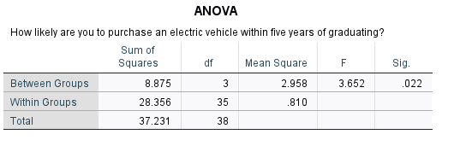

Figure 1.1

To test our hypothesis for research question one we utilized One Way ANOVA analysis method since our independent variable was a nominal measurement with multiple subgroups. Albeit results for Albert Dorman Honors College & J. Robert and Barbara A Hillier College of Architecture and Design were excluded as the subgroups contained less than two respondents. Upon running our research method we can conclude that the college a student attends does influence their likelihood of purchasing an electric vehicle with a significance of 0.22 (figure 1.1). With our significance value lower than 5% we were able to run a Tukey test to further examine the significant difference between the means of each subgroup. We were able to conclude that Ying Wu College of Computing is significantly more likely to purchase an electric vehicle within five years of graduating in comparison to Newark College of Engineering (figure 1.2). The results demonstrate that my hypothesis for this question was wrong as I had originally hypothesized that Newark College of Engineering would be the most likely to purchase an electric vehicle as the subgroup was more unsure of such a decision.

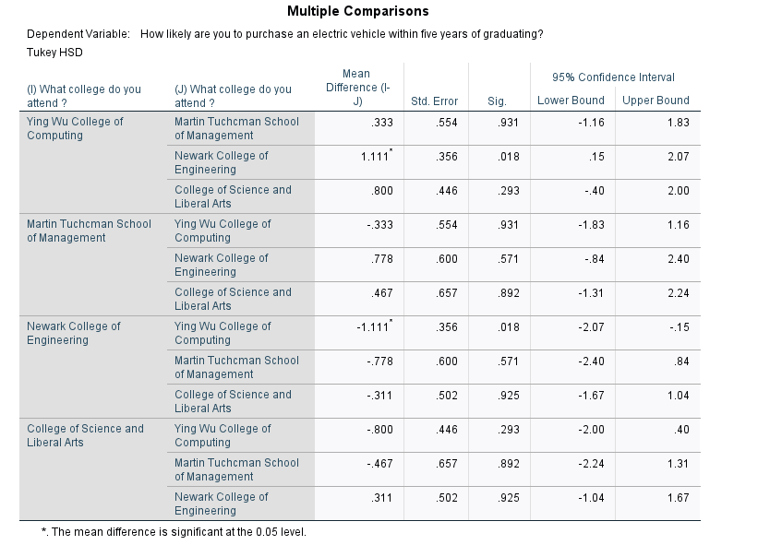

Figure 1.2

## Results Question 2 Results:

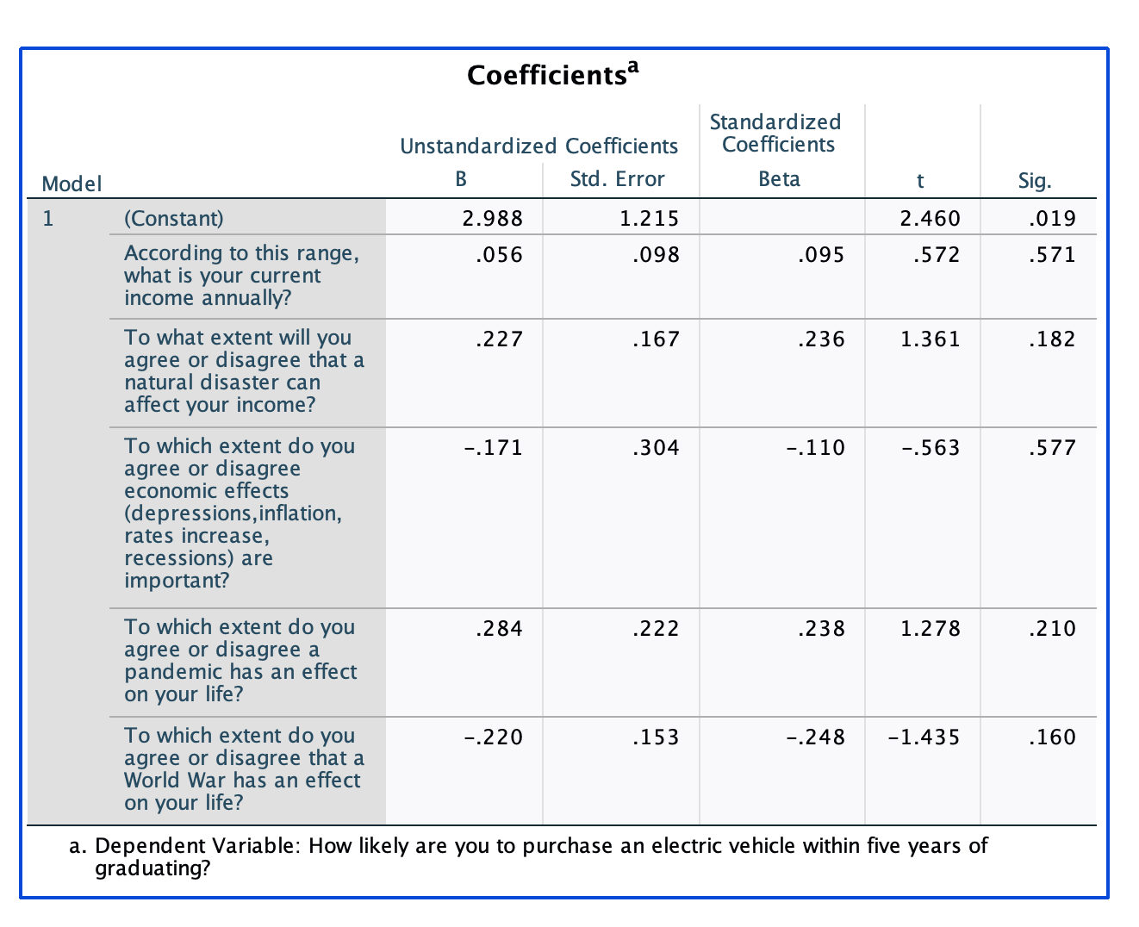

After using Multiple linear regression in question two and its control variables, the group was able to see that income has no significance into the likelihood of purchasing an electric vehicle within five year of graduation. He decided to run multiple regression as we wanted to compare different factors affecting the main question of the research. That is how the team came to the use of this method to be able to find our result above.

## Results Question 3 Results:

## RQ3:

To test out our hypothesis for “Assess the hypothesis that a student's work experience will have an impact in purchasing an electric vehicle.” The group used multiple regression for this and we found that this hypothesis doesn’t have any relevance to a student being likely to buy an electric car. The hypothesis we had for this, turned out that work experience wouldn’t have any effect on a student buying an electric car within five years after graduating

Research Question 4 Results:

## 

## For comparing the means we wanted to compare the means of “How likely are you to purchase an electric vehicle within five years of graduating?” and “What type of transportation method do you take”. We found that other and services that use uber, lift, etc. both have a mean of 4.5 and following behind them is bus with a mean of 4 and car with a mean of 3.71. We can see that these groups are more likely to purchase an electric vehicle but because our frequency is not diverse enough we cannot conclude our analysis.

## 

## 

## 

## 

## 

## In the one way ANOVA test, the Dependent variable is “How likely are you to purchase an electric vehicle within five years of graduating?” and the Nominal Factor is “What method of transportation do you take?”. We did this to see if there is any correlation between the types of transportation and the likelihood of purchasing an electric vehicle within 5 years of graduating. The significance within multiple comparisons are all greater than 5% and therefore we could not conclude any correlation between transportation method and the likelihood of purchasing an electric vehicle within 5 years of graduation.

## 

In the multiple regression for the control variables, we used “How long is your commute” and “To which degree will you travel to places besides work and or school?” as the variables entered and the dependent variable being “How likely are you to purchase an electric vehicle within five years of graduating?”. Again for the two variables, the significance is both greater than 5% and we cannot conclude if these variables may or may not affect the likelihood of our respondents purchasing an electric vehicle within five years of graduating.

Research question 4 “Our hypothesis is that our respondents will more likely purchase an electric vehicle for commuting rather than other modes of transportation because of the benefits”. Our hypothesis cannot be conducted because our significance is too high to do further analysis on the data. We can however conclude that NJIT students that use other methods and use services like Uber are more likely to consider buying an electric vehicle through the means of comparison tests.

## Discussion

For Research Question 2, the hypothesis of this variable was that income would have a positive effect on the decision to purchase an electric vehicle. After concluding all the tests, we see that income has gone over the significance tolerance of 5%. Also, the results show that the level of significance from the control variables are also over the 5% significance tolerance of 5%. These results help to the conclusion of rejecting the hypothesis.

For Research Question 3, running a multiple regression test, it was found that the hypothesis would turn out to be inconclusive. For all the results that we had received from the survey, we found that work experience was not relative for a student to purchase an electric vehicle. With our Results being over 5% for all the questions regarding this hypothesis, the conclusion would lead to us rejecting the current hypothesis.

For Research Question 4, we ran a one-way ANOVA test, multiple regression test, and comparing means. For the multiple regression, we cannot conclude if these variables may or may not affect the likelihood of our respondents purchasing an electric vehicle within five years of graduating. For one-way ANOVA, the significance within multiple comparisons is greater than 5%. Therefore, we could not conclude any correlation between transportation methods and the likelihood of purchasing an electric vehicle within five years of graduation. For comparison of means, we can conclude that other services that use uber are groups that are more likely to purchase an electric vehicle within five years of graduating than other uber services to be more likely.

## Market Implications

This research was based on finding out if NJIT students would purchase an electric vehicle within the first five years of graduating. Our survey findings showed that regardless of most variables examined in our report, NJIT students were likely to purchase an electric vehicle. We could not conclude any significant differences among the variables examined aside from college attended. With the knowledge that we have provided, electric car companies would understand what students would be interested in purchasing an electric vehicle. For electric vehicle managers, we would recommend that they start by trying to sell electric vehicles to the "Ying Wu College of Computing" because we found that students from that college in NJIT would more likely consider buying an electric vehicle in comparison to others.

## Limitations of Research

During the research, the team realized that there has been some limitations in the data collection. Some of these limitations have been the lack of responses from some colleges within our sample population. The sample population has not been accurate because most of the responses do not adequately represent the entire population of NJIT students. These sample errors and limitations are also due to the limitations of the convenience sampling research method. As convenience sampling tends to be used to obtain faster responses, it can lack the ability to randomize the population for better data analysis as a result of a sample error. Another limitation the group ran over during the research was the lack of commitment of the respondents. Some of our respondents were not NJIT students or were not over the age required for the survey. As a result of this data, the group ran into misleading data and had to exclude those responses. This sampling error was unintentional, but we considered their mistakes in the end. The last implication we ran into was the time of the data collection. Our sample size was not adequate to represent the entire population, bringing back the fact that this sampling error was unintentional.

## Reference List or Work Cited

*New Jersey Institute of Technology |*, https://www.njit.edu/.

Hardman, Scott, et al. “A Perspective on Equity in the Transition to Electric Vehicles.” *MIT Science Policy Review*, 20 Dec. 2021, https://sciencepolicyreview.org/2021/08/equity-transition-electric-vehicles/.

“Salaries for New Jersey Institute of Technology (NJIT) Graduates.” *PayScale*, https://www.payscale.com/research/US/School=New_Jersey_Institute_of_Technology_(NJIT)/Salary.

Electric Vehicle Council. (2021, June). *Ev consumer behavior - fuelsinstitute.org*. Fuels Institute. Retrieved March 21, 2022, from https://www.fuelsinstitute.org/Research/Reports/EV-Consumer-Behavior/EV-Consumer-Behavior-Report.pdf

**Appendix**

**Cover Letter**

**Introduction:** We are a group of NJIT students in Marketing 430 and we will be conducting a marketing research report with the data from this survey.

**Research Introduction:** The research project will discuss the effects of sustainability and social responsibility through the availability of electric cars in the market. The research will also study the likelihood of college students purchasing an electric vehicle within five year of graduation.

**Incentive:** We will provide our respondent’s confidentiality and anonymous responses for our research. An opportunity to win a $20 dollar gift card.

**If you are under the age of 18 please stop here.**

**If you do not give consent to our research please stop here.**

Survey Questions

1. Are you over the age of 18?
   1. Yes
   2. No
2. Are you a NJIT student?
   1. Yes
   2. No

Questions in regards to our Variables/ Research Questions

1. What college do you attend (RQ 1)?
   1. College of computing
   2. School of management
   3. College of engineering
   4. College of science and liberal arts
   5. School of architecture
   6. Honors College
2. To which extent will you agree that your instructors have influenced you in technology during your time at NJIT?
   1. Strongly agree
   2. Agree
   3. Neutral
   4. Disagree
   5. Strongly Disagree
3. To which extent will you participate in school activities/clubs?
   1. Never
   2. Rarely
   3. Occasionally
   4. Sometimes
   5. Almost always
4. How much exposure do you have with technology?
   1. None
   2. Below average
   3. average
   4. Above average
   5. A lot
5. To what degree your starting salary will affect purchasing an electric vehicle?
   1. Very unlikely
   2. unlikely
   3. Neutral
   4. Likely
   5. Very likely
6. How long have you worked for?
   1. None
   2. Less than 1 year
   3. 1 year
   4. 2-3 years
   5. 4 years or more
7. To which extent is your work experience related to the field you want to pursue upon graduation?
   1. Not Important
   2. Slightly Important
   3. Fairly Important
   4. Important
   5. Very Important
8. To which extent are you satisfied with your current job?
   1. Very Dissatisfied
   2. Moderately dissatisfied
   3. Slightly Dissatisfied
   4. Neutral
   5. Slightly Satisfied
   6. Moderately Satisfied
   7. Very Satisfied
9. What method of transportation do you take ?
   1. Bus
   2. Train
   3. Car
   4. Services (like uber)
   5. Combination of multiple transportations
   6. Other
10. To which degree will you travel to places besides work and or school ?
    1. Never
    2. rarely
    3. Sometimes
    4. Often
    5. Always
11. How long is your commute?
    1. 0-10 minutes
    2. 11-20 minutes
    3. 21-30 minutes
    4. 31-40 minutes
    5. 41-50 minutes
    6. More than 50 minutes
12. How likely are you to purchase an electric vehicle within five years of graduating?
    1. None
    2. Less likely
    3. Neutral/unsure
    4. More Likely
    5. Very likely
13. How many NJIT clubs are you in?
    1. None
    2. 1
    3. 2
    4. 3
    5. 4+
14. To what extent will you agree or disagree that a natural disaster can affect your income?
    1. Strongly disagree
    2. Disagree
    3. Neutral
    4. Agree
    5. Strongly agree
15. To which extent do you agree or disagree economic effects(Depressions, Inflation, Rates increase, Recessions) are important?
    1. Strongly disagree
    2. Disagree
    3. Neutral
    4. Agree
    5. Strongly agree
16. To which extent do you agree or disagree a pandemic has an effect on your life?
    1. Strongly disagree
    2. Disagree
    3. Neutral
    4. Agree
    5. Strongly agree
17. To which extent do you agree or disagree that a World War has an effect on your life?
    1. Strongly disagree
    2. Disagree
    3. Neutral
    4. Agree
    5. Strongly agree
18. According to this range, what is your current income annually?
    1. 0-5k
    2. 5-10k
    3. 10-15k
    4. 15-20k
    5. 20-25k
    6. More than 25k
19. How old are you?
    1. 18
    2. 19
    3. 20
    4. 21
    5. 22
    6. 23
    7. 24
    8. More than 25
20. Link to other survey to participate in giveaway
21. Link: <https://forms.gle/bKyxeB8GTzKmUqnV6>