Analysis of Bryophyte Richness and Diversity in the Americas

Jackie O’Malley ’21, Julia Eckberg ’21, Carter Powell ’20, and Dr. Andrew J. Kerkhoff

Department of Biology, Kenyon College, Gambier, OH 43022

require(knitr)  
require(sp)  
require(vegan)  
require(raster)  
require(wesanderson)  
require(ggplot2)  
require(gridExtra)

As an extension of the work done by Carter Powell ’20, who mapped alpha diversity of bryophytes in the Americas using species distribution data from BIEN, we have calculated and mapped beta diversity of bryophytes in the Western Hemisphere.

Our analysis begins with bryophyte presence data from BIEN, which was constructed through species distribution modeling based on occurrence records for 4,802 species. We convert this data to a species-by-cell presence-absence matrix in order to calculate beta diversity using the ‘betadiver’ function from the *vegan* package. The resulting “BetaMat.rds” file is a Jacccard similarity matrix showing the beta diversity for each pair of cells. Additionally, we load a blank raster file containing 100km by 100km cells, a numeric vector equal to the number of cells in the raster, cell richness (alpha diversity) data, and a vector of the cell IDs for each occuppied cell.

BlankRas <-raster("Data/blank_100km_raster.tif")  
CellRichness <- readRDS("Data/CellRichness.rds")  
CellID <- CellRichness$CellID  
CellVec <- c(1:15038)  
  
BetaMat <- readRDS("Data/BetaMat.rds")  
BetaMat<-as.matrix(BetaMat)  
row.names(BetaMat) <- CellID  
names(BetaMat) <- CellID

In order to identify and isolate the occuppied cells with 7 or 8 occcuppied neighbor cells, we use the ‘adjacent’ function from the *raster* package, and apply it to the vector of cell IDs. The output is a list which includes each occuppied cell and the cells that neighbor it. We then convert this list to a vector from which we extract the cells with 7 or 8 occuppied neighbors, creating two distinct vectors.

neighbor <- function(CellVec) {(adjacent(BlankRas, CellVec, directions=8, pairs=FALSE, target=CellID, sorted=TRUE, include=FALSE, id=FALSE))}  
Neighbors <- lapply(CellVec, neighbor)  
names(Neighbors) <- CellVec  
  
bryneighbors <- Neighbors[CellID]  
bryneighborvect <- unlist(lapply(bryneighbors, length))  
  
Cell8 <- CellID[which(bryneighborvect==8)]  
Neighbors8 <-Neighbors[Cell8]  
Neighbors8 <- data.frame(Neighbors8)  
names(Neighbors8) <- Cell8  
  
Cell7 <- CellID[which(bryneighborvect==7)]  
Neighbors7 <- Neighbors[Cell7]  
Neighbors7 <- data.frame(Neighbors7)  
names(Neighbors7) <- Cell7

Next, we create two new beta diversity matrices for the cells with 7 neighbors and those with 8 neighbors, respectively.

BetaMat8<- BetaMat[!Cell8, !Cell8, drop=TRUE]  
inx8 <- match(as.character(Cell8), rownames(BetaMat8))  
BetaMat8 <- BetaMat8[inx8,inx8]  
  
BetaMat7 <- BetaMat[!Cell7, !Cell7, drop=TRUE]  
inx7 <- match(as.character(Cell7), rownames(BetaMat7))  
BetaMat7 <- BetaMat7[inx7,inx7]

For each cell, pairwise beta diversity is extracted for that focal cell and each of its 8 or 7 neighbors, and the mean of those values is calculated (McFadden *et al.* 2019).

Cell8CH <- as.character(Cell8)  
Beta8 <- lapply(Cell8CH, function(x)mean(BetaMat[x, as.character(Neighbors8[,x])]))  
names(Beta8) <- Cell8CH  
  
Cell7CH <- as.character(Cell7)  
Beta7 <- lapply(Cell7CH, function(x)mean(BetaMat[x, as.character(Neighbors7[,x])]))  
names(Beta7) <- Cell7CH

We then plotted the mean pairwise β-diversity by cell ID for cells with both 7 and 8 neighbors to examine the range of values and investigate outliers.

Beta7Vec<-unlist(Beta7)  
Beta8Vec<-unlist(Beta8)  
  
BetaVec <- rep(0, 15038)  
  
BetaVec[Cell8]<-Beta8Vec  
BetaVec[Cell7]<-Beta7Vec  
BetaVec[BetaVec==0]<-NA  
  
plot(BetaVec, ylab = "Mean Pairwise β-Diversity", xlab = "Cell ID")

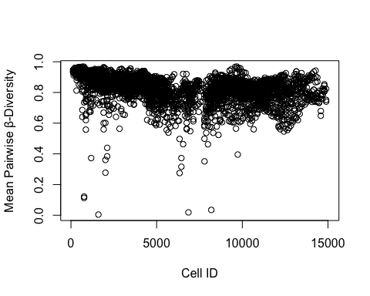

Next, we mapped these values onto the blank raster and found that the extreme outliers stretch the color gradient, making it difficult to see more intricate variation within the majority of the values.

cols <- rev(wes_palette("Zissou1", 500, type = "continuous"))  
  
BetaRaster <- setValues(BlankRas, BetaVec)  
BetaDF<-rasterToPoints(BetaRaster)  
  
BetaDF <- data.frame(BetaDF)  
colnames(BetaDF) <- c("Longitude", "Latitude", "MAP")  
  
theme_set(theme_void())  
RawBetaMap <- ggplot() + geom_tile(data=BetaDF, aes(x=Longitude, y=Latitude, fill=MAP)) +   
 scale_fill_gradientn(name="β-diversity", colours=cols, na.value="transparent", limits = c(0,1)) +   
 coord_equal()  
  
RawBetaMap

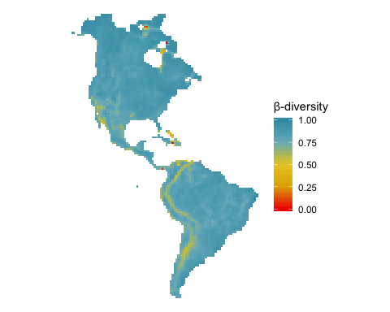

To combat this issue, we subsetted β-diversity values under 0.5 in order to map them separately in dark grey. The resulting dataset contains 19 cells.

LowBetaVec <- rep(0, 15038)  
LowBetaVec[Cell8]<-Beta8Vec  
LowBetaVec[Cell7]<-Beta7Vec  
LowBetaVec[LowBetaVec==0]<-NA  
LowBetaVec[LowBetaVec>0.5]<-NA  
  
LowBetaRaster <- setValues(BlankRas, LowBetaVec)  
LowBetaPoints<-rasterToPoints(LowBetaRaster)  
LowBetaDF <- data.frame(LowBetaPoints)  
colnames(LowBetaDF) <- c("Longitude", "Latitude", "MAP")

The resulting map shows the mean of all pairwise β-diversity values for each occuppied cell and its adjoining neighbors, with warmer colors indicating higher turnover. Values under 0.5 are shown in dark grey.

source("Functions/gplot_data.R")  
gplotB<- gplot_data(BetaRaster)  
gplotLB<- gplot_data(LowBetaRaster)  
  
BetaMap <- ggplot() +  
 geom_tile(data = dplyr::filter(gplotLB, !is.na(value)),   
 aes(x = x, y = y), fill = "gray25") +  
 geom_tile(data = gplotB,   
 aes(x = x, y = y, fill = value)) +  
 scale_fill_gradientn(name="β-diversity", colours=cols, na.value="transparent", limits = c(0.5,1)) +  
 coord_quickmap()  
BetaMap

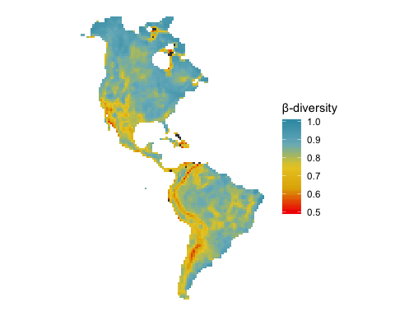

Next, we incorporated Carter Powell’s richness map into our study to compare α-diversity and β-diversity trends for bryophytes in the Americas.

RichnessVec <- readRDS("Data/RichnessVec.rds")  
RichnessVec[which(RichnessVec==0)]=NA  
RichnessRaster <- setValues(BlankRas, RichnessVec)  
  
RichnessDF <- rasterToPoints(RichnessRaster)  
RichnessDF <- data.frame(RichnessDF)  
  
colnames(RichnessDF) <- c("Longitude", "Latitude", "MAP")  
  
theme_set(theme_void())  
RichnessMap <- ggplot() + geom_tile(data=RichnessDF, aes(x=Longitude, y=Latitude, fill=MAP)) +   
 scale_fill_gradientn(name="α-diversity", colours=cols, na.value="transparent") +  
 coord_equal()   
grid.arrange(RichnessMap, BetaMap, ncol=2)

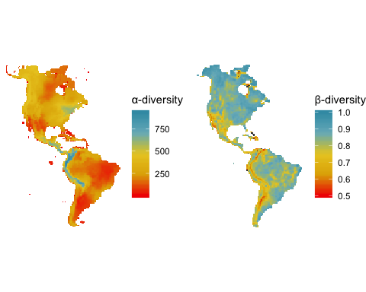

Finally, we did the same calculations using the Sorensen similarity index to see how it compared to the Jaccard similarity index. The “SorBetaVec.rds” file can be loaded into the code in place of “BetaVec” to create maps using the Sorensen index.

SorBetaVec <- readRDS("Data/SorBetaVec.rds")  
SorBetaVec[SorBetaVec<0]<-NA  
BetaVec[BetaVec<0]<-NA  
  
plot(BetaVec, ylab = "β-diversity", xlab = "Cell ID", col="darkgoldenrod2")  
points(SorBetaVec, col="cadetblue4")  
legend("bottomright", legend=c("Jaccard", "Sorensen"),  
 fill=c("darkgoldenrod2","cadetblue4"), horiz=FALSE, cex=0.9)

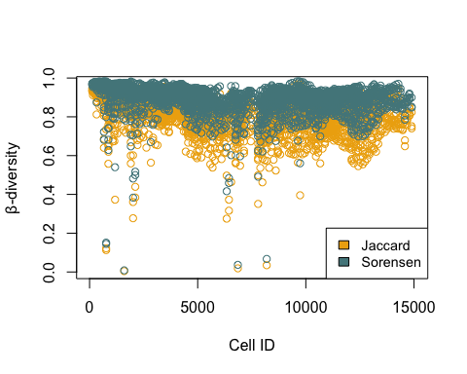

**References**

McFadden, I. R., Sandel, B. , Tsirogiannis, C. , Morueta‐Holme, N. , Svenning, J. , Enquist, B. J. and Kraft, N. J. (2019), Temperature shapes opposing latitudinal gradients of plant taxonomic and phylogenetic β diversity. Ecol Lett, 22: 1126-1135. <doi:10.1111/ele.13269>