Estimate Fossil LMA

## Data Prep

Loading require packages

require(BIEN)

## Loading required package: BIEN

## Loading required package: RPostgreSQL

## Loading required package: DBI

## Type vignette("BIEN") to get started

## The BIEN database has been updated to version 4.1 (as of 31-10-2018)! This version includes nearly twice as many occurrence records and improved validations.

require(plyr)

## Loading required package: plyr

require(tidyr)

## Loading required package: tidyr

require(dplyr)

## Loading required package: dplyr

##   
## Attaching package: 'dplyr'

## The following objects are masked from 'package:plyr':  
##   
## arrange, count, desc, failwith, id, mutate, rename, summarise,  
## summarize

## The following objects are masked from 'package:stats':  
##   
## filter, lag

## The following objects are masked from 'package:base':  
##   
## intersect, setdiff, setequal, union

require(mosaic)

## Loading required package: mosaic

## Loading required package: lattice

## Loading required package: ggformula

## Loading required package: ggplot2

## Registered S3 methods overwritten by 'ggplot2':  
## method from   
## [.quosures rlang  
## c.quosures rlang  
## print.quosures rlang

## Loading required package: ggstance

##   
## Attaching package: 'ggstance'

## The following objects are masked from 'package:ggplot2':  
##   
## geom_errorbarh, GeomErrorbarh

##   
## New to ggformula? Try the tutorials:   
## learnr::run_tutorial("introduction", package = "ggformula")  
## learnr::run_tutorial("refining", package = "ggformula")

## Loading required package: mosaicData

## Loading required package: Matrix

##   
## Attaching package: 'Matrix'

## The following object is masked from 'package:tidyr':  
##   
## expand

## Registered S3 method overwritten by 'mosaic':  
## method from   
## fortify.SpatialPolygonsDataFrame ggplot2

##   
## The 'mosaic' package masks several functions from core packages in order to add   
## additional features. The original behavior of these functions should not be affected by this.  
##   
## Note: If you use the Matrix package, be sure to load it BEFORE loading mosaic.

##   
## Attaching package: 'mosaic'

## The following object is masked from 'package:Matrix':  
##   
## mean

## The following object is masked from 'package:ggplot2':  
##   
## stat

## The following objects are masked from 'package:dplyr':  
##   
## count, do, tally

## The following object is masked from 'package:plyr':  
##   
## count

## The following objects are masked from 'package:stats':  
##   
## binom.test, cor, cor.test, cov, fivenum, IQR, median,  
## prop.test, quantile, sd, t.test, var

## The following objects are masked from 'package:base':  
##   
## max, mean, min, prod, range, sample, sum

require(stringr)

## Loading required package: stringr

require(lme4)

## Loading required package: lme4

##   
## Attaching package: 'lme4'

## The following object is masked from 'package:mosaic':  
##   
## factorize

require(magrittr)

## Loading required package: magrittr

##   
## Attaching package: 'magrittr'

## The following object is masked from 'package:tidyr':  
##   
## extract

## Mixed-Effects Modeling

First, we need to create the fossil data for prediction.

florissant_fossil_int <- readRDS("./data/processed/04_florissant_fossil_clean.rds")  
renova_fossil_int <- readRDS("./data/processed/04_renova_fossil_clean.rds")  
bridgecreek_fossil_int <- readRDS("./data/processed/04_bridgecreek_fossil_clean.rds")  
  
fossil_comb <- rbind(florissant_fossil_int,renova_fossil_int,bridgecreek_fossil_int)  
fossil_gen <- fossil_comb$Genus  
fossil_gen <- unique(fossil_gen)  
fossil_gen_df <- as.data.frame(fossil_gen)  
fossil_tax <- BIEN_taxonomy_genus(fossil_gen)  
fossil_tax <- fossil_tax[-c(1,7:9)]  
fossil_tax <- unique(fossil_tax)  
  
all_fossil <- rbind(florissant_fossil_int, renova_fossil_int, bridgecreek_fossil_int)  
all_fossil$binomial <- paste(all_fossil$Genus, all_fossil$species)  
all_fossil$binomial <- str_replace_all(all_fossil$binomial,"\\s+","_")  
all_fossil <- all_fossil[-c(1,2)]  
  
 all_fossil_LMEpred <- all_fossil %>%  
 separate(binomial,   
 c("scrubbed_genus", "species"))

## Warning: Expected 2 pieces. Additional pieces discarded in 39 rows [10, 48,  
## 50, 96, 97, 98, 104, 108, 286, 287, 288, 289, 294, 318, 324, 325, 343, 364,  
## 377, 384, ...].

all_fossil_royer_pred <- left_join(all_fossil_LMEpred, fossil_tax, by = "scrubbed_genus")  
  
all_fossil_royer_pred <- na.omit(all_fossil_royer_pred)  
all_fossil_royer_pred <- unique(all_fossil_royer_pred)  
  
colnames(all_fossil)[colnames(all_fossil)=="Petiole Width (cm)"] <- "avg_petiole_width"  
colnames(all_fossil)[colnames(all_fossil)=="Leaf Area (cm^2)"] <- "avg_LA"  
colnames(all_fossil)[colnames(all_fossil)=="PW^2/A"] <- "log_pet_leafarea"  
colnames(all_fossil)[colnames(all_fossil)=="LMA (g/m^2)"] <- "log_LMA"

Next, we have to apply a fit linear mixed-effects model. By using the lmer function in the lme4 package, we are able to fit the model to the selected data.

royer_tax_full <- readRDS("./data/processed/07_lm4_royer")  
royer_tax_na_omit<-na.omit(royer_tax_full)  
  
royer_lme <- lmer(log_lma~royer_tax_full$log_pet_leafarea + (1|order/scrubbed_family/scrubbed_genus), data=royer_tax_full)  
royer_lme_sum<- summary(royer_lme)  
  
  
royer_pred <- as.data.frame(predict(royer_lme, newdata = all_fossil_royer_pred, allow.new.levels= TRUE))

## Warning in pred + REvals: longer object length is not a multiple of shorter  
## object length

#lm predictions and models using family as factor  
royer_fossil_dropped <- all_fossil_royer_pred %>%   
 filter(!grepl('Cercidiphyllaceae', scrubbed_family)) %>%  
 filter(!grepl('Smilacaceae', scrubbed_family)) %>%  
 filter(!grepl('Staphyleaceae', scrubbed_family))  
  
royer_fossil_dropped <- all_fossil_royer_pred %>%   
 filter(!grepl('Cercidiphyllaceae', scrubbed_family)) %>%  
 filter(!grepl('Smilacaceae', scrubbed_family)) %>%  
 filter(!grepl('Staphyleaceae', scrubbed_family))  
  
royer_tax_fam_count <- royer_tax_full%>%   
 group_by(scrubbed_family) %>%   
 tally() %>%  
 filter(!grepl('Unknown', scrubbed_family))  
  
royer_tax_count <- left_join(royer_tax_full, royer_tax_fam_count, by="scrubbed_family")

### Preparing Logistic Regression

Determining the top 5 extant families with the most samples, and the top 10 families respectively.

royer_tax_top5 <- subset(royer_tax_count, as.numeric(n)>23)  
royer_tax_over10 <- subset(royer_tax_count, as.numeric(n)>9)

Creating the linear models for comparing log lma and predictions for log(lma)

royer_lmfam_top5 <- lm(log_lma~log_pet_leafarea, data = royer_tax_top5)  
pred_lmfam_top5 <- as.data.frame(predict(royer_lmfam_top5, interval="prediction"))

## Warning in predict.lm(royer_lmfam_top5, interval = "prediction"): predictions on current data refer to _future_ responses

royer_lmfam_top5_bound <- cbind(royer_tax_top5, pred_lmfam_top5)

Plotting log_lma vs log(petiole^2/leafarea) for the top 5 families

ggplot(royer_lmfam_top5_bound, aes(log_pet_leafarea, log_lma))+  
 aes(color=royer_lmfam_top5_bound$scrubbed_family)+  
 geom_point() +  
 geom_smooth(method=lm, se=TRUE)+  
 labs(x="log(petiole^2/leafarea)")+  
 labs(y="log(lma)")+  
 labs(color = "Family")

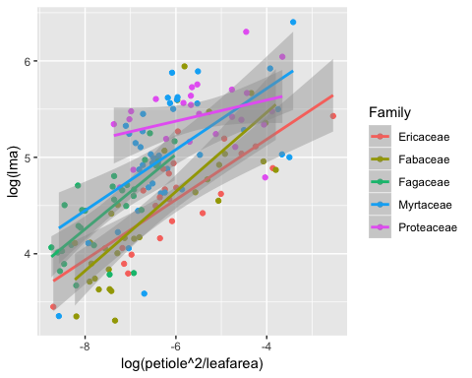

ggplot(royer_lmfam_top5_bound, aes(log_pet_leafarea, log_lma))+  
 geom_point() +  
 geom_smooth(method=lm, se=TRUE)+  
 labs(x="log(petiole^2/leafarea)")+  
 labs(y="log(lma)")+  
 labs(color = "Family")

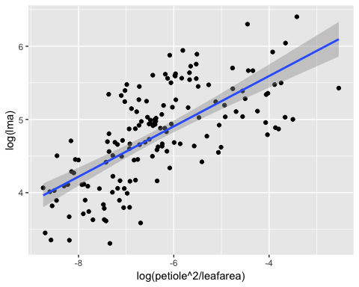

### Logistic Regression

Logistic regression predicting phenology off of log_lma

###Create sets so we can determine the top 5 extant families with the most samples, and the top 10 families respecitively  
  
##Creation of fossil esitmates of top 5 fossil families  
fossil_top5 <- royer_fossil_dropped%>%   
 group_by( scrubbed_family) %>%   
 tally()%>%  
 filter(!grepl('Unknown', scrubbed_family))  
fossil_top5 <- left_join(fossil_top5, royer_fossil_dropped, by="scrubbed_family")  
fossil_top5 <- subset(fossil_top5, as.numeric(n)>22)  
  
#Creation of extant off of the five top families  
fossil_top5_tax <- as.data.frame(unique(fossil_top5$scrubbed_family))  
extant_top5_fossil_tax <- subset(royer_tax_na_omit, (royer_tax_na_omit$scrubbed_family %in% fossil_top5_tax))  
  
#creation of fossils that are in all extant families with more than 10 observations-----  
extant_over10_fossil_tax <- subset(royer_tax_na_omit, (royer_tax_na_omit$scrubbed_family %in% royer_tax_over10$scrubbed_family))  
  
##Create royer_data_split so genus and species are separated  
royer_data<-read.csv("./data/raw/royer_data.csv")  
royer_data_split <-  
 royer_data %>% separate(binomial, c("genus", "species"))

## Warning: Expected 2 pieces. Additional pieces discarded in 74 rows [11,  
## 15, 16, 20, 21, 22, 34, 35, 37, 38, 39, 40, 60, 61, 83, 84, 92, 117, 126,  
## 131, ...].

royer_data_split <- subset(royer_data_split, royer_data_split$genus %in% extant_over10_fossil_tax$scrubbed_genus)  
royer_data_split <- subset(royer_data_split, royer_data_split$species %in% extant_over10_fossil_tax$species)

Logistic regression predictions on deciduous vs evergreen for fossils

royer_data_split <- unique(royer_data_split)  
colnames(royer_data_split)[colnames(royer_data_split)=="leaf_area"] <- "avg_LA"  
glm_pred_data <- left_join(extant_over10_fossil_tax, royer_data_split, by = "avg_LA")  
glm_pred_data <- na.omit(glm_pred_data)  
glm_pred_data <- unique(glm_pred_data)  
  
  
ggplot(glm_pred_data, aes(log_lma, phenology))+   
 geom_point() +   
 stat_smooth(method="glm", method.args=list(family="binomial"), se=FALSE)

## Warning: Computation failed in `stat_smooth()`:  
## y values must be 0 <= y <= 1

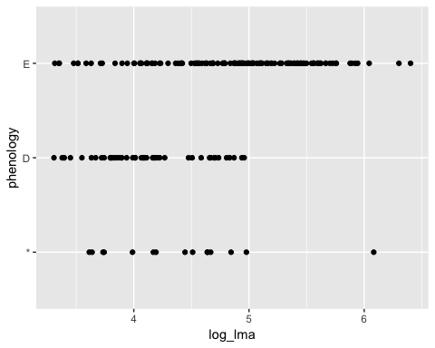

ggplot(glm_pred_data, aes(log_lma, phenology, group=(scrubbed_family), color=scrubbed_family)) +   
 geom_point() +   
 stat_smooth(method="glm", method.args=list(family="binomial"), se=FALSE)

## Warning: Computation failed in `stat_smooth()`:  
## y values must be 0 <= y <= 1

