**MS Teams Info**

**MS Teams Link:**

<https://teams.microsoft.com/l/channel/19%3aNQ8MTVyeNs5T9S6SUFQx4oc49LIjDsB6ASDpmwdKbsI1%40thread.tacv2/General?groupId=a92e7889-ccf9-4855-923d-6100571277b3&tenantId=d1323671-cdbe-4417-b4d4-bdb24b51316b>

**Meetings:**

21/12/21 | Recording | Minutes

30/12/21 | Agenda | Recording | Minutes

04/01/22 | Agenda | Recording | Minutes

07/01/22 | Agenda | Recording | Minutes

11/01/22 | Agenda | Recording | Minutes

14/01/22 | Agenda | Recording | Minutes

**21 December 2021**

**10:00PM**

**Video Recording Link:**

[**https://rmiteduau.sharepoint.com/:v:/s/demo334/ETzn3Zajnd9FkwvO2k7yH6wB4jIg7eNWCtmMI5bXUDmsgA?e=SP7gFC**](https://rmiteduau.sharepoint.com/:v:/s/demo334/ETzn3Zajnd9FkwvO2k7yH6wB4jIg7eNWCtmMI5bXUDmsgA?e=SP7gFC)

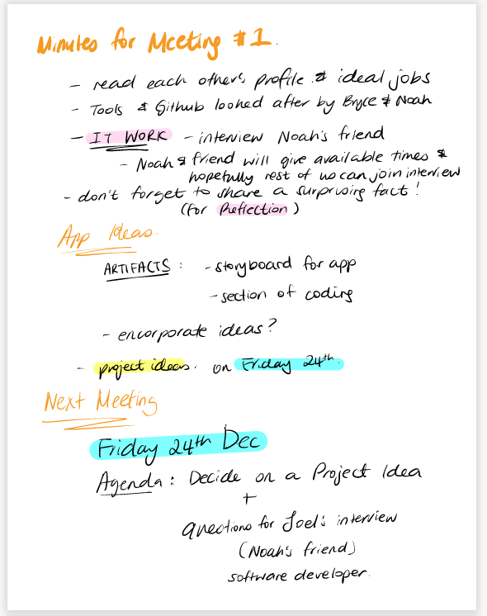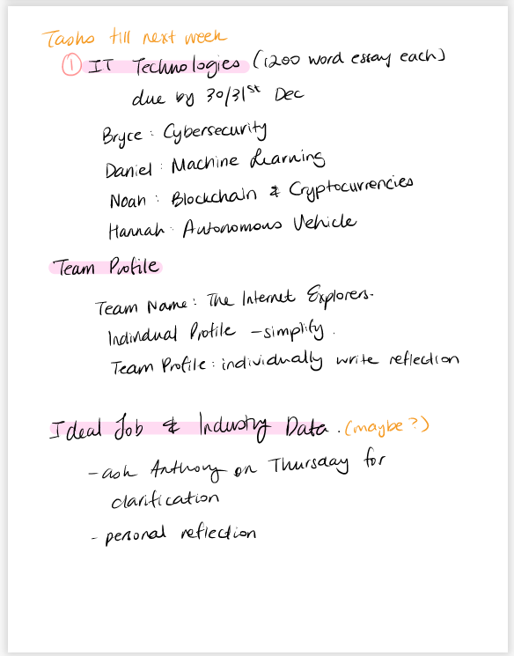**Meeting Minutes:**

**30 December 2021**

**01:00 PM**

**Video Recording Link:**

**<https://rmiteduau-my.sharepoint.com/:v:/g/personal/s3932976_student_rmit_edu_au/ERm6ezTNKl1IuCOYcnXgInQBtscQnn2-0V39JsdAP0nNag?e=PENNuo>**

**Meeting Agenda:**

Title of meeting: Progress check and setting up the interview with Joel

Date and time of meeting: 24/12/2021 time TBA

Chaired by: Daniel Coles

Attendees: Daniel Coles, Bryce McKerlie, Noah Etherington, Hannah Son, Rhiannon

**Meeting goal:**

* Prepare for interview with Joel
* Finalise a *Project Idea*
* Assess progress of *IT Technologies*
* Assess progress of Github repository

**Agenda Item 1: *IT Work***

Time: 10-15 minutes

Purpose: Finalise the *IT Work*section interview.

Leader: Noah

a. Finalise a series of question for Joel ensuring they meet all the requirements as per the rubric

b. Discuss interview time to 4ensure most group members are present

**Agenda Item 2: Finalise *Project Idea***

Time: 10 – 15 minutes

Purpose: To land on a project Idea as a group, to set deadline for description section as per rubric

Leader: TBA

a. Pick an idea

b. Segment the writing into section (can use assignment one for this) assign sections to group members

c. Decide on a deadline

**Agenda Item 3: assess progress on *IT Technologies***

Time: 5 minutes

Purpose: see where we are at for this section

Leader: TBA

a. where are we up to

b. any issues?

**Agenda Item 4: assess progress on group profile and github**

Time: 5 minutes

Purpose: see where we are up to regarding these tasks

Leader: TBA

a. where are we up to?

b. any issues?

**Agenda Item 5: set date and time for next meeting**

Time: 5 minutes

Purpose: set a date and time for next meeting

Leader: TBA

* + Check when everyone is available for next meeting
  + Finalise a date and time for next meeting

**5. End of meeting review**

  Time: 5 minutes

Purpose: try to improve on our meeting each week

Leader: TBA

a. What did we do well in this meeting?

b. What needs improving for our next meeting?

**Meeting Minutes:**

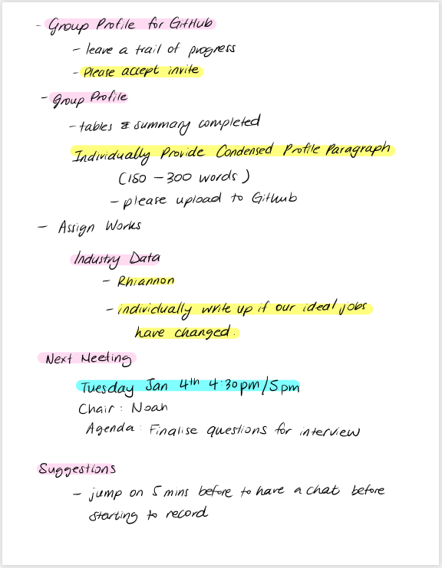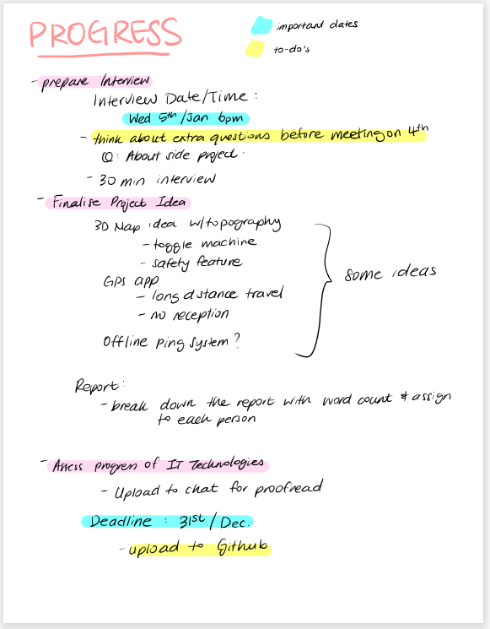

**04 January 2022**

**4:30 PM**

**Video Recording Link:**

[**https://rmiteduau-my.sharepoint.com/:v:/g/personal/s3932976_student_rmit_edu_au/EVg38TVFKdpNrvbap9kAHaUBaJpdYti_xaOQp3Pt2r0_LQ?e=9cd2Mx**](https://rmiteduau-my.sharepoint.com/:v:/g/personal/s3932976_student_rmit_edu_au/EVg38TVFKdpNrvbap9kAHaUBaJpdYti_xaOQp3Pt2r0_LQ?e=9cd2Mx)

**Meeting Agenda:**

Title of meeting: Progress check, deciding Project idea, and assigning tasks

Date and time of meeting: 04/01/2022 time 16:30

Chaired by: Daniel Coles

Attendees: Daniel Coles, Bryce McKerlie, Noah Etherington, Hannah Son, Rhiannon

**Meeting goal:**

* *Assess progress of Industry Data and everyone’s input*
* *Discuss contributions to assignment*
* *Discuss IT professional interview*
* *Finalise a Project Idea*
* *Assign sections to group members*
* *Decide on next meeting date/time*

**Agenda Item 1:** *Assess progress of Industry Data and Personal Information sections*

Time: 5 minutes

Purpose: Finalise the Personal Information and Industry Data sections

Leader: TBA

a. See if everyone has completed their personal information paragraph

b. Check if everyone has finished their “Burning Glass” data section or how far away they are

c. Set due date if either of these are incomplete

**Agenda Item 2:** *Discuss contributions to assignment*

Time: 5 minutes

Purpose: Discuss everyone’s current contributions and predict final tally

Leader: Bryce

a. Let everyone know their current contributions

b. Predict what can be done for everyone to have equal contributions at end of assessment

c. Check if everyone agrees, if someone disagrees, discuss and come up with solution

**Agenda Item 3:** *Discuss IT professional interview*

Time: 5 minutes

Purpose: Discuss who is attending interview and questions that will be asked

Leader: TBA

a. Find out who will be attending the interview

b. Decide who will be responsible for recording interview and making sure transcripts are recorded, and who will be responsible for asking which questions

c. Make sure everyone is on the same page with the questions being asked

**Agenda Item 4:** *Finalise Project Idea*

Time: 10 minutes

Purpose: To land on a project Idea as a group and distribute sections

Leader: TBA

a. Decide on Project Idea, either a new idea or one of our existing ones

b. Distribute sections of project idea to everyone

c. Explain description section, everyone to do 300 words on 1-2 features each, to total 1500 words.

**Agenda Item 5:** *Assign any unfinished sections of report*

Time: 5 minutes

Purpose: Assign remaining unfinished sections to group members

Leader: TBA

a. See if Rhiannon is willing to do Ideal Jobs section to equal out contributions

b. If Rhiannon isn’t comfortable, assign to a different group member

c. Assign any remaining sections

**Agenda Item 6:** set date and time for next meeting

Time: 5 minutes

Purpose: set a date and time for next meeting

Leader: TBA

* + Check when everyone is available for next meeting
  + Finalise a date and time for next meeting

**7. End of meeting review**

  Time: 5 minutes

Purpose: try to improve on our meeting each week

Leader: TBA

a. What did we do well in this meeting?

b. What needs improving for our next meeting?

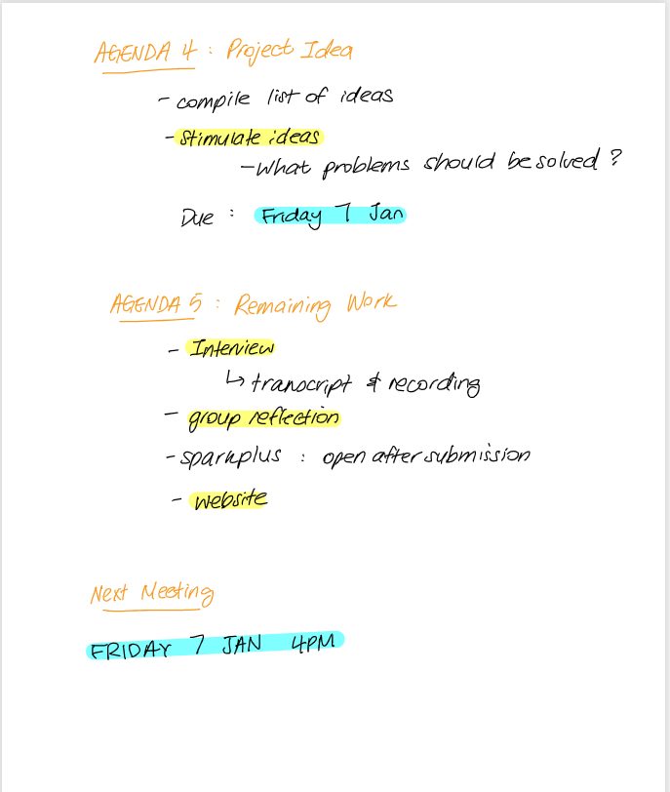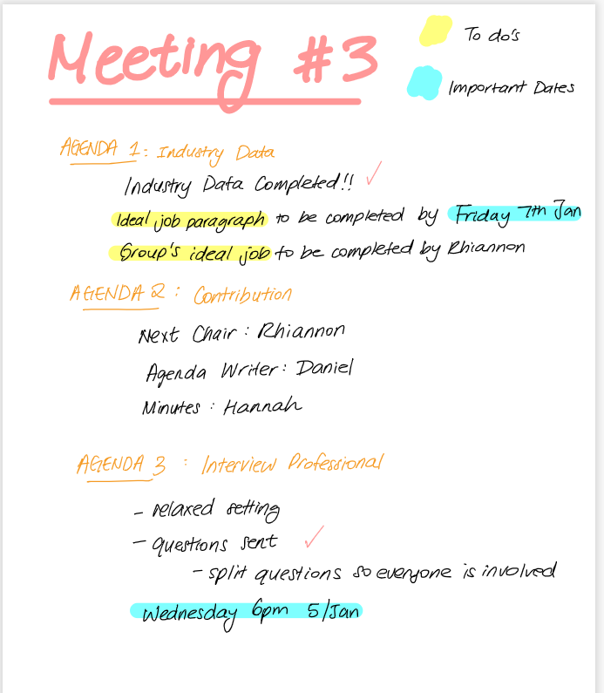**Meeting Minutes:**

**07 January 2022**

**4:00 PM**

**Video Recording Link:**

**<https://rmiteduau-my.sharepoint.com/:v:/g/personal/s3932976_student_rmit_edu_au/EXHLZhWX0wFMuBRc7IdochkBNo9dvj3fdCgKl7ddi3IatQ?e=1DsyAn>**

**Meeting Agenda:**

Title of meeting: Project Idea

Date and time of meeting: 07/01/2022 time 16:00

Chaired by: Rhiannon

Attendees: Daniel Coles, Bryce McKerlie, Noah Etherington, Hannah Son, Rhiannon

**Meeting goal:**

* **1**
* **2**
* **3**

**Agenda Item 1:** Project Idea

Time: 20 minutes

Purpose: Discuss ideas and pick one

Leader: TBA

a. everyone presents their ideas, discuss, and pick one

b. talk about that idea in more depth

c. assign sections of description for each person to write about

**Agenda Item 2:** Post interview check-up

Time: 5 minutes

Purpose: Discuss turning the interview into assignment appropriate format

Leader: TBA

a. what needs to be done here

b. who will do it

**Agenda Item 3:** Discuss any outstanding work to be done for the assignment

Time: 5 minutes

Purpose: to make sure we are across the remaining workload

Leader:

a. Ideal Jobs section progress

b. Burning glass data progress

c. Any remaining sections to do

**End of meeting review**

  Time: 5 minutes

Purpose: try to improve on our meeting each week

Leader: TBA

a. What did we do well in this meeting?

b. What needs improving for our next meeting?

**Meeting Minutes:**

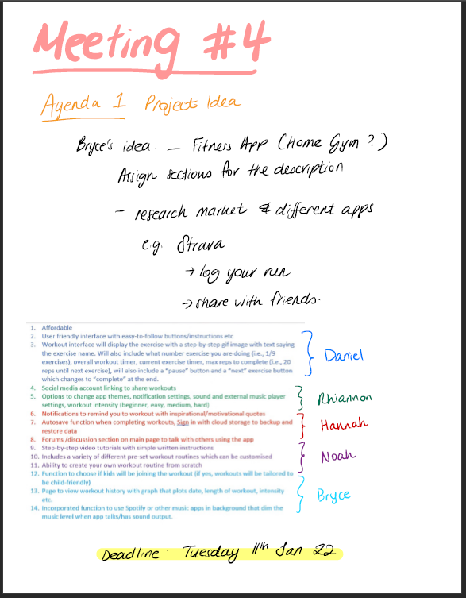

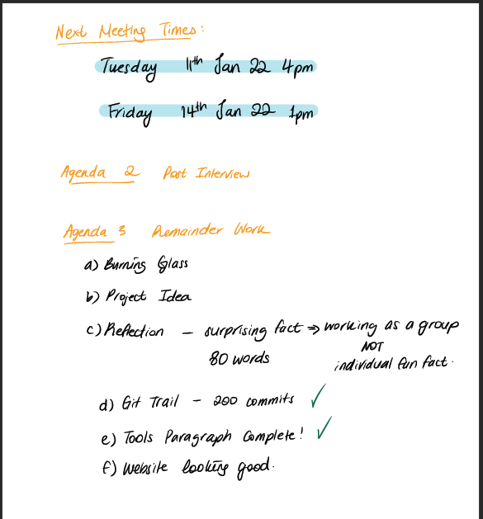

**11 January 2022**

**4:00 PM**

**Video Recording Link:**

**<https://rmiteduau-my.sharepoint.com/:v:/g/personal/s3932976_student_rmit_edu_au/EXzDi6TxUHNHu-d-cuXmQYcBzq3iBz6HEr-H7C8Y9HdL8A?e=sofc7g>**

**Meeting Agenda:**

Title of meeting: Project Update

Date and time of meeting: 11/01/2022 time 16:00

Chaired by: Daniel

Attendees: Daniel Coles, Bryce McKerlie, Noah Etherington, Hannah Son, Rhiannon Lloyd

**Meeting goal:**

* **1**
* **2**
* **3**

**Agenda Item 1:** Project Update

Time: 15 minutes

Purpose: Update on progress of Project idea

Leader: TBA

a. Discuss progress

b. Work yet to be done

**Agenda Item 2:** Assignment update

Time: 5 minutes

Purpose: Update on progress of assignment

Leader: TBA

a. Discuss any outstanding work

b. SparkPLUS update (RL) per Thomas’s class Monday

**Agenda Item 3:** Discuss next meeting

Time: 5 minutes

Purpose: Plan final meeting

Leader:

a. Anything to be tabled for final meeting

**End of meeting review**

  Time: 5 minutes

Purpose: try to improve on our meeting each week

Leader: TBA

a. What did we do well in this meeting?

b. What needs improving for our next meeting?

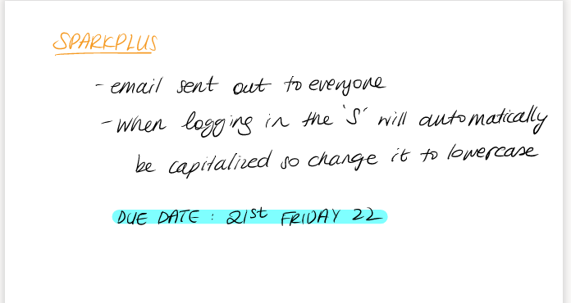**Meeting Minutes:**

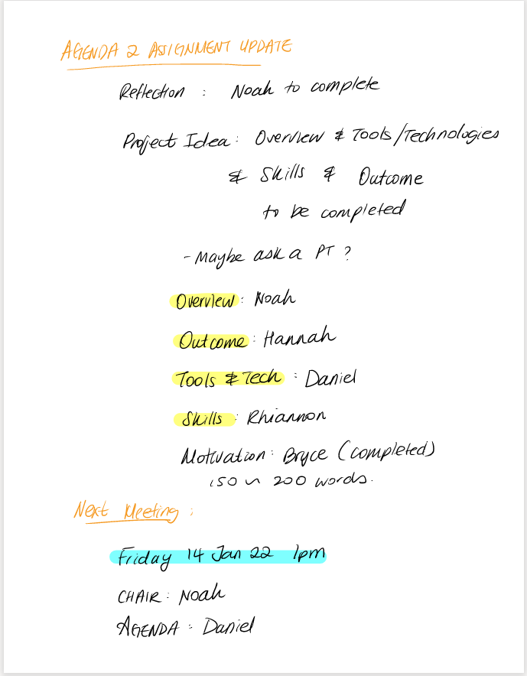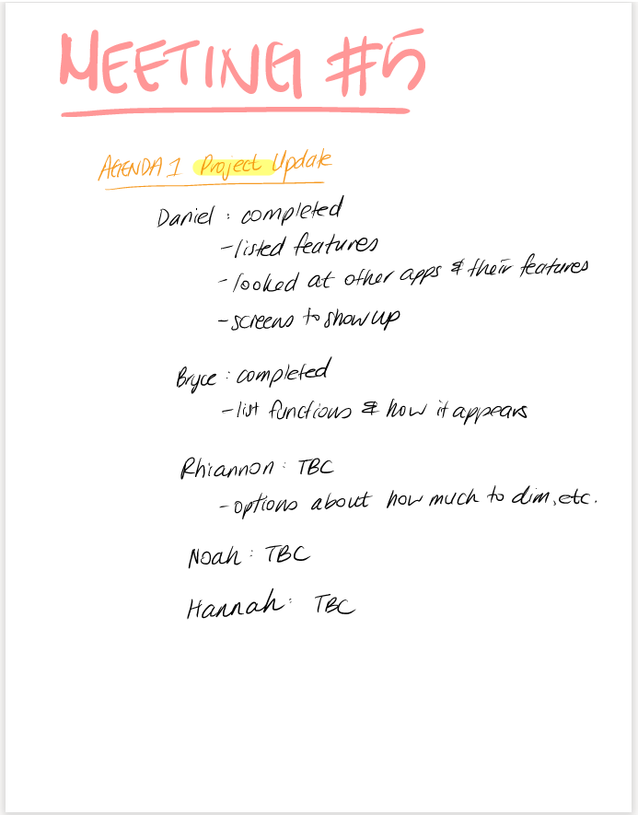

**14 January 2022**

**4:30 PM**

**Video Recording Link:**

**<https://rmiteduau-my.sharepoint.com/:v:/g/personal/s3932976_student_rmit_edu_au/ETGANPcO4MtJmq4mkg3HmZAB43GFie5oh0E1N_voYQivmw?e=ZFOQaI>**

**Meeting Agenda:**

Title of meeting:

Date and time of meeting: 14/01/2022 time 16:30

Chaired by: Noah

Attendees: Daniel Coles, Bryce McKerlie, Noah Etherington, Hannah Son, Rhiannon Lloyd

**Meeting goal:**

1. **Identify loose ends**

**Agenda Item 1:** Flesh out Project Idea Sections

Time: 5

Purpose: See where we are up to

Leader: tba

**Agenda Item 2:** Can the markers access all our content?

Time: 5

Purpose: Make sure all our work is accessible to markers

Leader: tba

**Agenda Item 3:** Loose Ends

Time: 15

Purpose: figure out exactly what is left to do and allocate work

Leader: tba

a. What is left?

b. Who can help

**Agenda Item 4:** Review the submission

Time: rest of meeting

Purpose: Go over the final product

Leader: tba

**Agenda Item 5:** This is just an idea but maybe schedule a chat session for submission so we can go over it all one final time before submitting and then submit it together?

**Meeting Minutes:**

