Plans and Progress: Part 2

The biggest barrier we have come across has been to do with the backend building of the mobile application. We have decided to use Android Studio to develop our mobile fitness application and have been using it to create high fidelity mock-ups. However, we have come across some barriers with using Kotlin as our programming language of choice since the language and methods that were previously known to us are irrelevant with Android Studio and we require to relearn Kotlin and specific methods to develop our app. At this current stage, there hasn’t been other barriers as a group and working collaboratively as a team. Everyone has been cooperative and quick to respond to any changes that has been happening with the project. However, one of the biggest barriers have been time constraints. Since there are many features we would like to include in this mobile application which boosts the motivation of users and encourages users to continue working out, there are many aspects that we must work on in this app. Hence, the time constraint is one of our biggest barriers that we are trying to work against.

We have made many decisions regarding the features and interface of our application. Our application will feature a social forum where users can interact with other fitness users and parents who are also working towards the same goal, to become fit with the limited time they have on their hands. But we have decided to further this social interaction so that users can connect the application to their social media account. Users can post their progress and achievements to their social media platform such as Facebook and post updates regarding their workouts. By allowing our app to link with other social media platforms, it will reduce the amount of times that the user will have to log in to share their progress, motivational quotes, and achievements.

Each person will take part in the whole process, and we have decided to share the roles around, focusing on everyone’s strength in each process in developing, designing and the research for the application. Some research includes different workout modules that are used in other workout applications and different intensities. We have also decided to get our fitness routines and schedules approved by a professional trainer so that our users can take faith in our app that it could help users get fit and healthy even with shorter workouts according to their time restraints.

Another aspect that we have decided on as a group is to focus on the notifications for the application. The main feature that distinguishes our app from other apps is our notification feature. It will ring to remind users to complete their workout multiple times throughout the day. But it will not stop at being a reminder, it will include inspirational quotes and encouraging thoughts to motivate users to use even the shortest time they can spare, to complete a workout. Our group has decided to find ways that these notifications are not bothersome to the user and will offer that kick that will get them to complete their workout at their desired time. These include modern and minimalist designs, short and sweet quotes and pictures which can make users feel better about completing their workout.

Some other features that we will include in this app are explanatory videos and background music. To enable music to be played in the background while doing workouts, our application will enable music apps such as Spotify and YouTube Music to run in the background simultaneously with the option to link these apps with ours being considered. The user can decide how to level out the music and the volume which they want the instructions, timer, or other audio from our fitness app to be compared to their background music. The explanatory videos can also be played along with background music, but the user will have the option to decrease the volume of the background music while these videos are playing or even have the music pause. These explanatory videos will help the users to maintain correct posture as they achieve their workout and avoid injuring themselves. They will short and concise, focusing on one aspect or position in each video. Users can choose to watch these explanatory videos during their workout or not if they are a seasoned user.

Another feature is a goals and achievements function. These will add a level of gamification to the application which will motivate users to return to unlock more achievements and enjoy their progress because they can visually see how much they have achieved. Some of the achievements will include working out 5 times a week or working out 5 times in a row, working out for 5 minutes or working out for 20 minutes, completing a 100-burpee challenge and so forth. There will be different achievements that users can unlock and share on their social forum or social media account which can give a sense of satisfaction and accomplishment to boost their motivation to continue working out.

Currently we are working on different features of the project. We have designed a basic interface for the application and are continuously working through user interactions and reactions. Since we are heavily focusing on our notifications, these are going through continuous ideas and changes to find a design suitable for users. Also, with the interface we have chosen the colour theme for the application, using mostly blue, white and shades of grey. We have a basic layout of the sequence that things will run in the menu or navigation bars. There will be little icons beside the names on the navigation panels so that users can more easily identify what each button will do or where it will take them. The social forum is also currently at work with links being created to make it more interactive and user friendly. We would like this forum to be easy to share posts and motivate other users as well as find encouragement, so we are working towards an efficient model. Gifs are also another part of our app so that users can watch those short clips to know what the current exercise is and what is coming up. These clips are currently under work along with our workout programs.

Another area we are currently working on is getting our workouts approved by a professional trainer. Since our app will provide not only workouts but child friendly workout programs, it is crucial to have our workouts approved by a professional trainer. Hence, we are at present working with a professional trainer in getting multiple workouts and different exercises that can be simultaneously done with a child, no matter their age. Also, since users would want a variety of workouts according to their needs, age, weight, level of difficulty and time constraints, it is possible that even in the future we will need to continuously work with a professional trainer to create approved workouts.

In the future we will continuously work on our app development and hire professionals either through an app development company or directly hiring a coding professional and interface designer to improve our app and the interface. We will try to work more on the social forum since it has unexpectedly taken more time to develop. Also as mentioned before, we will continue to work on the workouts, with plans to film the videos and clips to incorporate into the application.

As shown in figure 1, we are expecting to complete the prototype and have it prepared for user testing and beta-testing. An initial user test with a prototype will help us to apply the user feedback and implement all the necessary changes both to simplify the app or to create more functions to improve user experience. As seen in week 14, when the user feedback is applied, we will be able to have our final product ready for beta-testing and customer validation. This will lead to our final step which is to upload the application to Google Play Store and find potential investors and make a pitch to the investors.

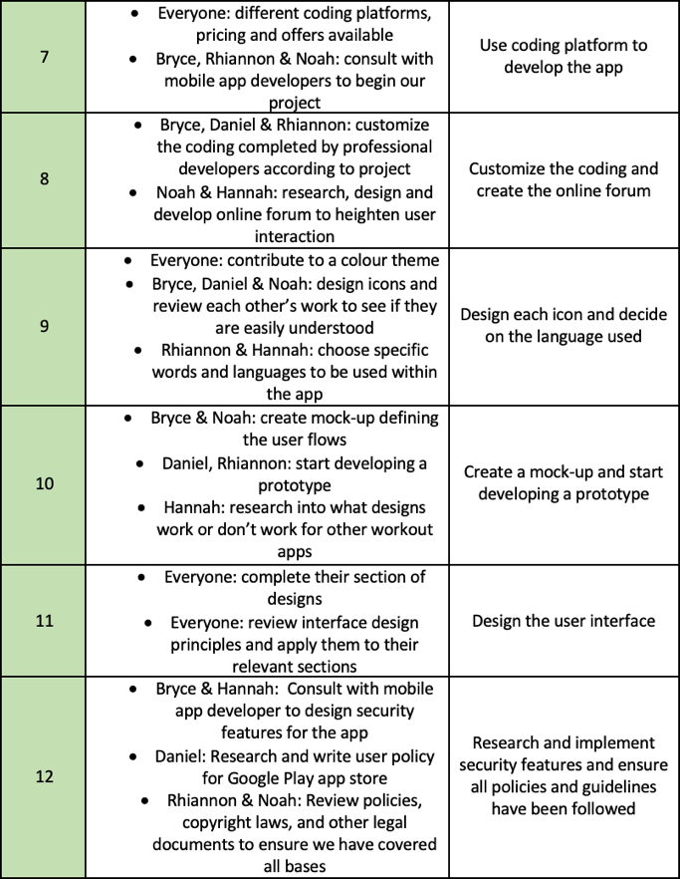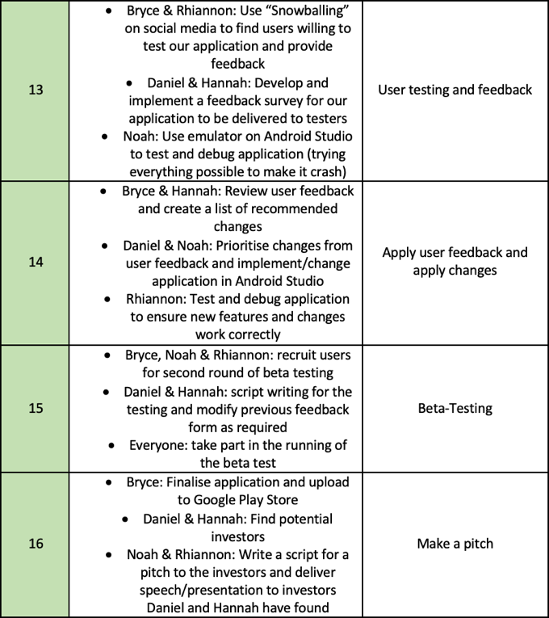

Figure 1: Weeks 7 – 12 of the project timeline