Exploring Innovative Machine Learning Models for Soil CO₂ Emission Forecasting
Vincent Lu
Basis Independent Fremont
Fremont, CA, USA
vincent.lu234@gmail.com

Abstract—Soil respiration, the natural process by which carbon dioxide (CO₂) is released from the soil into the atmosphere, is the largest flux of CO₂ from the Earth’s surface. Despite its significance, accurately predicting CO₂ emissions caused by soil respiration remains challenging, and the influence of environmental variables are not yet fully understood. Early studies using artificial intelligence (AI) to predict soil respirations often relied on linear models or overly simplified datasets which lacked real-world applications. This study introduces a novel integration of XGBoost and Shapley Additive exPlanations (SHAP) to achieve both high predictive accuracy and detailed feature interpretability. In this study, an innovative ensemble model, XGBoost, is developed to estimate annual soil respiration (Rs) using spatial, temporal, climatic, and other independent variables. Additionally, a deep neural network (DNN) model is explored. Among the machine learning models evaluated, XGBoost shows the best performance, with a 4% reduction in Mean Absolute Error (MAE) and Root Mean Squared Error (RMSE) and a 3.7% increase in R² compared with the Random Forest model, which was so far believed to be the state-of-the-art method. To aid in model explainability, SHAP is used to give feature importance at both the global and individual levels of analysis. Results indicate that Mean Annual Temperature (MAT) and Mean Annual Precipitation (MAP) are the most dominant environmental factors, with geographic variables such as latitude and longitude also significant. Other strong predictors include Study Year, Soil Type, soil composition-related features, Elevation, and Basal Area (BA). This study fills the gap between predictive modeling and interpretability, providing an explainable AI framework that is scalable for real-world environmental research.
Keywords—Soil Respiration, Machine Learning, CO₂ Emission, XGBoost Regressor, SHapley Additive exPlanations, SHAP, Predictive Modeling

Introduction
Soil respiration refers to the dynamic and complex process by which carbon dioxide (CO₂) is released from the soil into the atmosphere. The emission occurs because of the synergistic activities of microorganisms decomposing organic matter and plant root respiration. Being the largest terrestrial flux of CO₂ to the atmosphere, soil respiration is fundamental in regulating the global carbon cycle. Its magnitude and sensitivity to environmental changes underline its importance in climate science and ecosystem management.
Accurately predicting CO₂ emissions from soil respiration remains, however, a very tough challenge. This complexity arises because the process depends on various environmental factors, including temperature, precipitation, soil composition, and vegetation dynamics. These interact in nonlinear and often unpredictable ways, making it even more difficult to construct reliable predictive models. While some variables—such as mean annual temperature and precipitation—are known to have critical roles, the detailed mechanisms by which they drive soil respiration remain vaguely understood by the broader scientific community.
Historically, modeling attempts at soil respiration have been described along two general approaches: process-based models and statistical methods. Process-based models aim at a simulation of the biophysical and biochemical processes underlying soil respiration. While these models provide mechanistic insights, they are all computationally intensive and hence often impractical for regional or global-scale applications. On the other hand, statistical models, such as linear regression, focus on the empirical capture of the relationships between soil respiration and environmental factors. The methods are computationally efficient but often fail to consider the inherent nonlinear interactions and variability within natural ecosystems.

Recent machine-learning developments have enabled the exploitation of new pathways toward these challenges. In this regard, ensemble methods like Random Forest and Gradient Boosting have been remarkable for improving predictive accuracy by accommodating complex nonlinear relationships. However, these approaches also come with their own set of limitations, such as dealing with missing data and the limitation in model interpretability. To address these challenges, this paper proposes a new framework to combine the strong predictive capacity of XGBoost (one of the state-of-the-art ensemble algorithms) with SHapley Additive exPlanations (SHAP) in a more interpretable way for the model. This research will develop an approach to make the modeling of soil respiration scalable, accurate, and explainable, thus contributing to the predictive capacity and understanding of the environmental drivers behind the processes.

Related Works
Numerous studies have been conducted on the estimation of soil respiration using process-based models. Lawrence et al. [1] gave a presentation on the Community Land Model version 5.0 (CLM5.0), a sophisticated tool for simulating interactions between land and atmospheric processes, including soil processes, vegetation dynamics, and river routing. In order to address uncertainties in land-use carbon emission processes, Lienert and Joos [2] used a Bayesian ensemble data assimilation approach to optimize model parameters, significantly improving stability and accuracy. This method uses a probabilistic framework to constrain uncertain model parameters through observational data, therefore increasing the precision of land-use carbon emission estimates. By applying Latin hypercube sampling to create a 1000-member perturbed parameter ensemble, they effectively addressed uncertainties in dynamic global vegetation models, which allows for more reliable assessments of historical and regional carbon flux patterns. Similarly, Ito [3] demonstrated that disturbance-induced emissions and non-CO₂ carbon export flows in the Vegetation Integrative Simulator for Trace Gases (VISIT) proved that these minor carbon flows impacted terrestrial carbon stocks greatly and reduced ecosystem storage by about 440 PgC, thus shortening the mean residence time of carbon stocks by 2.4 years globally. While these process-based models provide in-depth insights into soil respiration mechanisms, they are computationally intensive and often impractical for large-scale applications.
In comparison, reduced-form modeling depends on statistical models to determine soil respiration using environmentally observable determinants without giving any explicit account of underlying processes that are complex. For example, Adachi et al. [4] combined land-use changes derived from remote sensing data with climate variables in statistical models for soil respiration. They estimated that global soil respiration would be 94.8 and 93.8 Pg C yr−1 for the years 2001 and 2009, respectively. Moreover, their results also pinpointed regional differences: for example, the larger spatial variability found in high-latitude regions and the problem of estimating Q10 values in tropical ecosystems because of poor seasonal variation. The study emphasized the need for higher spatial resolution remote sensing data and diverse field observations to refine predictions. Bahn et al. [5] examined the relationship between mean annual soil temperature and annual CO₂ emissions from soil respiration using statistical analyses. The results showed that higher soil temperatures were mostly associated with higher CO₂ emissions, thus underlining the important role of temperature as a predictive variable in models of soil respiration and its possible consequences for understanding regional carbon dynamics. Jian et al. [6] improved upon this by incorporating both annual mean soil and air temperatures to predict annual CO₂ emissions. More recently, Lu et al. [7] and Liu et al. [8] used novel machine learning approaches to model soil respiration with higher accuracy by using Random Forest models.
Numerous previous studies have relied on process-based approaches, which, though detailed, are resource-intensive and challenging to scale up effectively. The public release of the Soil Respiration Database (SRDB) has produced a unique opportunity to implement modern machine learning models as a practical alternative. In contrast with traditional regression techniques, decision tree-based ensemble methods, including Random Forest and Gradient Boosting, do not stipulate strict assumptions about how dependent and independent variables may interact. These models segment the data according to different thresholds of independent variables, thereby effectively representing nonlinear associations and intricate interactions. Ensemble models additionally improve predictive accuracy by integrating outcomes from several decision trees.
Although some studies have applied ensemble methods to this task [4, 5], most have focused on Random Forest models, while few have explored more recent and powerful algorithms such as XGBoost. Also, most of these studies lack detailed analyses of which factors contribute most to model outputs, which is indispensable in environmental applications.

Methodology

Datasets
The data used in this study is taken from the Soil Respiration Database Version 5 (SRDB-V5), a comprehensive global archive of published research data on soil respiration. This database collates soil respiration measurements taken in a wide range of ecosystems across the globe, thus providing an invaluable resource for the analysis of CO₂ flux dynamics.

TABLE I. SUMMARY OF FEATURE NAMES AND VARIABLE TYPES
Category | Feature Names | Definition | Variable Type
Spatial/temporal | Study_year | Year study was performed (middle year if multiple years) | Numerical
 | YearsOfData | Years of data in the study | Numerical
 | Latitude | Latitude of the site | Numerical
 | Longitude | Longitude of the site | Numerical
 | Biome | Biome type | Categorical
 | Elevation | Elevation of the site | Numerical
Climate | MAT | Reported mean annual temperature | Numerical
 | MAP | Reported mean annual precipitation | Numerical
Land use | Ecosystem_type | Ecosystem type (grassland, forest, etc) | Categorical
 | Ecosystem_state | Ecosystem state (managed, unmanaged, natural) | Categorical
Soil | Soil_type | Soil description (classification and texture) | Categorical
 | Soil_drainage | Soil drainage (dry, wet) | Categorical
 | Soil_BD | Soil bulk density | Numerical
 | Soil_CN | Soil C:N ratio | Numerical
 | Soil_sand | Sand ratio | Numerical
 | Soil_silt | Silt ratio | Numerical
 | Soil_clay | Caly ratio | Numerical
Vegetation | Leaf_habit | Dominant leaf habit (deciduous, evergreen) | Categorical
 | Stage | Developmental stage (aggrading, mature) | Categorical
 | LAI | Leaf area index at site | Numerical
Carbon | BA | Basal area at site | Numerical
 | C_veg_total | Total carbon in vegetation at site | Numerical
 | C_AG | Total carbon in aboveground vegetation | Numerical
 | C_BG | Total carbon in belowground vegetation | Numerical
 | C_CR | Total carbon in coarse roots | Numerical
 | C_FR | Total carbon in fine roots | Numerical
 | C_soilmineral | Total carbon in soil organic matter | Numerical
 | C_soildepth | Depth to which soil C recorded | Numerical
To ensure the integrity of the data, records with entries flagged in the Quality_flag field were excluded from the analysis. Extreme outliers, with Rs_annual values above 5000 gCm⁻², were also removed; this corresponded to 22 records from a total of 12,272 entries (less than 0.2%). This was done to limit the potential influence of outliers on model training and testing. Missing values for the independent variables were replaced by the median value of each respective feature to ensure that the dataset is uniform.

The dependent variable, in this case, Rs_annual, refers to the quantity of carbon dioxide emitted in a year by soil respiration. A set of independent variables, simply referred to as features, includes the spatial, temporal, climatic, and soil parameters. All relevant features with descriptions are depicted in Table 1: mean annual temperature (MAT), mean annual precipitation (MAP), elevation, latitude, soil organic carbon, and others not mentioned here. These features encapsulate the complex traits inherent to the phenomenon.
For the purpose of developing and assessing predictive models, the dataset was divided into 80% designated for training and 20% allocated for testing. This division guarantees that the models are instructed on a varied collection of instances while preserving a distinct subset for an objective evaluation of performance. The training subset is employed to refine the parameters of the model, whereas the testing subset serves to assess the model's generalizability to novel data. This rigorous approach ensures the models can be used for reliable soil respiration predictions in different ecological settings.

Model Training
A novel machine learning framework XGBoost is proposed to estimate annual soil respiration (Rs), and a deep neural network (DNN) is employed for comparison. Two benchmark models, Random Forest (RF) and Gradient Boosting (GB), are implemented with the same dataset, and previous studies indicated better performance of RF. XGBoost has advantages over the traditional GB by its efficient regularization, good handling of missing data, parallelized training procedures, and improved implementation strategies that bring in better speed and accuracy.

The DNN model contains an input layer, a normalization layer, and two dense layers (44 and 16 neurons) with ReLU activation, followed by a single output neuron for continuous regression output. This architecture efficiently models nonlinear dependencies and reduces overfitting with dropout regularization. Hyperparameter optimization for both models is done using GridSearchCV with K-fold cross-validation: for XGBoost, parameters like estimators, tree depth, and learning rate are optimized, while for the DNN, neuron counts, learning rate, and batch size are optimized. This approach guarantees accuracy and robustness in the prediction of annual soil respiration.

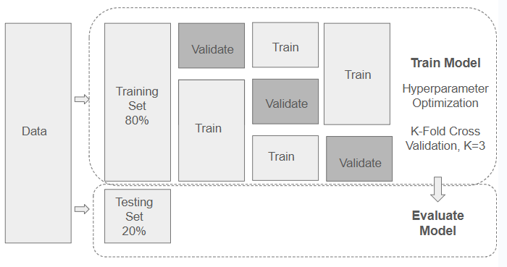

Fig. 1. illustrates the model training with hyperparameter optimization and model evaluation process.

Model Evaluation
Model performance is evaluated with the test dataset in order to validate the reliability as well as the accuracy of the predictions. Three basic measures are adopted to compare model performances. The first is Mean Absolute Error (MAE), calculated by finding the average absolute difference between predicted and real observed values. This type of measure directly reflects prediction accuracy since it directly estimates the size of the error.
The second measure, the Root Mean Squared Error (RMSE), is calculated by taking the square root of the mean of the squared differences between the predicted and actual values. Since RMSE penalizes larger errors more heavily, it emphasizes model performance in cases where large deviations occur, making it a more sensitive measure of predictive accuracy.
Lastly, the Coefficient of Determination (R²) describes the amount of variance in the dependent variable that can be explained by the independent variables in the regression model. It measures how good the independent variables are, taken together, at predicting the outcome. The larger the value of R², the better the explanatory power and model fit.
Taken together, these metrics provide a comprehensive evaluation of model performance along several dimensions of error and predictive reliability.

Results and Discussion

TABLE II. SUMMARY OF MODEL PERFORMANCE AND COMPARISON
Evaluation metrics | RF | GB | XGBoost | DNN
MAE | 186.97 | 206.63 | 179.43 | 331.08
RMSE | 311.43 | 324.87 | 297.90 | 500.71
R² | 0.700 | 0.673 | 0.726 | 0.225

As shown in Table 2, the XGBoost model has better performance in terms of predictive accuracy and error reduction compared with the other three models. The R² value is highest, indicating that it has the best explanatory power and fitness with the variance of the dependent variable. XGBoost also has the lowest Mean Absolute Error (MAE) and Root Mean Squared Error (RMSE), which means it performs better than the others in prediction error reduction.
Specifically, the XGBoost model has a 4% decrease in MAE and RMSE compared to the Random Forest model, which was previously considered the best-performing method for soil respiration modeling based on studies by Lu et al. [7] and Liu et al. [8]. XGBoost, in addition, shows a 3.7% increase in R² over Random Forest, which highlights its better capacity in capturing the complex, non-linear relationships typical for soil respiration data.

On the other hand, the DNN model shows poor performance compared to the ensemble methods. This is probably due to the limited size of the dataset, which limits the generalization capabilities of the model. Neural networks, such as DNNs, often require large datasets to optimize their parameters and reduce the danger of over-fitting. This limitation is manifested during training, as illustrated by the loss curve in the plot below. There are clear signs that the deep neural network is overfitting: whereas the loss on the training set continues to decrease as the number of epochs increases, the loss on the validation set levels off and no longer improves. This discrepancy most likely indicates that the model is memorizing the training data rather than learning patterns that generalize to unseen data. As a result, it becomes hard for the DNN model to compete with more robust and data-efficient ensemble methods, such as XGBoost.

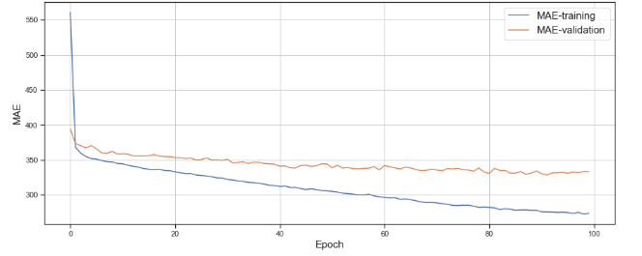

Fig. 2. Loss function vs number of epochs in training and validation set.

One of the major criticisms leveled at machine learning models concerns their noninterpretability: a feature inherently present in statistical models by nature, while machine learning methods are mostly seen as "black boxes." To overcome this drawback, SHAP provides an all-encompassing framework for model interpretation by assigning a value to each input feature's contribution to the prediction, globally and locally. SHAP has been applied in so many fields, as seen in papers like [9] and [10]. In this paper, SHAP is applied together with the XGBoost model to analyze feature importance, feature distribution, partial dependence, and the interactions between different features.
AA | A.  B.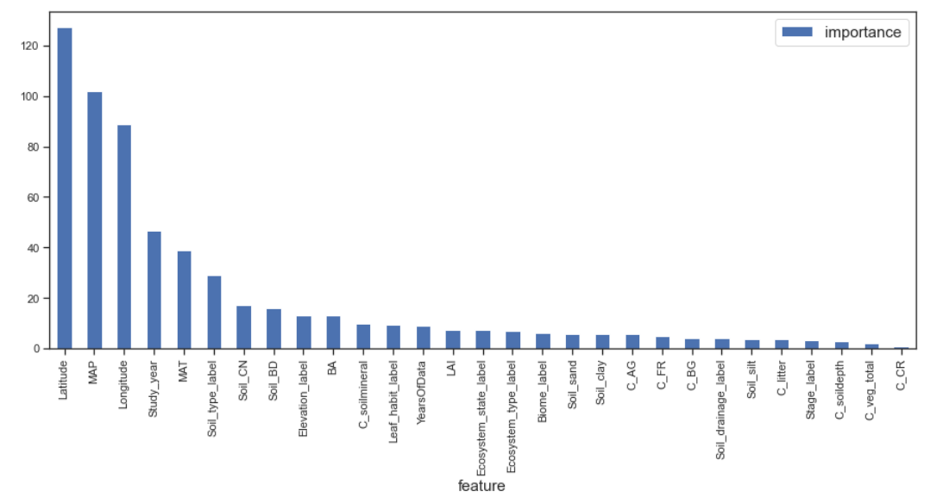
 | 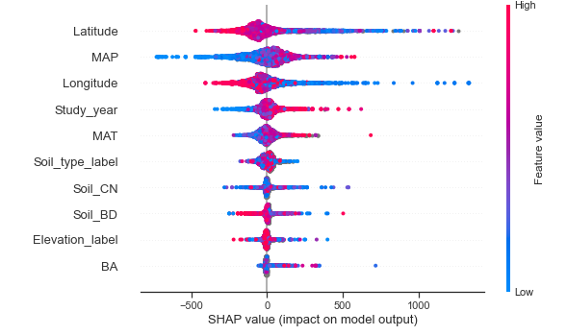
Fig. 3. A) Diagram of feature importance; and B) Feature dispersion - XGBoost Model.

The average impact of different features on model predictions is shown in Figure 3.A. Latitude emerges as the most influential feature, followed by Mean Annual Precipitation (MAP), Longitude, Study Year, and Mean Annual Temperature (MAT). Soil-related features, Elevation, and Basal Area (BA) also rank within the top 10 most influential features. These findings align with previous results reported in [8], where MAP and MAT are also identified as key factors alongside geographical features such as longitude and latitude. A notable difference, however, is the ranking of Elevation, which appears at number 9 in this study compared to the top 5 in [8]. This discrepancy may be attributed to missing values in the elevation data.

In addition to global feature importance, SHAP analysis also reveals the impact of features on individual predictions. Figure 3.B presents a distribution plot that illustrates how features contribute to the predicted value for each data point. The shade of each dot represents the feature value, and the x-axis indicates the predicted value. The plot shows that lower latitudes are associated with higher Rs values, while higher MAP and MAT values also correlate with higher Rs values.

Partial dependence plots from SHAP illustrate how the model outcome changes as a specific feature change, while other features remain unchanged. It is a robust way to examine the relationship between input features and model predictions. Partial dependence plots can also show how two features interact with each other.
A.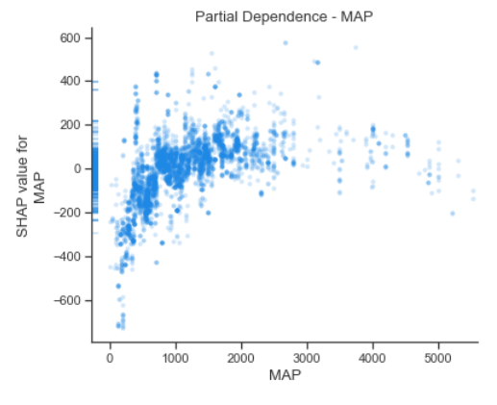
B.
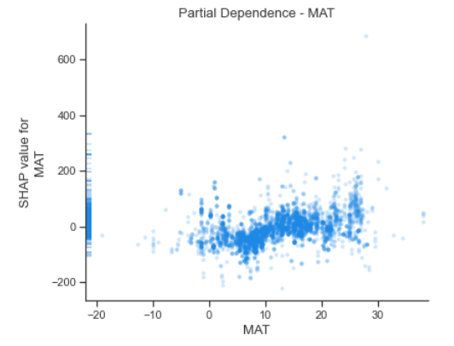
C.
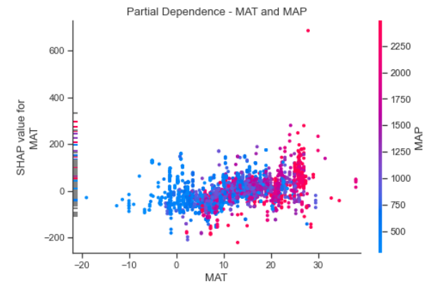
Figure 4.A shows the predicted Rs values for different MAP values across all observations in the dataset, assuming other features remain unchanged. As MAP increases up to 1000 mm, Rs increases. However, beyond 1000 mm of MAP, the predicted Rs values level off. Figure 4.B displays a slight upward trend between MAT and Rs. Figure 4.C illustrates that when both MAT and MAP are low, predicted Rs values are also low. High MAT and MAP lead to higher Rs. However, when MAT is moderate, the positive correlation between MAP and predicted Rs becomes less pronounced.
Figure 5.A shows a clear upward trend between study year and predicted Rs, indicating higher Rs in recent years. Figure 5.B illustrates the relationship between Leaf Area Index (LAI) and Rs. LAI is an index that measures leaf coverage at a site; a higher LAI value signifies a denser canopy with more leaves per unit of ground area. The figure shows that as LAI increases, Rs also increases.
A.
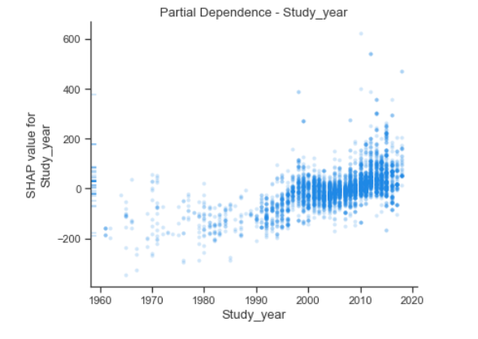
B.
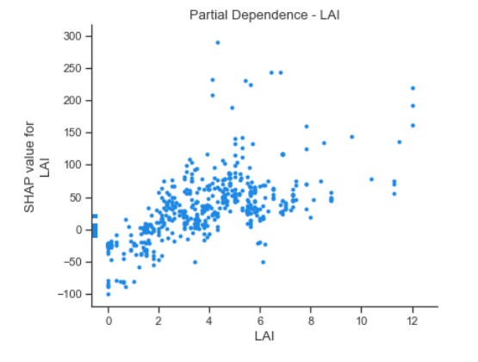
Fig. 5. A) Partial dependence with respect to study year; B) with respect to LAI.

SHAP force plot visualizes how different features influence the model prediction for a specific observation. The features driving the prediction higher are in red and the features decreasing the predicted value are in blue. Figure 6 shows the top features in driving Rs higher for this observation are Longitude, Soil_sand, Soil_silt. However, Latitude, MAP, LAI and Study Year, impact the results negatively.
Fig. 4. A) Partial dependence with respect to MAP; B) with respect to MAT; and C) interaction between MAT and MAP.

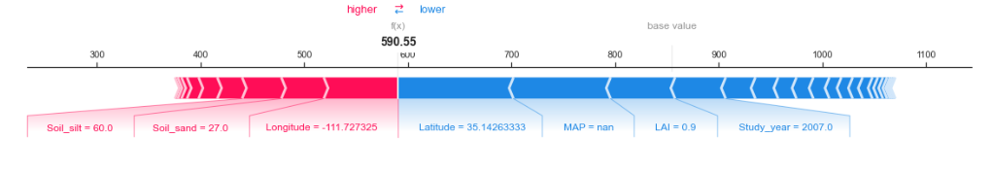
Fig. 6. Force plot of a specific prediction.
Two independent forecasting models for soil respiration prediction were developed: XGBoost and a Deep DNN. In addition, Random Forest and Gradient Boosting models were used as baseline comparisons to improve performance analysis. Among all the studied models, the XGBoost model exhibited the best performance, with the smallest Mean Absolute Error (MAE), the smallest Root Mean Squared Error (RMSE), and the largest coefficient of determination (R²). It outperformed the Random Forest model, which previous studies [7, 8] had established as the best-performing model for similar datasets. The DNN model had lower performance, mainly due to the limited amount of data available. On the other hand, one of the biggest advantages of XGBoost over the Random Forest and DNN models is its ability to handle missing values inherently without the need for imputation of the data. This feature makes XGBoost resilient when used on datasets with missing values, which is particularly useful for the present study. The dataset had a few extreme values of Rs_annual, as it contained almost 99.8% below the threshold 5000 gCm⁻², while there were just 22 values higher than this threshold. The exclusion of these outlier values increased R² by roughly 10% for both XGBoost and Random Forest models, thereby underpinning the necessity for treating outliers.
In contrast, the DNN model was quite sensitive to outliers; therefore, a normalization layer right after the input layer was needed to stabilize the model training. While both XGBoost and Random Forest proved resilient to outliers and required no such normalization, the DNN struggled to match the results even after extensive hyperparameter tuning. This may be an indication that the small dataset and missing values in some of the attributes significantly reduced the performance of the DNN model, hence showing the urge to explore more or alternative sources of data in future studies.

The present study has a few limitations. First, the sample size is relatively small; although the original dataset included 12,272 observations, only 6,379 observations remained after excluding data with quality issues and extreme outliers. Second, many attributes, particularly those related to vegetation and carbon, had missing values, which might have reduced the accuracy of the model. Thirdly, the dataset was compiled from available research publications, which resulted in inconsistent and limited representation that may not fully capture the diversity found in ecosystems worldwide. These limitations mean that future studies could benefit by expanding the dataset and filling in missing data to further enhance model performance.

Conclusion
In this work, an innovative ensemble model, XGBoost, is developed to predict annual Rs from spatial, temporal, climate, and other independent variables. In addition, a DNN model is experimented. The models are evaluated against two baseline models, Random Forest (RF) and Gradient Boosting (GB), which are established as benchmarks in previous studies [7] and [8].
The XGBoost model delivers the best performance, achieving a 4% reduction in MAE and RMSE and a 3.7% improvement in R² compared to the Random Forest model, previously identified as the top-performing approach. However, the DNN model fails to achieve reasonable results, primarily due to the limited sample size. SHAP (SHapley Additive exPlanations) is employed as a robust method for model explainability, enabling the assessment of feature impacts on predictions both globally and at the individual observation level. Results reveal that Mean Annual Temperature (MAT) and Mean Annual Precipitation (MAP) are the most influential environmental factors, alongside geographic features such as latitude and longitude, aligning with previous studies. In addition, the four features, Study Year, Soil Type, soil composition related features, Elevation, and Basal Area (BA) also demonstrate high impact on Rs estimates.
A notable challenge in this study is the significant amount of missing data for vegetation and carbon-related features. Median imputation is applied to address this issue. As a next step, further exploration of alternative data repositories, such as ERA5, is planned to improve data quality and model performance. Another challenge is the small sample size, especially after excluding records with quality issues. Identifying reliable data sources and addressing data quality issues will be critical areas of focus to improve model robustness and performance.

References
- D. M. Lawrence et al., "The Community Land Model version 5: Description of new features, benchmarking, and impact of forcing uncertainty," J. Adv. Model. Earth Syst., vol. 11, no. 12, pp. 4245–4287, 2019.
- S. Lienert and F. Joos, "A Bayesian ensemble data assimilation to constrain model parameters and land-use carbon emissions," Biogeosciences, vol. 15, no. 9, pp. 2909–2930, 2018.
- A. Ito, "Disequilibrium of terrestrial ecosystem CO₂ budget caused by disturbance-induced emissions and non-CO₂ carbon export flows: A global model assessment," Earth Syst. Dyn., vol. 10, no. 4, pp. 685–709, 2019.
- M. Adachi et al., "Estimation of global soil respiration by accounting for land-use changes derived from remote sensing data," J. Environ. Manag., vol. 200, pp. 97–104, 2017.
- M. Bahn et al., "Soil respiration at mean annual temperature predicts annual total across vegetation types and biomes," Biogeosciences, vol. 7, no. 7, pp. 2147–2157, Jul. 2010. doi: 10.5194/bg-7-2147-2010.
- J. Jian et al., "Prediction of annual soil respiration from its flux at mean annual temperature," Agric. For. Meteorol., vol. 287, 107961, 2020.
- J. Liu, J. Hu, H. Liu, et al., "Global soil respiration estimation based on ecological big data and machine learning model," Sci. Rep., vol. 14, 13231, 2024. doi: 10.1038/s41598-024-64235-w.
- H. Lu, S. Li, M. Ma, et al., "Comparing machine learning-derived global estimates of soil respiration and its components with those from terrestrial ecosystem models," Environ. Res. Lett., vol. 16, no. 5, Art. 054048, 2021. doi: 10.1088/1748-9326/abf526.
- E. Strumbelj and I. Kononenko, "An efficient explanation of individual classifications using game theory," J. Machine Learning Res., vol. 11, pp. 1–18, 2010.
- H. Luo, C. Xiang, L. Zeng, et al., "SHAP-based predictive modeling for 1-year all-cause readmission risk in elderly heart failure patients: Feature selection and model interpretation," Sci. Rep., vol. 14, 17728, 2024. doi: 10.1038/s41598-024-67844-7.

