Profile
Former Graphic Designer, And Visualiser.. Working as a Professional Photographer since 2008, specializing in fields such as Photojournalism , People, & Advertising.

Experience

Stock Photographer, National Geographic Stock Photo - August 2010.
Contributor.

Freelance Photographer, Marie claire magazine - december 2009-Present.
Contributor for Opening Feature Story ‘’ Weave to a Wedding’’ - A feature on the weaving of Dimasa tribes of North East India, This story has been done for the first time in India.

Freelance Photographer, jET aIRWAYS IN fLIGHT magazine - MAY 2010
Contributor for Article ‘’ Fabrics of Legends’’

Freelance Photographer, Ele/tz - december 2009-Present
Stlye and Feel for upcoming Products.

Freelance Photographer, TATA titan - February 2010
Xylus Watches Launch

Freelance Photographer, Tata Tanishq - august 2009 - February 2010
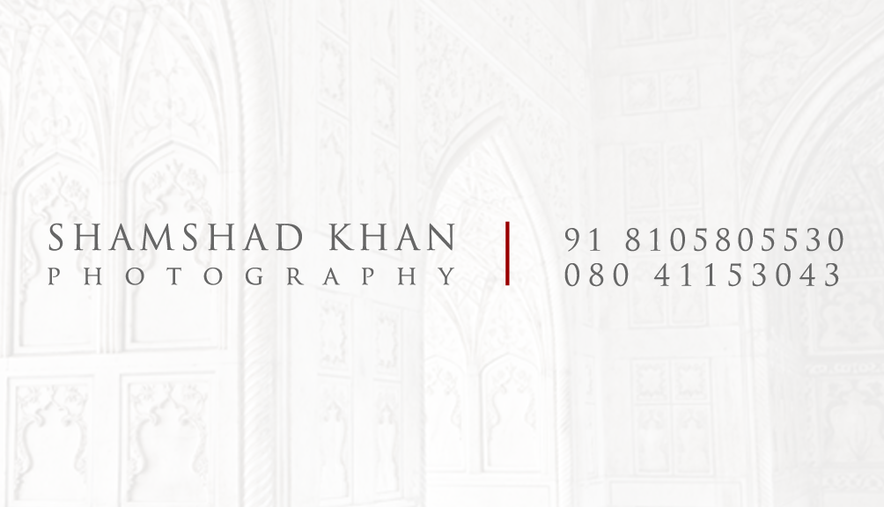
Zoya Collection, Aliyah Collection, Wedding Collection, E- Commerce etc.

Freelance Photographer, C.krishniah chetty&sons - august 2009 - February 2010
Advertisements, Wedding Collections, Heritage Collection etc.

Education

POST -GRADUATION:
LIGHT&LIFE ACADEMY 2005- 2007 Post Graduation in Professional Photography. Ootacamund, Tamilnadu, India.

HIGHER NATIONAL DIPLOMA
Wigan&Leigh College 2002- 2004 Higher National Diploma in Advertising&Graphic Designing. Bangalore, Karnataka, India.

PRE UNIVERSITY EDUCATION-ARTS 1998-2001
Baldwins Women Methodist College
Subjects: HISTORY/ SOCIOLOGY/ ECONOMICS/ LANGUAGE/ HOME SCIENCE
Skills : Adobe, Macintosh Platform, Capture One Pro, Light room, Indesign, Illustrator.

