Exponential CLT & ToothGrowth Data Analysis - Simulation and Basic Inference
Riccardo Del Signore
2025-08-27 21:55:54
Table of Contents
Overview 1
Part 1: Exponential CLT 1

Overview
In this report, we answer the following questions: 1. How does the Central Limit Theorem (CLT) apply to the Exponential distribution? 2. Inference on the ToothGrowth dataset.

Part 1: Exponential CLT
Exp(lamda) = 1/lamda Var(X) = 1/lamda^2
We are going to set lamda as 0.2 and n as 40 Repeating the experiment 1000 times we are going to explore the effect of the CLT on the Exponential distribution, and how it tends to a Normal distribution.

Parameters and design simulation
set.seed(123) #for reproducibility
#TODO set simulation pareters
lambda <- 0.2 #rate
n <- 40 #sample size
nsim <- 1000 #number of simulations
#theoretical mean and variance
theor_mean <- 1/lambda
theor_var <- (1/lambda)^2 / n
theor_sd <- sqrt(theor_var)
theor_mean; theor_var; theor_sd
## [1] 5
## [1] 0.625
## [1] 0.7905694

Simulation
Build vector of means using replicate function. This function will repeat the expression mean(rexp(n, rate = lambda)) nsim times and store the results in a vector.
#TODO Build vector means with lennght nsim
means <- replicate(nsim, mean(rexp(n, rate = lambda)))
head(means)
## [1] 4.811212 5.360077 4.592871 4.900051 5.516619 5.612835

Theoretical vs empirical mean and variance
#TODO empirical mean and variance and sd
sample_mean <- mean(means)
sample_var <- var(means)
sample_sd <- sd(means)
df_confronto <- data.frame(theoretical = c(theor_mean, theor_var, theor_sd),
empirical = c(sample_mean, sample_var, sample_sd),
row.names = c("mean", "variance", "sd"))
knitr::kable(df_confronto, digits = 3, caption = "Theoretical vs Sample")
Theoretical vs Sample
 | theoretical | empirical
mean | 5.000 | 5.012
variance | 0.625 | 0.600
sd | 0.791 | 0.775

Histogram of the means
#histogram of the means prob = TRUE
hist(means, prob = TRUE, main = "Sample mean vs Theoretical Mean", xlab = "Means")
lines(density(means), col = "blue", lwd = 2)
curve(dnorm(x, mean = theor_mean, sd = theor_sd), col = "red", lwd = 2, add = TRUE)
#adding vertical line for the 2 means
abline(v = theor_mean, col = "red", lwd = 1)
abline(v = sample_mean, col = "blue", lwd = 1)
#report nnumbers on the plot
text(x = theor_mean + 0.35, y = 0.15, labels = paste(round(theor_mean, 2)), col = "red")
text(x = sample_mean - 0.30, y = 0.15, labels = paste(round(sample_mean, 2)), col = "blue")
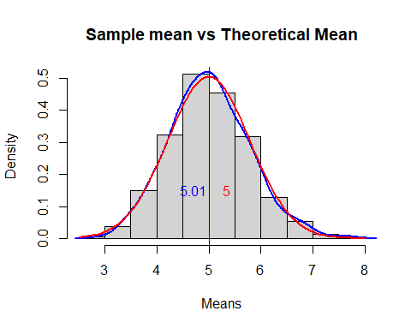
#QQ-plot
qqnorm(means, main = "QQ-plot of the sample means")
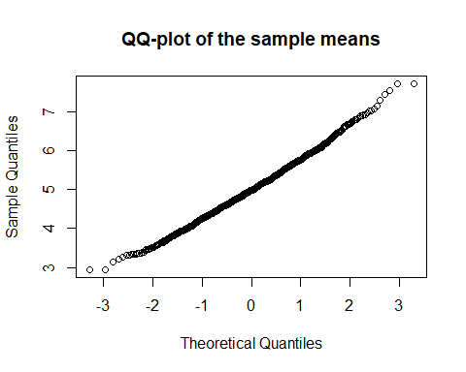
plot(density(means), main = "Sample Variance vs Theoretical Variance", xlab = "Means")
curve(dnorm(x, mean = theor_mean, sd = theor_sd), col = "red", lwd = 2, add = TRUE)
curve(dnorm(x, mean = sample_mean, sd = sqrt(sample_var)), col = "blue", lwd = 2, add = TRUE)
