COA PROJECT REPORT
This report is based on the design and simulation of a running lights system using a PIC16F627A microcontroller, programmed in Assembly language and tested in the PROTEUS 7 environment. The objective of this project is to demonstrate how a microcontroller can be used to control multiple LEDs in response to digital inputs (push buttons). The system is designed to respond to four different button inputs by activating specific patterns of six LEDs, simulating basic decision-making logic and hardware control.

The aim of this project is to design, program, and simulate a digital running lights control system using a PIC16F627A microcontroller. The system allows users to control six LEDs through four push buttons using Assembly language and simulate the result in PROTEUS 7.

Requirements:
- Microcontroller: PIC16F627A
- Software Tools: MPLAB IDE (for Assembly coding), PROTEUS 7 (for circuit simulation)
- Hardware Components (in simulation):
  - 4 Push Buttons connected to RA0–RA3 with 10k Ohms pull-down resistors
  - 6 LEDs connected to RB0–RB5 through 100 Ohms series resistors
- Functionality:
  - On start: All LEDs off
  - Btn1 (RA0) pressed → All LEDs OFF
  - Btn2 (RA1) pressed → LED1, LED3, LED5 ON
  - Btn3 (RA2) pressed → LED2, LED4, LED6 ON
  - Btn4 (RA3) pressed → All LEDs ON

Procedure
- Writing the Assembly code in MPLAB:
- Configured PORTA as input for buttons.
- Configured PORTB as output for LEDs.
- Wrote logic to detect button presses and control corresponding LEDs.
- Designing the Circuit in PROTEUS:
- Added the PIC16F627A microcontroller.
- Connected 4 push buttons to RA0–RA3 with pull-down resistors.
- Connected 6 LEDs to Btn1 to Btn5 with 100 Ohms resistors.
- Added two grounds and a power within the circuit.
- Compiling and Generating HEX File:
- Used MPLAB to assemble the code and generate a .hex file.
- Loading Code into PROTEUS:
- Loaded the .hex file into the PIC16F627A microcontroller.
- Simulated the circuit to observe behaviour of all the components to check they operate as expected.

Experimentation and Discussion
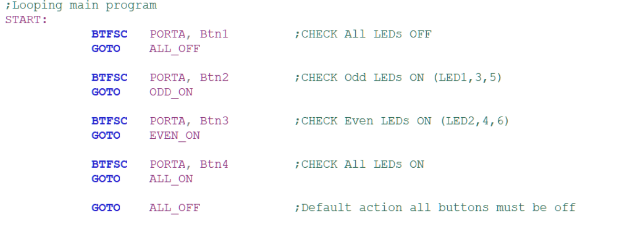

This section discusses the implementation logic and how the behaviour of the system was achieved through the assembly code in MPLAB.

Explanation:
- Button 1 (Btn1): If pressed, the system jumps to the ALL_OFF label, clearing PORTB to turn off all LEDs.
- Button 2 (Btn2): If pressed, the system jumps to ODD_ON, where LEDs 1, 3, and 5 (RB0, RB2, RB4) are turned ON using the binary pattern 00010101 (0x15).
- Button 3 (Btn3): If pressed, the program jumps to EVEN_ON, turning ON LEDs 2, 4, and 6 (RB1, RB3, RB5) with the pattern 00101010 (0x2A).
- Button 4 (Btn4): If pressed, all six LEDs are turned ON using the pattern 00111111 (0x3F).
- Default Condition: If no button is pressed, the program ensures all LEDs remain OFF as a safety/default state.

This logic ensures that only one pattern is active at any given time, and the system responds instantly to any button press. The BTFSC instruction (Bit Test File Skip if Clear) is used effectively to detect button presses and conditionally jump to the appropriate LED control logic. Each of the LED patterns is controlled using the MOVLW and MOVWF instructions under corresponding labels (ALL_OFF, ODD_ON, EVEN_ON, and ALL_ON), ensuring modular and readable code. This experimental design was tested in the PROTEUS 7 simulator. The circuit and code worked as expected, and pressing each button triggered the correct LED pattern while no interference occurred between the buttons.

The project successfully demonstrates how to control multiple outputs (LEDs) using button inputs with a PIC16F627A microcontroller programmed in Assembly and the Simulation in PROTEUS verified all required behaviours. Although the project was successful, we faced a lot of challenges when coming about write the code and building the circuit. One big issue was with setting up the input and output pins correctly was tricky. If the program doesn’t switch to the right bank of memory, the pins might not work as expected. Another problem was because there are no delays in the program, the LEDs change very fast and it’s hard to see what’s happening. Lastly since the circuit has 6 LEDs and 4 buttons it was tricky to make sure that each LED and button work as expected.

