Boy Scout Popcorn sales

Using MS Access and coding in SQL Server 2014 Management Studio

By

Debra Kernstock

IST 659

During the months of August, September, and October my son sells boy scouts popcorn. The sales are a way the scouts fundraise to earn their own way in Scouting. It provides him the opportunity to fund his entire year in Scouting. It provides Units the funding needed to execute a successful program year.

Business Rules:

* Each sale must have at least one customer
* Each customer must purchase at least one or more product
* Donations are always accepted
* Each sale must be purchased with cash or a credit card/debit card
* At the beginning and end of each sales day, an inventory of product will be conducted
* At the end of each sales day, all cash, PayPal sales, and donations will be accounted for

Conceptual ERD from Project 1 Below:

A screenshot of a social media post

Description generated with very high confidence

Normalized Logical Model:

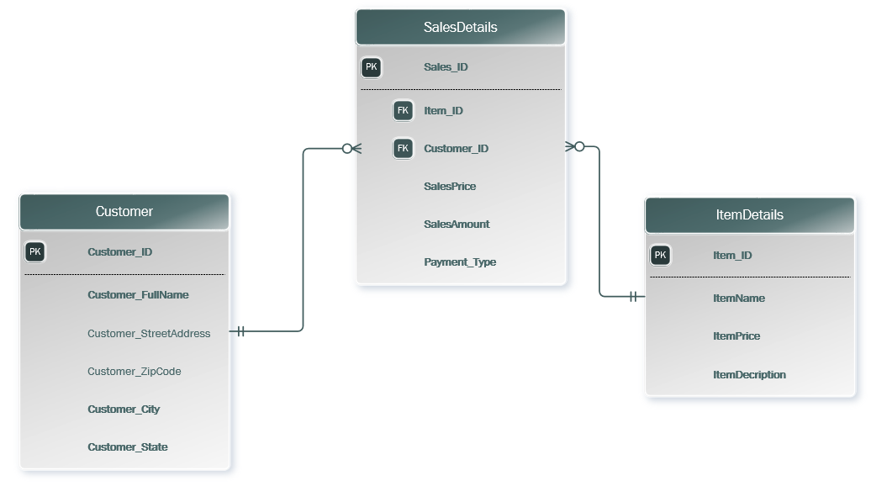  
SQL Code

-- Creating the Customer table

Create Table Customer (

-- Columns for the User Table

Customer_ID int identity,

Customer_FullName varchar(50) not null,

Customer_StreetAddress varchar(50),

Customer_ZipCode varchar(5),

Customer_State varchar(50),

Customer_City varchar(50),

-- Constraits on the User Table

Constraint Customer Primary Key (Customer_ID)

)

-- Creating the ItemDetails table

Create Table ItemDetails (

-- Columns for the User Table

Item_ID int identity,

ItemName varchar(50) not null,

ItemPrice varchar(50) not null,

ItemDescription varchar(max) not null,

-- Constraits on the User Table

Constraint ItemDetails Primary Key (Item_ID)

)

-- Creating the SalesDetails table

Create Table SalesDetails (

-- Columns for the User Table

Sales_ID int identity,

Item_ID varchar(50) not null,

Customer_ID varchar(50) not null,

SalesPrice varchar(5) not null,

SalesDate datetime not null,

SalesAmount varchar(50) not null,

Payment_Type varchar(10) not null,

-- Constraits on the User Table

Constraint SalesDetails Primary Key (Sales_ID),

Constraint FK1_SalesDetails Foreign Key (Item_ID) References ItemDetails(Item_ID),

Constraint FK2_SalesDetails Foreign Key (Customer_ID) References Customer(Customer_ID),

)

-- Creating the Inventory table

Create Table Inventory (

-- Columns for the User Table

Inventory_ID int identity,

Item_ID int not null,

Item_Amount int not null,

UOM varchar(10),

-- Constraits on the User Table

Constraint Inventory Primary Key (Inventory_ID),

Constraint FK1_SalesDetails Foreign Key (Item_ID) References ItemDetails(Item_ID),

)

-- Adding Data to the Customer Table

Insert into Customer(Customer_FullName, Customer_State, Customer_City)

Values

('Jan Reitz', 'VA', 'Chesapeake'),

('CHRISTOPHER M BILELLO', 'VAz', 'Chesapeake'),

('MORGAN J CORYELL', 'VA', 'Chesapeake'),

('DONALD JENKINS', 'VA', 'Chesapeake'),

('RACHEL LEIGH ELLIOTT', 'VA', 'Chesapeake')

-- Adding Data to the ItemDetails Table

Insert into ItemDetails(ItemName, ItemPrice, ItemDescription)

Values

('Classic Trio', '30', 'Everyone’s favorite blend of sweet & savory,

a snack you won’t be able to put down. Mix them together for a Chicago

style treat, or enjoy them individually. '),

('Caramel Sea Salt', '20', 'Caramel corn made with real butter, brown

sugar & the perfect amount of sea salt. The crunchy, sweet & salty

combination will leave you wanting more.'),

('Micro - Butter','20', 'Take advantage of this convenient way to

enjoy freshly popped taste with a rich butter f lavor. 0 grams of

trans fats'),

('Micro - Kettle', '20', 'Experience the combination of the sweet,

yet salty f lavor of Kettle Corn anytime. 0 grams of trans fats.'),

('Yellow Popping Corn', '15','America’s healthiest snack food in a

re-sealable Popcorn Stars & Stripes tub! Pops up tender for that

fresh popcorn taste you’re craving.')

-- Adding Data to the SalesDetails Table

Insert into SalesDetails(Item_ID,Customer_ID, SalesPrice, SalesDate, SalesAmount, Payment_Type)

Values

('Classic Caramel','CHARLOTTE RUSH', '10.27', '8/18/2018', '9.99', 'PayPal'),

('Classic Caramel','ROBERT BECK', '10.27', '8/19/2018', '9.99', 'PayPal'),

('Caramel Sea Salt','STEPHEN ENGLISH', '20.54', '8/19/2018', '19.99', 'PayPal'),

('Classic Caramel','SKYE K STEWART', '10.27', '8/18/2018', '9.99', 'PayPal'),

('Micro - Butterr','THOA VU', '20.54', '8/19/2018', '19.99', 'PayPal')

Insert into Inventory(Item_ID, Item_Amount, UOM)

Values

('Classic Trio', '5', 'Package'),

('Caramel Sea Salt', '10', 'Package'),

('Micro - Butter', '20', 'Package'),

('Micro - Kettle', '20', 'Package'),

('Classic Caramel', '20', 'Package')

-- Correcting a Customer's Item Purchase

Update SalesDetails Set Item_ID = 'Micro - Butterr' where Item_ID = 'Micro - Butter'

***Reflection***

1. What assumptions did you have at the start of your project that changed by the end? Think in terms of both your own problem domain as well as your knowledge of the process.

My first assumption was that this was easy. Towards the end of the project, I learned that I need to focus more on the smaller errors I made and to be more vigilant of my ERD. It did change and I expected it change.

1. The next time you do this, what will be different?

The next time I do this, I would want to build a model. I made some changes that I had to go back and fix.

1. Regardless of whether you go through these steps again, how do you think it will inform your approach to data as an information professional?

This was a learning experience and I learned that I need to take my time. In my job, I will be working with the database and I will definitely be deliberate with my actions.