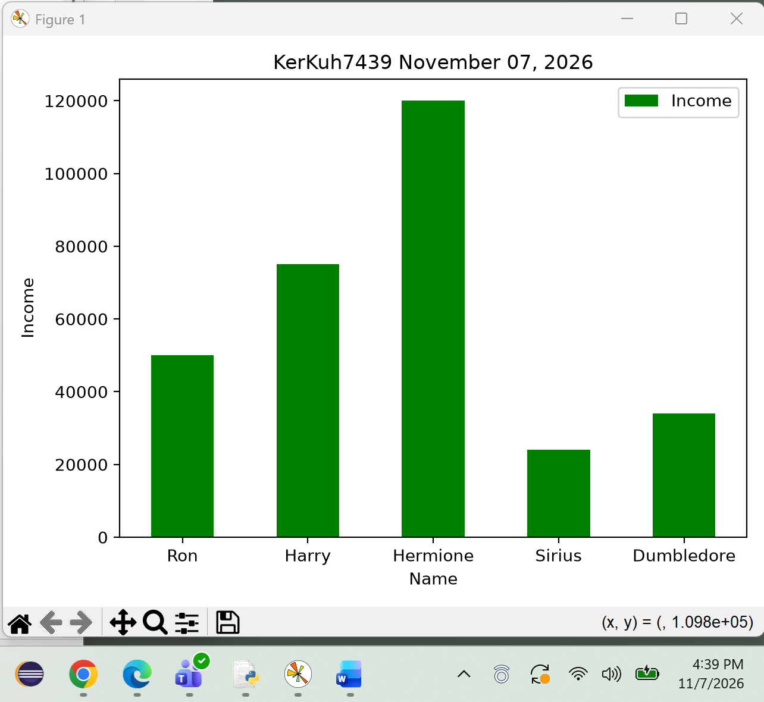
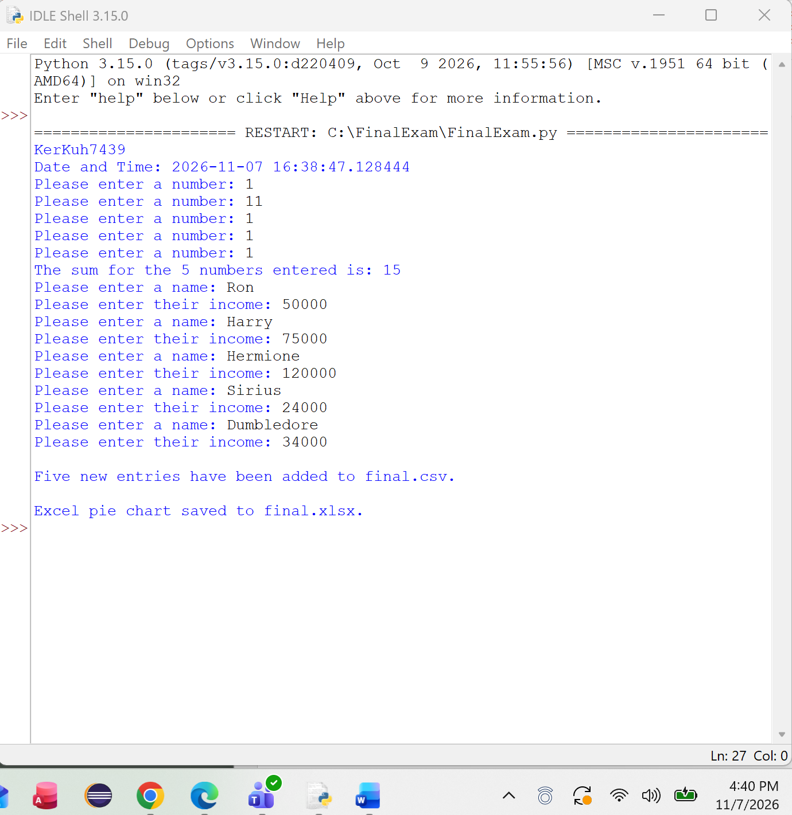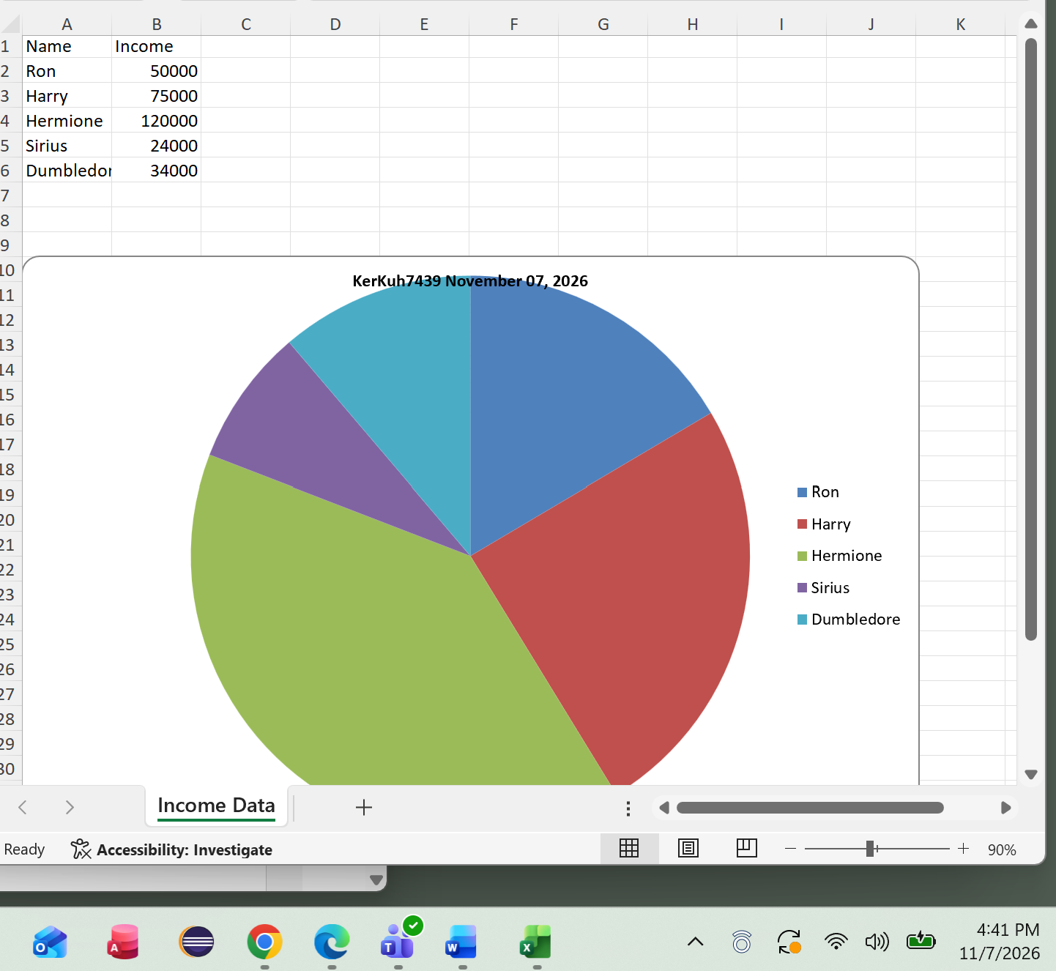

Questions:
1. Implicitly typed means that Python automatically determines the data type of a variable based on the value assigned to it. Programmers do not need to declare whether a variable is an integer, string, or another data type before using it. Python determines the type when the program runs.
2. Code reuse means using existing code multiple times instead of writing the same instructions repeatedly. Functions make code reuse possible by allowing programmers to create a block of code that performs a specific task. The function can then be called whenever that task needs to be completed. This saves time, reduces errors, and makes programs easier to maintain.
3. We specify permissions, or file modes, to tell Python what operations we want to perform on a file. For example, read mode (r) allows us to read data, write mode (w) allows us to write data, and append mode (a) allows us to add information without deleting existing content. Choosing the correct mode helps prevent accidental changes or loss of data.
4. A list stores multiple values in an ordered collection, and each value can be accessed using its index position. A dictionary stores information using key-value pairs, where each key is associated with a specific value. Lists are useful for storing sequences of data, while dictionaries are useful for organizing and accessing data using descriptive keys.
5. Python uses zero-based indexing, meaning the first element in an indexed sequence, such as a list or tuple, begins at index 0. The second element is at index 1, and the third is at index 2. This allows programmers to access individual elements based on their positions.
6. Three common graph types used in data analytics are bar graphs, line graphs, and pie charts. Bar graphs compare values across different categories, line graphs show changes or trends over time, and pie charts display how individual categories contribute to a whole. These graphs help present data in a way that is easier to understand and analyze.
7. The two commonly used parameters are the file path and the file mode. The file path identifies the location and name of the file, while the mode specifies whether the file should be opened for reading, writing, or appending. For example, open("final.csv", "a") opens the file in append mode so new information can be added without removing existing data. The mode is optional in Python because it defaults to reading.
8. When data is read from a text or CSV file, numerical values are often stored as strings. Strings cannot be used directly for arithmetic calculations in the same way as numbers. Converting the values into integers using int() allows Python to perform mathematical operations such as addition, subtraction, and multiplication correctly.
9. A CSV file stores data as plain text, with values typically separated by commas. It is commonly used to transfer data between programs and does not support features such as charts, formulas, or formatting. An XLSX file is a Microsoft Excel workbook that can contain multiple worksheets, formulas, charts, and formatted cells. CSV files are simpler, while XLSX files offer more advanced spreadsheet features.
10. An absolute path specifies the complete location of a file, including the drive and folders where it is stored. This allows Python to locate the file regardless of the program's current working directory. A relative path depends on the current working directory, which can cause file-not-found errors if the directory changes. Absolute paths are helpful when working with files stored in specific locations.

