Github URL: https://github.com/KerrKuh7439/Week3_PA1.git
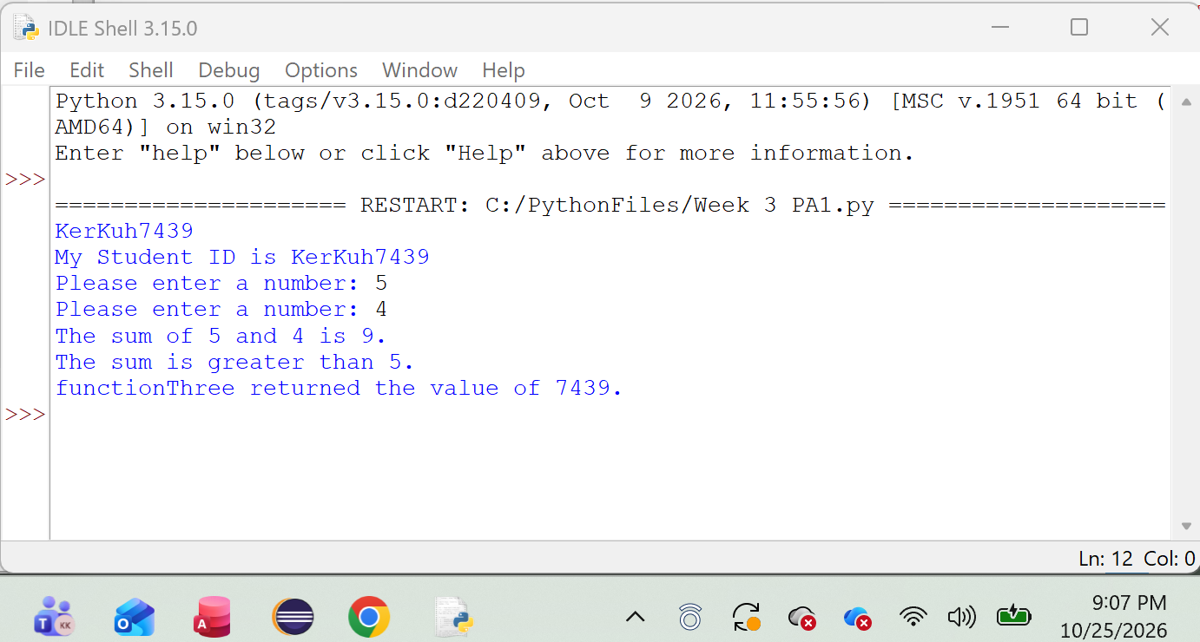
Questions:
- What is the purpose of a function?
A function groups code together to perform a specific task. It helps make a program easier to organize and allows code to be reused.
- Why might you pass more than one parameter to a function?
You pass more than one parameter when the function needs multiple pieces of information to complete its task.
- If a function returns a value, what do you do with that value in the calling function?
You can store the returned value in a variable so it can be used later in the program.
- Explain this line of code:
print(f’I am sending output to the console showing the value {num1}.’)
This is an f-string that prints a message to the console. The {num1} part is replaced with the current value stored in the num1 variable.
- After myFunction() executes, what is the next step in the program flow?
The program returns to main() and continues with the next line of code after the call to myFunction().

