Econ Glider Factory
A hands-on activity for diminishing returns and cost curves
ECON 2103 · Unit 2, Lecture 2 (Costs) · Teacher Guide & Answer Key

What it teaches
Each group is a small paper-airplane factory. Add one worker at a time to the same fixed setup (one workbench, one marker, one test lane), and the extra planes each new worker adds first grows, then shrinks — diminishing marginal returns. Attach prices to the inputs and the group’s own numbers become a cost table showing AVC, ATC, MC, and the efficient scale (the output where cost per plane is lowest, where MC meets ATC).

Set it up so no one performs at the front
Run it as parallel factories at tables — every group works at once, so the room is busy and collective and nobody is folding alone on stage. Groups of about five. Each round, one more person from the group joins as a worker; the rest time, count, and predict.

Materials (per group / factory)
– One “workbench” — a manila folder or a single sheet taped to the desk. Planes may be folded ONLY on the workbench. This is the fixed capital / plant; it never changes.
– One marker — every finished plane must have “Econ Glider” written on a wing, and only the marker-holder can sign. Shared → a real bottleneck.
– One test lane — a strip of masking tape ~2 m from the group; a plane must fly PAST the line to count, and only one plane is tested at a time.
– A big stack of scrap paper (raw material, unlimited) and a timer at the front.
Why these three matter: one workbench + one marker + one test lane are the scarce fixed inputs. As you add workers they start bumping elbows, waiting for the marker, and queuing at the test line — that congestion is what makes returns diminish. Keep them scarce and the lesson works. Time: about 18 minutes.

How to run it
1. Set up (3 min). Cluster groups of ~5. Tell them: “This folder and this marker are your entire factory — fixed capital, and they never change. Paper is unlimited raw material. We’ll add one worker at a time.”
2. Rules. (a) Planes are folded ONLY on the workbench, using the folding card. (b) Each plane must be signed “Econ Glider” with the one marker. (c) It must fly PAST the test line to count — crashes and short flights don’t. (d) 2 minutes per round; count good planes = output.
Practice first (1 min). Show the Dart folding sheet and give groups one minute to practice and teach each other — this doesn’t count, it just gets everyone able to fold before the clock matters.
3. Round 1 = 1 worker. One person folds, signs, and test-flies for 2 minutes. Count good planes; record.
4. Add a worker each round. Before each round, have the group predict the new total (this is what makes it lively). Same workbench, same marker, same lane. Go 1 → 2 → 3 → 4 → 5 workers.
5. Price it. Factory rent = $50 per round (fixed cost); each worker’s wage = $20 per round (variable). Groups fill the cost table from their own plane counts.
Scorekeeper. Within each group of five, one person is the scorekeeper: after each round they count the planes that flew past the line and fill in the recording sheet. They fold only in the final round — so Round 5 = 4 folders + scorekeeper = 5 workers.

Answer key (example — real numbers will differ)
Illustrative output showing the hump. Fixed cost $50; wage $20/worker. MC = change in TC ÷ change in planes.
Workers | Planes (Q) | Marg. product | Total cost | ATC | MC (new planes)
1 | 6 | 6 | $70 | $11.67 | $3.33
2 | 14 | 8 | $90 | $6.43 | $2.50
3 | 20 | 6 | $110 | $5.50 | $3.33
4 | 24 | 4 | $130 | $5.42 ◄ lowest | $5.00
5 | 26 | 2 | $150 | $5.77 | $10.00
The point: marginal product rises (2–3 hands help) then falls (they queue for the marker, the workbench, the test lane). Cost per plane bottoms out at 4 workers — that’s the efficient scale — and MC ≈ ATC right there. The 5th worker adds only 2 planes, so those last planes cost $10 each.

Debrief (whole class, ~3 min)
1. Why did each new worker add fewer planes? Which fixed inputs were people waiting for? (One marker, one workbench, one lane → diminishing returns.)
2. At how many workers was cost per plane (ATC) lowest? What is MC doing there? (Efficient scale; MC = ATC.)
3. If each plane sold for $6, how many workers would you hire? (Compare each worker’s MC to $6 — stop when MC > price.)

Facilitation tips
– Keep the three fixed inputs scarce — one workbench, one marker, one test lane per group. That congestion is the whole point; loosen it and returns won’t diminish.
– Use the simple dart on the folding card so time goes to the bottleneck, not to figuring out the fold. Everyone in a group folds the same design.
– Keep the 2 minutes strict; count only planes that are signed AND fly past the line.
– Diminishing returns here is physical (waiting, bumping elbows), not about money — the same point the published versions make.

Make it a competition (optional)
– The prize goes to the lowest average cost — each group’s lowest cost per plane (best ATC), not the most planes. That reversal is the lesson: efficient scale, not maximum output, wins. Reward: candy, a bonus point, or bragging rights.
– Richer version: set a selling price (e.g., $6 per plane) and reward the highest single-round profit — groups discover that piling on workers past efficient scale loses money.
Source: adapted from the Airplane Production experiment (SERC/Carleton) and its costs extension “Costs in the Short Flight”; same family as the tennis-ball (Economics Network) and math-problems (Vazquez-Cognet, IREE) production experiments.

Econ Glider Factory — Recording Sheet
Group name: ______________________ Section: ____________

The rules
– Your factory = one workbench + one marker + one test lane. They never change.
– Fold only on the workbench, using the folding card. Sign each plane “Econ Glider” with the one marker.
– A plane counts only if it flies PAST the test line. 2 minutes per round.
– Each round you get one more worker. Same factory.
– One of you is the scorekeeper — after each round, count the planes that flew past the line and fill in the table below. You fold too in the last round.

1) Fill in your factory’s costs
Each round, write the planes your scorekeeper counted in the Planes column, then fill in the rest. Factory rent = $50 each round (fixed). Each worker = $20 (variable).
Workers | Planes (Q) | TFC | TVC = $20×workers | TC = TFC+TVC | ATC = TC÷Q | MC = ΔTC÷ΔQ
1 |  | $50
2 |  | $50
3 |  | $50
4 |  | $50
5 |  | $50
Want to split ATC apart? AFC = TFC ÷ Q and AVC = TVC ÷ Q (so ATC = AFC + AVC).
★ Circle your lowest ATC. That single round is your best (most efficient) scale — and the lowest ATC in the class wins the prize.

2) Think about it
1. As you added workers, why did the extra planes per new worker eventually shrink? What were people waiting for?
2. At how many workers was your cost per plane (ATC) lowest? That output is your factory’s efficient scale. What is MC doing there?
3. If each plane sold for $6, how many workers would you actually hire? Why?

Folding Card — The Econ Glider
One card per group. Everyone folds this same design so planes are comparable.
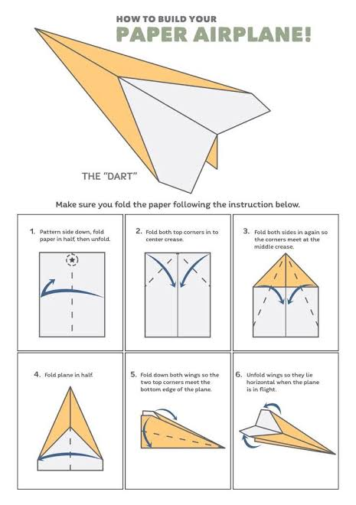
A plane counts only if it is signed “Econ Glider” and flies past the test line. Everyone in the group folds this same Dart.

