ECON 2103 · MARKET FAILURE: PUBLIC GOODS AND THE FREE-RIDER PROBLEM
The Contribution Game
Instructor Run Sheet · groups of 4 · about 40 minutes · in-class experiment
OBJECTIVE  Let students create, then try to fix, the under-provision of a public good, and feel why individually rational choices produce a collectively bad outcome (market failure). | YOU NEED  Player Cards (1 per student), one opaque cup per group, identical tokens or slips, a projector or whiteboard for the class trend, and a small prize or bonus point.

The rule that drives everything
Each round every player gets tokens and privately splits them between a Group Fund and their own pocket. The Group Fund is doubled (times 2) and then split equally among all 4 players, no matter who paid in.
- A contributed token returns only 0.5 to you (2 divided by 4) but 1 if you keep it, so keeping everything is each player's dominant strategy.
- Yet if everyone contributes, the group is far better off. That gap, private incentive versus social optimum, is the free-rider problem.
- Score each round: your earnings = tokens you kept + (total Group Fund times 2 divided by 4).
- Fast share: because the fund doubles the cup and then splits it four ways, each player's share is simply half the cup total. A cup of 20 gives everyone 10. Use this to score in seconds.
Setup (5 min)
- Form groups of 4. In each group assign roles to build in asymmetry (like real industries):
- 2 Big Firms get 25 tokens per round; 2 Startups get 15 tokens per round. The 0.5 return on contributing is the same for everyone.
- Give each student a Player Card and give each group one opaque cup. Contributions go into the cup, so no one sees who put in how much. Only the group total is ever counted.
Run the rounds (about 22 min)
Round | Rule in play | What you say / do | ~min
1 | Play it in secret | Contributions go in the cup, fully anonymous. Just play and score. Expect the group total to fall. | 3
2 | Same rules | Play a second anonymous round exactly like round 1. Watch whether cooperation slips further. | 3
3 | Talk it out first | Give groups 30 sec to talk and make promises, then contribute into the cup. Promises are not binding. | 3
4 | Out in the open | Each player names their contribution aloud before it goes in. Anyone may give up 1 of their own tokens (set aside, not into the cup) to cut a named member's score by 3. It costs the punisher 1 to cost the target 3. | 4
5 | Still in the open | Play another open round with the same reveal and penalty option. Does the pressure hold cooperation up? | 3
6 | Contribution is required | Each player must contribute at least 60% of their tokens (Big Firm at least 15, Startup at least 9). This is government provision. | 3
7 | Rules off (optional) | Remove every rule, back to the anonymous cup, and play once more. Does cooperation collapse again? | 3
Tip: keep individual scores private the whole game. In the anonymous rounds a player's score reveals what they contributed, so let each student track only their own card. Announce only the shared amount and the class trend.
Fast scoring (do not count every group yourself)
Counting each cup and working out each person's share is what eats the clock. Push both jobs to the groups and you just keep the pace:
- Name a Banker in each group (rotate the role so it is not always the same person). After the cup is filled, the Banker counts only the total, so no one's individual amount is seen.
- The Banker halves that total and calls it out: share each = cup total divided by 2. Every player writes that number on their own card and adds their kept tokens. You never do the arithmetic.
- Keep endowments and the tax minimum even (25, 15, 15, 9) so the halves stay whole numbers.
- You circulate, confirm each Banker's halving at a glance, collect the group total for the class trend, and move to the next round. For zero counting at all, run it digitally on classEx or Veconlab (below).
Debrief (about 12 min)
Ask, in order:
- Did contributions rise or fall over the anonymous rounds, and why? (Trust unravels; each person's best move is to ride free.)
- What is each player's dominant strategy? Why can't the group reach the outcome that is best for everyone?
- Which intervention worked best in your group, and which real policy does it mirror?
Land the point: a public good is non-excludable and non-rival, so people free-ride and the market under-provides it, a market failure. Fixes: reputation and social norms, government provision and taxes, or making it excludable.
Real cases to name: open-source software (everyone uses Linux, few contribute), Wikipedia's donation banner, Netflix ending password sharing (making it excludable), vaccination and herd immunity, industry R&D consortia, and global climate agreements.
Run it on paper, or online
The Player Cards and the cup run the whole game on paper. To skip the arithmetic and project a live contribution graph instead, use a free classroom-experiment platform, handy for a 30-plus student section:
- classEx at classex.de. Students join any phone by a game number or QR code and a participant password, no account or install. You control the rounds and choose when results appear. Its public-goods game is the one CORE's Experiencing Economics course uses. This also gives you true anonymity for free.
- Veconlab (Univ. of Virginia, Charles Holt), the Voluntary Contributions experiment at veconlab.econ.virginia.edu/pg/pg.php. You set group size and payoff; students join by a session code; it scores every round and graphs the group averages for you.
Going digital? The standard research settings are groups of 4, 20 tokens each, a 0.4 return per token contributed (fund times 1.6, split 4 ways), about 10 rounds, and 5 rounds without then 5 with punishment (Fehr and Gachter, 2000). Our paper version keeps the same logic with a simpler times 2 rule plus asymmetric firms.
What to expect
A typical class shows this shape: contributions fall while anonymous, revive under reputation and penalties, run near-full when required, and slip again once the rules come off. Watch for it, and pause to point out the trend as it happens.
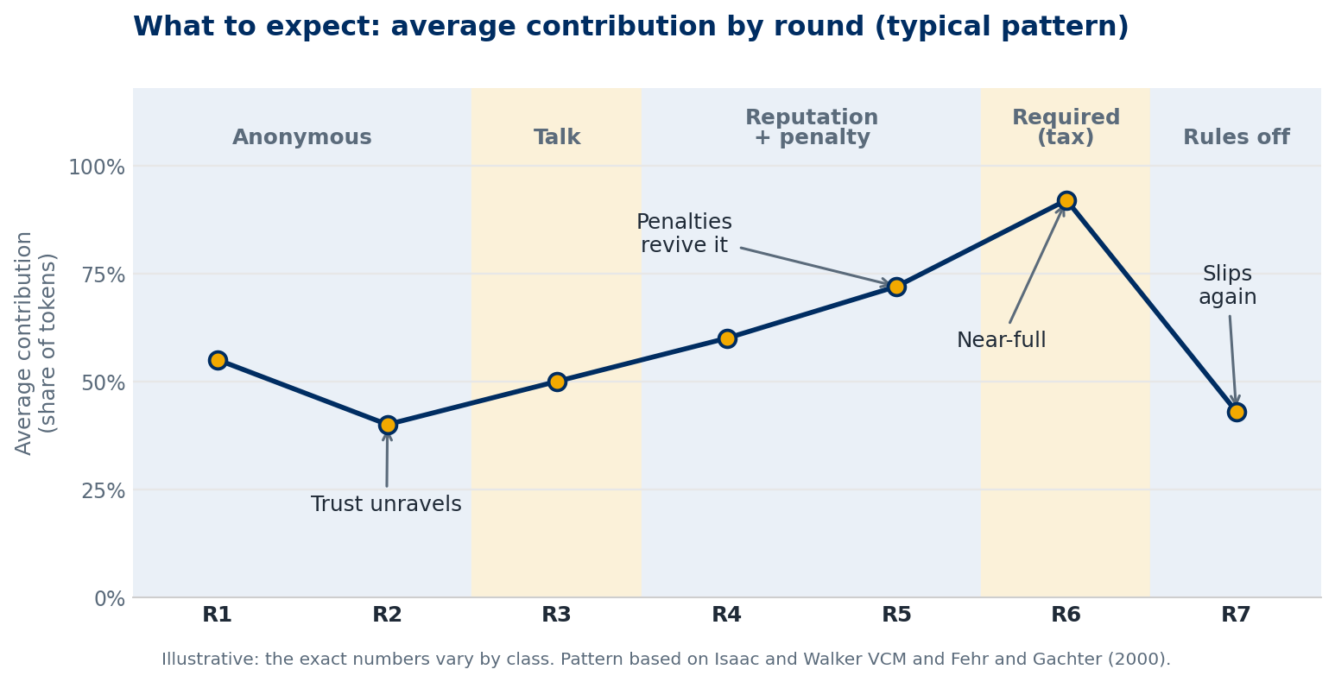
Sources: Holt and Laury, Classroom Games: Voluntary Provision of a Public Good, J. Economic Perspectives (1997); Fehr and Gachter, Cooperation and Punishment in Public Goods Experiments, AER (2000); CORE Experiencing Economics; Veconlab; classEx.

