These are all the files immediately needed to run the Jupyter Notebooks, once you have changed my directory names to your own directories. The student manual details instructions to process the practice dataset.
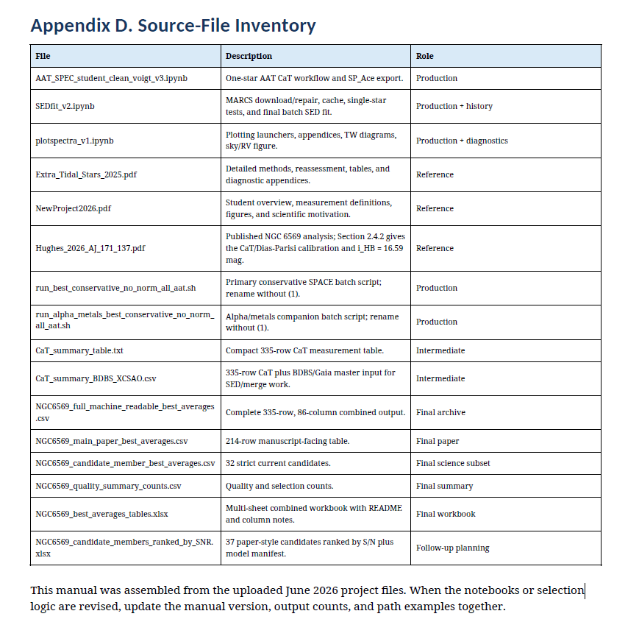
The spectra 1D images are in the aat_spectra_2.tar.gz archive, which you have to unpack.

What format are the files?
FITS (Flexible Image Transport System) is an open-standard file format used primarily in astronomy to store, transmit, and process scientific data. Unlike standard image formats (like JPEG or PNG), FITS files contain raw, uncompressed sensor data along with descriptive metadata, making them the standard choice for professional and amateur astrophotography. [1, 2, 3, 4]

Why FITS is Unique
- Uncompressed Raw Data: FITS files do not compress or alter image data, ensuring that no scientific details or subtle light variations are lost.
- Dual Structure: Every FITS file consists of a human-readable ASCII Header and the binary Data.
- Rich Metadata: The header details exactly how the data should be read, storing critical information like exposure time, date, telescope coordinates, temperature, and camera calibration details.
- Multi-dimensional Arrays: FITS files can store multi-dimensional arrays (like 2D images or 3D cubes) and complex numerical tables, allowing them to stack multiple exposures or different wavelengths of light into a single file. [1, 4, 9]
How to View and Edit Them

Because FITS files are meant to preserve unadulterated scientific data, standard image editors (like Photoshop) cannot open them directly without specialized plugins or prior conversion. [2]

Common tools for viewing and processing FITS files include:
- Dedicated Astrophotography Software: Programs like PixInsight, AstroImageJ, or DeepSkyStacker are built specifically to stack, calibrate, and edit FITS images.
- Astronomical Viewers: Software like SAOImage9 allows you to view the raw data and examine the headers for scientific research.
- Python and MATLAB: FITS files can be easily read, modified, and plotted programmatically using specific language libraries.
  - In Python, you can use the Astropy FITS Package.
  - In MATLAB, use the built-in MATLAB FITS Functions. [12, 13, 14]
For more information, you can read the NASA FITS Primer or explore the community discussion on Reddit ELI5. [4, 6]
[1] https://en.wikipedia.org/wiki/FITS
[2] https://www.photographingspace.com/how-to-use-fits/
[3] https://www.cloudynights.com/forums/topic/231381-fits-files-what-are-they-what-software-uses-them/
[4] https://www.reddit.com/r/explainlikeimfive/comments/vbqu0a/eli5_what_are_fits_files_and_why_are_they_used_in/
[5] https://www.youtube.com/watch?v=ySflm8LUQM4
[6] https://fits.gsfc.nasa.gov/fits_primer.html
[7] https://philuttley.github.io/prog4aa_lesson2/10-fitsfiles/index.html
[8] https://www.astropixelprocessor.com/community/main-forum/nina-tiffs-vs-fits-which-is-better/
[9] https://www.aanda.org/articles/aa/full_html/2010/16/aa15362-10/aa15362-10.html
[10] https://www.facebook.com/groups/seestar/posts/579019308243689/
[11] https://en.wikipedia.org/wiki/FITS
[12] https://www.sdss4.org/dr17/software/fitsfiles/
[13] https://www.mathworks.com/help/matlab/flexible-image-transport-system.html
[14] https://docs.astropy.org/en/latest/io/fits/index.html

