Louisville Weather Vibes
Project Proposal
Developer: Kerry Basham
Target Audience: Louisville, KY residents and visitors
Technology Stack: Python, Open-Meteo API, SQLite, SQLAlchemy, Power BI

Background
This project proposes the development of an interactive weather dashboard that translates daily weather forecasts into fun and easy-to-comprehend weather vibes. The dashboard uses the Open-Meteo API to retrieve daily weather data for Louisville, KY and applies dominance-first rule-based logic to categorize conditions based on temperature, precipitation hours, precipitation sum, and wind speed. The pipeline is implemented as a single, self-contained Python ETL script that extracts, transforms, validates, loads, and exports data automatically. All outputs are written to a dedicated data/ directory.

Business Problem
Weather data is widely available but is typically presented as numerical values with basic icons. This project addresses that gap by transforming raw weather data into 11 engaging weather vibes that summarize daily conditions in a relatable and actionable way. The dashboard extends this concept by pairing each vibe with a unisex outfit recommendation and accessory callout, turning a weather forecast into a practical daily planning tool.

Objectives
- Create an intuitive, interactive weather visualization application using Power BI
- Integrate daily weather data from the Open-Meteo API for Louisville, KY
- Develop a dominance-first rule-based classification system producing 11 distinct weather vibes
- Provide users with a 7-day view of weather vibes, outfit recommendations, and forecast metrics
- Demonstrate end-to-end data engineering: extraction, transformation, validation, normalized loading, and star schema analytics export

Technical Approach

1. ETL Pipeline (Single Script)
The complete ETL workflow is implemented in a single modular Python script (weather_vibes_app.py). All outputs are written to a data/ directory created automatically on first run.
- Extract: Open-Meteo API with 5-retry logic, 1-hour response caching, and API response validation
- Transform: float32 to float64 cast, NaN fill, whole-number temp rounding, derive temp_range_f and weather_vibe
- Validate: 7 named data quality checks with PASS/FAIL logging — halts pipeline on failure
- Load: 4-table normalized SQLite schema via SQLAlchemy written to data/weather.db
- Export: 5 CSV files in data/ including forecast_fits.csv with explicit PK and FK columns

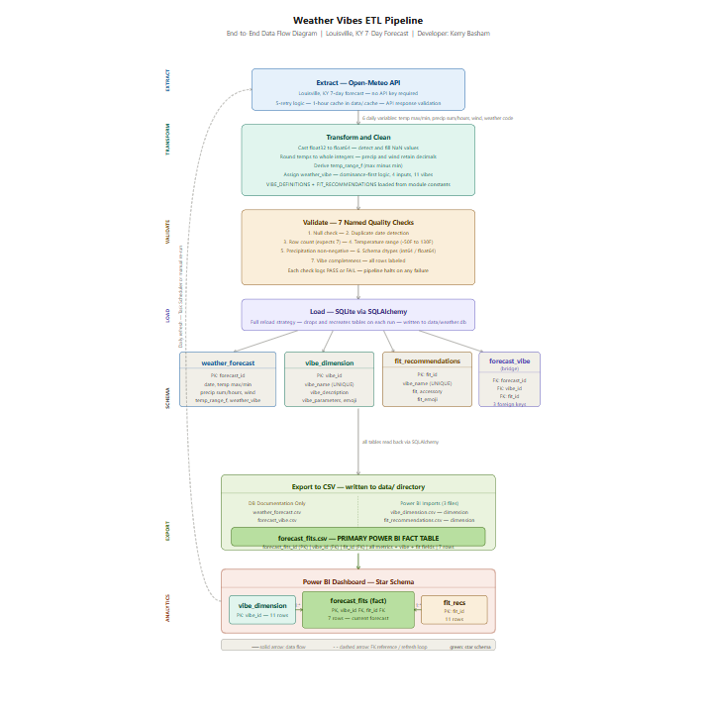

2. Weather Vibe Classification (11 Vibes)
Vibe | Emoji | Trigger Conditions
Dramatic Weather Era | ⛈️ | Heavy rain >= 0.50 in and wind >= 25 mph
Hot Mess Express | 🌧️🥵 | Meaningful rain, wind < 25 mph, temp >= 86F
Lo-Fi Chill Day | 🌧️ | Meaningful rain, wind < 25 mph, temp < 86F
Unhinged Wind Day | 💨 | No rain, wind >= 25 mph
Offensively Hot | 🥵 | Temp >= 90F, no rain, wind < 25 mph
Almost Too Much | 🫠 | Temp 86-89F, no rain, wind < 25 mph
Just Let It Go Day | 🥶 | Temp <= 35F, no rain, wind >= 20 mph
Main Character Energy | 😎 | Temp 72-85F, no rain, wind < 15 mph
Soft Launch Day | 🌤️ | Temp 60-71F, no rain, wind < 15 mph
Cozy Blanket Day | 🧣 | Temp 35-50F, no rain, wind < 15 mph
Existential Meh | 😶 | Fallback — no other vibe matches

3. Two-Layer Schema Design
Normalized Database Layer (weather.db):
- weather_forecast — fact table with 9 columns including precipitation_hours, temp_range_f, and weather_vibe
- vibe_dimension — 11 vibes with descriptions, parameters, and emojis
- fit_recommendations — 11 unisex outfit and accessory recommendations
- forecast_vibe — bridge table with 3 foreign keys (forecast_id, vibe_id, fit_id)

Star Schema Analytics Layer (Power BI):
- forecast_fits.csv — primary fact table with forecast_fits_id (PK), vibe_id (FK), fit_id (FK), and all metrics/vibe/fit fields pre-joined. 7 rows scoped to the current forecast only.
- vibe_dimension.csv — dimension table, all 11 vibes
- fit_recommendations.csv — dimension table, all 11 fits
Note: weather_forecast.csv and forecast_vibe.csv are exported for database documentation purposes and are not used in Power BI.

4. Database Platform Decision
Due to project timeline constraints, SQLite was selected as the database backend in place of PostgreSQL or Supabase. SQLite provides identical schema structure, SQL querying, and SQLAlchemy integration. Migration to PostgreSQL requires only a connection string change.

5. Interactive Power BI Dashboard
- 7-day temperature trend line chart with vibe emojis as data point labels
- Vibe distribution bar chart showing days per vibe category
- KPI cards — average high temp, average low temp, total precipitation, average wind speed
- Vibe forecast table with emoji, name, description, and trigger parameters
- Fit recommendations table with emoji, vibe name, outfit, and accessory
- Vibe slicer filtering all visuals dynamically

Timeline
Week | Tasks
Week 1 | Research topic, explore API, draft proposal
Week 2 | Build API extraction and initial transformation pipeline
Week 3 | Complete data cleaning, validation, storage layer, and documentation
Week 4 | Develop Power BI dashboard, star schema setup, and final documentation
Week 5 | Final testing, refinement, GitHub setup, and project submission

Expected Outcomes
- A functioning Python ETL pipeline with 6 stages, 7 validation checks, and professional logging
- A 4-table normalized SQLite database with PK/FK constraints written to data/weather.db
- 5 CSV exports in data/ including forecast_fits.csv with explicit PK and FK columns
- An interactive Power BI dashboard using a clean 3-table star schema
- Complete documentation: README, CHANGELOG, ERD (two-section), and data flow diagram
- A polished demonstration of end-to-end data engineering concepts

