***Jalebi***

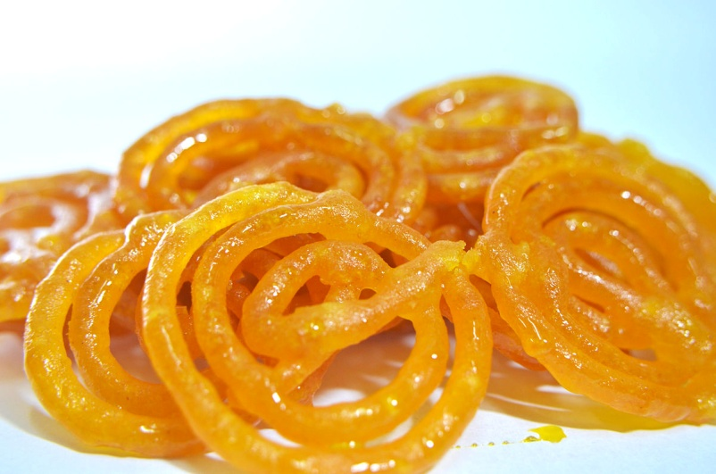

***Information:***

Jalebi is a popular Indian sweet that is made by deep-frying a wheat flour batter in circular or pretzel-like shapes and then soaking them in a sugar syrup. It is a traditional dessert that is enjoyed across India and neighboring countries. Jalebis are often served warm and are crispy on the outside with a syrupy texture on the inside. The batter used to make jalebis is typically made from all-purpose flour, water, and yogurt, which is then fermented for several hours to develop a sour flavor. The sugar syrup used to soak the jalebis is usually flavored with cardamom or saffron to give it a distinct taste and aroma. Jalebis are often enjoyed on special occasions such as weddings, festivals, and religious ceremonies, and they are a must-have during the Indian festive season of Diwali. They are also commonly found in sweet shops across India and are a favorite among both children and adults.

***Nutritional Information:***

Jalebi is a popular sweet dish in India and some other South Asian countries. It is made of deep-fried batter that is soaked in sugar syrup. Jalebi is a high-calorie food that is rich in carbohydrates and sugar.

Here is the approximate nutritional information for a 100-gram serving of Jalebi:

* Calories: 459
* Protein: 1.5 grams
* Fat: 18 grams
* Carbohydrates: 75 grams
* Fiber: 0.5 grams
* Sugar: 50 grams
* Sodium: 34 milligrams

It is important to note that these values may vary depending on the recipe and preparation method used. Additionally, consuming large amounts of Jalebi on a regular basis may not be healthy due to its high sugar and calorie content.

***Ingredients:***

* 1 cup all-purpose flour (maida)
* 1 tablespoon besan (gram flour)
* 1 tablespoon yogurt (dahi)
* 1/4 teaspoon baking soda
* 3/4 cup warm water
* Oil or ghee for frying
* For the syrup:
* 1 cup sugar
* 1/2 cup water
* 1/4 teaspoon saffron strands
* 1/2 teaspoon cardamom powder (elaichi)

***Instructions:***

1. In a mixing bowl, add all-purpose flour, besan, yogurt, baking soda and mix well.
2. Add warm water to the bowl and w
3. hisk well to make a smooth batter. The batter should not be too thick or too thin.
4. Cover the bowl with a lid and let the batter rest for about 10-15 minutes.
5. Meanwhile, prepare the syrup by heating sugar, water, saffron strands, and cardamom powder in a saucepan. Cook on medium heat until the sugar dissolves completely and the syrup thickens. Keep the syrup aside.
6. After 15 minutes, whisk the batter again. The batter should be smooth and of pouring consistency.
7. Heat oil or ghee in a frying pan on medium heat. Transfer the batter to a squeeze bottle or a piping bag with a nozzle.
8. Squeeze the batter in a circular motion to form jalebi shapes in the hot oil. Fry until golden brown on both sides.
9. Remove the jalebi from the oil and soak them in the syrup for a few minutes.
10. Serve hot or cold.

Enjoy your delicious homemade jalebi!