***Gujarati Khaman***

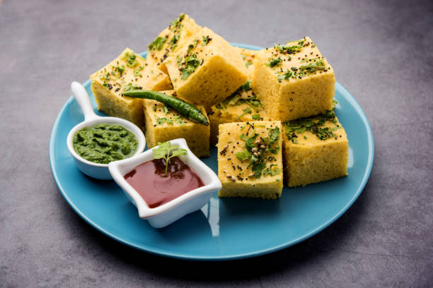

***Information about Khaman:-***

Gujarati Khaman is a beloved snack and breakfast dish from the Indian state of Gujarat. Made from a batter of gram flour, yogurt, and spices, it is steamed to create a light, fluffy texture that is perfect for snacking or as a quick meal. The dish is often tempered with a mix of mustard seeds, green chilies, and grated coconut for added flavor, and served with sweet and sour tamarind chutney or green mint chutney. Low in calories and high in protein, Gujarati Khaman is also gluten-free and vegan, making it a healthy and delicious option for anyone looking for a nutritious snack or meal.

***Nutritional information for a 100-gram serving of Khaman:***

• Calories: 200-220

• Carbohydrates: 30-35 grams

• Protein: 6-7 grams

• Fat: 4-5 grams

• Fiber: 2-3 grams

• Sugar: 2-3 grams

• Sodium: 400-500 mg

Khaman is a low-fat and low-sugar snack, which makes it a healthier alternative to other fried or processed snacks. It is a good source of complex carbohydrates that provide energy to the body. The high protein content of Khaman also helps to keep you fuller for longer and supports muscle growth and repair. Khaman is also a good source of dietary fiber, which supports digestion and helps to lower cholesterol levels.

However, some variations of Khaman may contain high amounts of sodium due to the use of baking soda or fruit salt, which can cause water retention in the body. Therefore, it is important to consume Khaman in moderation as part of a balanced diet to ensure a healthy intake of nutrients.

***Ingredients:***

• 1 cup gram flour (besan)

• 1/2 cup semolina (rava)

• 1/4 cup yogurt (dahi)

• 1 tsp ginger paste

• 1 green chili, finely chopped

• 1 tsp sugar

• 1 tsp lemon juice

• 1 tsp Eno fruit salt

• 1/2 cup water

• Salt to taste

• For tempering:

• 2 tbsp oil

• 1 tsp mustard seeds

• 1 tsp sesame seeds

• 1 tbsp chopped coriander leaves

• 2-3 green chilies, slit

***Instructions:***

1. In a mixing bowl, add gram flour, semolina, yogurt, ginger paste, chopped green chili, sugar, lemon juice, and salt. Mix well.

2. Add water little by little and mix well until there are no lumps. The batter should be of pouring consistency.

3. Grease a 7-inch plate or a steaming dish with oil and keep it ready.

4. In a steamer, add water and let it boil. Meanwhile, add Eno fruit salt to the batter and mix well. The batter will become frothy and increase in volume.

5. Pour the batter into the greased plate or steaming dish and place it in the steamer.

6. Cover the steamer with a lid and steam for 15-20 minutes on medium flame or until a toothpick inserted in the center comes out clean.

7. Once done, remove the plate from the steamer and let it cool for a few minutes.

8. In a pan, heat oil and add mustard seeds and sesame seeds. Let them crackle.

9. Add green chilies and sauté for a few seconds.

10. Pour the tempering over the steamed khaman and spread it evenly.

11. Cut the khaman into squares or diamonds and garnish with chopped coriander leaves.

12. Serve Gujarati khaman with green chutney and tamarind chutney.

Enjoy your delicious Gujarati Khaman!