***Kheer***

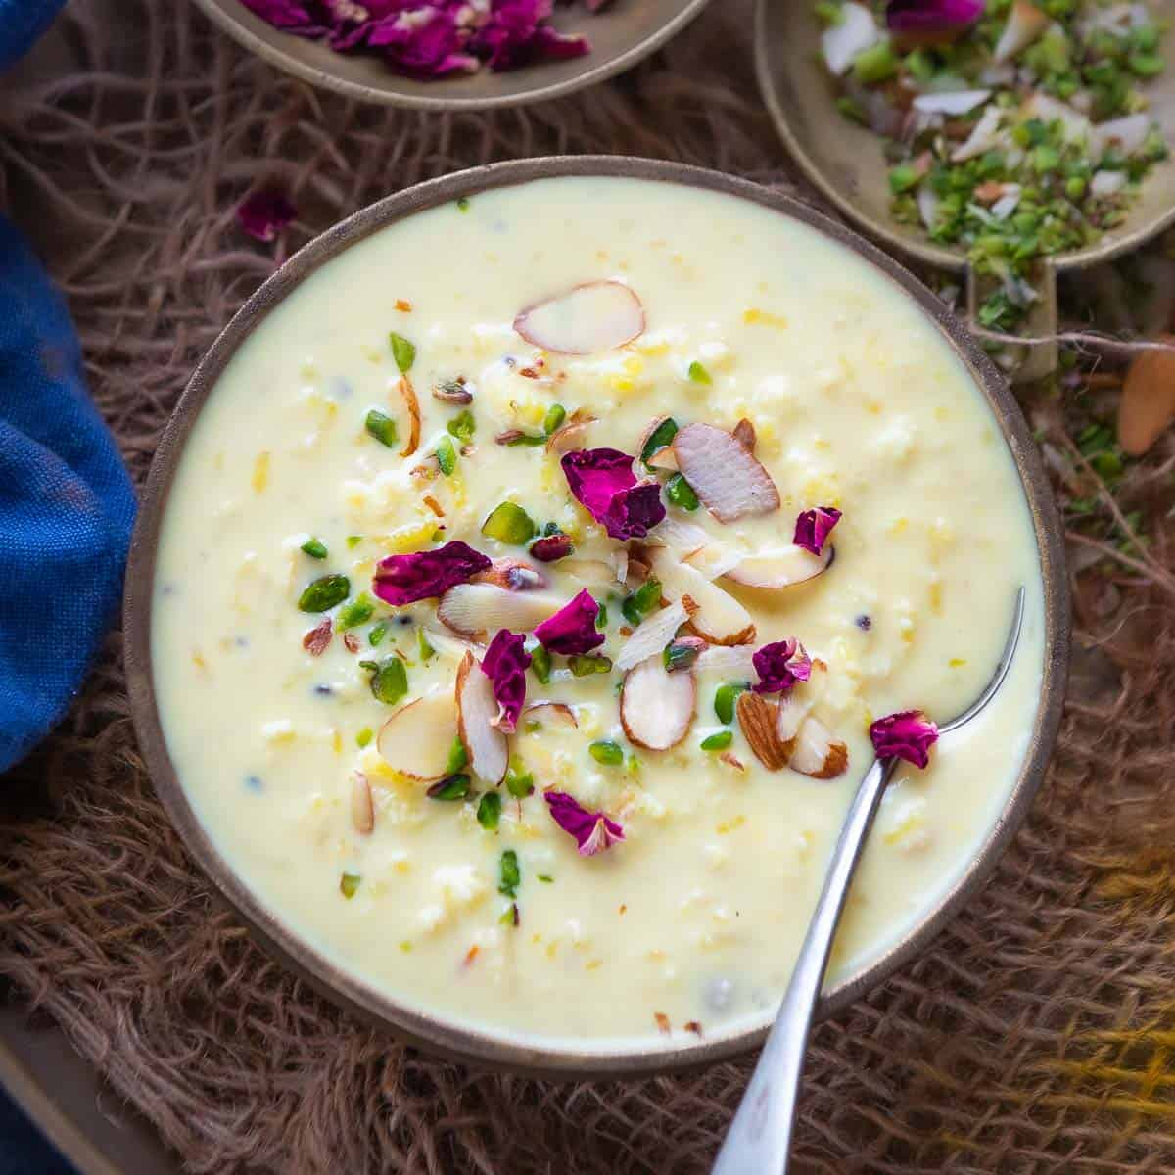

***Information:***

Gujarati kheer is a traditional dessert from the western Indian state of Gujarat. It is a creamy, sweet, and aromatic rice pudding made by cooking rice in milk and flavored with cardamom, saffron, and nuts. Gujarati kheer is often served as a dessert during festivals and special occasions, such as weddings and religious ceremonies. It is a popular sweet dish that is loved by people of all ages. The use of aromatic spices gives this kheer a distinct and irresistible flavor. Gujarati kheer is also a versatile dish that can be enjoyed warm or chilled, making it a perfect dessert for any season. Overall, Gujarati kheer is a delicious and delightful dessert that is sure to satisfy your sweet tooth.

***Nutritional Information:***

The nutritional information of Gujarati kheer may vary depending on the specific recipe and ingredients used, but in general, it is a high-calorie dessert due to the presence of milk, sugar, and nuts. A 100-gram serving of Gujarati kheer may contain approximately 150-200 calories, 4-5 grams of protein, 7-8 grams of fat, and 20-25 grams of carbohydrates.

While kheer is a good source of calcium, due to the milk content, it can also be high in saturated fats and sugar. It is important to consume it in moderation and as a treat rather than a regular part of the diet. Additionally, the use of nuts in the recipe can provide some nutritional benefits, such as healthy fats, protein, and fiber, but they also add calories.

Overall, Gujarati kheer can be a part of a healthy diet if consumed in moderation and balanced with other nutrient-dense foods.

***Ingredients:***

* 1/2 cup Basmati rice
* 1 litre full-fat milk
* 1/2 cup sugar (adjust to taste)
* 1/4 tsp cardamom powder
* A pinch of saffron strands
* 2 tbsp chopped almonds and pistachios
* 1 tbsp raisins
* 1 tbsp ghee

***Instructions:***

1. Wash the rice and soak it in water for about 30 minutes.
2. In a heavy-bottomed pan, bring the milk to a boil.
3. Drain the water from the soaked rice and add it to the boiling milk.
4. Lower the heat and let the rice cook in the milk until it is soft and the mixture thickens, stirring occasionally. This should take about 25-30 minutes.
5. Once the rice is cooked, add the sugar and mix well until it dissolves completely.
6. Add the cardamom powder and saffron strands to the mixture and stir well.
7. In a separate pan, heat ghee and add the chopped nuts and raisins. Roast them until the nuts turn golden brown and the raisins are puffed up.
8. Add the roasted nuts and raisins to the kheer and mix well.
9. Allow the kheer to cool down and then refrigerate until ready to serve.

Your Gujarati kheer is ready to be enjoyed! Garnish it with some extra chopped nuts and saffron strands for a beautiful presentation.