***Gujarati Samosa***

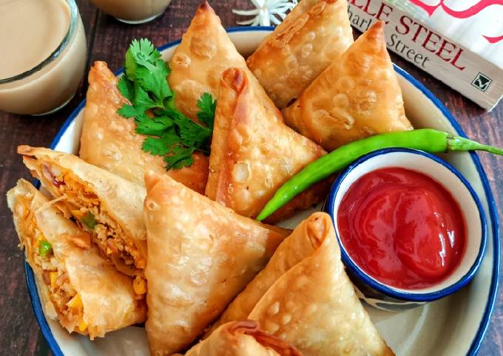

***Information about Samosa***

Gujarati samosas are a popular snack in India that originated in the state of Gujarat. Unlike traditional samosas, Gujarati samosas are smaller in size and have a flakier crust made of all-purpose flour and ghee. The filling is typically made of mashed potatoes, peas, onions, and a variety of spices such as cumin, coriander, and turmeric. Gujarati samosas are often served with tamarind chutney or mint chutney and are a staple at weddings, festivals, and other celebratory occasions. They are loved for their crispy texture, savory flavor, and ability to satisfy hunger pangs on the go.

***Nutritional Information:-***

The nutritional information of Gujarati samosas can vary depending on the recipe and the size of the samosas. However, here is a general idea of the nutritional value of Gujarati samosas:

One medium-sized Gujarati samosa (approximately 50-60 grams) contains around 130-150 calories.

It typically has 7-8 grams of fat, 15-20 grams of carbohydrates, and 2-3 grams of protein.

Gujarati samosas are usually deep-fried, which can increase their fat content and calorie count.

The filling of the samosas is mostly made up of potatoes, which are a good source of carbohydrates and dietary fiber. However, the samosas may also contain other vegetables and spices, which can add to their nutritional value.

Since Gujarati samosas are a snack food, they should be consumed in moderation as part of a balanced diet. It is also recommended to pair them with healthier side dishes like salads or fresh fruit to increase their nutritional value.

***Ingredients:***

* 2 cups all-purpose flour (maida)
* 1/2 tsp salt
* 1/4 cup oil or ghee
* Water as required
* 2 potatoes, boiled, peeled, and mashed
* 1/2 cup green peas, boiled and mashed
* 2 green chilies, finely chopped
* 1/2 tsp cumin seeds (jeera)
* 1 tsp ginger paste
* 1/2 tsp garam masala
* 1/2 tsp coriander powder
* 1/2 tsp red chili powder
* 1 tbsp lemon juice
* Salt to taste
* Oil for deep frying

***Instructions:***

1. In a large mixing bowl, combine the flour, salt, and oil or ghee. Mix well with your fingers until the mixture resembles breadcrumbs.
2. Gradually add water, a little at a time, and knead to form a smooth, firm dough. Cover and set aside for 15 minutes.
3. In a separate bowl, combine the mashed potatoes, mashed peas, green chilies, cumin seeds, ginger paste, garam masala, coriander powder, red chili powder, lemon juice, and salt. Mix well.
4. Divide the dough into small portions and roll each one out into a thin circle.
5. Cut each circle in half to form two semi-circles.
6. Take one semi-circle and shape it into a cone by bringing the two straight edges together and sealing them with a little water.
7. Fill the cone with the potato and pea mixture, leaving a small space at the top.
8. Seal the top of the cone with a little water to form a triangular shape.
9. Heat the oil for deep frying in a large pan.
10. Once the oil is hot, carefully add the samosas and fry until golden brown and crispy.
11. Remove from the oil and place on a paper towel to remove excess oil.
12. Serve hot with your favorite chutney or sauce.

Enjoy your delicious Gujarati-style samosas!