***Thepla***

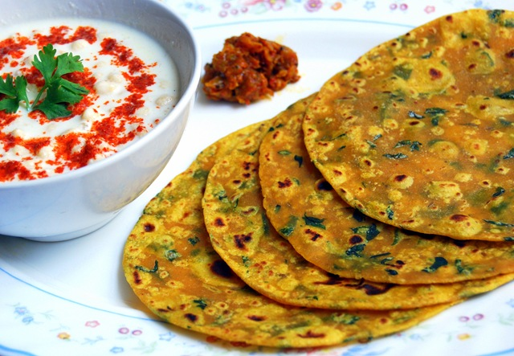

***Information:***

Thepla is a popular Gujarati flatbread that is made with whole wheat flour, spices, and fresh herbs. This dish is a common breakfast and snack item in Gujarat and is often enjoyed with pickles, yogurt, or chutney. The dough for thepla is prepared by mixing whole wheat flour with grated vegetables such as methi (fenugreek leaves), dudhi (bottle gourd), or mooli (radish) along with spices like turmeric, red chili powder, and cumin. The addition of fresh herbs like coriander leaves, mint leaves, or ajwain leaves gives thepla its unique and refreshing flavor. Thepla is typically cooked on a tawa (griddle) with a small amount of oil or ghee until both sides are golden brown and crispy. Thepla is a healthy and nutritious food that is a good source of fiber, vitamins, and minerals. It is also low in fat and can be a good option for those who are trying to maintain a healthy diet.

***Nutritional Information:***

Here's the nutritional information for one serving (one thepla) of thepla, which typically weighs around 30 grams:

* Calories: 100 kcal
* Protein: 3 g
* Carbohydrates: 16 g
* Fat: 3 g
* Fiber: 2 g
* Sugar: 1 g
* Sodium: 180 mg

Thepla is a relatively low-calorie food that is also low in fat and sugar. It is a good source of complex carbohydrates, which can provide sustained energy throughout the day. The addition of vegetables like methi or mooli can also boost the fiber and nutrient content of thepla. However, the exact nutritional value may vary depending on the specific recipe and the ingredients used. Additionally, the use of oil or ghee during cooking can add to the fat and calorie content of the dish.

***Ingredients:***

* 2 cups whole wheat flour
* 1/2 cup finely chopped methi (fenugreek leaves) or any other vegetable of your choice (optional)
* 2 tbsp oil
* 1 tsp cumin powder
* 1/2 tsp turmeric powder
* 1/2 tsp red chili powder (optional)
* Salt to taste
* Water as needed
* Oil or ghee for cooking (oil is better to use in thepla)

***Instructions:***

1. In a mixing bowl, combine the whole wheat flour, chopped methi (if using), cumin powder, turmeric powder, red chili powder (if using), and salt.
2. Add 2 tablespoons of oil and mix well with your fingertips until the flour mixture resembles breadcrumbs.
3. Gradually add water to the flour mixture and knead it into a soft and smooth dough. The dough should not be too sticky or too dry.
4. Cover the dough with a damp cloth and let it rest for at least 15-20 minutes.
5. After resting, divide the dough into small lemon-sized balls.
6. On a clean and dry surface, roll each ball into a thin, circular disc using a rolling pin.
7. Heat a tawa or griddle over medium heat.
8. Place the rolled thepla on the tawa and cook for 30-40 seconds on one side.
9. Flip the thepla and cook the other side for another 30-40 seconds.
10. Drizzle a little oil or ghee on both sides of the thepla and cook until both sides are golden brown and crispy.
11. Repeat the process with the remaining dough balls.
12. Serve hot with yogurt, pickle, or chutney.

Enjoy your delicious and nutritious theplas!