***Undhyu***

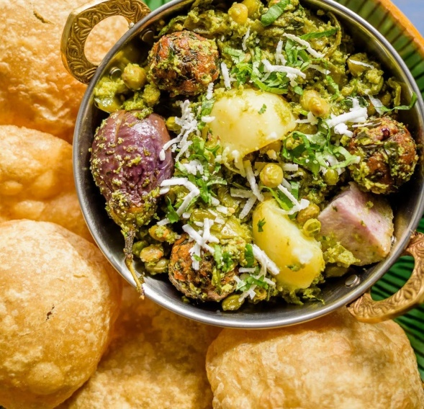

***Information***

Undhiyu is a traditional Gujarati dish that is a celebration of winter vegetables. It is a mixed vegetable dish that is typically made using a variety of seasonal vegetables, such as yam, eggplant, green beans, potatoes, and peas. The vegetables are spiced with a blend of aromatic and flavorful spices, including cumin, coriander, and cinnamon, and are slow-cooked to perfection. Undhiyu is traditionally cooked in an earthen pot, called a "matlu," which gives the dish a unique smoky flavor. This dish is often served during special occasions and festivals, such as Uttarayan, the Gujarati harvest festival, and is enjoyed by both vegetarians and non-vegetarians alike. Undhiyu is not only delicious but also a nutritious and healthy way to enjoy the bounty of winter vegetables.

***Nutritional Information***

Undhiyu is a mixed vegetable dish that is typically made using a variety of seasonal vegetables and spices, and is commonly consumed in the Indian state of Gujarat. It is a nutritious and healthy dish that provides a range of essential vitamins and minerals. The exact nutritional content of undhiyu may vary depending on the specific ingredients and preparation method used, but in general, it is a low-calorie, high-fiber, and nutrient-rich food.

A typical serving of undhiyu (about 1 cup or 150 grams) contains approximately:

* Calories: 150-200
* Carbohydrates: 20-30 grams
* Protein: 3-5 grams
* Fat: 7-10 grams
* Fiber: 8-12 grams

Undhiyu is a good source of several essential vitamins and minerals, including:

* Vitamin C: helps boost immunity, protects against infections, and supports healthy skin and bones
* Vitamin K: important for blood clotting and bone health
* Potassium: helps regulate blood pressure and supports heart health
* Iron: important for healthy blood and energy production
* Calcium: supports healthy bones and teeth

Overall, undhiyu is a nutritious and delicious dish that can be enjoyed as part of a balanced and healthy diet.

***Ingredients:***

* 2 cups of fresh pigeon peas (tuvar lilva), shelled
* 1 cup of purple yam (ratalu), peeled and cubed
* 1 cup of sweet potatoes (shakarkand), peeled and cubed
* 1 cup of baby eggplants (baingan), slit and cut into 4 pieces
* 1 cup of potatoes, cubed
* 1 cup of fresh green beans, chopped
* 1/2 cup of fresh fenugreek leaves (methi), chopped
* 1/2 cup of fresh coriander leaves, chopped
* 1/2 cup of grated coconut
* 1/4 cup of chopped cashews
* 1/4 cup of raisins
* 1/4 cup of oil
* 1 teaspoon of mustard seeds
* 1 teaspoon of cumin seeds
* 1/2 teaspoon of asafoetida (hing)
* 1 teaspoon of turmeric powder
* 1 teaspoon of red chili powder
* 1 teaspoon of coriander powder
* 1 teaspoon of cumin powder
* 2 teaspoons of sugar
* Salt to taste

***Instructions:***

1. In a large mixing bowl, combine the pigeon peas, purple yam, sweet potatoes, baby eggplants, potatoes, green beans, and fenugreek leaves. Mix well and set aside.
2. In a separate bowl, combine the grated coconut, chopped cashews, and raisins. Mix well and set aside.
3. Heat oil in a large deep pan. Add mustard seeds and let them splutter. Add cumin seeds and asafoetida and let them sizzle.
4. Add the mixed vegetables and stir well.
5. Add turmeric powder, red chili powder, coriander powder, cumin powder, sugar, and salt. Mix well.
6. Cover the pan and cook on medium heat for 10-12 minutes, stirring occasionally.
7. Add the coconut, cashew, and raisin mixture on top of the vegetables. Cover the pan and cook for another 5-7 minutes.
8. Garnish with chopped coriander leaves and serve hot with puri, roti, or rice.

Enjoy your delicious undhiyu!