2018~2019第一学期《数据结构》上机实验报告（2017级理科实验班）
序号 | 班级 | 姓名 | 学号 | 完成模块
1 | 理试1701 | 朱帅成 | 41721603 | 类定义 主函数 窗体设计
2 | 理试1701 | 孙嘉彬 | 41721609 | 类定义 主函数 窗体设计
3 | 理试1701 | 芦明铭 | 41721610 | 类定义 主函数 窗体设计
4
指导教师：张志刚 |  |  |  | 助教：张林桐
实验名称： 图及其相关运算
实验任务：
根据邻接矩阵创建图
实现图的深度优先搜索和广度优先搜索
利用Prim算法找出最小生成树
利用Dijkstra算法求最短路径
实验目的：
学习图的生成与运算，尤其是深度优先与广度优先搜索算法。学习最小生成树的概念，了解并掌握如何求出最小生成树以及搜索最小生成树的Prim算法。学习并掌握最短路径的求法，掌握求最短路径的Dijkstra算法。
运行结果：
图的生成与绘画
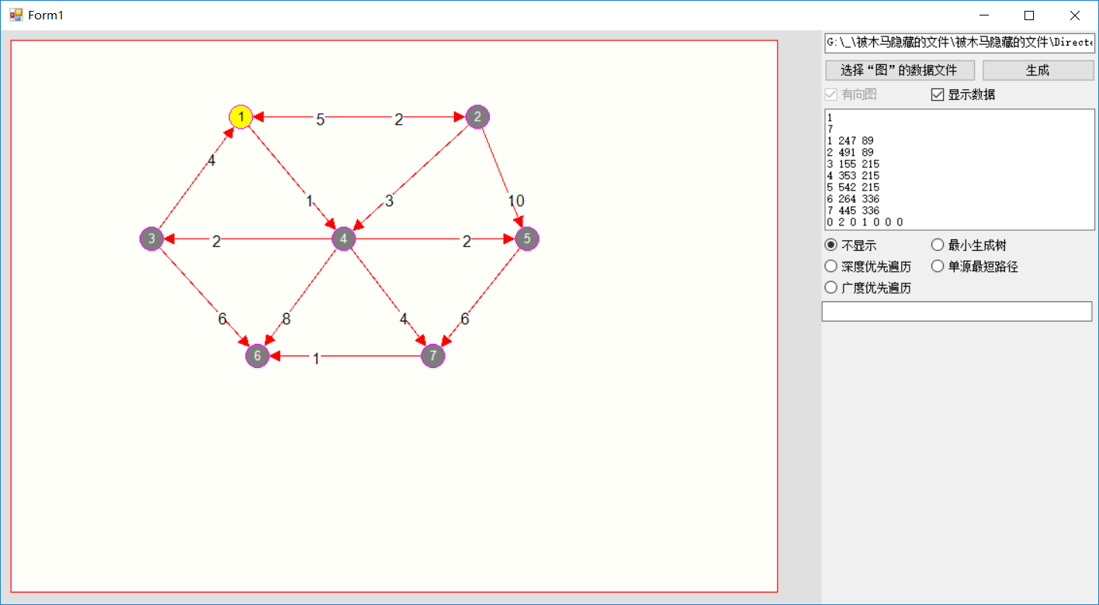

广度优先遍历与深度优先遍历
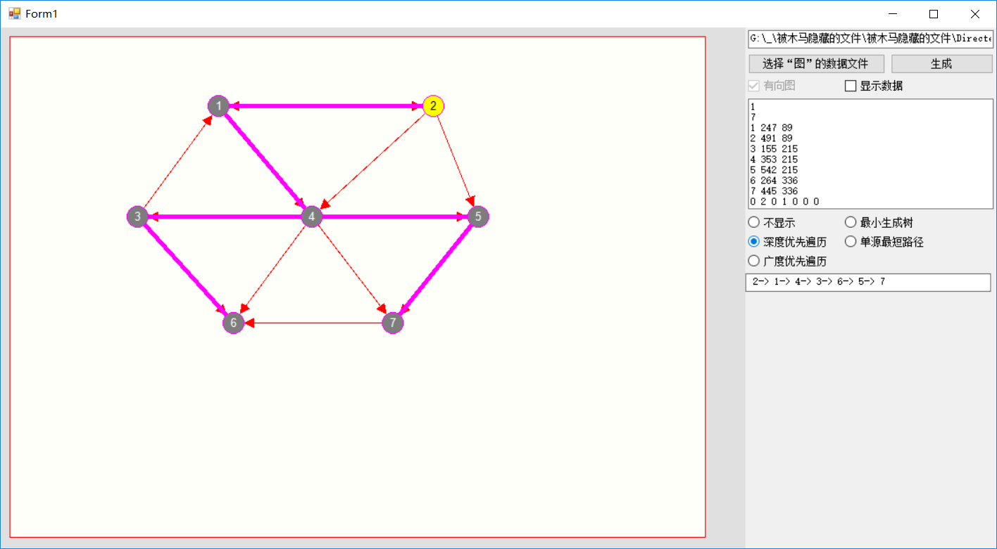

最小生成树
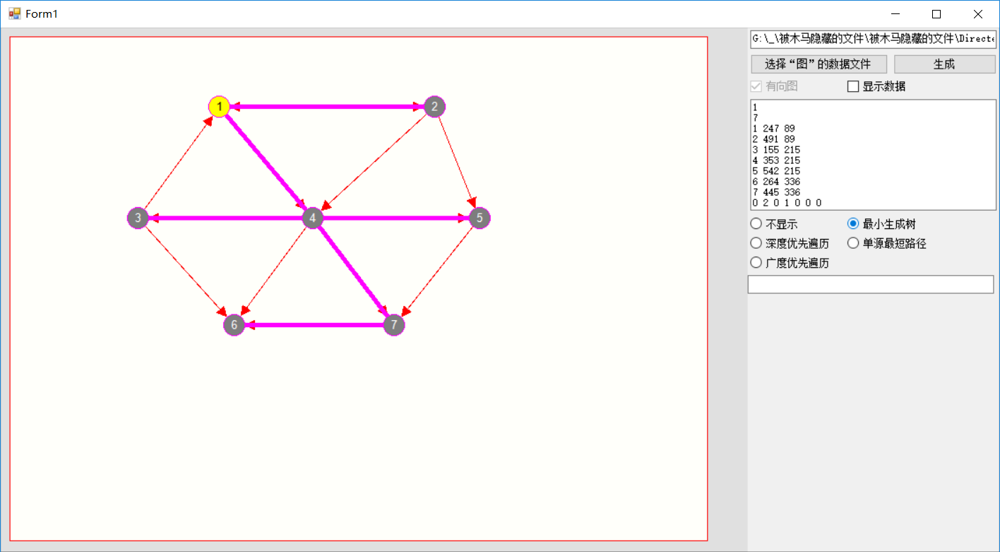

最短路径
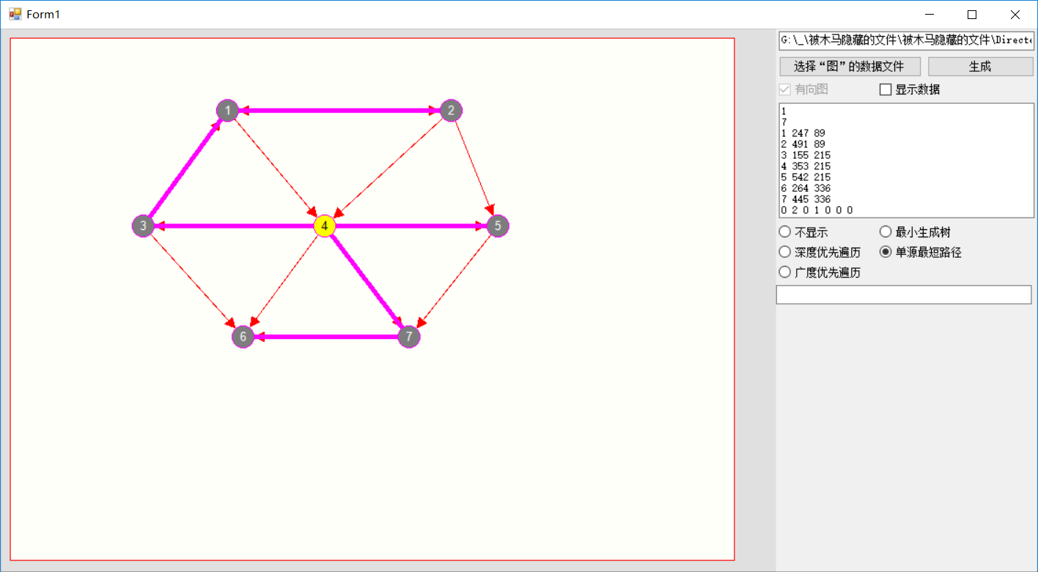
分析讨论：
图是一种多对多的结构，因此图，尤其是有向图，可以表示许多常见的结构。图的运算中最重要的是遍历、搜索。图的遍历方式由深度优先与广度优先两种，实现这两种算法分别用到了队列和栈的结构，同时也要注意避免重复访问的问题发生。Prim算法是搜索图中最小生成树的算法，而Dijkstra算法是寻找最短路径的算法，是图的结构中十分重要的运算。
心得体会：
经过此次实验，我们学习到了图的储存结构与逻辑结构，图的两种遍历与Prim算法、Dijkstra算法。利用它们我们可以轻松实现遍历与搜索，寻找最小生成树和最短路径。掌握这些内容也为之后学习拓扑排序、关键路径等打下更好的基础。

2018年 11月 13日
设计方案描述（类设计）：
using System;
using System.Collections.Generic;
using System.Text;
using System.Drawing;

namespace DirectedGraph
{
public class vtype
{
public int no;//点的序号
public string name;//存放点图的名字
public int x,y;//点的坐标
public vtype()
{
no=0;x=y=0;name="";
}
public vtype(int no, int x, int y)
{
this.no = no;this.x = x;this.y = y;this.name = "";
}
public vtype(int no, int x, int y, string name)
{
this.no = no;this.x = x;this.y = y;this.name = name;
}
}
public class EL
{
public int e; //最早开始时间
public int l; //最迟开始时间
public EL(int e,int l)
{ this.e = e; this.l = l; }
}
public class CGraph_zzg
{
private vtype[] vertex;//存放顶点的数组
private float[,] edge;//存放边的矩阵

protected int directed;//图的类型(0:无向图,1:有向图)
protected int vertexno;//顶点个数
protected string fname;//创建图的文件名
protected int currentID;//当前点的序号

protected int[] visited;//存放某种顺序遍历时的顶点序列,visited[0]为遍历序列个数
protected int[] treeparent;//存放生成树边的数组(存放双亲的顶点号)
protected EL[] vertexc;//图的关键路径的顶点存放的e,l值
protected EL[,] edgec;//图的关键路径的边存放的e,l值

public CGraph_zzg(int ver)
{ vertexno = ver; }
public CGraph_zzg()
{
vertex = null;
edge = null;
directed = 0;
vertexno = 0;
fname = "";
currentID = 0;
treeparent = null;
visited = null;
vertexc = null;
edgec = null;
}
public bool IsDirected()
{ return directed==1; }
public int Getvertexno()//取顶点个数
{ return vertexno; }
public int GetCurrentID()//取当前顶点的序号
{ return currentID; }
public void SetCurrentID(int k)//设置当前顶点的序号
{ currentID=k; }
public int Visited(int vi)
{ return visited[vi]; }
public void setVisited(int vi, int k)
{ visited[k] = vi; }
public int TreeParent(int vi)//取顶点vi在生成树中双亲的顶点号
{ return treeparent[vi]; }
public EL Vertexc(int vi)//顶点vi的e,l值
{ return vertexc[vi]; }
public EL Edgec(int vi, int vj)//取边<vi,vj>的权值
{ return edgec[(vi - 1), (vj - 1)]; }
public string printVisited()
{
String strout = "";
for (int i = 1; i <= visited[0]; i++)
{
strout += " " + visited[i];
if (i < visited[0])
strout += "->";
}
return strout;
}
public void DFS()//图的深度优先遍历
{//图从当前顶点开始深度优先搜索,将顶点序列存入数组visited
int vi = currentID;//当前顶点号
int k = 0, currenti = vi, n, p, i;
n = vertexno;//顶点的个数
if ((vi < 1) || (vi > n)) return;
CLinkStack<int> mstack = new CLinkStack<int>(); //存放遍历时顶点序号的栈
bool[] tag = new bool[n + 1];//存放顶点是否被访问过
for (i = 0; i <= n; i++)
{ tag[i] = false; }
for (i = 1; i <= n; i++)//清除原生成树的边
{ treeparent[i] = 0; }
tag[vi] = true; visited[0] = ++k; visited[k] = vi;//加入遍历序列
p = GetFirstV(vi);//求vi的第一个相邻顶点
mstack.Push(vi);//顶点vi入栈
while ((p != 0) || (!mstack.IsEmpty()))
{
while (p != 0)//存在相邻顶点
{
if (tag[p] == false)//未访问过顶点p
{
tag[p] = true; //已访问过
treeparent[p] = currenti;
currenti = p;//这是当前被访问的顶点
visited[0] = ++k;
visited[k] = currenti;//顶点currenti加入遍历序列
mstack.Push(currenti);//顶点currenti入栈
p = GetFirstV(currenti);//求第一个相邻顶点
}
else//已访问过顶点p
{
p = GetNextV(currenti, p);//求下一个相邻顶点
}
}
if (!mstack.IsEmpty())
{
currenti = mstack.Pop();//栈顶为当前顶点
p = GetFirstV(currenti);//再找currenti的相邻结点
while (p != 0)
{
if (tag[p] == false)//未访问过顶点p
{
break;
}
else//已访问过顶点p
{
p = GetNextV(currenti, p);//下一个相邻顶点 }
}
}
if (p != 0)//currenti还有相邻结点,再入栈
{
mstack.Push(currenti);//顶点currenti入栈 }
}
}
}
return;
}
public void BFS()//图的广度优先遍历
{//图从当前顶点开始广度优先搜索,将顶点序列存入数组visited
int vi = currentID;//当前顶点号
int k = 0, currenti = vi, n, p, i;
n = vertexno;//顶点的个数
if ((vi < 1) || (vi > n))
{
return;
}
CQueue<int> mqueue = new CQueue<int>();//队列
bool[] tag = new bool[n + 1];//存放顶点是否被访问过
for (i = 0; i <= n; i++)
{
tag[i] = false;
}
for (i = 1; i <= n; i++)//清除原生成树的边
{
treeparent[i] = 0;
}
tag[vi] = true;
visited[0] = ++k; visited[k] = vi;//顶点vi加入遍历序列
p = GetFirstV(vi);//求vi的第一个相邻顶点
mqueue.In(vi);//顶点vi入队
while (!mqueue.IsEmpty())
{
currenti = mqueue.Out();//访问过的顶点出队
p = GetFirstV(currenti);//求第一个相邻顶点
while (p != 0)
{
if (tag[p] == false)//未访问过
{
tag[p] = true;//已访问过
treeparent[p] = currenti;
visited[0] = ++k; visited[k] = p;//顶点p加入遍历序列
mqueue.In(p);
}
p = GetNextV(currenti, p);//求顶点的下一个相邻顶点
}
}
return;
}

public Point GetArrow(int x1, int y1, int x2, int y2, int R)
//求箭头的坐标,点(x1,y1)到(x2,y2)的有向边,R:点圈的半径,d:箭头半长
{
double k;//直线的斜率
Point p0 = new Point(0, 0);
if(x1!=x2)
{
k=1.0*(y2-y1)/(x2-x1);
if(x1<x2)
{
p0.X = (int)(x2 - R / Math.Sqrt(1 + k * k) + 0.5);//直线(x1,y1)(x2,y2)与圆(x2,y2,R)的交点
p0.Y = (int)(y2 - k * R / Math.Sqrt(1 + k * k) + 0.5);
}
else //x1>x2
{
p0.X = (int)(x2 + R / Math.Sqrt(1 + k * k) + 0.5);
p0.Y = (int)(y2 + k * R / Math.Sqrt(1 + k * k) + 0.5);
}
}
else//x1==x2
{
if(y1<y2)
{
p0.X = x1;
p0.Y = y2 - R;
}
else if(y1>y2)
{
p0.X = x1;
p0.Y = y2 + R;
}
}
return p0;
}
public void ReadData(int directed, int vertexno, int[,] vertex, float[,] edge)
{
int i,j;
if (vertexno == 0)
{
this.vertexno = 0;
return;
}
this.directed = directed;
this.vertexno = vertexno;
this.vertex = new vtype[this.vertexno + 1];
this.edge = new float[this.vertexno, this.vertexno];
this.visited = new int[this.vertexno + 1];
this.treeparent = new int[this.vertexno + 1];
this.vertexc = new EL[this.vertexno + 1];
this.edgec = new EL[this.vertexno, this.vertexno];

for (i = 1; i <= this.vertexno; i++)
{
this.vertex[i] = new vtype(vertex[i - 1, 0], vertex[i - 1, 1], vertex[i - 1, 2]);
this.treeparent[i] = 0;
this.vertexc[i] = new EL(-1, -1);
}
for (i = 0; i < this.vertexno; i++)
{
for (j = 0; j < this.vertexno; j++)
{
this.edge[i, j] = edge[i, j];
this.edgec[i, j] = new EL(-1, -1);
}
}
currentID = 1;
this.visited[0] = 0;//遍历序列个数为0
}
public string Write()
{
string strout = "";
strout += "" + directed + "\r\n";
strout += "" + vertexno + "\r\n";
for (int i = 1; i <= vertexno; i++)
{
strout += "" + vertex[i].no + " ";
strout += "" + vertex[i].x + " ";
strout += "" + vertex[i].y + "\r\n";
}
for (int i = 1; i <= vertexno; i++)
{
for (int j = 1; j <= vertexno; j++)
{
strout += "" + Edge(i, j) + "\r\n";
}
strout += "" + "\r\n";
}
return strout;
}
public vtype Vertex(int vi)//顶点vi的值
{ return vertex[vi]; }
public float Edge(int vi, int vj)//取边<vi,vj>的值
{
return edge[(vi - 1), (vj - 1)];
}
public int GetFirstV(int vi)//取顶点vi的第一个邻接点
{//取顶点vi的第一个邻接点
for (int j = 1; j <= vertexno; j++)
{
if ((j != vi) && (!Edge(vi, j).Equals(0)))
{
return j; //返回顶点vi的第一个相邻结点
}
}
return 0;//顶点vi不存在相邻结点
}
public int GetNextV(int vi, int vk)//取顶点vi的从顶点vk后的第一个邻接点
{//取顶点vi的邻接点vk的下一个邻接点
for (int j = vk + 1; j <= vertexno; j++)
{
if ((j != vi) && (!Edge(vi, j).Equals(0)))
{
return j; //返回顶点vi的第一个相邻结点
}
}
return 0;//顶点vi不存在相邻结点
}
public void print(out string strout)
{ strout = ""; }
public void Prim()//图的最小生成树,Prim算法
{
float[,] houxuan = new float[vertexno, vertexno];
houxuan = edge;
int i, j;
int[] T = new int[vertexno];
T[vertexno - 1] = 0;
T[0] = 1;
int num = 1;
while (num != vertexno)
{
float min = 100;
int m = 0, n = 0;
for (int k = 0; k < num; k++)
{
i = T[k];
for (int w = 1; w < vertexno + 1; w++)
{
if (houxuan[i - 1, w - 1] == 0)
continue;
bool ga = false;
for (j = 0; j < num; j++)
{
if (w == T[j])
{
ga = true;
break;
}

}
if (ga)
continue;
if (min > houxuan[i - 1, w - 1])
{
min = houxuan[i - 1, w - 1];
m = i;
n = w;
}
}
}
if (min == 100)
break;
else
{
treeparent[n] = m;
T[num++] = n;
}
}
return;
}
public void Dijkstra() //图的单源最短路径,Dijkstra算法
{
float[] dp = new float[Getvertexno()+1], tmp;
int vi = currentID, vk;
CQueue<int> queue = new CQueue<int>();

Array.Clear(treeparent, 1, Getvertexno());

for (int i = 1; i <= Getvertexno(); i++)
{
dp[i] = 99999;
}

queue.In(vi);
dp[vi] = 0;
while(!queue.IsEmpty())
{
vi = queue.Out();
tmp = dp;
vk = 0;
while (GetNextV(vi, vk) != 0)
{
vk = GetNextV(vi, vk);
if (dp[vk] > tmp[vi] + Edge(vi, vk))
{
dp[vk] = tmp[vi] + Edge(vi, vk);
treeparent[vk] = vi;
queue.In(vk);
}
}
}
return;
}
public string GetDijkstraPath() //求图的Dijkstra算法得到的路径及路径长度
{ return ""; }
public bool CriticalPath() //图的关键路径
{ return true; }
}
}

using System;
using System.Collections.Generic;
using System.Text;

namespace DirectedGraph
{
public class CQueue<Type>
{
private int front, rear;
private Type[] elems;
private const int Maxsize = 1000;
//--------------------------------------------------------------------------------
public void MakeEmpty() { front=rear=0; }//清空
public bool IsEmpty() { return front==rear; }//判队空
public bool IsFull() { return (rear+1)%Maxsize==front; }//判队满
public int Front() { return front; }
public int Rear() { return rear; }
///////////////////////////////////////////////////////////
public CQueue()
{
elems = new Type[Maxsize];
front = rear = 0;
}
///////////////////////////////////////////////////////////
public bool In(Type item)//入队
{
if (!IsFull())
{
rear = (rear + 1) % Maxsize;
elems[rear] = item;
return (true);
}
else
return (false);
}
///////////////////////////////////////////////////////////
public Type Out()//出队
{
front = (front + 1) % Maxsize;
return elems[front];
}
///////////////////////////////////////////////////////////
public Type Getfront()
{
return elems[(front + 1) % Maxsize];
}
///////////////////////////////////////////////////////////
public Type Getdata(int k)
{
return elems[k];
}
///////////////////////////////////////////////////////////
}
}

using System;
using System.Collections.Generic;
using System.Text;

namespace DirectedGraph
{
public interface ICStack<Type>//接口
{
bool IsEmpty();//判栈空
bool IsFull();//判栈满
void MakeEmpty();//清空
bool Push(Type item);//入栈
Type Pop();//出栈
Type Gettop();//取栈顶
string GetStackALLDate(string sname);
}

class CStacknode<Type>//链栈结点类
{
private Type data;
private CStacknode<Type> next;
//--------------------------------------------------------------------------------
public CStacknode()
{
next = null;
}
public CStacknode(Type data)
{
this.data = data;
next = null;
}
public CStacknode(Type data, CStacknode<Type> next)
{
this.data = data;
this.next = next;
}
public Type Data
{
get { return data; }
set { data = value; }
}
public CStacknode<Type> Next
{
get { return next; }
set { next = value; }
}
}
class CLinkStack<Type>: ICStack<Type>
{
private CStacknode<Type> top;
//--------------------------------------------------------------------------------
public void MakeEmpty() { top = null; }//清空
public bool IsEmpty() { return top == null; }//判栈空
public bool IsFull() { return false; }//判栈满

public CLinkStack()
{
top = null;
}
public bool Push(Type item)//入栈
{
top = new CStacknode<Type>(item,top);
return (true);
}
public Type Pop()//出栈
{
Type dt = top.Data;
top = top.Next;
return dt;
}
public Type Gettop()//取栈顶
{
if (top == null)
return default(Type);
else
return top.Data;
}
public string GetStackALLDate(string sname)
{
string str = " 】";
if (IsEmpty()) str = sname + " stack is null";
CStacknode<Type> p = top;
while (p != null)
{
str = p.Data + " " + str;
p = p.Next;
}
str = "【 "+str + "\r\n";
str = str + "---------------------------------------" + "\r\n";
return str;
}
}

public class CSeqStack<Type> : ICStack<Type>
{
private int top;
private Type[] elems;
private int Maxsize=100;
//--------------------------------------------------------------------------------
public void MakeEmpty() { top=-1; }//清空
public bool IsEmpty() { return top==-1; }//判栈空
public bool IsFull() { return top==Maxsize-1; }//判栈满
///////////////////////////////////////////////////////////
public Type this[int index]
{
get { return elems[index]; }
set { elems[index] = value; }
}
public int Top
{
get { return top; }
}

public CSeqStack()
{
elems=new Type[Maxsize];
top = -1;
}
public CSeqStack(int max)
{
Maxsize = max;
elems = new Type[Maxsize];
top = -1;
}
///////////////////////////////////////////////////////////
public bool Push(Type item)//入栈
{
if(!IsFull())
{
elems[++top]=item;
return(true);
}
else
return(false);
}
///////////////////////////////////////////////////////////
public Type Pop()//出栈
{
if (!IsEmpty())
return elems[top--];
else
return elems[0];
}
///////////////////////////////////////////////////////////
public Type Gettop()//取栈顶
{
if (!IsEmpty())
return elems[top];
else
return elems[0];
}
public string GetStackALLDate(string sname)
{
string str="";
if (IsEmpty()) str = sname + " stack is null";
for(int i=0;i<=top;i++)
{
str = str + " " + elems[i].ToString() + " ";
}
str = str + "\r\n";
//str = str + "--------------------------------------------------" + "\r\n";
return str;
}
///////////////////////////////////////////////////////////
}
}

主要程序清单：
using System;
using System.Collections.Generic;
using System.ComponentModel;
using System.Data;
using System.Drawing;
using System.Text;
using System.Windows.Forms;
using System.IO;//读取文件所需的

namespace DirectedGraph
{
public partial class Form_Graph : Form
{
private CGraph_zzg m_graphm;
Graphics myg = null;

bool m_IsDrawTree = false;
bool m_IsDraw = false;
bool m_IsDrawing = false;

int minx = 0, maxx = 0;
int miny = 0, maxy = 0;
int dx = 0;
int dy = 0;
int midx = 0;
int midy = 0;
//--------------------------------------------------------------------------

public Form_Graph()
{
InitializeComponent();
}

private void Form_Graph_Load(object sender, EventArgs e)
{
myg = this.CreateGraphics();

dx = 10;
minx = dx;
maxx = Convert.ToInt32(Math.Floor((this.ClientSize.Width - dx) / 10.0) * 10) - 320;
dy = 10;
miny = dy;
maxy = Convert.ToInt32(Math.Floor((this.ClientSize.Height - dy) / 10.0) * 10);
midx = Convert.ToInt32(Math.Floor((minx + maxx) / 20.0) * 10);
midy = Convert.ToInt32(Math.Floor((miny + maxy) / 20.0) * 10);

}

private void Form_Graph_Paint(object sender, PaintEventArgs e)
{
initdraw();
if (m_IsDraw)
DrawGraph();
}
public int GetIntData(string strdata, int k, out int outk)
{
int len = strdata.Length;
int ks = k, data;
string str;
while ((ks < len) && ((strdata[ks] < '0') || (strdata[ks] > '9')))
ks++;
str = "";
while ((ks < len) && ((strdata[ks] >= '0') && (strdata[ks] <= '9')))
str = str + strdata[ks++];
if (str != "")
data = Convert.ToInt32(str);
else
data = 0;
outk = ks;
return (data);
}
public void ReadData(string graphstrin)
{
int know = 0;
int directed = GetIntData(graphstrin, know, out know);//有向图无向图
int n = GetIntData(graphstrin, know, out know);//结点个数
int[,] dv = new int[n, 3];
float[,] de = new float[n, n];
for (int i = 0; i < n; i++)
{
for (int j = 0; j < 3; j++)
{
dv[i, j] = GetIntData(graphstrin, know, out know);
}
}
for (int i = 0; i < n; i++)
{
for (int j = 0; j < n; j++)
{
de[i, j] = GetIntData(graphstrin, know, out know);
}
}
m_graphm = new CGraph_zzg();
m_graphm.ReadData(directed, n, dv, de);
m_IsDraw = true;
}
public void initdraw()
{
myg.Clear(Color.FromArgb(255, 224, 224, 224));
Brush b0 = new SolidBrush(Color.FromArgb(255, 255, 255, 250));
myg.FillRectangle(b0, minx, miny, maxx - minx, maxy - miny);

Pen pen1 = new Pen(Color.Red, 1);
myg.DrawLine(pen1, new Point(minx, miny), new Point(maxx, miny));
//myg.DrawLine(pen1, new Point(minx, midy), new Point(maxx, midy));
myg.DrawLine(pen1, new Point(minx, maxy), new Point(maxx, maxy));
myg.DrawLine(pen1, new Point(minx, miny), new Point(minx, maxy));
//myg.DrawLine(pen1, new Point(midx, miny), new Point(midx, maxy));
myg.DrawLine(pen1, new Point(maxx, miny), new Point(maxx, maxy));
Brush b1 = new SolidBrush(Color.Blue);
//myg.FillEllipse(b1, midx - 5, midy - 5, 10, 10);

}

public void DrawGraph()
{
int n = m_graphm.Getvertexno();//点的个数
if (n == 0)
return;
string str;
int i, j, x1, y1, x2, y2;
int R = 12;//点圈的半径
int d1 = 6;//普通线的箭头长
int LW = 1;//线宽

//设置显示颜色

Color BKColor, BKColor0, BKColor1, ArrowColor, TreeColor;
Brush BKBrush, BKBrush0, BKBrush1, ArrowBrush;
BKColor = Color.FromArgb(255, 255, 255, 255);
BKBrush = new SolidBrush(BKColor);//背景色
BKColor0 = Color.FromArgb(255, 125, 125, 125);
BKBrush0 = new SolidBrush(BKColor0);//节点颜色
BKColor1 = Color.FromArgb(255, 255, 255, 0);
BKBrush1 = new SolidBrush(BKColor1);//当前节点颜色
ArrowColor = Color.FromArgb(255, 255, 0, 0);
ArrowBrush = new SolidBrush(ArrowColor);//箭头颜色
TreeColor = Color.FromArgb(255, 255, 0, 255);//生成树的边的颜色

Pen pen = new Pen(Color.FromArgb(255, 255, 255, 255), LW);
Pen pen0 = new Pen(Color.FromArgb(255, 255, 0, 255), 1);//点的圆圈
Pen PenLine = new Pen(ArrowColor, LW);//边
Pen Pentree = new Pen(TreeColor, 5);//生成树的边

System.Drawing.Drawing2D.AdjustableArrowCap lineCap = new System.Drawing.Drawing2D.AdjustableArrowCap(6, 6, true);
Pen PenLineA = new Pen(ArrowColor, LW);
PenLineA.CustomEndCap = lineCap;

if (m_graphm.IsDirected())//有向图
{
cb_IsDirected.Checked = true;
for (i = 1; i <= n; i++)//画线
{
for (j = 1; j <= n; j++)
{
if ((m_graphm.Edge(i, j) != 0))
{
x1 = m_graphm.Vertex(i).x;
y1 = m_graphm.Vertex(i).y;
x2 = m_graphm.Vertex(j).x;
y2 = m_graphm.Vertex(j).y;
Point p0 = m_graphm.GetArrow(x1, y1, x2, y2, 2 * d1);
myg.DrawLine(PenLineA, new Point(x1, y1), p0);
}
}
}
}
else//无向图
{
for (i = 1; i <= n; i++)//画线
{
for (j = 1; j <= n; j++)
{
if ((m_graphm.Edge(i, j) != 0) && (m_graphm.Edge(j, i) != 0))
{
x1 = m_graphm.Vertex(i).x;
y1 = m_graphm.Vertex(i).y;
x2 = m_graphm.Vertex(j).x;
y2 = m_graphm.Vertex(j).y;
myg.DrawLine(PenLine, new Point(x1, y1), new Point(x2, y2));
}
}
}
}
if (m_IsDrawTree)//画生成树的边
{
for (i = 1; i <= n; i++)//画线
{
j = m_graphm.TreeParent(i);
if (j != 0)
{
x1 = m_graphm.Vertex(i).x;
y1 = m_graphm.Vertex(i).y;
x2 = m_graphm.Vertex(j).x;
y2 = m_graphm.Vertex(j).y;
myg.DrawLine(Pentree, new Point(x1, y1), new Point(x2, y2));
}
}
}
if (cb_dispedge.Checked)//画边上的数据
{
Font font = new Font("Arial", 12);
SolidBrush b1 = new SolidBrush(Color.Black);
StringFormat sf1 = new StringFormat();
if (m_graphm.IsDirected())//有向图
{
for (i = 1; i <= n; i++)//画边的数据
{
for (j = i + 1; j <= n; j++)
{
x1 = m_graphm.Vertex(i).x;
y1 = m_graphm.Vertex(i).y;
x2 = m_graphm.Vertex(j).x;
y2 = m_graphm.Vertex(j).y;
if ((m_graphm.Edge(i, j) != 0) && (m_graphm.Edge(j, i) == 0))
{//只有小点到大点的边
str = "" + m_graphm.Edge(i, j);
myg.FillEllipse(BKBrush, (int)((x1 + 2 * x2) / 3 - 6), (int)((y1 + 2 * y2) / 3 - 6), 12, 12);
myg.DrawString(str, font, b1, (int)((x1 + 2 * x2) / 3 - 6), (int)((y1 + 2 * y2) / 3 - 6), sf1);
}
else if ((m_graphm.Edge(i, j) == 0) && (m_graphm.Edge(j, i) != 0))
{//只有大点到小点的边
str = "" + m_graphm.Edge(j, i);
myg.FillEllipse(BKBrush, (int)((2 * x1 + x2) / 3 - 6), (int)((2 * y1 + y2) / 3 - 6), 12, 12);
myg.DrawString(str, font, b1, (int)((2 * x1 + x2) / 3 - 6), (int)((2 * y1 + y2) / 3 - 6), sf1);
}
else if ((m_graphm.Edge(i, j) != 0) && (m_graphm.Edge(j, i) != 0))
{//有双向边
str = "" + m_graphm.Edge(i, j);
myg.FillEllipse(BKBrush, (int)((x1 + 2 * x2) / 3 - 6), (int)((y1 + 2 * y2) / 3 - 6), 12, 12);
myg.DrawString(str, font, b1, (int)((x1 + 2 * x2) / 3 - 6), (int)((y1 + 2 * y2) / 3 - 6), sf1);
str = "" + m_graphm.Edge(j, i);
myg.FillEllipse(BKBrush, (int)((2 * x1 + x2) / 3 - 6), (int)((2 * y1 + y2) / 3 - 6), 12, 12);
myg.DrawString(str, font, b1, (int)((2 * x1 + x2) / 3 - 6), (int)((2 * y1 + y2) / 3 - 6), sf1);
}
else
{//无边
continue;
}
}
}
}
else//无向图
{
for (i = 1; i <= n; i++)//画边的数据
{
for (j = 1; j <= n; j++)
{
if ((m_graphm.Edge(i, j) != 0) && (m_graphm.Edge(j, i) != 0))
{
x1 = m_graphm.Vertex(i).x;
y1 = m_graphm.Vertex(i).y;
x2 = m_graphm.Vertex(j).x;
y2 = m_graphm.Vertex(j).y;
str = "" + m_graphm.Edge(i, j);
myg.DrawString(str, font, b1, (int)((x1 + x2) / 2 - 6), (int)((y1 + y2) / 2 - 6), sf1);
}
}
}
}
}

for (i = 1; i <= n; i++)//画点
{
Font font = new Font("Arial", 10);
SolidBrush b1 = new SolidBrush(Color.White);
StringFormat sf1 = new StringFormat();
x1 = m_graphm.Vertex(i).x;
y1 = m_graphm.Vertex(i).y;
str = "" + m_graphm.Vertex(i).no;
myg.FillEllipse(BKBrush1, x1 - R, y1 - R, 2 * R, 2 * R);
if (i == m_graphm.GetCurrentID())
{
myg.FillEllipse(BKBrush1, x1 - R, y1 - R, 2 * R, 2 * R);
b1 = new SolidBrush(Color.Black);
}
else
{
myg.FillEllipse(BKBrush0, x1 - R, y1 - R, 2 * R, 2 * R);
b1 = new SolidBrush(Color.White);
}
myg.DrawString(str, font, b1, (x1 - 5), (y1 - 8), sf1);
myg.DrawEllipse(pen0, x1 - R, y1 - R, 2 * R, 2 * R);
}
}

private void bt_creategraph_Click(object sender, EventArgs e)
{
ReadData(tb_graph_matrix.Text);
this.Refresh();
}

private void cb_dispedge_CheckedChanged(object sender, EventArgs e)
{
this.Refresh();
}

private void rb_traversal0_CheckedChanged(object sender, EventArgs e)
{
if (rb_traversal0.Checked)
{
m_IsDrawTree = false;
tb_traversal.Text = "";
}
else
m_IsDrawTree = true;
if (rb_traversal1.Checked)
{
m_graphm.DFS();
tb_traversal.Text = m_graphm.printVisited();
}
if (rb_traversal2.Checked)
{
m_graphm.BFS();
tb_traversal.Text = m_graphm.printVisited();
}
if (rb_traversal3.Checked)
m_graphm.Prim();
if (rb_traversal4.Checked)
m_graphm.Dijkstra();
this.Refresh();
}

private void Form_Graph_MouseDown(object sender, MouseEventArgs e)
{
if (m_graphm == null)
return;
if (!m_IsDraw)
return;
int n = m_graphm.Getvertexno();
if (n == 0)
return;
m_IsDrawing = true;
int vi = m_graphm.GetCurrentID();
for (int i = 1; i <= n; i++)
{
int x = m_graphm.Vertex(i).x;
int y = m_graphm.Vertex(i).y;
if ((e.X - x) * (e.X - x) + (e.Y - y) * (e.Y - y) <= 12 * 12)
{
m_graphm.SetCurrentID(i);
if (vi != i)
{
rb_traversal0_CheckedChanged(sender, e);
}
break;
}
}
}

private void bt_opernfile_Click(object sender, EventArgs e)
{
OpenFileDialog dlg = new OpenFileDialog();
string str = "..\\..\\data\\";
dlg.InitialDirectory = str;
dlg.Filter = "数据文件（*.dat）|*.dat|文本文件（*.txt）|*.txt";
dlg.Title = "打开图的数据文件";
if (dlg.ShowDialog() == DialogResult.OK)
{
tb_fname.Text = dlg.FileName;
StreamReader sr = new StreamReader(tb_fname.Text);
string strdata = sr.ReadToEnd();
sr.Close();
tb_graph_matrix.Text = strdata;
}
}

private void cb_IsDirected_CheckedChanged(object sender, EventArgs e)
{
//
}

private void Form_Graph_MouseMove(object sender, MouseEventArgs e)
{
if (m_IsDrawing)
{
if (m_graphm != null)
{
int n = m_graphm.Getvertexno();
if (n == 0)
return;
}
int i = m_graphm.GetCurrentID();
if ((e.X >= 30) && (e.Y >= 30) && (e.X <= maxx - 30) && (e.Y <= maxy - 30))
{
m_graphm.Vertex(i).x = e.X;
m_graphm.Vertex(i).y = e.Y;
initdraw();
DrawGraph();
}
}

}

private void Form_Graph_MouseUp(object sender, MouseEventArgs e)
{
m_IsDrawing = false;
}

}
}

