LAB 1
1)
Aim:
1. Write a C++ program to find the sum of 'n' integers using only pointers. Maintain proper boundary conditions and follow coding best practices.

Algorithm:

Input: n,temp
Output: sum
- Start.
- Allocate memory dynamically to store the number of integers n and the sum of the integers (sum). Initialize sum to 0.
- Prompt the user to enter the number of integers they wish to sum up and store this value in n.
- While the value of n is not equal to 0, repeat steps 5-7.
- Allocate memory dynamically for a temporary integer pointer (num) to store the current integer entered by the user.
- Prompt the user to enter an integer and store this value in num.
- Add the value pointed to by num to sum, decrement the value of n, and free the memory allocated for num.
- After exiting the loop, print the value of sum as the sum of the entered integers.
- Free the memory allocated for sum and n.
- End

Time complexity analysis- O(n)

Program:
//Write a C++ program to find the sum of 'n' integers using only pointers. Maintain proper boundary conditions and follow coding best practices.

#include <stdio.h>
#include <stdlib.h>

int main() {
int *n,*sum,*temp;
n = (int *)malloc(sizeof(int));
sum = (int *) malloc(sizeof(int));

*sum = 0;

printf("Enter the value of n: ");
scanf("%d",n);

if(*n<=0) {
printf("\nn should be positive\n");
}
else {
printf("Enter the integers: \n");
while(*n !=0) {
scanf("%d",temp);
*sum += *temp;
*n -= 1;
}
printf("The sum is: %d",*sum);
}

return 0;
}

Screenshot of Output:
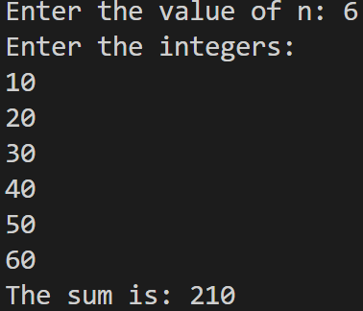

2.
Aim:
To implement a calculator that performs various arithmetic operations.

Algorithm:

- Start the program
- Declare and initialize variables `choice`, `num1`, and `num2` to 0.
- Prompt the user to enter the first number (`num1`).
- Read the value of `num1` from the user.
- Prompt the user to enter the second number (`num2`).
- Read the value of `num2` from the user.
- Display the menu with options for arithmetic operations.
- Read the user's choice (`choice`).
- Perform the following steps in a loop until the user chooses to exit:
  - If `choice` is 1, add `num1` and `num2`, and display the result.
  - If `choice` is 2, subtract `num2` from `num1`, and display the result.
  - If `choice` is 3, multiply `num1` and `num2`, and display the result.
  - If `choice` is 4:
If num2==0, display an error message indicating division by zero is not possible.
Else, divide `num1` by `num2` and display the result.
  - If `choice` is 5, exit the loop.
  - If `choice` is invalid, display an error message.
- End the program.

Time Complexity:
- Addition – O(1)
- Subtraction – O(1)
- Multiplication – O(1)
- Division – O(1)

Program:
Header:
#include <stdio.h>

int add_no(int *n1 , int *n2){
return *n1 + *n2;
}

int sub_no(int *n1 , int *n2){
return *n1 - *n2;
}

int mul_no(int *n1 , int *n2){
return *n1 * *n2;
}

int div_no(int *n1 , int *n2){
return (*n1 / *n2);
}
CPP file:
#include "Q2.h"

int main() {
int n1= 1,n2 =1 ,choosen_opt =1;

while(choosen_opt != 6) {
printf("\nCALCULATOR \n 1)SET \n 2)ADD \n 3)SUBTRACT \n 4)MULTIPLY \n 5)DIVIDE \n 6)EXIT \n");
printf("Choose a number: ");
scanf("%d",&choosen_opt);

switch(choosen_opt) {
case 1:
printf("Enter the value of 1st number: ");
scanf("%d",&n1);

printf("Enter the value of 2nd number: ");
scanf("%d",&n2);

case 2:
printf("Sum of %d and %d is: %d",n1,n2,add_no(&n1,&n2));
break;

case 3:
printf("Difference Of %d and %d is %d",n1,n2,sub_no(&n1,&n2));
break;

case 4:
printf("Multiplication Of %d and %d is %d",n1,n2,mul_no(&n1,&n2));
break;

case 5:
printf("Division Of %d and %d is %d",n1,n2,div_no(&n1,&n2));
break;

case 6:
printf("APPLICATION CLOSED\n");
break;

default:
printf("Not available");
break;
}
}
}
Output:
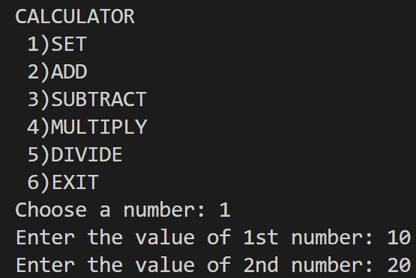
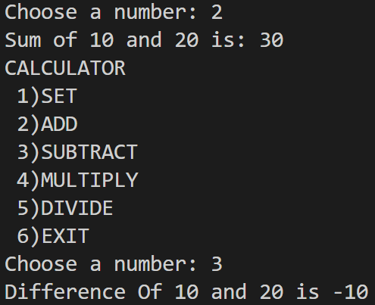
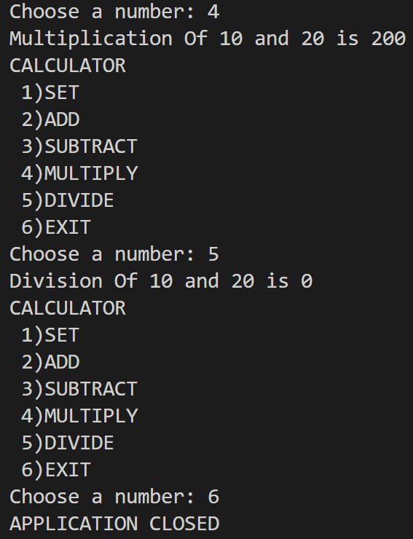

Lab 2 - Searching and Sorting

1)
Aim:
To implement a program to search for the presence of a number in an array.
Algorithm:
    - Set flag to -1.
    - Initialize i to 0.
    - Repeat until i is less than n:
    - If arr[i] equals target:
      - Set flag to i.
      - Break the loop.
    - Increment i by 1.
    - Return flag.
Time complexity -> O(n)
Code:
// Write a C++ program to search for the presence of a number in an array.
#include <stdio.h>
#include <stdlib.h>

int main() {
int *a,*size,*element,*i;
size = (int *)malloc(sizeof(int));
element = (int *)malloc(sizeof(int));
i = (int *)malloc(sizeof(int));
printf("Enter number of elements ");
scanf("%d",size);
a = (int *)malloc(sizeof(int) * (*size));

for ( *i = 0 ; *i < *size ; (*i)++) {
printf("Enter %d element",*i + 1);
scanf("%d",(a + (*i)));
}
printf("Enter a element to search ");
scanf("%d",element);
for(*i = 0 ; *i < *size ; (*i )++ ) {
if(*(a + (*i)) == *element) {
printf("ELEMENT FOUND in %d position\n",(*i) + 1);
return 0;
}

}
printf("Element not found\n");

}
Output:
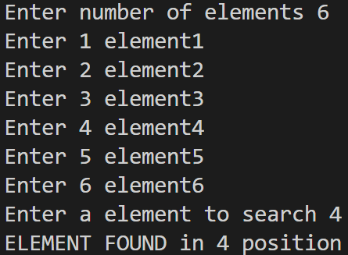

2)

Aim:

To implement a program to search for the presence of a number in an array.

Algorithm:

  - Ascend – sort:

- Initialize variables i, j, and temp.
- Start an outer loop from j = 0 to num - 1.
- Within the outer loop, start an inner loop from i = 0 to num - 1 - j.
- Inside the inner loop:
- Compare n[i] and n[i + 1].
- If n[i] is greater than n[i + 1], swap n[i] and n[i + 1].
- After each pass through the array (j), the smallest element will be placed at the beginning of the array.

  - Descend – sort:

    - Initialize variables i, j, and temp.
    - Start an outer loop from j = 0 to num - 1.
    - Within the outer loop, start an inner loop from i = 0 to num - 1 - j.
    - Inside the loop, compare n[i] and n[i + 1].
    - If n[i] is lesser than n[i + 1], swap n[i] and n[i + 1].
    - After each pass through the array (j), the largest element will be placed at the beginning of the array.

Time Complexity:
The program was implemented using bubble sort algorithm and it has a time complexity of O(n^2) in the worst case, where n is the number of elements in the array.
- Ascending – O(n^2)
- Descending – O(n^2)

Code:
//2. Write a C++ menu-driven program to sort an array of numbers in ascending or descending order. After you write the function for sorting, search online and find what type of sorting you have done in your code.
#include <stdio.h>
#include <stdlib.h>

void ascending(int *arr,int *n){
int *i,*first,*second,*tmp;
first = (int *)malloc(sizeof(int));
second = (int *)malloc(sizeof(int));
tmp = (int *)malloc(sizeof(int));
for(*first = 0;*first <*n -1;(*first)++){
for(*second = *first + 1;*second < *n;(*second)++){
if(*(arr + (*first)) > *(arr + (*second))){
*tmp = *(arr + (*first)) ;
*(arr + (*first)) = *(arr + (*second));
*(arr + (*second)) = *tmp;
}
}
}
for(*i = 0; *i < *n;(*i)++){
printf("%d ",*(arr + (*i)));
}
printf("\n");
}
void descending(int *arr,int *n){
int *i,*first,*second,*tmp;
first = (int *)malloc(sizeof(int));
second = (int *)malloc(sizeof(int));
tmp = (int *)malloc(sizeof(int));
for(*first = 0;*first <*n -1;(*first)++){
for(*second = *first + 1;*second < *n;(*second)++){
if(*(arr + (*first)) < *(arr + (*second))){
*tmp = *(arr + (*first)) ;
*(arr + (*first)) = *(arr + (*second));
*(arr + (*second)) = *tmp;
}
}
}
for(*i = 0; *i < *n;(*i)++){
printf("%d ",*(arr + (*i)));
}
}

int main() {
int option = 0;
int *a,*n,*i;
n = (int *)malloc(sizeof(int));
i = (int *)malloc(sizeof(int));

while(option != 4) {
printf("MENU \n 1)INPUTARRAY \n 2)ASCENDING \n 3)DESCENDING \n 4)EXIT \n ");
printf("Enter the option ");
scanf("%d",&option);
switch(option) {
case 1:
printf("Enter the size of the array ");
scanf("%d",n);
a = (int *)malloc(sizeof(int) * (*n));
for( *i = 0;*i< *n;(*i)++) {
printf("Enter a[%d]",*i);
scanf("%d",a + (*i));

}
break;

case 2:
ascending(a,n);
break;

case 3:
descending(a,n);
break;

case 4:
printf("PROGRAM ENDED");
break;

default:
break;

}

}

Output:
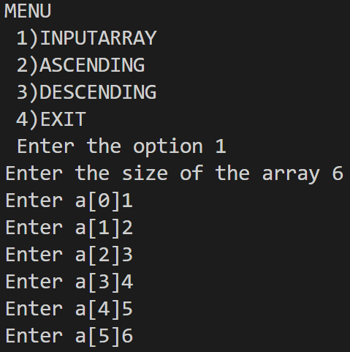
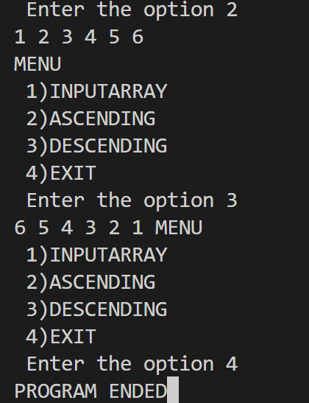

3)
Aim:
Program to search for the given roll number in a sorted array.
Algorithm:
- Compare the roll number with the middle element.
- If present -> return index + 1
Otherwise check if the roll number to be searched is bigger than the number in the current index.
- If so, set the current location as the starting point and repeat 1
- Otherwise, set the current location as the ending point and repeat 1
- If there are no more e
- lements to be searched, then return that the roll number is not present in the array.

Time complexity:
Binary search : O(logn)

Code :
// Program to find a number
#include <stdio.h>
#include <stdlib.h>

int main(){
int *arr,*n,*search,*i;
n = (int *)malloc(sizeof(int));
search = (int *)malloc(sizeof(int));
i = (int *)malloc(sizeof(int));
printf("Enter the size of the array ");
scanf("%d",n);
arr = (int *)malloc(sizeof(int) * (*n));
for(*i = 0 ; *i<*n ; (*i)++){
printf("Enter the number in arr[%d] ",(*i) + 1);
scanf("%d",(arr + (*i)));
}
printf("Enter the number to search ");
scanf("%d",search);
for(*i = 0 ; *i < *n ; (*i)++){
if(*(arr + (*i)) == *search){
printf("Element is at %d position\n",*i + 1);
return 0;
}
}
printf("Element not found \n");
return 0;
}
Output:
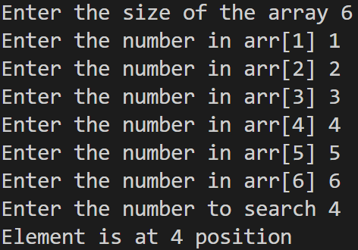

WEEK 3: List ADT: Array implementation Date:07/02/24

Aim:
To write a program to implement List ADT.

Functions used:
- insertbeg();
- display();
- append();
- insertpos();
- deletebeg();
- pop();
- deletepos();
- search();
Algorithm:

- Insert at beginning
Input: num
Output: 1 if element is added else 0
If cur=size-1
Return 0
Else
Temp=cur
While temp!=0
Arr[temp+1]=arr[temp]
Temp--
Arr[0]=num
Inc cur
Return 1

2)Insert at end

Input:num
Output:1 if number is added else 0
If cur=size-1
Return 0
Else
Arr[cur]=num
Return 1

3)Insert at end
Input:num,pos
Output:1 if element is added and 0 if not
If cur=size-1 or pos>cur
Return 0

Else
Temp=pos
Repeat until temp>=cur
Arr[temp+1]=arr[temp]
Arr[pos]=num
Cur++
Return 1

4)Delete at beginning

Input : none
Output: 0 or 1

If cur=-1
Return 0
Else
Temp=0
Repeat until temp=cur
Arr[temp]=arr[temp+1]
Cur - -
Return 1

5) Delete at end

Input: none
Output:0 or 1

If cur=-1
Return 0
Else
Cur - -
Return 1

6) Delete at position

Input: pos
Output:0 or 1

If cur=-1
Return 0;
Else:
If pos=0
Call delbeg
Else if pos=cur
Call delend
Else
Temp=pos
Repeat until temp<=cur
Arr[temp]=arr[temp+1]
Cur- -
Return 1

7) Search

Input: num
Output: 0 or 1

I=0
Repeat until I is not greater than or equal to cur
If arr[i]=num
Return 1

Return 0

8)Display

Input: none
Output: displaying the elements

If cur =-1
Display array is empty
else
Temp=0
Repeat until temp <=cur
Display arr[temp]

Time complexity:

- Insertion at beginning : O(n)
- Insertion at end : O(1)
- Insertion at position : O(n)
- Deletion at beginning: O(n)
- Deletion at end: O(n)
- Deletion at position: O(n)
- Search: O(n)
- Display: O(n)

Code:
/*
1. Write a C++ menu driven program to implement List ADT using arrays. Maintain proper boundary conditions and follow good coding practices.
*/
#include<stdio.h>
#include<stdlib.h>
#define SIZE 5
class List
{
int arr[SIZE];
int cur;
public:
List()
{
cur = -1;
}
int insertbeg(int);
void display();
int append(int);
int insertpos(int,int);
int deletebeg();
int pop();
int deletepos(int);
int search(int);
};

int main()
{
List l1;
int choice, num;
int app;
while (1)
{
printf("\nEnter \n1. Insert Begin\n2. Append\n3. Insert Position");
printf("\n4. Delete Begin\n5. Pop\n6. Delete Position");
printf("\n7. Search\n8. Display\n9. Exit");
printf("\n Enter a choice:");
scanf("%d",&choice);
switch (choice)
{
case 1:
printf("\n Enter the number to insert ");
scanf("%d",&num);
if(l1.insertbeg(num))
{
printf("\n %d successfully inserted.",num);
}
else
{
printf("\n Failed to insert %d. The list is full",num);
}
break;
case 2:
printf("\n Enter the number to append");
scanf("%d",&app);
if(l1.append(app)) {
printf("\n %d SUCCESSFULLY APPENDED ",app);
}
else {
printf("Failed to append");
}
break;

case 3:
int num;
int pos;
printf("\n Enter the number to insert and its position ");
scanf("%d %d",&num,&pos);
if(l1.insertpos(num,pos)) {
printf("Sucessfully inserted %d",num);
}
else{
printf("Empty in middle or position greater than size");
}
break;
case 4:
if(l1.deletebeg()) {
printf("Successfully deleted");
}
else {
printf("Empty list");
}
break;

case 5:
if(l1.pop()) {
printf("Successfully poped");
}
else {
printf("Empty list");
}
break;

case 6:
int position;
printf("Enter the position of the list to delete ");
scanf("%d",&position);
if(l1.deletepos(position)) {
printf("Sucessfully deleted");
}
else if(l1.deletepos(position) == 2) {
printf("The position is empty");
}
else {
printf("List empty");
}
break;

case 7:
int searchelement;
printf("Enter the element to search in the list ");
scanf("%d",&searchelement);
if(!l1.search(searchelement)) {
printf("Not Found");
}
break;
case 8:
l1.display();
break;

case 9:
exit(0);
break;
default:
printf("\n Enter a valid choice\n");
break;
}

}
return 0;
}

//Method to insert a number in begining of the list
int List::insertbeg(int num)
{
if(cur==SIZE-1)
{
return 0;
}
else if(cur==-1)
{
cur = 0;
arr[0]=num;
return 1;
}
else
{
for(int i=cur;i>=0;i--)
{
arr[i+1]=arr[i];
}
cur = cur + 1;
arr[0]=num;
return 1;

}
}
//Method to append a number to last of the list
int List::append(int num) {
if(cur == SIZE-1) {
return 0;
}
else if (cur == -1) {
cur = 0;
arr[0] = num;
return 1;
}
else {
cur = cur + 1;
arr[cur] = num;
return 1;

}
}
//Method to insert a value in its position and shifting the previous values to the rightbrave
int List::insertpos(int num , int pos) {
if(pos > cur + 1 || pos > SIZE) {
return 0;
}
else if(cur == -1 && pos == 0){
cur = 0;
arr[0] = num;
return 1;
}

else {
for(int i=cur;i>=pos;i--){ // If cur < pos for loop will not be triggered and the value will automatically be appended
arr[i+1]=arr[i];
}
cur = cur + 1;
arr[pos]=num;
return 1;

}
}

//Method to delete the beginning value
int List::deletebeg() {
if(cur == -1) {
return 0; // LIST EMPTY
}
else {
for(int i = 0;i < cur + 1 ; i++) {
arr[i] = arr[i+1];

}
cur = cur - 1;
return 1;

}
}

//Method to pop the last element
int List::pop() {
if (cur == -1) {
return 0;
}
else {
//arr[cur] = 0; //0 ACTS AS SPECIAL NUMBER AND USER CANNOT ADD 0 TO THE LIST HEREAFTER
cur = cur - 1;

}
}

//Method to delete element in the position of the list
int List::deletepos(int pos) {
if (cur == -1 || pos > cur) {
return 0;
}
else {
for( int i = pos + 1 ; i < cur + 1; i++ ) {
arr[i] = arr[i+1];
}
cur = cur - 1;
return 1;
}
}

//Method to search for the element in the list
int List::search(int searchelement) {
for(int i = 0 ; i< (cur + 1) ; i++) {
if(arr[i] == searchelement) {
printf("The element %d is found in the %d position",searchelement,i);
return 1;
}
}
return 0;
}

//Method to display the contents of the list
void List::display() {
{
printf("\nThe contents of the list are:");
for(int i=0;i<=cur;i++)
{
printf("%d ",arr[i]);
}
}
}
Output:
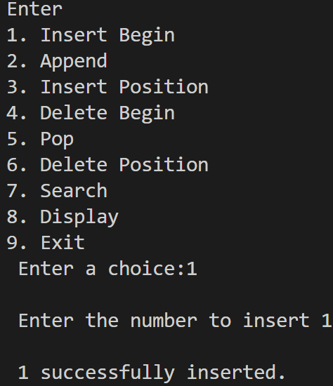

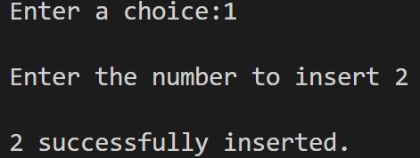
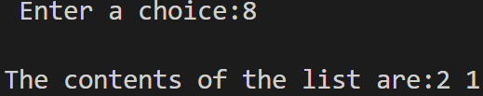
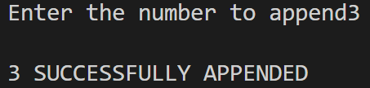
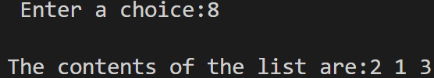

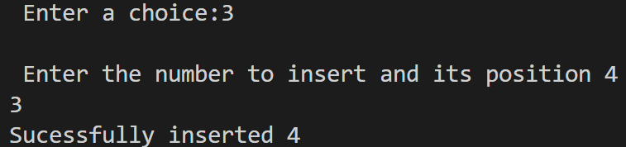
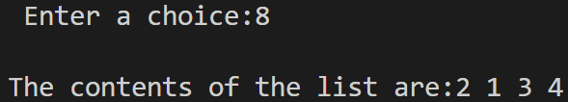
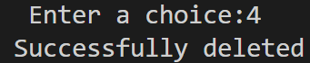
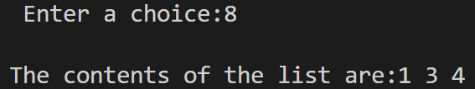
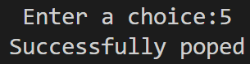
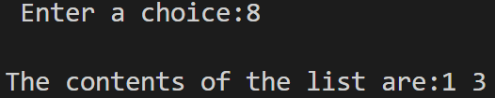
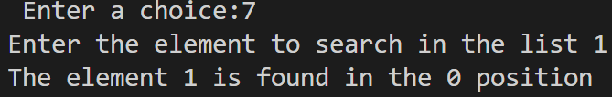
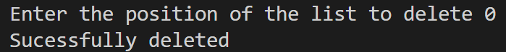
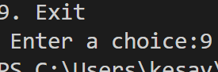

WEEK 4:LIST ADT:SINGLY LINKED LIST Date:14/02/24
Aim:
To Write a C++ menu-driven program to implement List ADT using a singly linked list.
Functions used and time complexity:
- int insert_beg(int num) : O(1)
- int insert_end(int num) : O(n)
- int insert_pos(int num , int pos) : O(n)
- int del_beg() : O(1)
- int del_end() : 0(n)
- int del_pos(int pos) : O(n)
- int search(int num) : O(n)
- void display() : O(n)
- void displayreverse() : O(n)
- int reverselist() : O(n)
- int size() : O(n)

Algorithms:

1.INSERT AT BEGINNING:

Input:num
Output: 0 or 1

If head=NULL
Head=newnode
Return 1
Else
Newnode->next=head
Head=newnode
Return 1

2.INSERT AT END:

Input:num
Output:0 or 1

If head=NULL
Head=newnode
Return 1
Else
Temp=head
Repeat until temp->next!=NULL
Temp=temp->next
Temp->next=newnode
Return 1

3.INSERT AT POS:

Input:num,pos
Output:0 or 1

If pos=0
Call insertbeg()
Else
Temp=head
Repeat until temp->next!=NULL and pos!=1
Temp=temp->next
Pos- -
Newnode->next=temp->next
Temp->next=newnode
Return 1

4.DELETE AT BEGINNING:

Input: none
Output: 0 or 1

If head==NULL
Return 0
Else
Head=head->next
Return 1

5.DELETE AT END:

Input: none
Output:0 or 1

If head=NULL
Return 0
Else
Temp=head
Repeat until temp->next!=NULL
Temp2=temp
Temp=temp->next
Temp2->next=NULL
Free(temp)
Return 1

6.DELETE AT POS:

Input: pos
Output: 0 or 1

If head=NULL
Return 0
Else
Temp=head
Repeat until temp->next!-NULL and pos!=1
Temp2=temp
Temp=temp->next
Pos- -
Temp2->next=temp->next
Free(temp)
Return 1

7.SEARCH:

Input: num
Output: 0 or 1

If head=NULL
Return 0
Else
Temp=head
Repeat until temp->next!=NULL
If temp->data=num
Return 1
Temp=temp->next
Return 0

8.DISPLAY:

Input:none
Output: All the elements in the list

If head=NULL
Display the list is empty
Else
Temp=head
Repeat until temp!=NULL
Display temp->data
Temp=temp->next

9.DISPLAY REVERSE:

Input:none
Ouput: elements displayed in reverse order

If head=NULL
Return
Else
Call disrev(head->next)
Display head->data

10.REVERSELINK :
Input: none
Output: List is reversed (0 or 1)

If head=NULL
Return 0
Else
Initialize temp1 and temp2 to NULL
Repeat until head!=NULL
Temp2=head->next
Head->next=temp1
Temp1=head;
Head=temp2
Head=temp1
Return 1

Code:
/*
A. Write a C++ menu-driven program to implement List ADT using a singly linked list. Maintain proper boundary conditions and follow good coding practices. The List ADT has the following operations,

1. Insert Beginning
2. Insert End
3. Insert Position
4. Delete Beginning
5. Delete End
6. Delete Position
7. Search
8. Display
9. Display Reverse
10. Reverse Link
11. Exit
*/

#include <stdio.h>
#include <stdlib.h>

class List {
struct Node {
int data;
struct Node *next;
};

struct Node *newnode = (struct Node *)malloc(sizeof(struct Node));
struct Node *head;

public:
List() {
head = NULL;
}
int insert_beg(int num);
int insert_end(int num);
int insert_pos(int num , int pos);
int del_beg();
int del_end();
int del_pos(int pos);
int search(int num);
void display();
void displayreverse();
int reverselist();
int size();

};

int main() {
List l1;
int choice;
int num;
int pos;
while(1) {

printf("\n SINGELY LINKED LIST \n");
printf("\n 1. Insert Beginning \n 2. Insert End \n 3. Insert Position");
printf("\n 4. Delete Beginning \n 5. Delete End \n 6. Delete Position");
printf("\n 7. Search \n 8. Display \n 9. Display Reverse \n 10. Reverse Link \n 11. Exit");
printf("\n Enter the choice ");
scanf("%d",&choice);

switch(choice) {
case 1:
printf("Enter the number ");
scanf("%d",&num);
if(l1.insert_beg(num)) {
printf("\n Inserted successfully.");
}
else {
printf("\n Insertion unsuccessful.");
}
break;

case 2:
printf("Enter the number ");
scanf("%d",&num);
if(l1.insert_end(num) == 2) {
printf("Insertion successful.");
}
break;

case 3:
printf("Enter the number and position to insert ");
scanf("%d %d",&num,&pos);
if(l1.insert_pos(num , pos)) {
printf("Inserted successfully.");
}
else {
printf("Position out of bounds");
}

break;

case 4:
if(l1.del_beg()) {
printf("Deleted successfully.");
}
else {
printf("List is empty.");
}
break;

case 5:
if(l1.del_end()) {
printf("Deleted successfully.");
}
else {
printf("The list is empty.");
}
break;

case 6:
printf("Enter the position ");
scanf("%d",&pos);
if(l1.del_pos(pos)) {
printf("Deleted successfully.");
}
else {
printf("The list is empty.");
}
break;

case 7:
printf("Enter the number ");
scanf("%d",&num);
printf("%d \n",l1.search(num));
break;

case 8:
l1.display();
break;

case 9:
l1.displayreverse();
break;

case(10):
if(l1.reverselist()) {
printf("Successfully reversed.");
}
else {
printf("The list is empty.");
}
break;

}
}

}

//Getting the size of the singely linked list.
int List::size() {
struct Node *temp = head;
int count = 0;
if(head == NULL) {
return 0;
}

else {
while(temp != NULL) {
count = count + 1;
temp = temp -> next;
}
return count;
}
}

//Inserting at the beginning of the singely linked list.
int List::insert_beg(int num) {
struct Node *newnode = (struct Node *)malloc(sizeof(struct Node));
newnode -> data = num;
newnode -> next = head;
head = newnode;
return 1;

}

//Inserting at the end of the singely linked list.
int List::insert_end(int num) {
struct Node *newnode = (struct Node *)malloc(sizeof(struct Node));
struct Node *temp = head;
newnode -> data = num;
newnode -> next = NULL;
if(head == NULL) {
head = newnode;
return 2;
}

else {
while(temp -> next != NULL) {
temp = temp -> next;

}
temp -> next = newnode;
return 2;
}
}

//Inserting at a position in the singely linked list.
int List::insert_pos(int num , int pos) {
int count = 0;
struct Node *temp = head;
struct Node *temp2;
struct Node *newnode = (struct Node *)malloc(sizeof(struct Node));
newnode -> data = num;

if(pos > (size())) {
return 0;
}
else {
if(head == NULL && pos == 0) {
insert_beg(num);
}
else if(pos == 1) {
temp = head -> next;
head -> next = newnode;
newnode -> next = temp;
return 1;
}
else {
while(count < pos - 1) {
temp = temp -> next;
count++;
}
temp2 = temp -> next;
temp -> next = newnode;
newnode -> next = temp2;
return 1;
}
}
}

//Deleting the beginning of the singely linked list.
int List::del_beg() {
struct Node *temp;
struct Node *temp2;
if(head == NULL) {
printf("The list is empty.");
return 0;
}

else {
temp2 = head; //temp2 stores the memory address of 0 element
temp = head -> next; //temp stores the memory of 1 element
head = temp;
free(temp2);
return 1;
}
}

//Deleting the end of the singely linked list.
int List::del_end() {
struct Node *temp = head;
if(head == NULL) {
return 0;
}
else {
while(temp -> next -> next != NULL) {
temp = temp -> next;
}
temp -> next = NULL;
free(temp -> next); //Frees the node in the memory address.
return 1;
}
}

//Deletes the element in that position in the singely linked list.
int List::del_pos(int pos) {
struct Node *temp = head;
struct Node *prev = head;
int count = 0;
if(head == NULL) {
return 0;
}

else {
while(count < pos && temp != NULL) {
prev = temp;
temp = temp -> next;
count++;
}
prev -> next = temp -> next; //Links previous node to one after the other.
return 1;
}
}

//Searching the number in the singely linked list.
int List::search(int num) {
struct Node *temp = head;
int count = 0;

while(temp -> data != num) {
temp = temp -> next;
count++;
}
return count;

}

//Displaying the data of each nodes in the singely linked list.
void List::display() {
struct Node *temp = head;
if(head == NULL) {
printf("List empty");
}
else {
while(temp != NULL) {
printf("%d ",temp->data);
temp=temp->next;
}
}
}

void List::displayreverse() {
int arr[100];
int count = 0;
struct Node *temp = head;
if(head == NULL) {
printf("List empty");
}

else {
while(temp != NULL) {
arr[count] = temp -> data;
temp = temp -> next;
count = count + 1;
}
}

for(int i = count-1 ; i >= 0 ; i--) {
printf("%d\n",arr[i]);
}
}

//Method to reverse List in the singely linked list.
int List::reverselist()
{
if(head==NULL)
{
return 0;
}
struct Node *left = head;
struct Node *temp1;
struct Node *temp2;
temp2=left->next;
while(temp2!=NULL)
{
temp1=left;
left=temp2;
temp2=left->next;
left->next=temp1;
}
head->next=NULL;
head=left;

return 1;
}
Output:

