SCREENSHOT FILE

COURSE END PROJECT 2

::Step 0: Login using azure cli

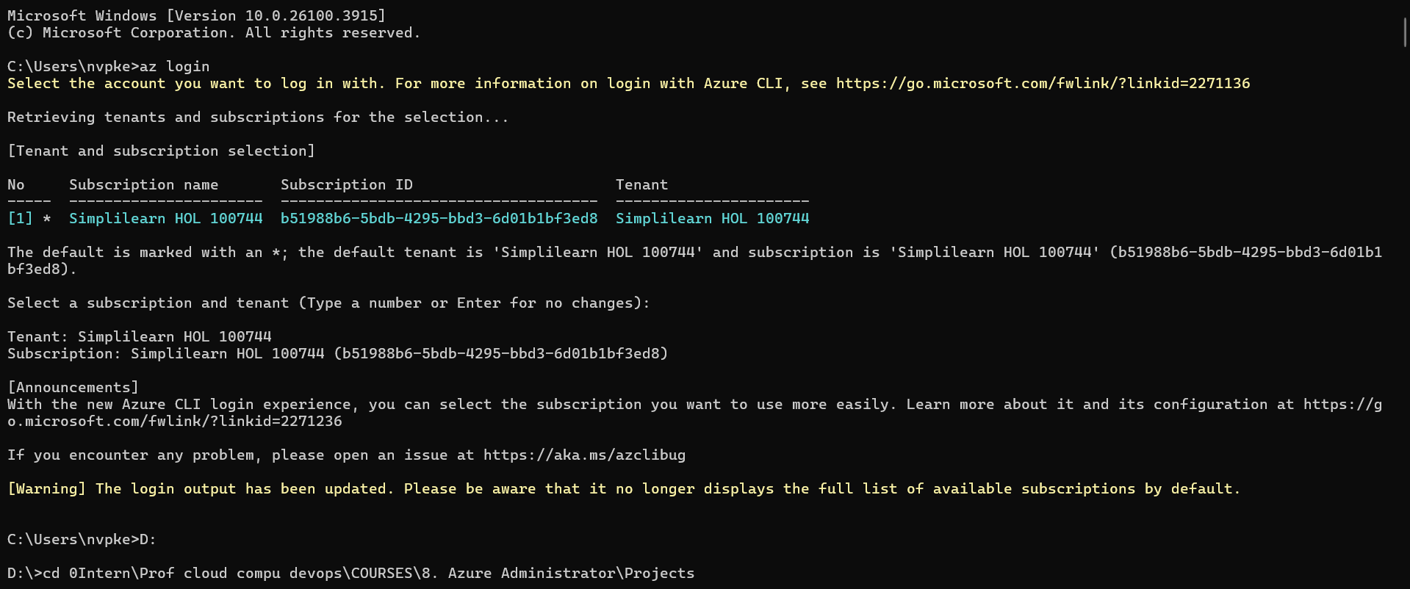

:: Step 1: Create a Resource Group

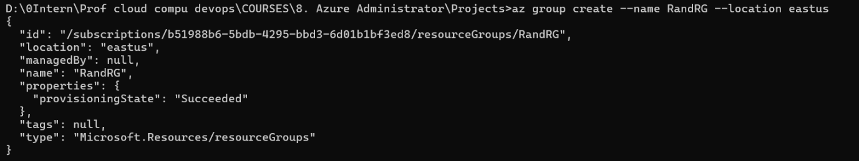

:: Step 2: Create Virtual Network and Subnet

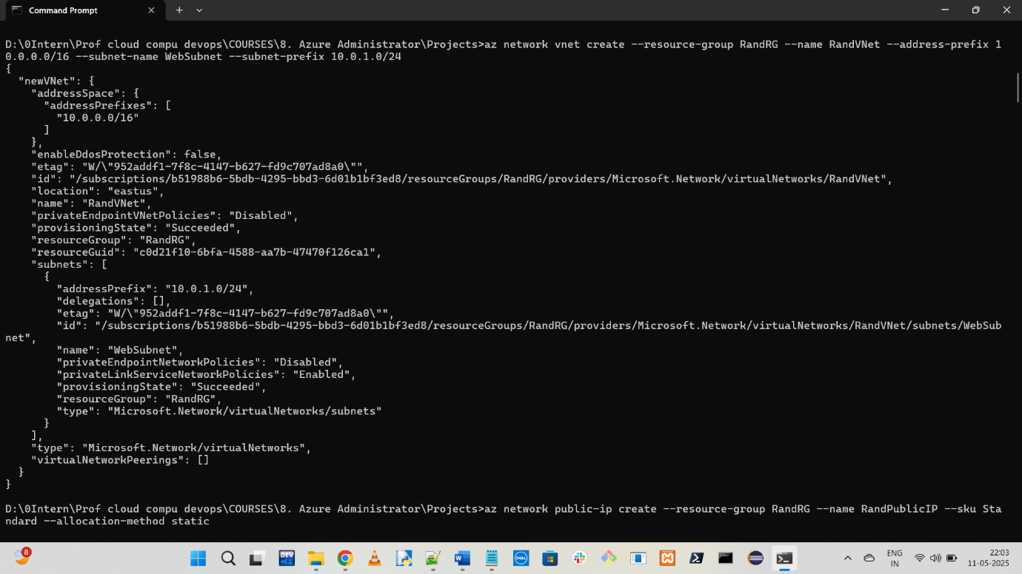

:: Step 3: Create Public IP for Load Balancer

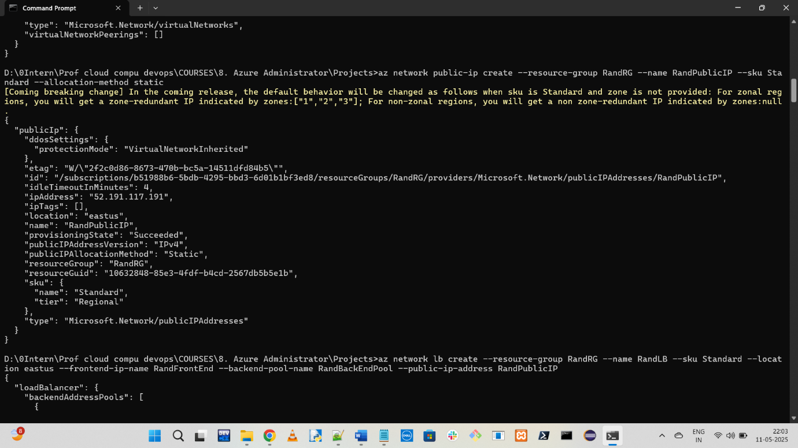

:: Step 4: Create Load Balancer

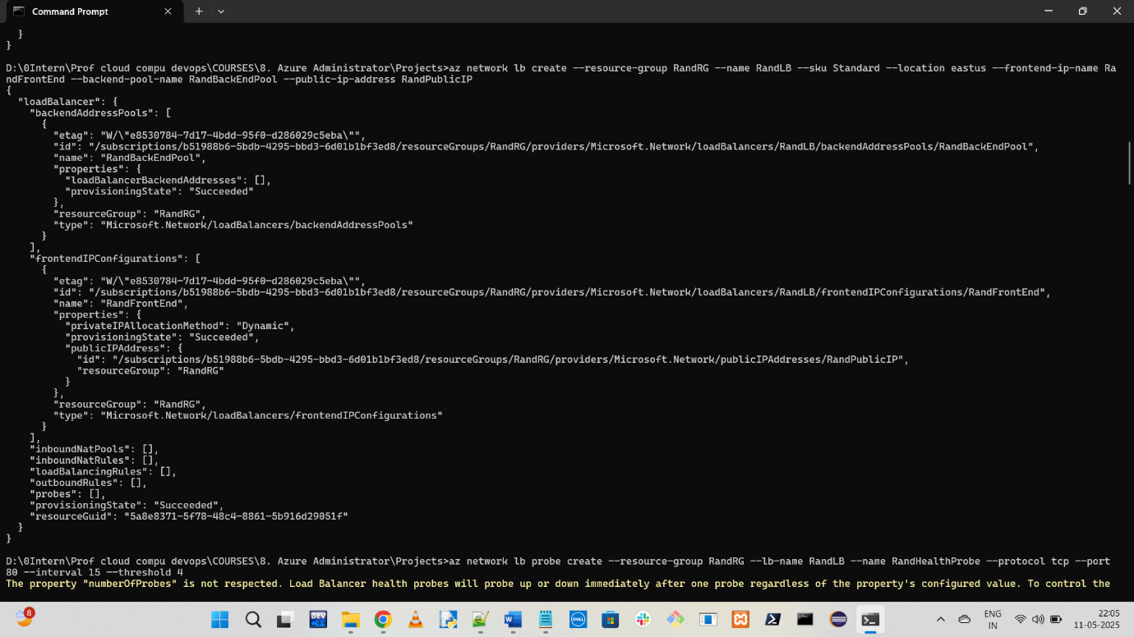

:: Step 5: Create Health Probe

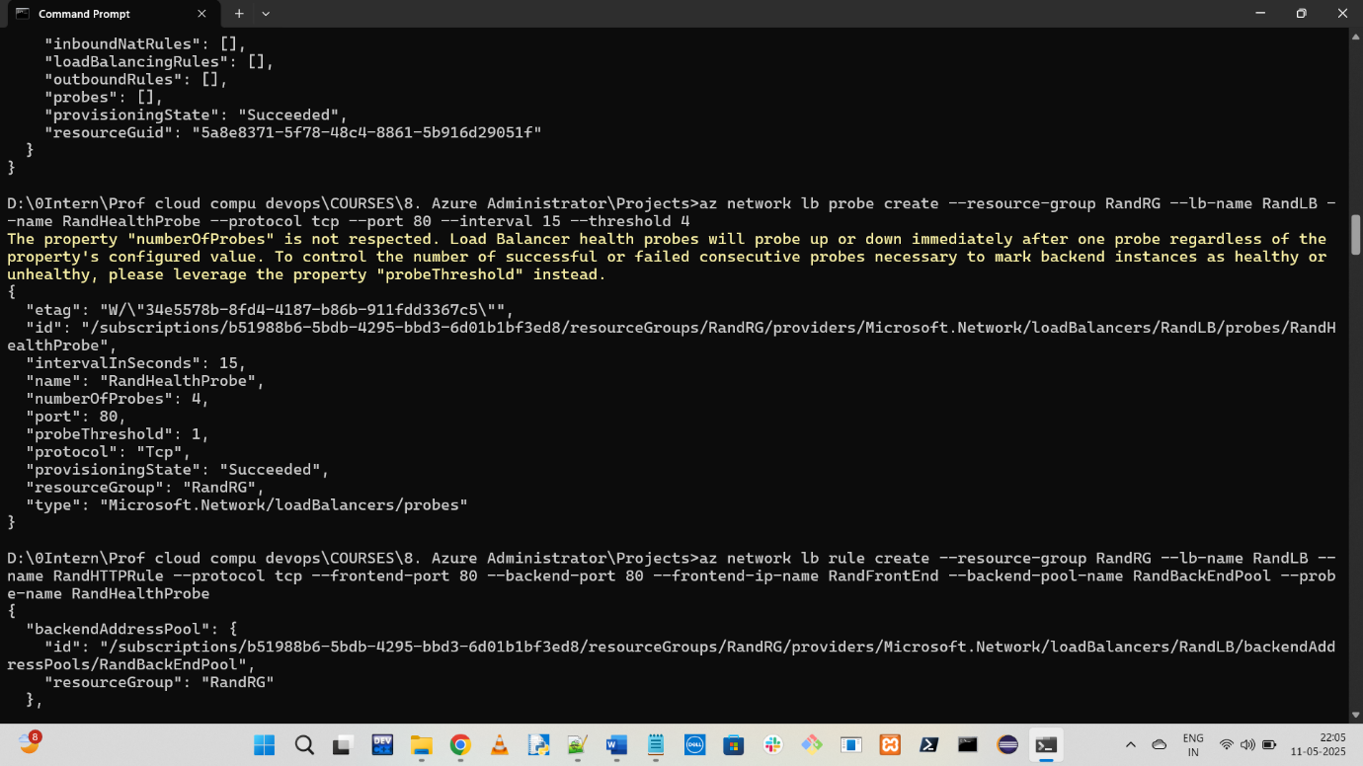

:: Step 6: Create Load Balancer Rule



:: Step 7: Create NSG and allow HTTP traffic

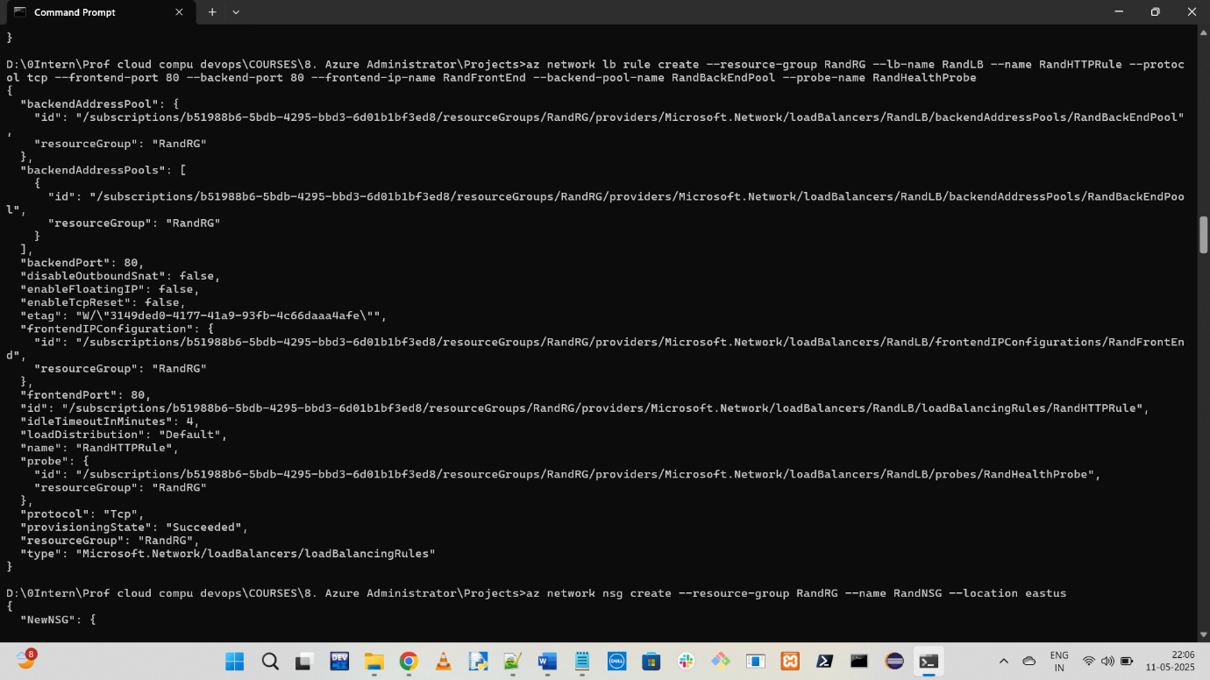

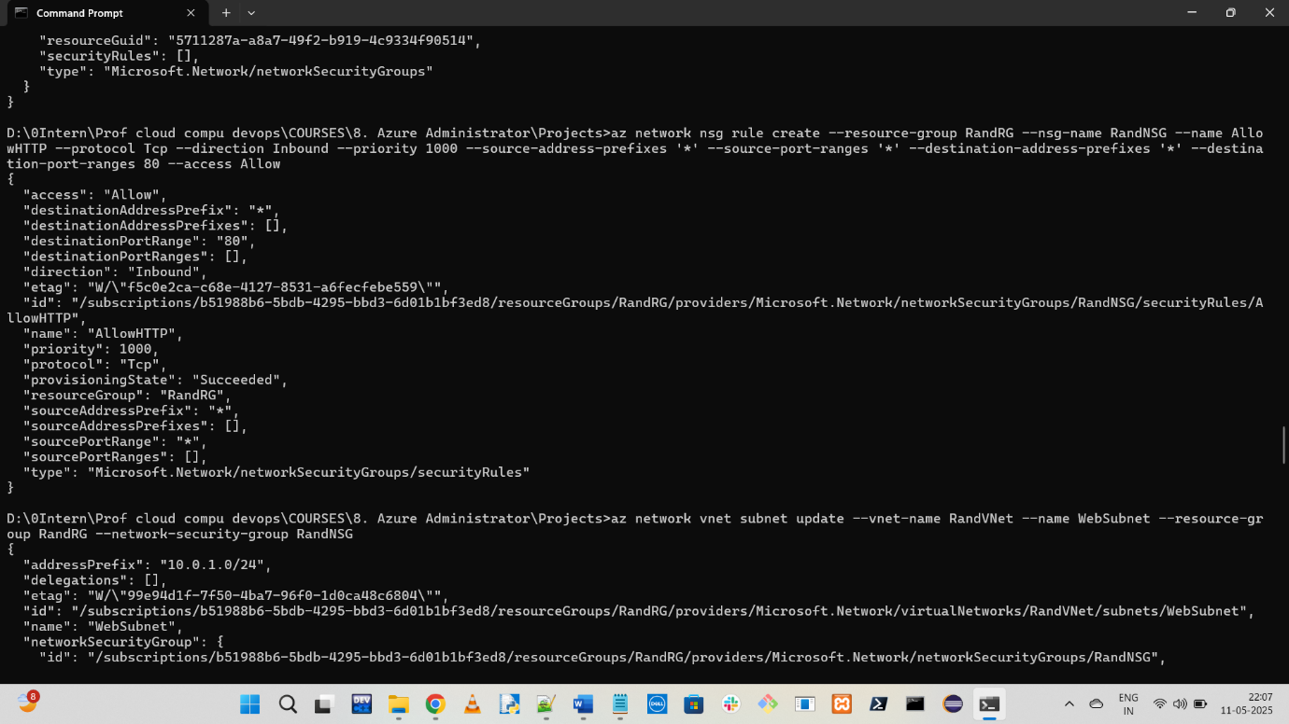

:: Step 8: Associate NSG to subnet

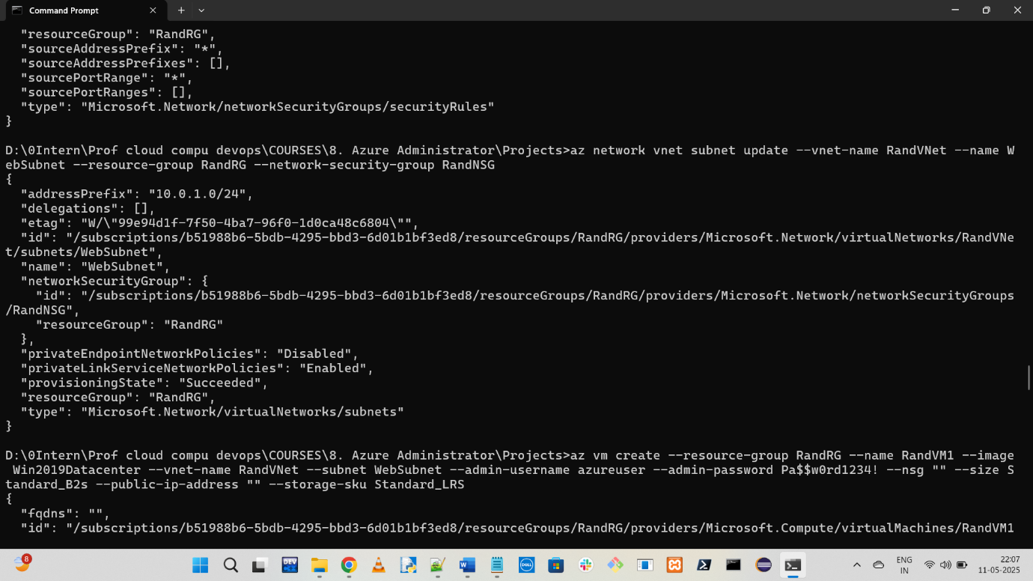

:: Step 9: Create two VMs without public IPs

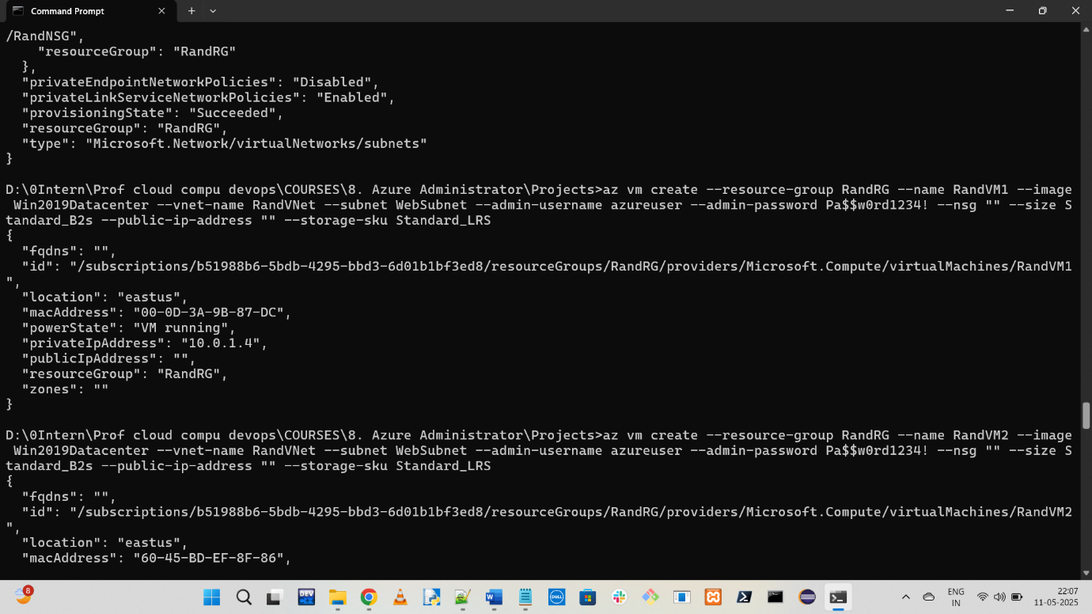

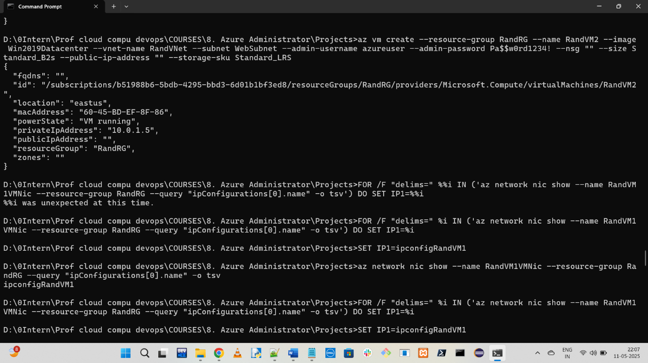

:: Step 10: Get IP config names for NICs

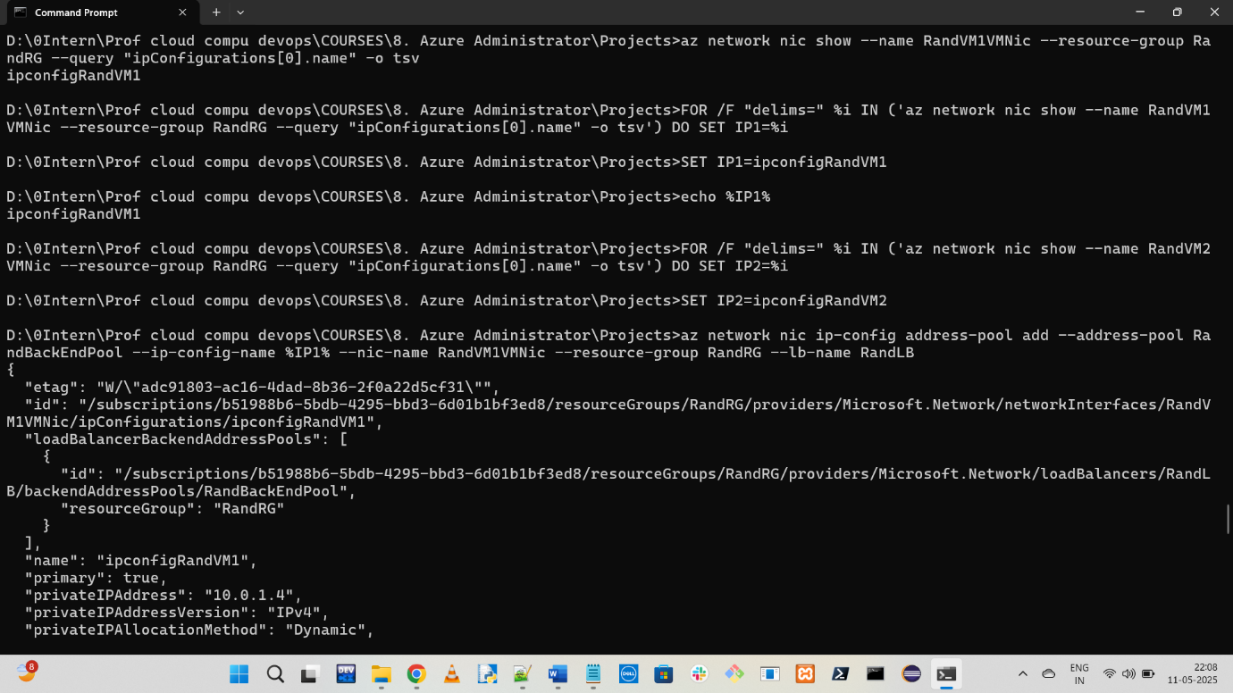

:: Step 11: Attach VMs to backend pool

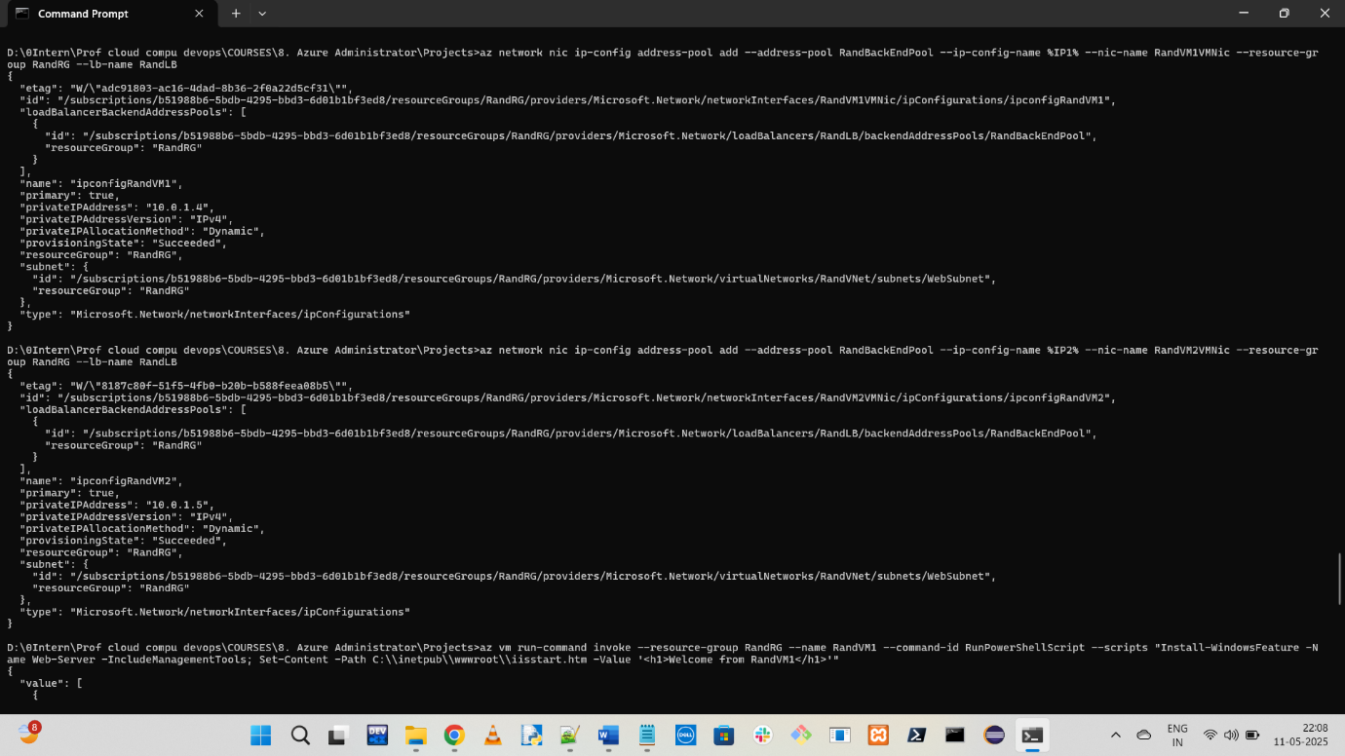

:: Step 12: Install IIS on both VMs

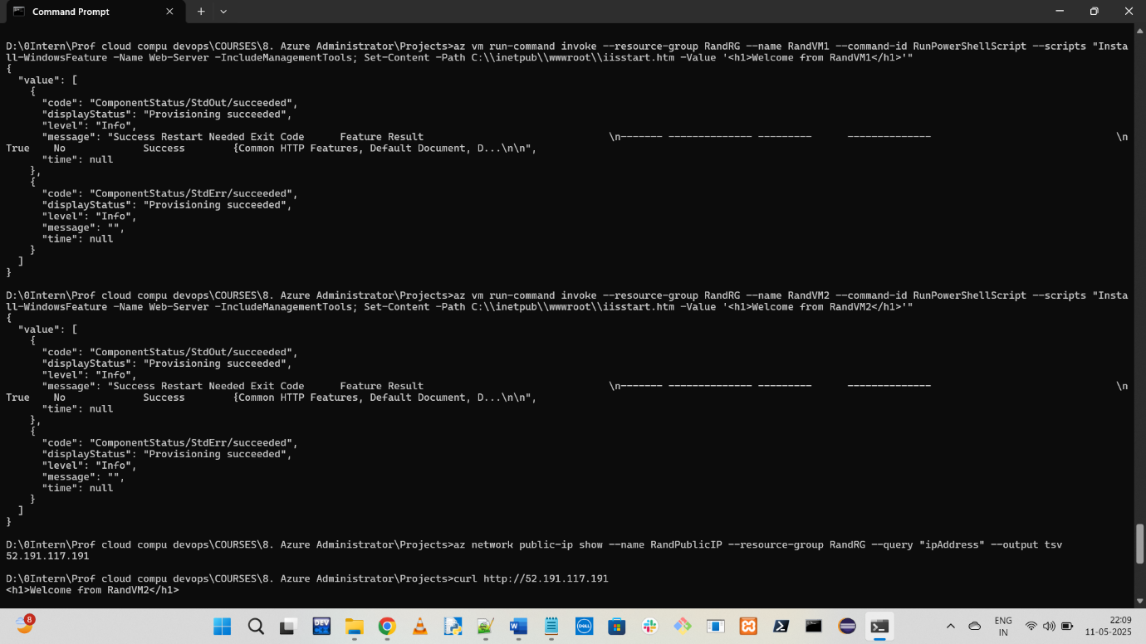

:: Step 13: Get Load Balancer IP

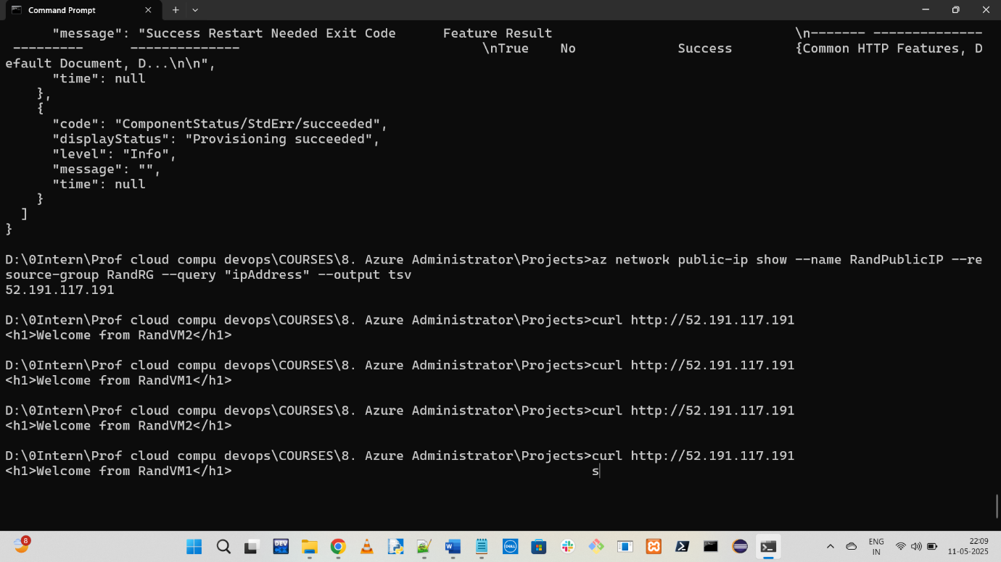

:: Step 14: See the output

