**SCREENS SHOTS:**

RESPIRATORY ANALYSIS DETECTION OF VARIOUS LUNG INFECTIONS USING COUGH SIGNAL

In this project we are using respiratory audio dataset to predict various diseases such as Asthma, Pneumonia, Bronchiectasis and many more. To implement this project we have taken disease diagnosis dataset and respiratory audio dataset and then extract features from all audio dataset and then trained a convolution neural network (CNN) algorithm model. After training model we can upload any new test data to predict disease from it.

To implement this project we have designed following modules

1. Upload Respiratory Audio Dataset: using this module we will upload disease diagnosis dataset and respiratory audio dataset
2. Extract Features from Audio Dataset: using this module we will extract features from both datasets and then build training dataset
3. Train CNN Algorithm: using above train dataset we will train CNN model and then build a trained model and this model can be used to predict disease from any new test audio files
4. CNN Accuracy & Loss Graph: using this module we will display comparison graph between accuracy and loss of CNN trained model
5. Upload Test Audio & Predict Disease: using this module we will upload test audio files and then apply CNN trained model on that test audio to predict disease

We have used below dataset to trained CNN model

To run project double click on ‘run.bat’ file to get below screen

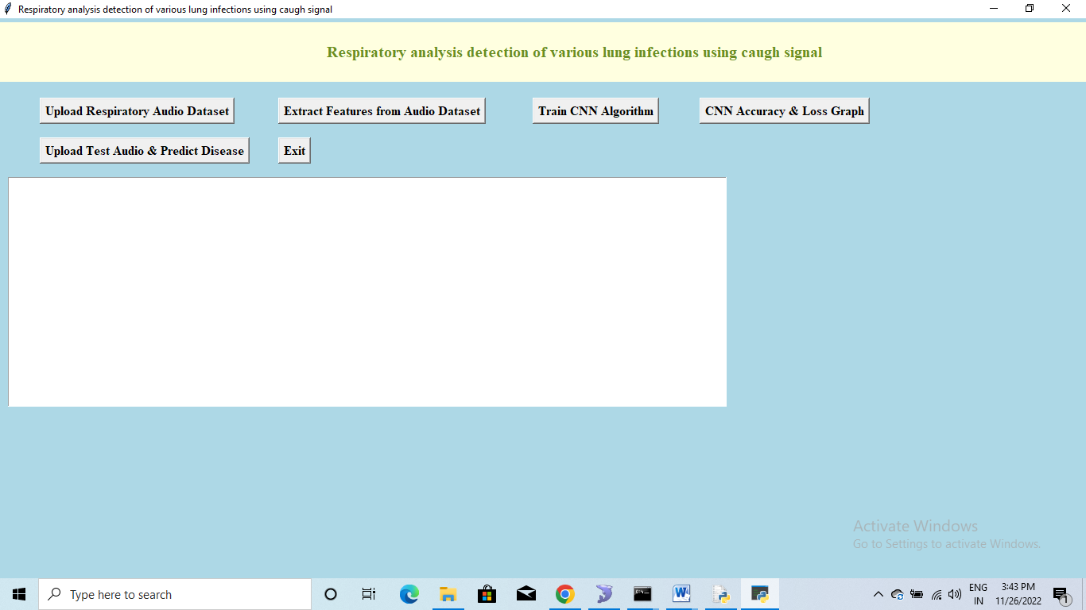

In above screen click on ‘Upload Respiratory Audio Dataset’ button to upload dataset

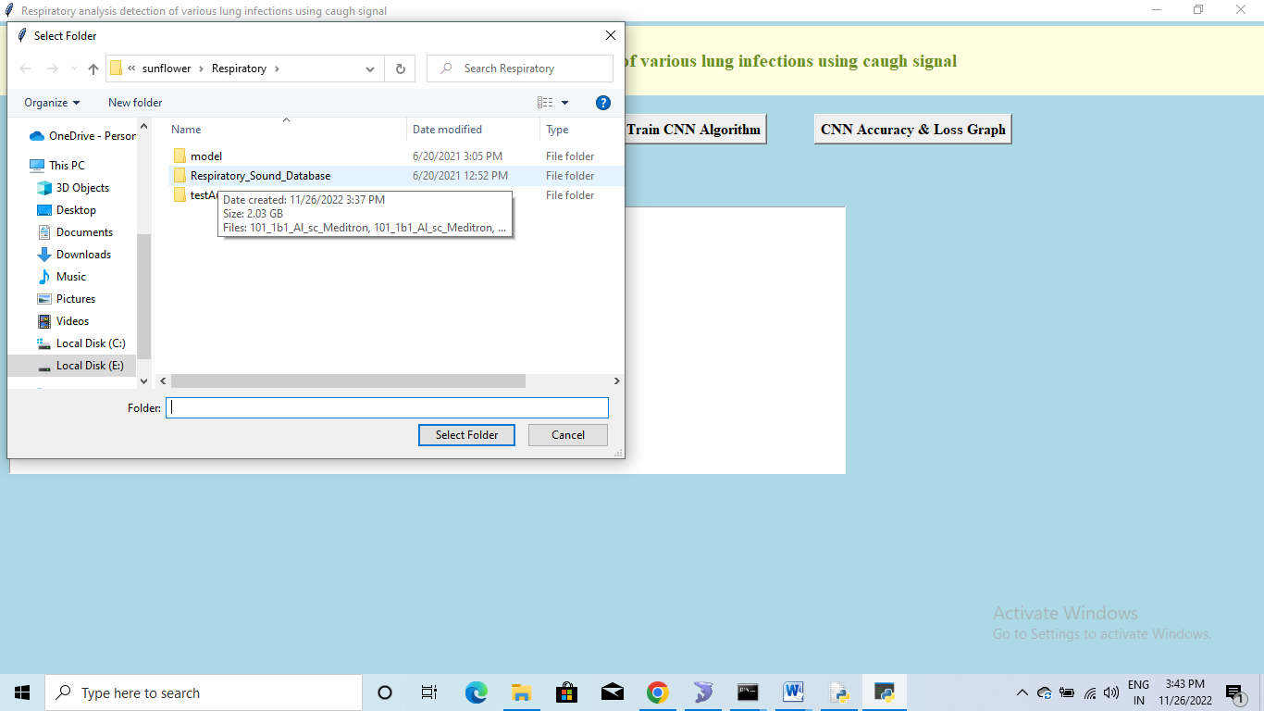

In above screen selecting and uploading entire respiratory sound folder and then click on ‘Select Folder’ button to load dataset and to get below screen

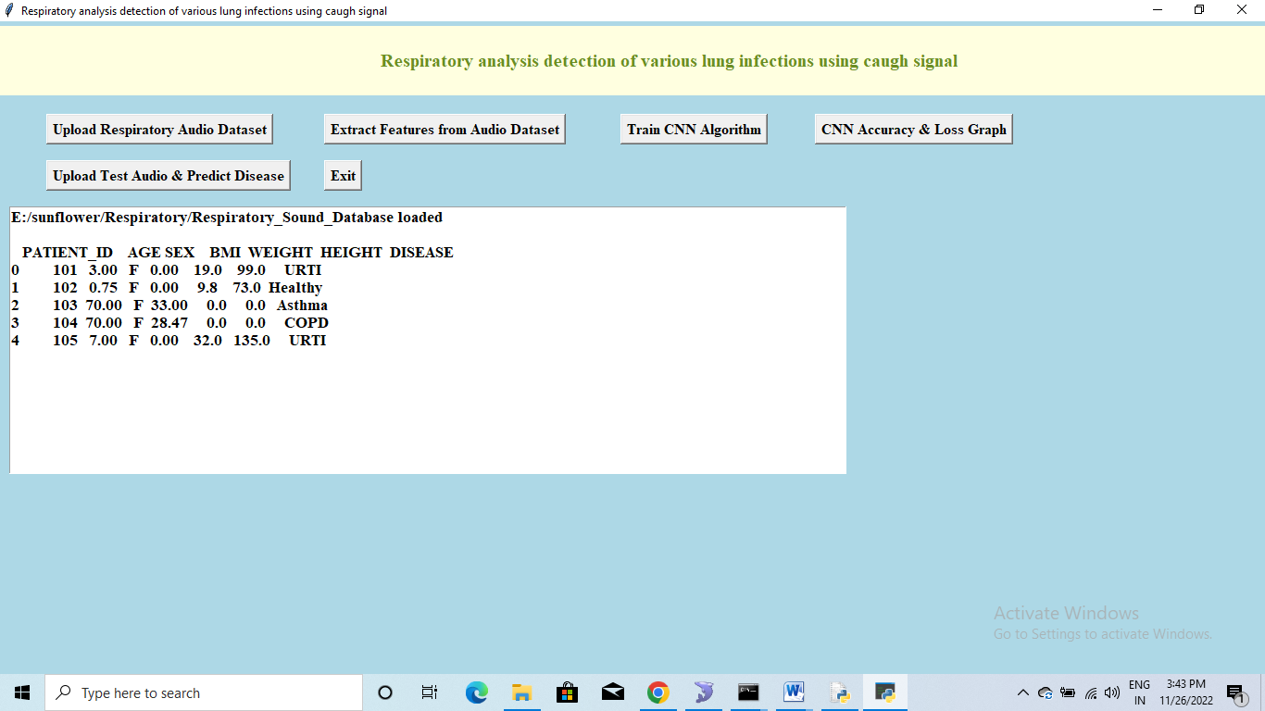

In above screen for each patient we can see associated with disease diagnose and above disease will be used as class label for each extracted audio features and now click on ‘Extract Features from Audio Dataset’ button to extract features from each audio files and then associate detected disease as class label to audio file.

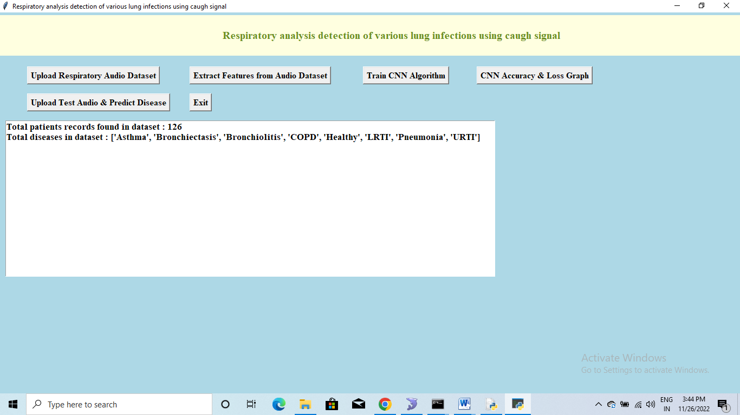

In above screen application found 126 patients audio files and this audio dataset contains 8 different diseases and now dataset is ready and now click on ‘Train CNN Algorithm’ button to train CNN with above dataset and then calculate CNN prediction accuracy

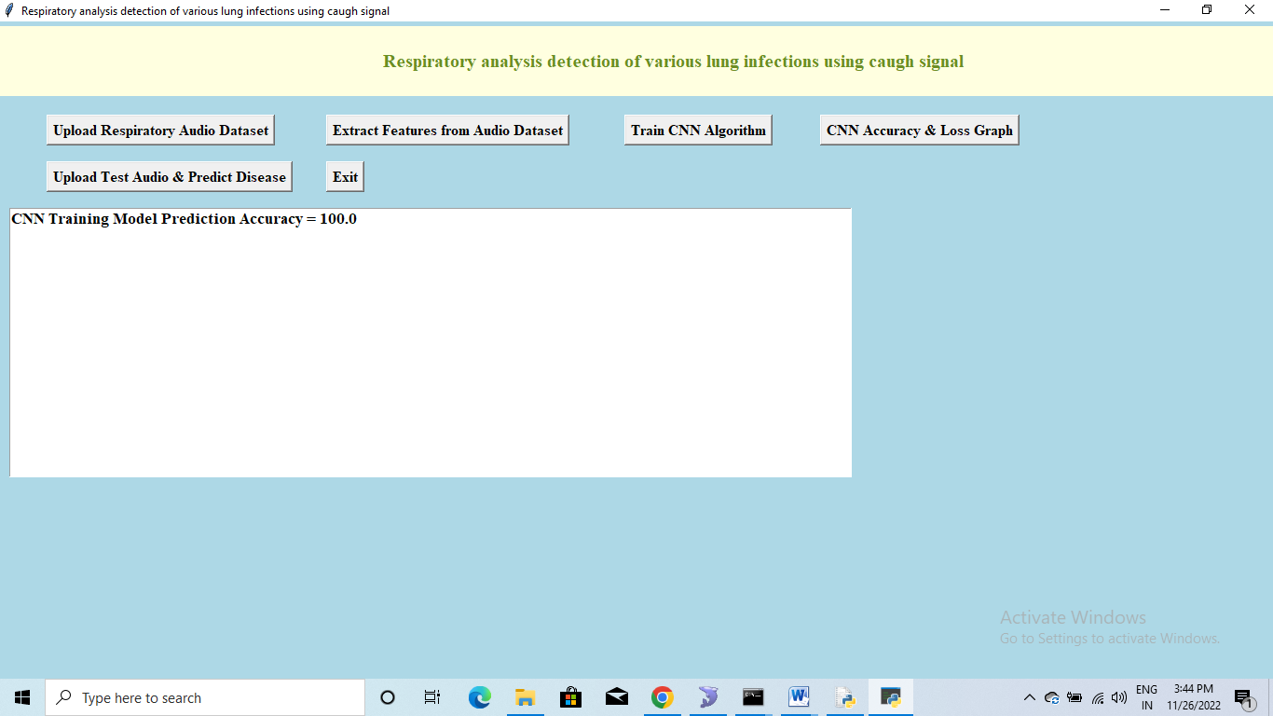

In above screen CNN trained on audio features and got 100% accuracy and now click on ‘CNN Accuracy & Loss Graph’ button to get below graph

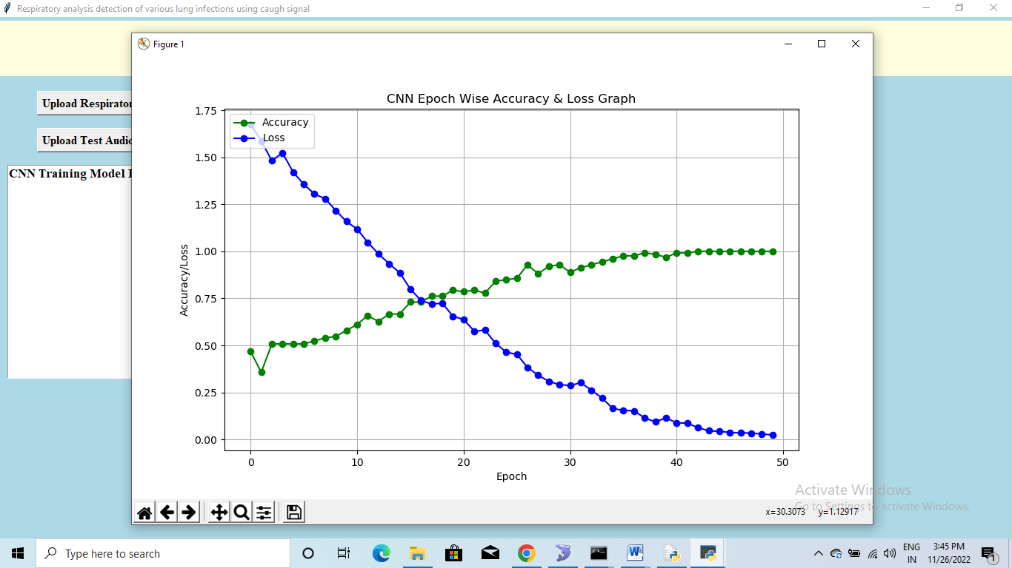

In above graph x-axis represents EPOCH/ITERATIONS and Y-axis represents accuracy and loss values and green line represents accuracy and blue line represents LOSS and we used 50 EPOCH to train CNN model and we can see with each increasing epoch accuracy get increased and loss value got decrease to 0 and accuracy increased to 100%. Now click on ‘Upload Test Audio & Predict Disease’ button to upload test audio file

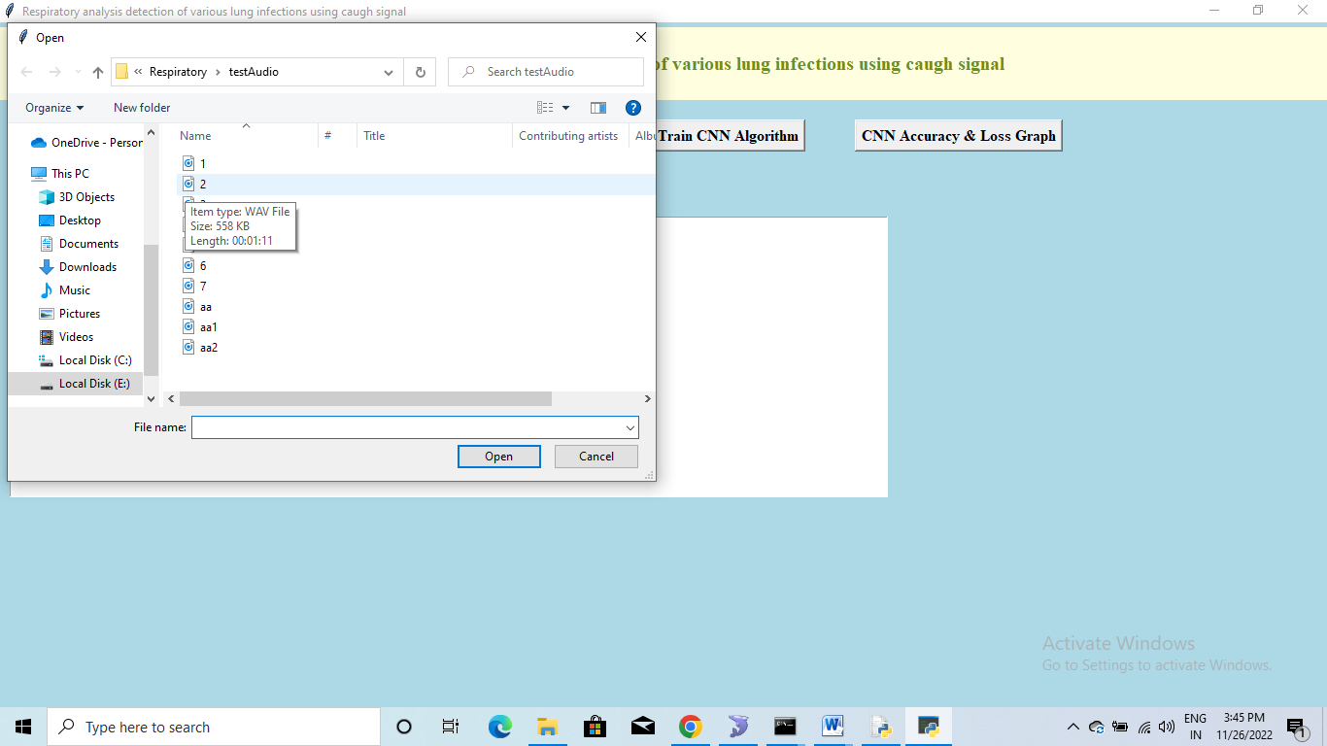

In above screen selecting and uploading ‘aa.wav’ file and then click on ‘Open’ button to get below prediction result

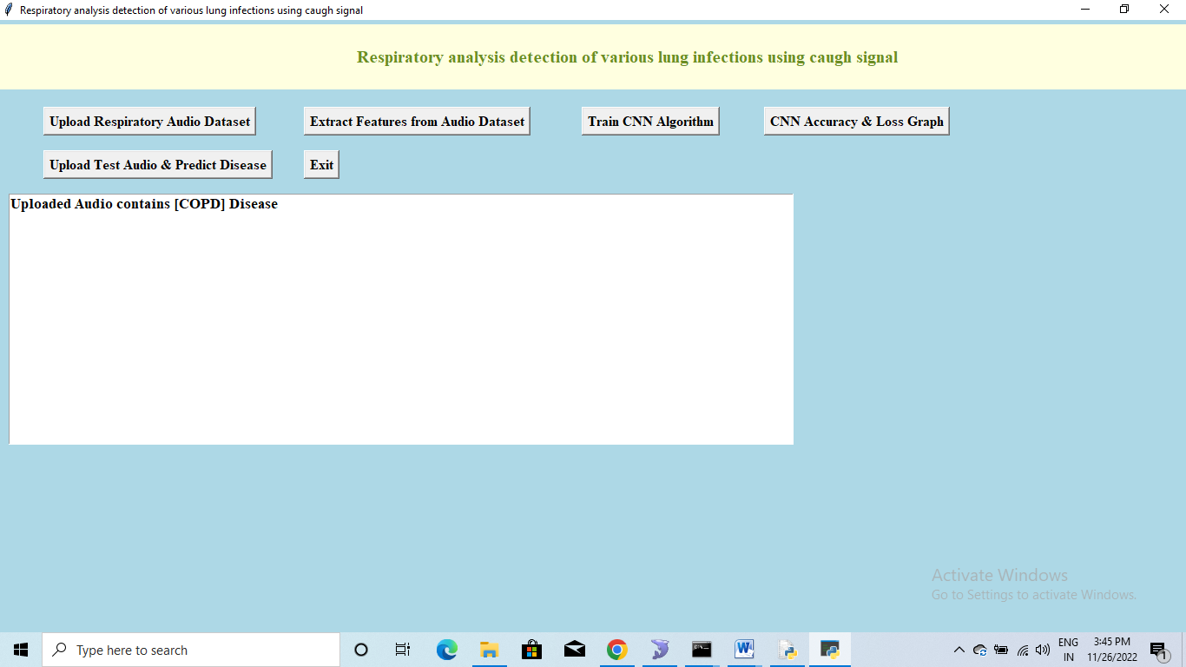

In above screen in blue colour text we can see disease predicted as “COPD” form uploaded audio file and test with other file also