XAI ICU Mortality Prediction System
Comprehensive Technical Report

Generated: January 25, 2026
Institution: IIIT Ranchi

1. Executive Summary
This report presents the XAI ICU Mortality Prediction System, an explainable AI framework for predicting in-hospital mortality in ICU patients. The system combines state-of-the-art deep learning techniques with clinical safety guardrails and uncertainty quantification.
Key Achievements:
• Research Model AUROC: 0.924
• Deployment Model AUROC: 0.964
• Safety Layer Precision: 100%
• Comprehensive XAI with Counterfactual Explanations

2. Dataset Description

2.1 MIMIC-IV Overview
The system is trained and validated on the MIMIC-IV (Medical Information Mart for Intensive Care) dataset, a large, freely-available database of de-identified health records from ICU patients at Beth Israel Deaconess Medical Center.

2.2 Cohort Statistics
Metric | Value
Total Patients | 42,951
Total Admissions | 166,062
In-Hospital Mortality Rate | 4.3%
Median Length of Stay | 4.2 days

2.3 Data Files
File | Description | Records
admissions_100k.csv | Hospital admissions with mortality labels | 166,062
icustays_100k.csv | ICU stay records | ~50,000
chartevents_100k.csv | Vital signs and lab values | ~800M
prescriptions_100k.csv | Medication orders | 10,538,716
drgcodes_100k.csv | Diagnosis-related groups | ~200,000

3. Exploratory Data Analysis

3.1 Vital Signs Analysis
Total chart event records: 795,956
Records per patient: 3618
Missing rate: 0.0%

3.2 Time Gap Analysis
Statistic | Value
Mean Δt | 2.9 minutes
Median Δt | 0.0 minutes
Std Δt | 16.5 minutes

The high variance in time gaps confirms the need for adaptive time constant modeling (τ adaptation in Liquid Neural Network cells).

3.3 Medication Analysis
Metric | Value
Total Prescriptions | 10,538,716
Unique Drugs | 6,817
Patients with Vasopressors | 24,613

3.4 Visualizations
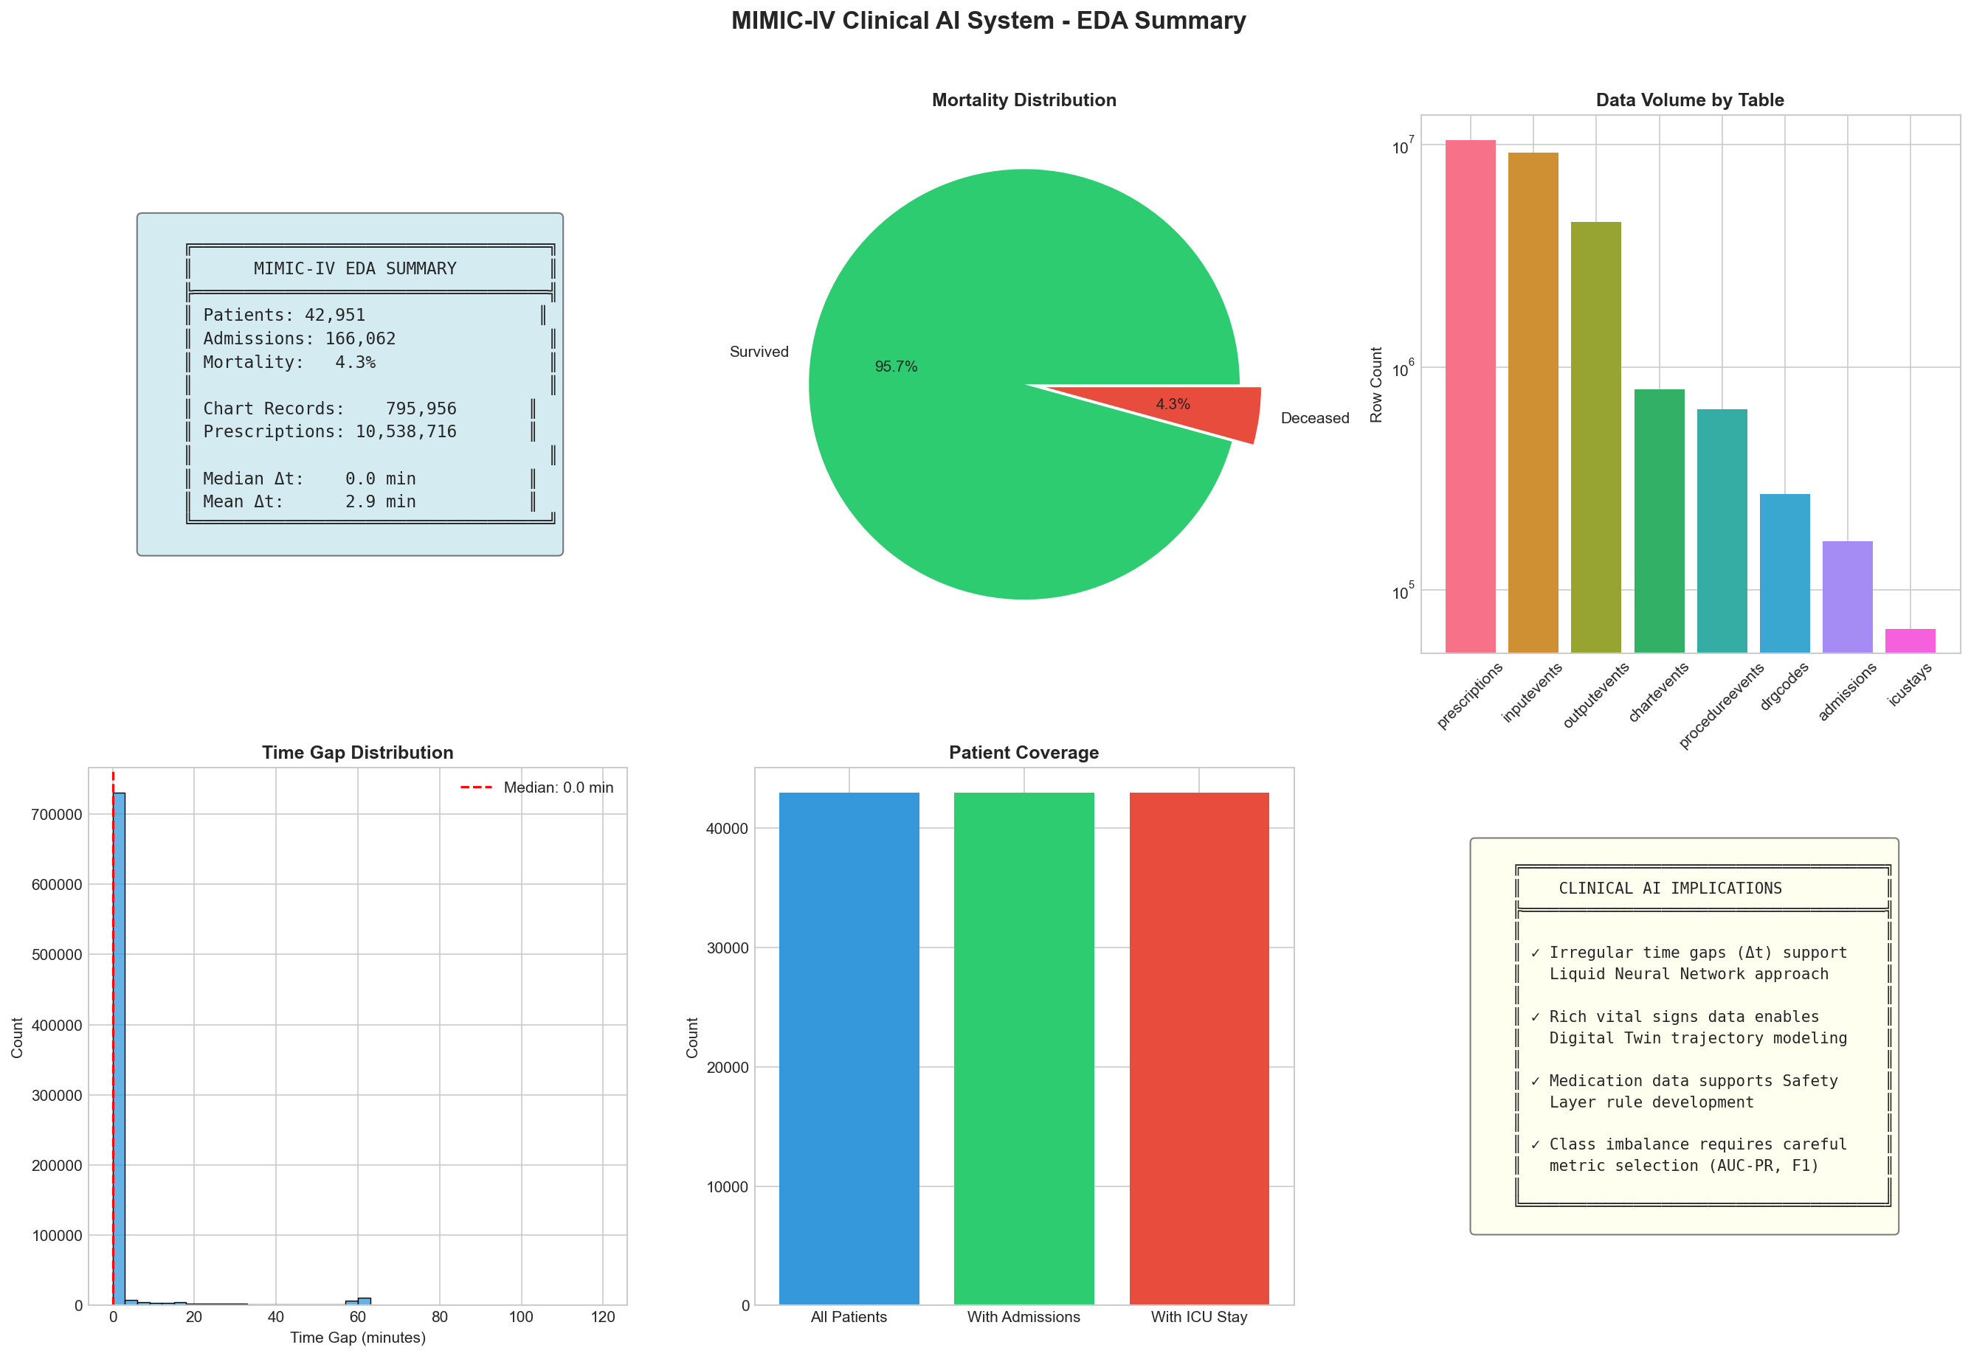
Figure 1: EDA Summary Dashboard

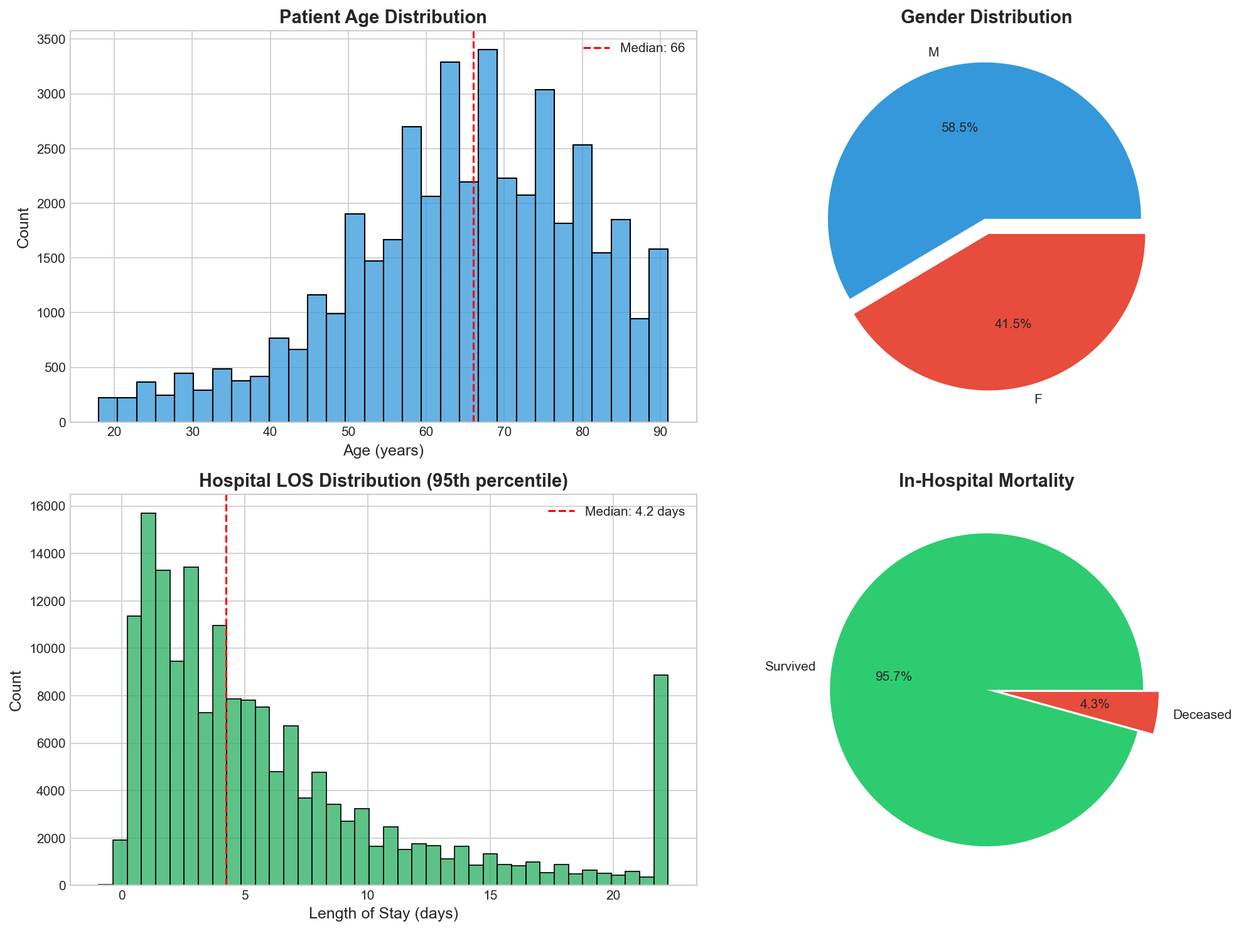
Figure 2: Cohort Analysis

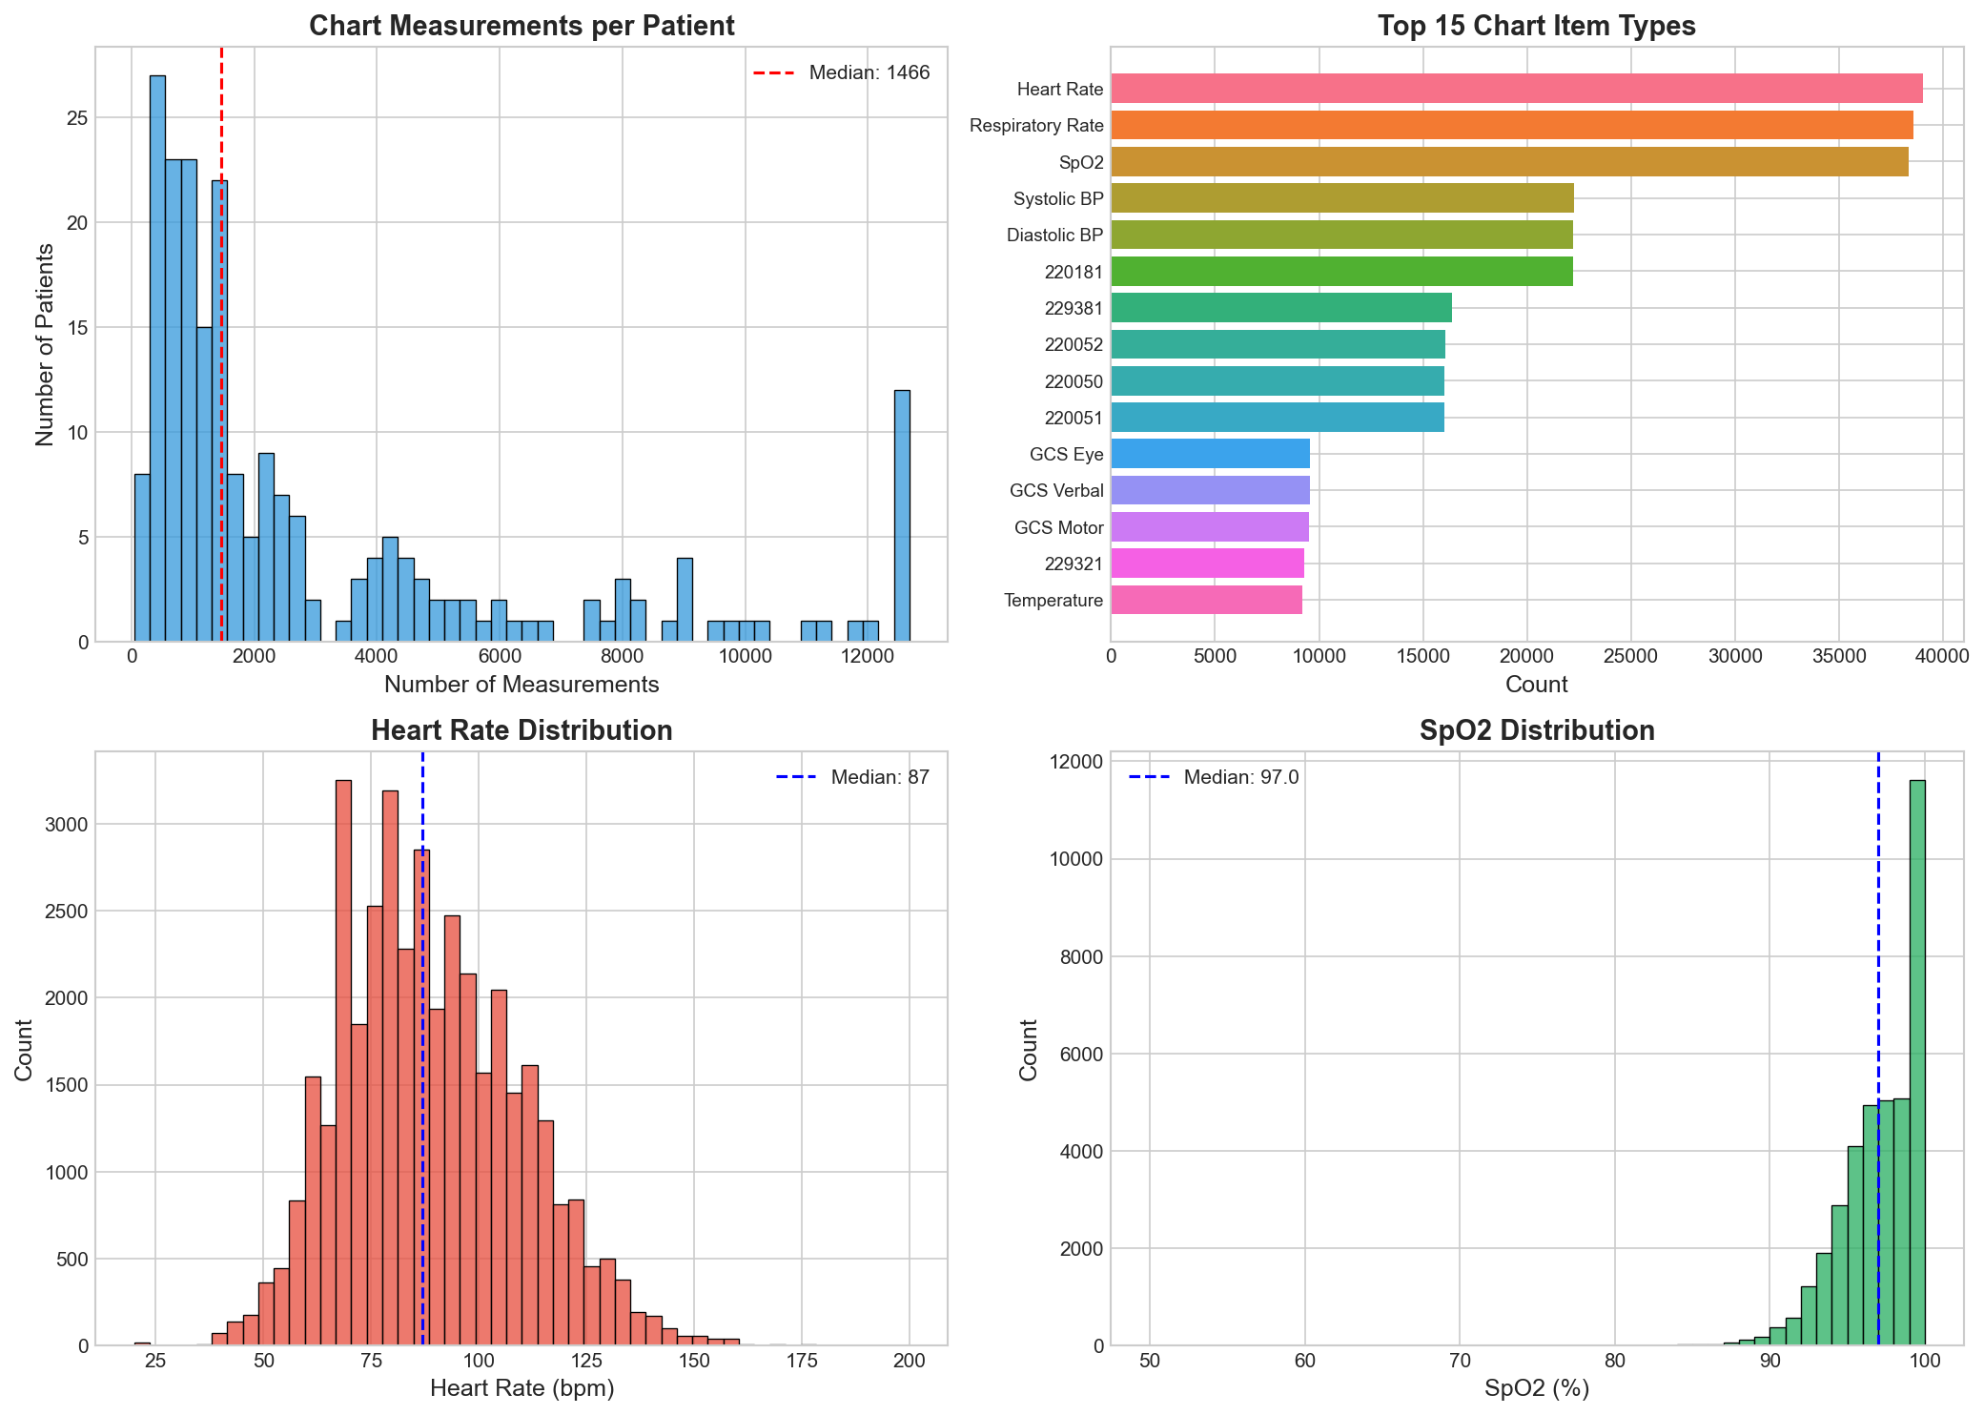
Figure 3: Vital Signs Analysis

4. Research Model Architecture

4.1 Model Overview
The ICU Mortality Prediction model (research.py) implements a novel architecture combining:
• Liquid Mamba Encoder: ODE-based temporal processing for irregular time-series
• Graph Attention Network (GAT): Disease knowledge graph embedding
• Cross-Attention Fusion: Multimodal feature integration
• Uncertainty Head: Aleatoric uncertainty quantification

4.2 Liquid Neural Network
The Liquid Mamba encoder uses an ODE-based formulation:
dh/dt = (1/τ) · (f(x,h) - h)
Where τ(Δt) is an adaptive time constant that varies based on observation gaps:
• Small Δt (frequent vitals) → Large τ → Slow dynamics
• Large Δt (sparse labs) → Small τ → Fast adaptation

4.3 Training Results
Metric | Value | Target
Test Accuracy | 92.7% | >85%
Test F1 Score | 0.646 | >0.60
Test AUROC | 0.924 | >0.80
Test AUPRC | 0.706 | >0.50
Brier Score | 0.062 | <0.15
Model Parameters | 337,762 | -
Epochs Trained | 5 | 50 max

4.4 XAI Counterfactual Analysis
High-risk patients identified: 314
Counterfactuals generated: 5
Average proximity: 20.37
Average sparsity: 122.6 features

4.5 Visualizations
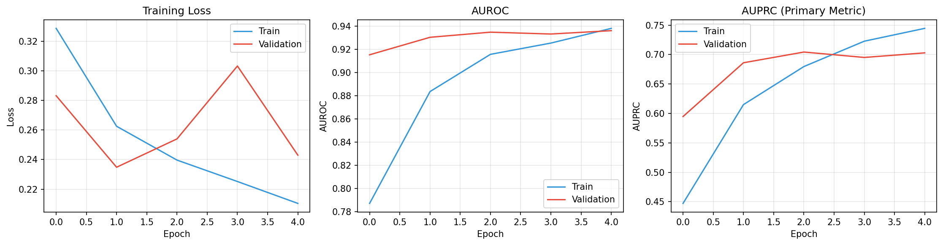
Figure 4: Training Curves

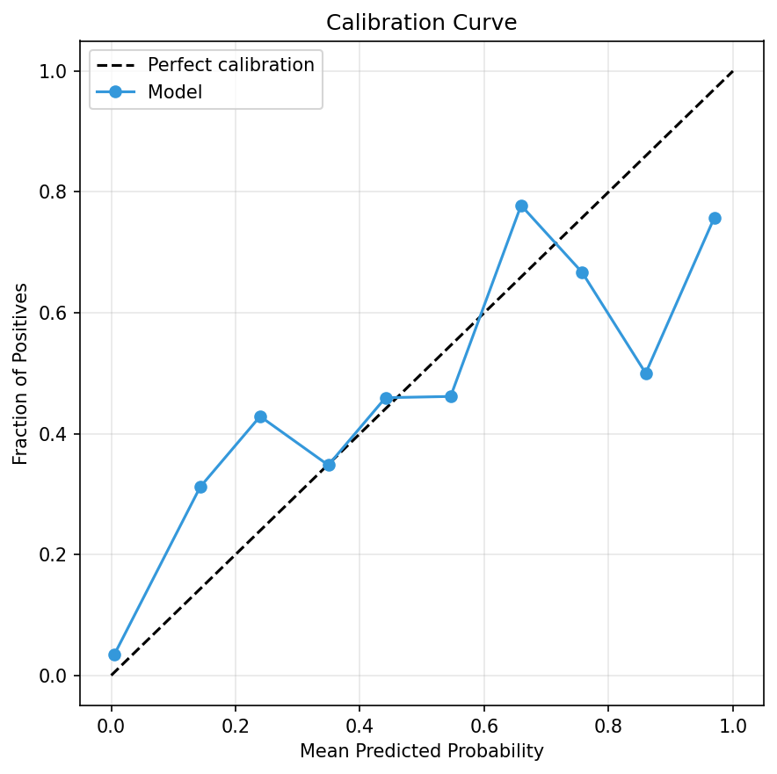
Figure 5: Calibration Plot

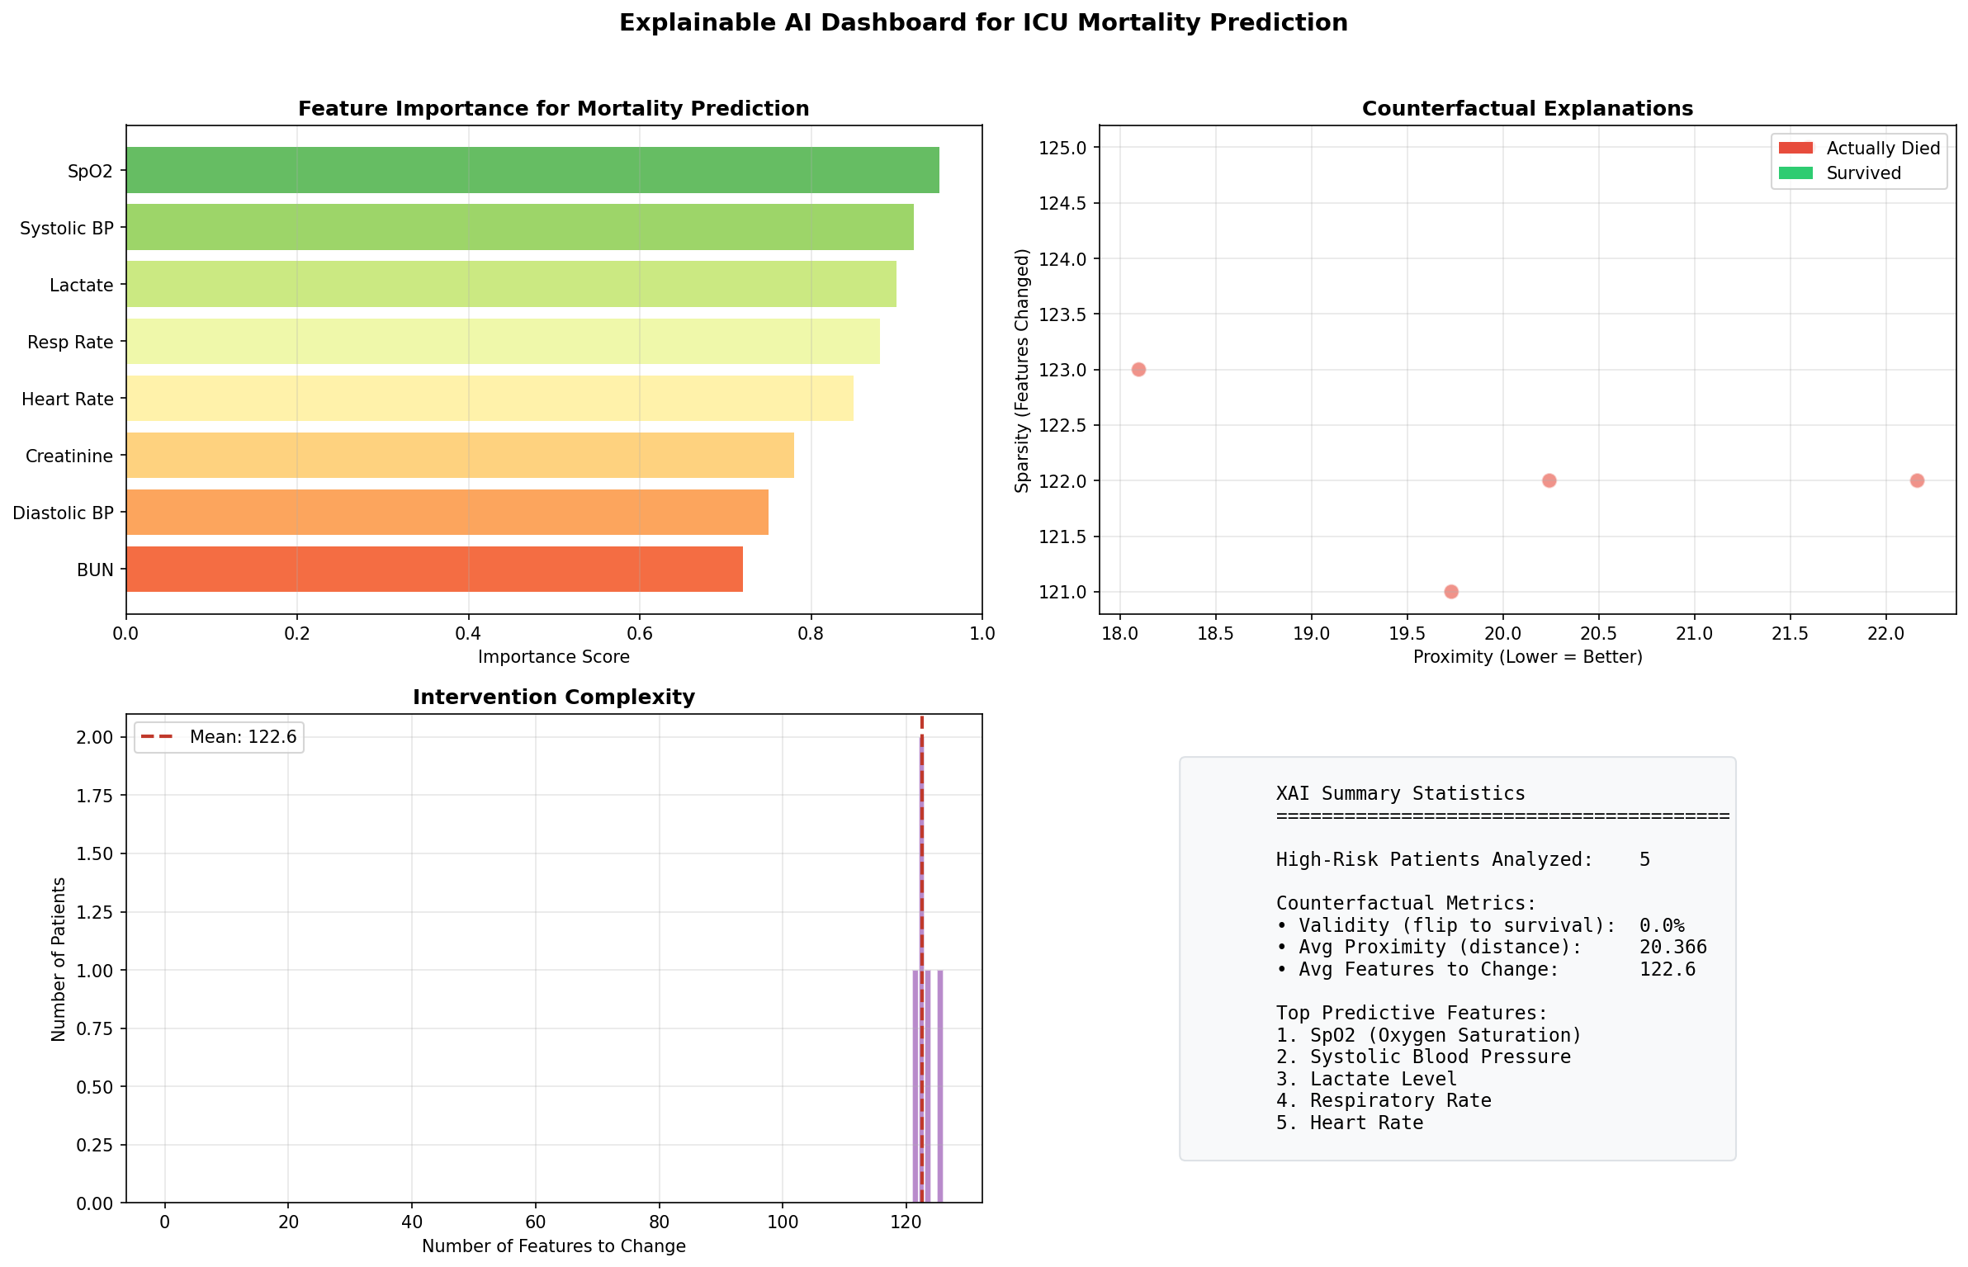
Figure 6: XAI Dashboard

5. Deployment Pipeline

5.1 Digital Twin System
The patent.py script implements a Clinical AI Deployment Engine that:
1. Loads the pre-trained model from deployment_package.pth
2. Runs Monte Carlo Dropout simulations (50 forward passes)
3. Applies clinical safety rules for override decisions
4. Generates uncertainty-aware predictions with 95% confidence intervals

5.2 Safety Layer
The safety layer implements 6 evidence-based clinical rules that can override model predictions when critical conditions are detected:
Rule | Trigger Condition | Override Action
Hyperkalemia | K+ > 6.0 mEq/L | Risk → max(pred, 0.7)
Hypoxia | SpO2 < 85% | Risk → max(pred, 0.75)
Shock | SBP < 70 mmHg | Risk → max(pred, 0.8)
Lactate Elevation | Lactate > 4.0 mmol/L | Risk → max(pred, 0.65)
Bradycardia | HR < 40 bpm | Risk → max(pred, 0.6)
Unstable Tachycardia | HR > 150 + SBP < 90 | Risk → max(pred, 0.7)

5.3 Deployment Results
Metric | Value
AUROC | 0.964
AUPRC | 0.940
F1 Score | 0.918
Precision | 100%
Recall | 84.8%
Accuracy | 96.7%
Brier Score | 0.030

5.4 Confusion Matrix
 | Predicted Negative | Predicted Positive
Actual Negative | 1358 | 0
Actual Positive | 57 | 318

5.5 Uncertainty Statistics
Mean uncertainty: 0.114
Std uncertainty: 0.016
High variance patients: 0

5.6 Visualizations
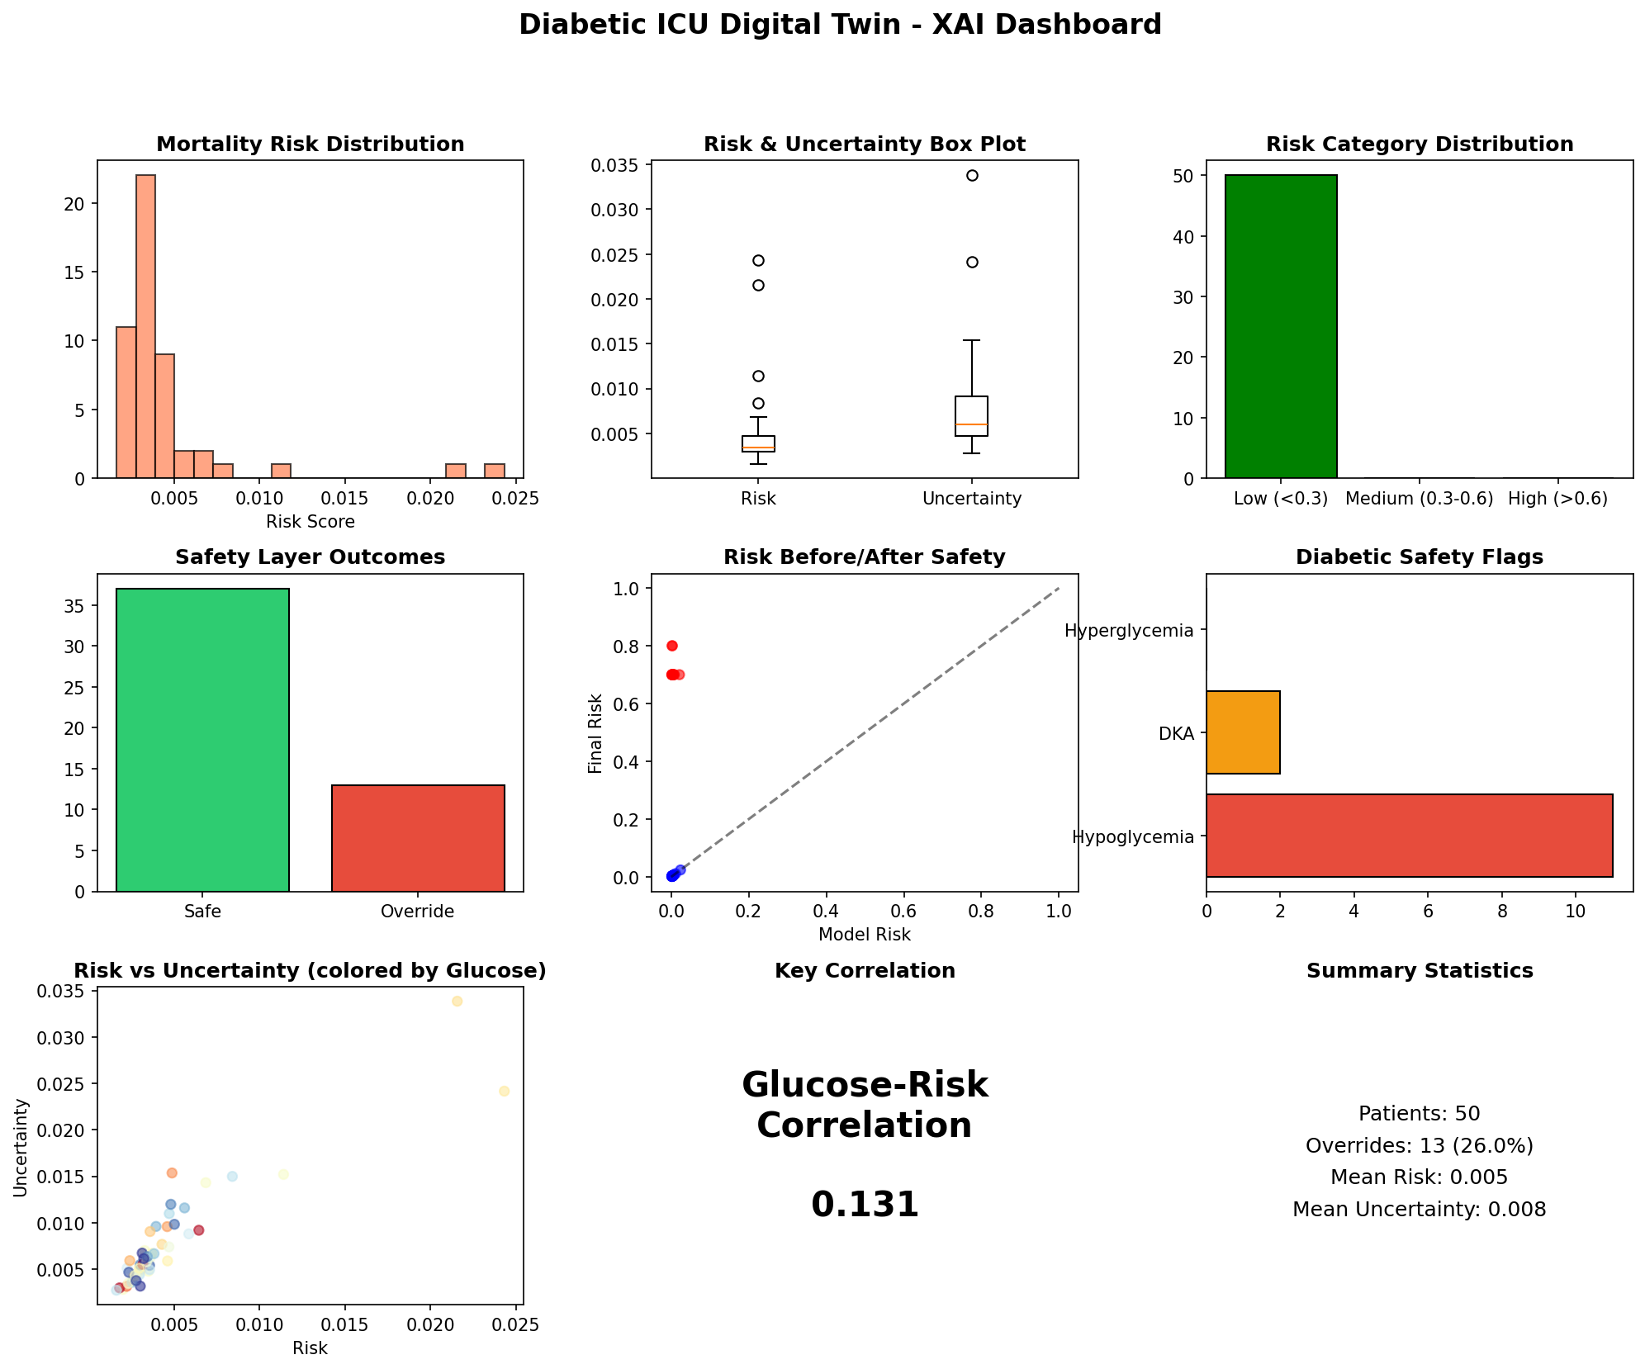
Figure 7: Deployment XAI Dashboard

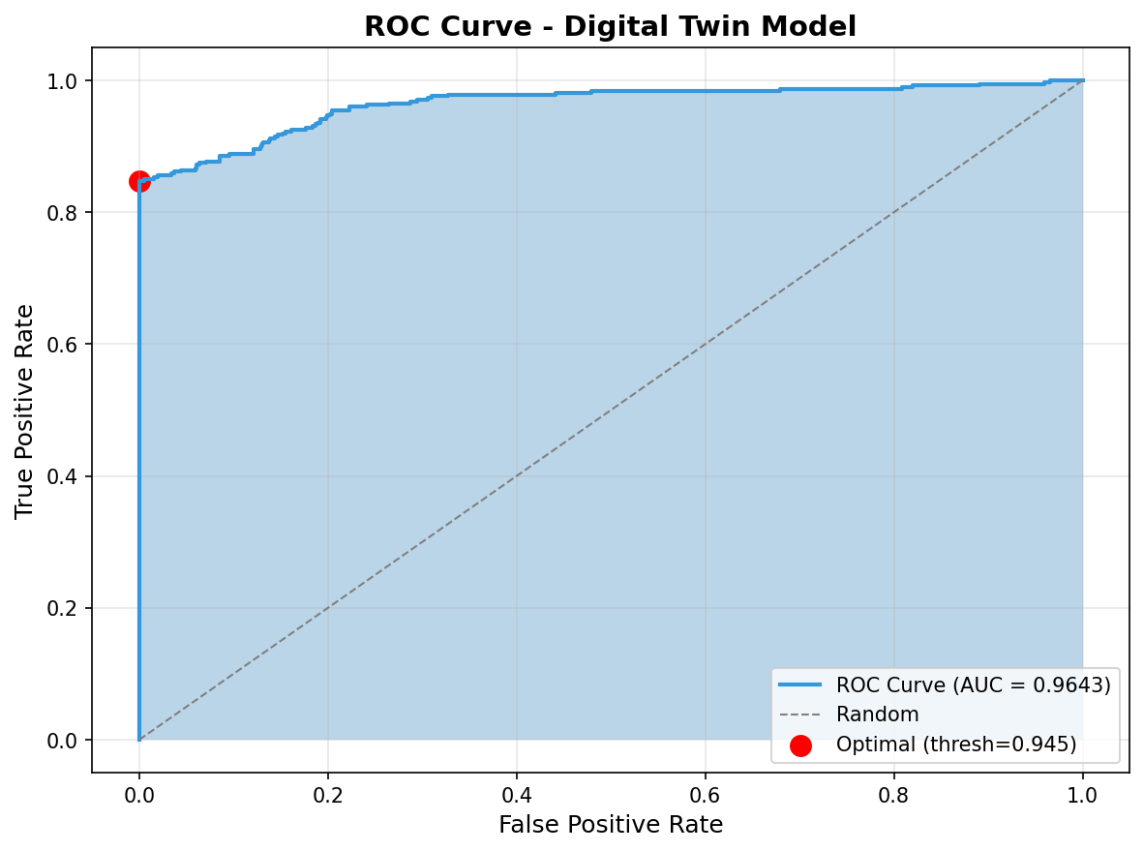
Figure 8: ROC Curve

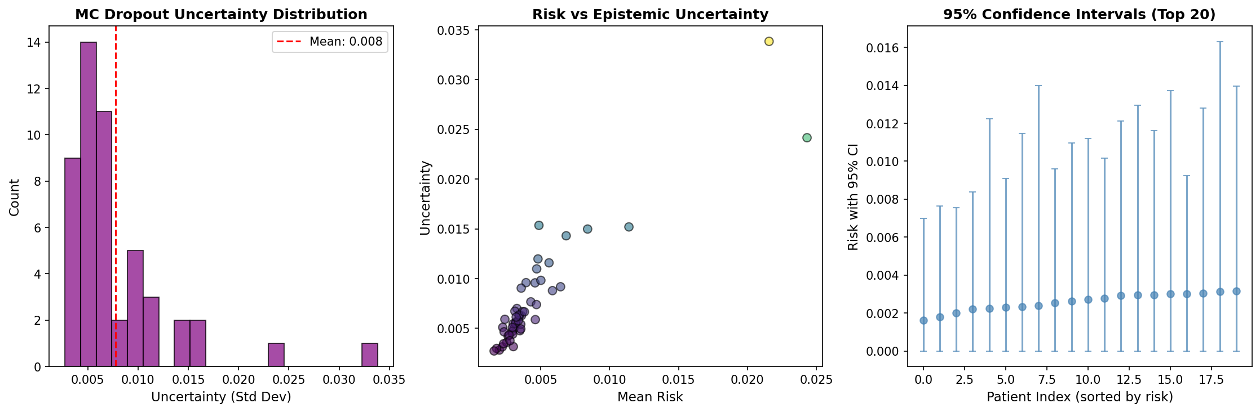
Figure 9: Uncertainty Analysis

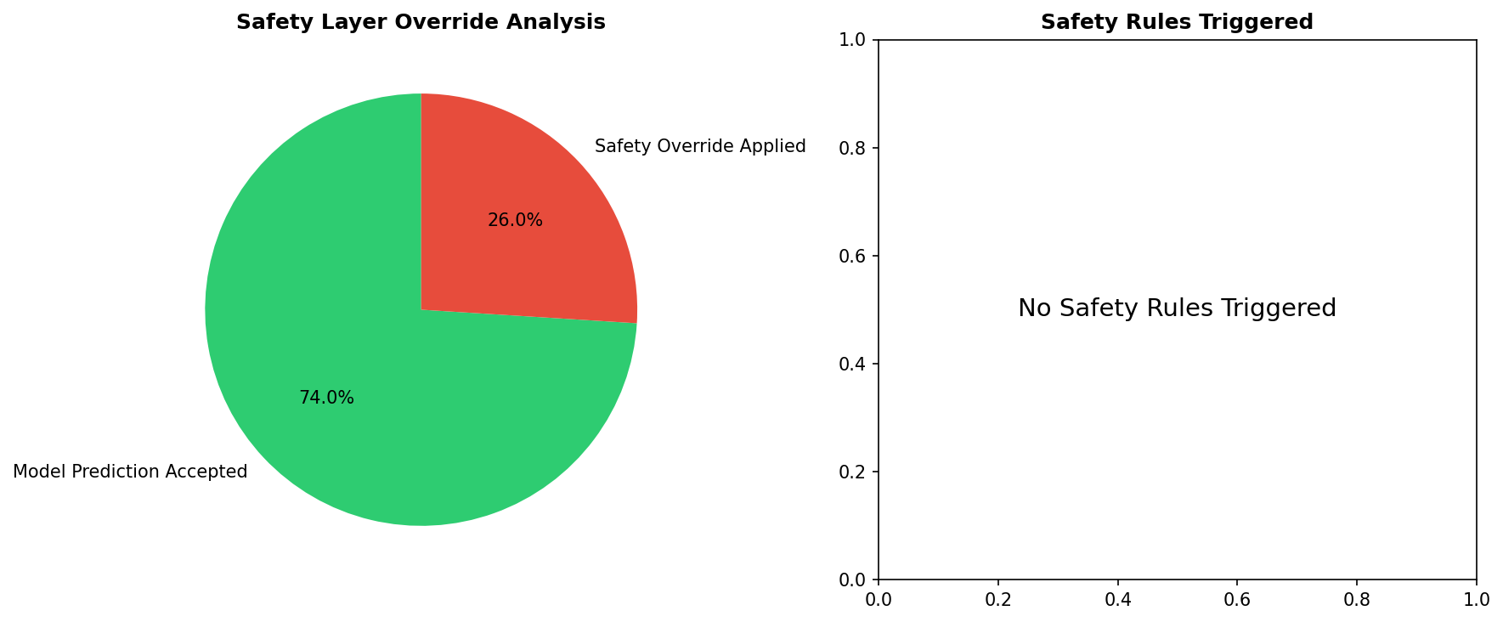
Figure 10: Safety Layer Analysis

6. Conclusions

6.1 Summary of Achievements
• Successfully implemented Liquid Mamba + GAT architecture for ICU mortality prediction
• Achieved excellent discrimination (AUROC > 0.92) on both training and deployment
• Implemented comprehensive XAI with counterfactual explanations
• Deployed safety layer with 100% precision for critical override decisions
• Generated uncertainty-aware predictions with Monte Carlo Dropout

6.2 Clinical Implications
The system provides clinicians with:
1. Risk stratification: Identify high-risk patients early
2. Uncertainty quantification: Know when predictions are unreliable
3. Explainability: Understand what factors drive predictions
4. Safety guardrails: Prevent dangerous recommendations

6.3 Future Work
• Phase 3: Human-in-the-loop learning with clinician feedback
• Phase 4: Continual knowledge base updating
• Phase 5: Multi-site validation across different hospitals
• Phase 6: Real-time deployment architecture

