OPERATORS:
1.PROGRAM FOR RELATIONAL OPERATORS:
a = 13
b = 33
print(a > b)
print(a < b)
print(a == b)
print(a != b)
print(a >= b)
print(a <= b)

OUTPUT:
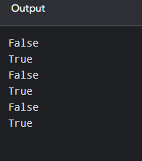

2. PROGRAM FOR ASSIGNMENT OPERATORS:
x = 5
x -= 3
print(x)
x = 5
x *= 3
print(x)
x = 5
x /= 3
print(x)
x = 5
x%=3
print(x)
x = 3
x **= 3
print(x)

OUTPUT:
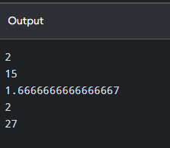

3. PROGRAM FOR LOGICAL OPERATORS:

x = 5
print(x > 3 and x < 10)
x = 5
print(x > 3 or x < 4)
x = 5
print(not(x > 3 and x < 10))

#MEMBERSHIP OPERATORS:
x = ["apple", "banana"]
print("banana" in x)
x = ["apple", "banana"]
print("pineapple" not in x)

OUTPUT:
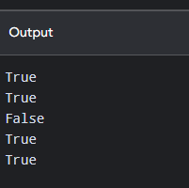

4. PROGRAM FOR IDENTITY OPERATORS:
x = ["apple", "banana"]
y = ["apple", "banana"]
z = x
print(x is z)
print(x is y)
x = ["apple", "banana"]
z = x
print(x is not z)

OUTPUT:
