**Introduction**

This system is a staff payroll management system, Payroll system is a system that assists finance and human resources department to sort out employee information. The purpose of this system is to assists a company to records of its employees' [salaries](https://en.wikipedia.org/wiki/Salary) and [wages](https://en.wikipedia.org/wiki/Wage), [bonuses](https://en.wikipedia.org/wiki/Bonus_payment), and [withheld taxes](https://en.wikipedia.org/wiki/Withholding_tax), so that the company's department can calculates all these information and pays his employees.

For accounting department, it is very important to have this system it allows the company to manage it finance where the profile and expenditure is healthy and it is also because to assists the accountant to do accounting report for audit.

For Human resources, it is important too because the primary mission of the payroll department is to ensure that all employees are paid accurately and timely with the correct withholdings and deductions, and that’s the withholdings and deductions are remitted in a timely manner. This system is also need to keep track of which employee is still working in the company.

For this staff payroll systems we provide add employee, edit employee, view employee, login, calculate employee salary and etc.

**Uml Diagram**

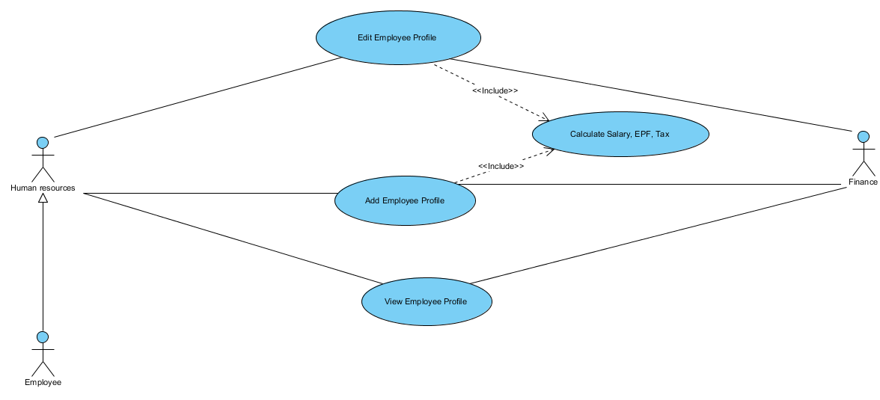

**Interface**

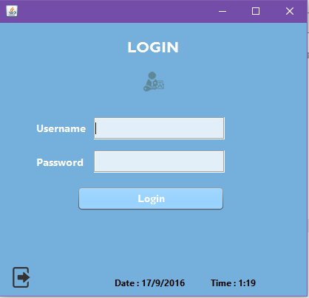

Diagram 1: Login Page

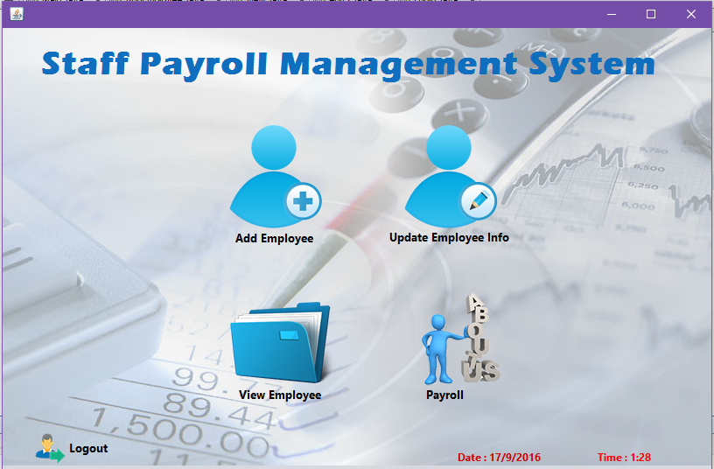

Diagram 2: Main Page

Diagram 1: Main Page

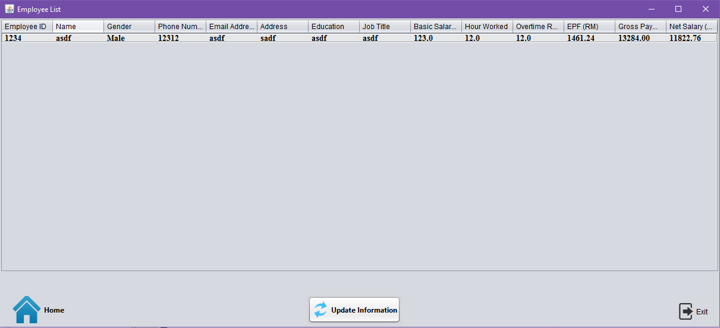

Diagram 4: Add Employee Page

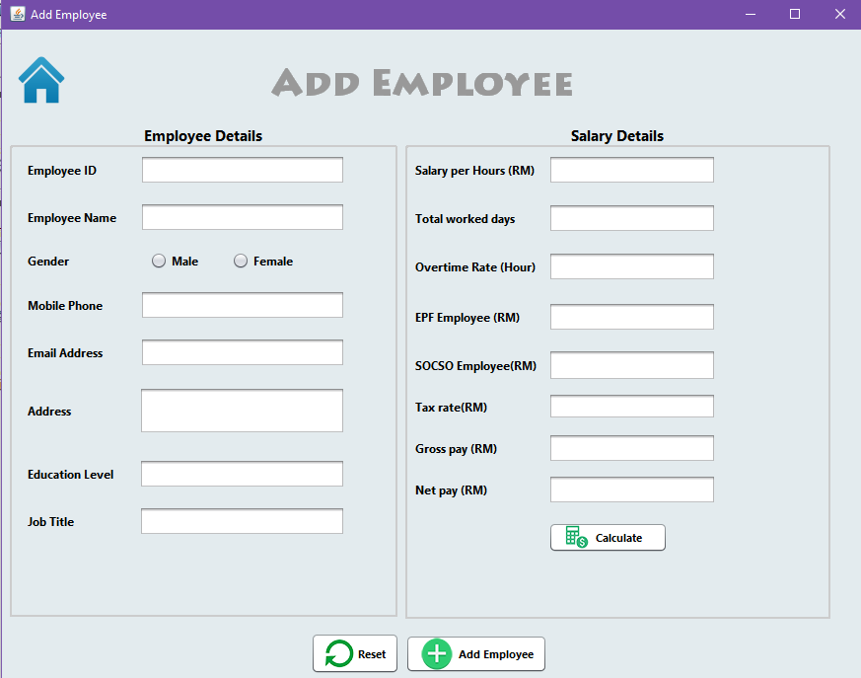

Diagram 3: View Employee Page

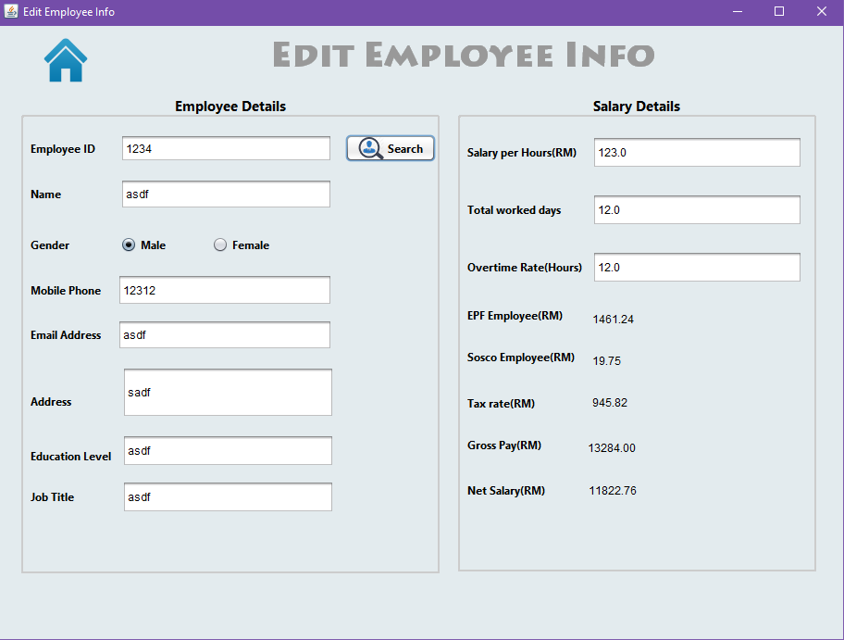

Diagram 5: Edit Employee Page

Diagram 6: About Us Page

