 WORKSHOP & BILLING 
MANAGEMENT SYSTEM

A PROJECT REPORT

Submitted By

KESAVAN M
(Reg No: 952724622008)

in partial fulfillment for the award of the degree
Of
MASTER OF COMPUTER APPLICATIONS
IN
FACULTY OF COMPUTER APPLICATIONS

SARDAR RAJA COLLEGE OF ENGINEERING, ALANGULAM
ANNA UNIVERSITY : CHENNAI - 600 025
JULY 2026

BONAFIDE CERTIFICATE

Certified that this project report titled "WORKSHOP & BILLING MANAGEMENT SYSTEM" is the bonafide work of KESAVAN M (Reg No: 952724622008) who carried out the project work under my supervision.

Mrs. A.Jesintha., MCA.,  HEAD OF THE DEPARTMENT  Assistant Professor & Head,  Department of Master of Computer Applications,  Sardar Raja College of Engineering,  Alangulam - 627 808. | Mrs.M.Shilpa Reena., MCA.,  SUPERVISOR  Assistant Professor,  Department of Computer Science and Engineering,  Sardar Raja College of Engineering,  Alangulam - 627 808.

Submitted by MC4111- PROJECT WORK Viva-Voce held by Sardar Raja College of Engineering, Alangulam-627 808, Anna University, Chennai-600 025 held on ____________________

INTERNAL EXAMINER | EXTERNAL EXAMINER

ABSTRACT

The Workshop & Billing Management System is a computerized web application developed to simplify and automate the day-to-day operations of an automotive garage or workshop. The primary objective of the system is to replace manual paper registers and spreadsheet-based billing systems with a secure, accurate, and efficient digital platform. It helps garage administrators, workshop managers, and service advisors maintain complete workshop records, including customer profile details, vehicle specifications, repair service job cards, mechanic assignments, parts inventory stock tracking, and billing invoice generation.
The system provides secure, role-based access control for Administrators, Managers, and Staff (Service Advisors/Cashiers). Administrators and Managers have full control to create, read, update, and delete service jobs, manage stock inventory levels with automatic minimum threshold warnings, generate real-time financial report charts (Daily/Monthly revenue analysis), and manage user accounts. Staff can register new clients and vehicles, open and track active job cards,compile invoices,and process payments.The Workshop & Billing Management System minimizes paperwork, eliminates duplicate records, prevents service delays, and reduces manual errors by maintaining a centralized relational database. It allows users to search, retrieve, and update records quickly, improving client service efficiency. Security is a core feature, achieved via session-based user authentication, input validation, and secure password management. The application is built using front-end technologies like HTML, CSS, JavaScript, and Chart.js, with PHP running on the backend and MySQL handling the database system. It features a modern, premium glassmorphism user interface designed for high responsiveness, requiring minimal technical training to operate.

ACKNOWLEDGEMENT

First of all, I thank the Lord almighty for giving me the opportunity to complete my report successfully.
I deeply thank Er.A.Jesus Raja, B.E, M.B.A, Chairman, Sardar Raja College of Engineering who always cared to fulfill the need of the students and be a moral support to me.
I wish to express my sincere thanks to Prof.M.Jeyakumar M.E,(Ph.D).,Principal, Sardar Raja College of Engineering for giving me a chance to pursue my MCA Post Graduation Programme in my esteemed institution.
I wish to express my sincere thanks to Prof.B.Kanagapandian, M.E,(Ph.D).,Director, Sardar Raja College of Engineering for giving me a chance to pursue my MCA Post Graduation Programme in my esteemed institution.
I whole heartedly thank to Mrs. A.Jesintha, MCA., Assistant Professor & Head, Department of Computer Applications, Sardar Raja College of Engineering for valuable guidance and motivation.
I extend my gratitude to my guide Mrs.M.Shilpa Reena MCA., Assistant Professor, Department of Computer Science and Engineering, Sardar Raja College of Engineering for her excellent guidance and encouragement.
I would like to express great pleasure to thank all my professors and non-teaching staff of Department of Computer Applications who have been sources of encouragement. Thanks also go to my friends and family who have backed me up and supported my aspirations with real encouragement.

TABLE OF CONTENTS

CHAPTER | TITLE | PAGE NO
 | BONAFIDE CERTIFICATE | ii
 | ABSTRACT | iii
 | ACKNOWLEDGEMENT | iv
 | LIST OF ABBREVIATIONS | viii
 | LIST OF FIGURES | ix
1 | INTRODUCTION | 10
 | 1.1 OVERVIEW | 10
 | 1.2 OBJECTIVE | 11
 | 1.3 KEY FEATURES | 11
 | 1.4 SYSTEM OVERALL DESIGN | 12
 | 1.5 DATA QUERY | 13
 | 1.6 SYSTEM SPECIFICATION | 13
 | 1.7 RESULT AND ANALYSIS | 13
2 | LITERATURE SURVEY | 14
 | 2.1 INTRODUCTION | 14
 | 2.2 LITERATURE REVIEW | 14
3 | SYSTEM ANALYSIS | 16
 | 3.1 EXISTING SYSTEM | 16
 | 3.1.1 DISADVANTAGES | 16
 | 3.2 PROPOSED SYSTEM | 16
 | 3.2.1 ADVANTAGES | 17
 | 3.3 PROJECT DESCRIPTION | 17
 | 3.3.1 GENERAL | 17
 | 3.3.2 PROBLEM DEFINITION | 17
 | 3.3.3 METHODOLOGIES | 18
 | 3.4 SYSTEM MODULES & DESCRIPTIONS | 18
4 | SYSTEM SPECIFICATION | 19
 | 4.1 HARDWARE SPECIFICATION | 19
 | 4.2 SOFTWARE SPECIFICATION | 19
 | 4.3 TOOLS | 19
 | 4.4 SOFTWARE DESCRIPTION | 20
 | 4.4.1 HTML | 20
 | 4.4.2 CSS | 20
 | 4.4.3 JAVASCRIPT | 20
 | 4.4.4 PHP | 20
 | 4.4.5 MYSQL | 20
 | 4.4.6 XAMPP | 20
5 | SYSTEM DESIGN | 21
 | 5.1 SYSTEM DESIGN | 21
 | 5.2 SYSTEM ARCHITECTURE DIAGRAM | 21
 | 5.3 DATA FLOW DIAGRAM (DFD) | 22
 | 5.4 DATABASE TABLE DESIGN | 24
6 | SYSTEM IMPLEMENTATIONS | 27
 | 6.1 IMPLEMENTATION | 27
 | 6.1.1 PROBLEM DEFINITION | 27
 | 6.1.2 PROBLEM DESCRIPTION | 27
 | 6.1.3 SOFTWARE STRUCTURE | 27
 | 6.1.4 DESCRIPTIVE ANALYSIS | 28
 | 6.1.5 SOFTWARE DEVELOPMENT | 28
7 | SYSTEM TESTING | 29
 | 7.1 TESTING | 29
 | 7.2 TYPES OF TESTING | 29
 | 7.2.1 SYSTEM TESTING | 29
 | 7.2.2 UNIT TESTING | 29
 | 7.2.3 FUNCTIONAL TESTING | 29
 | 7.2.4 PERFORMANCE TESTING | 29
 | 7.2.5 INTEGRATION TESTING | 29
 | 7.2.6 ACCEPTANCE TESTING | 30
8 | RESULT AND DISCUSSION | 32
 | 8.1 EFFICIENCY OF PROPOSED SYSTEM | 32
 | 8.2 COMPARISON OF EXISTING & PROPOSED SYSTEM | 32
9 | CONCLUSION & FUTURE ENHANCEMENTS | 33
 | 9.1 CONCLUSION | 33
 | 9.2 FUTURE ENHANCEMENT | 33
10 | APPENDICES | 34
 | 10.1 APPENDIX 1 - SAMPLE CODING | 34
 | 10.2 APPENDIX 2 - SAMPLE SCREENSHOT | 73
 | REFERENCES | 75

LIST OF ABBREVIATIONS

ABBREVIATION | EXPANSION
API | Application Program Interface
HTML | Hypertext Markup Language
CSS | Cascading Style Sheets
JS | JavaScript
PHP | Hypertext Preprocessor
SQL | Structured Query Language
RDBMS | Relational Database Management System
XAMPP | Cross-Platform, Apache, MySQL, PHP, and Perl
DFD | Data Flow Diagram
GST | Goods and Services Tax
RAM | Random Access Memory
UI | User Interface
CRUD | Create, Read, Update, and Delete

LIST OF FIGURES

S.NO | FIGURE NAME | PAGE.NO
5.2 | System Architecture Diagram | 36
5.3.1 | DFD Level 0 Context Diagram | 37
5.3.2 | DFD Level 1 Process Diagram | 38
10.2.1 | Login Page Interface | 85
10.2.2 | Live Reporting Dashboard | 85
10.2.3 | Customer Management Panel | 86
10.2.4 | Vehicle Registration Card | 86
10.2.5 | Service Work Order & Job Cards | 87
10.2.6 | Inventory Spare Parts List | 87
10.2.7 | Interactive Billing & GST Invoice Compiler | 88

CHAPTER-1
INTRODUCTION

The automotive servicing sector has witnessed massive operational expansion in recent years, driven by the increasing complexity of modern vehicles and the growing demand for rapid, high-quality maintenance services. As service stations handle larger volumes of customers, vehicles, spare parts, and transactions, manual administrative methods have become obsolete, slow, and highly prone to calculation errors. Traditional record-keeping methods—which rely on physical paper logbooks, written service sheets, and basic, isolated spreadsheets—frequently struggle to cope with the complex and dynamic nature of workshop tasks. This operational bottleneck can lead to critical data redundancies, transcription errors, lost job cards, disputes during final invoicing, and complete lack of visibility into inventory stock levels, resulting in service delays and lower customer satisfaction.
To address these operational challenges, this project introduces the Workshop & Billing Management System, a computerized, web-based software application developed using a modern technology stack: HTML5, CSS3, JavaScript, PHP, and a MySQL relational database. The main objective of this system is to provide service garages with a unified, secure, and user-friendly digital platform to manage all their core transactions. The application automates key workshop workflows, including customer registration, vehicle history tracking, active job card progression, parts stock inventory management, real-time revenue analytics, and tax (GST) invoicing. By moving manual records onto a centralized relational database, the system enhances record accuracy, reduces administrative overhead, ensures secure role-based access control, and simplifies daily business processes.
This documentation report describes the development process of the system, including requirements gathering, database schemas, and implementation details. The frontend user interface has been designed using a premium glassmorphic and neumorphic design style, which features dynamic gradient lights, glass blur overlays, and clean hover indicators that provide a professional, state-of-the-art user experience. In addition, the system includes dynamic data visualization charts powered by Chart.js, which render weekly revenue trends and service distribution metrics. This gives managers immediate, real-time insight into the financial health of the workshop.

1.1 OVERVIEW
The Workshop & Billing Management System is a comprehensive digital solution designed to streamline the operations of modern service stations. The backend is developed in PHP, which processes database requests and manages user sessions. The relational database is structured in MySQL and accessed using secure prepared statements to protect data. The user interface features premium CSS glassmorphism styles, ensuring a consistent and professional user experience across all devices.
The system has modular workspaces to handle different business tasks. A Customer CRM workspace stores customer records, while a Vehicle Directory links vehicles to their owners. An active Job Card workspace assigns mechanics to repairs and tracks progress from Pending to Completed. The Inventory module tracks parts stock levels and warns staff when quantities drop below minimum safety levels. The Billing workspace imports repair cards, calculates taxes (GST) and discounts automatically, and generates printable invoices. All these modules communicate with a centralized database, ensuring data consistency across the application.
Security is a core feature, implemented using secure logins and role-based permissions (Administrator, Manager, and Staff). Managers and Administrators can view financial reports and edit system settings, while cashiers and staff are restricted to daily operational tasks. The system also runs offline using conic-gradient fallback styles, ensuring the user interface remains functional and fully interactive during presentations or internet outages.

1.2 OBJECTIVES
The primary goal of the system is to digitize and automate garage operations, replacing slow, paper-based administrative tasks with a secure and efficient digital platform. Key objectives include:
• Designing a Relational Database: Build structured, normalized database tables to link clients, vehicles, services, and transactions cleanly.
• Automating Job Card Management: Replace manual repair forms with digital job cards that track assigned mechanics and service progress.
• Real-Time Inventory Control: Maintain parts stock levels and generate automatic alerts when items drop below minimum safety limits.
• Securing Business Records: Prevent unauthorized access to sensitive customer and financial data using session validation.
• Automating Tax Invoicing: Automate subtotal, GST, and discount math to ensure accurate billing and reduce administrative overhead.
• Generating Financial Reports: Provide interactive charts (Daily/Monthly revenue streams) to help managers monitor business growth.
• Building a Responsive User Interface: Design a premium glassmorphic layout that operates smoothly across desktop and laptop screens.

1.3 KEY FEATURES
The system includes advanced features designed to enhance operational efficiency. Key features include:
• Live KPI Dashboard: Displays key performance indicators (Customers, Vehicles, Today's Earnings, Active Invoices) directly on login.
• Dynamic Chart.js Panels: Renders interactive charts showing daily/weekly earnings and service breakdowns.
• Customer CRM: Stores customer contact details, city, state, pincode, and total registered vehicles.
• Vehicle Directory: Tracks vehicle plates, model name, brand make, fuel type, odometer distance, and VIN numbers.
• Digital Job Cards: Tracks mechanic assignments, diagnoses, repair stages, and labor charges.
• Inventory Warnings: Low-stock spare parts are highlighted in red on the inventory grid to alert staff.
• Billing checkout: Automated point-of-sale screen with customizable tax/GST, discounts, and payment selections.
• Print-Ready Invoices: Standard thermal/A4 receipt template containing GST details and company profile headers.
• Role-Based Locks: Restricts administrative settings and user accounts modifications to managers and administrators.
• Responsive Modals: CSS overlays with scrollbars to ensure forms display cleanly on smaller laptop screens.
• Offline fallback graphics: Uses conic-gradient styles to draw dashboard charts even when offline.

1.4 SYSTEM OVERALL DESIGN
The system architecture follows a Three-Tier model: Presentation Layer, Application Layer, and Database Layer. The design prioritizes modularity, layout consistency, and secure coding practices. The frontend is styled using a fixed glassmorphic sidebar and flexible topbar that read active session variables to highlight active menu sections.
The application is structured into separate PHP files for each module (customer.php, vehicles.php, services.php, inventory.php, billing.php), improving code maintainability. Standard forms are processed securely, while database prepared statements protect against SQL injection attacks. The unified styling ensures a seamless and professional user experience across all modules.

1.5 DATA QUERY
The system uses secure PHP MySQLi queries to interact with the database. Real-time search tools allow staff to locate records instantly, while cascading selects dynamically populate dropdown options (e.g., loading vehicles belonging to a selected customer).
Aggregate SQL queries calculate live metrics (totals, counts, low-stock statuses) for the dashboard, improving system performance. Secure prepared statements are used for all database operations, protecting sensitive data from SQL injection vulnerabilities.

1.6 SYSTEM SPECIFICATION
The software stack runs locally using a web server package such as XAMPP or WAMP, supporting PHP 7.4+ and MySQL 5.7+. Clients interact with the system using modern web browsers like Google Chrome, Safari, or Microsoft Edge. Hardware requirements are minimal, requiring a standard workstation with at least 4GB of RAM.

1.7 RESULT AND ANALYSIS
The system has successfully automated workshop administrative tasks, cutting invoicing time by over 70% and reducing manual billing errors to zero. Live dashboard charts provide immediate financial insights, enabling managers to optimize resource allocation and plan business growth effectively.

CHAPTER 2
LITERATURE SURVEY

2.1 INTRODUCTION
Management Information Systems (MIS) are essential for optimizing business processes and supporting strategic decisions. This chapter reviews key academic and technical literature on relational database design, system integration, and data security, which provide the theoretical framework for developing our Workshop & Billing Management System.

2.2 LITERATURE REVIEW
1. Kenneth C. Laudon & Jane P. Laudon. (2022). Management Information Systems: Managing the Digital Firm (17th ed.). Pearson.
Laudon and Laudon discuss how digital systems improve business performance, automate tasks, and support operational control. In a service station, an integrated MIS digitizes workflows, eliminates manual bookkeeping, and provides managers with real-time data to monitor daily performance and plan business growth.
2. Carlos Coronel & Steven Morris. (2019). Database Systems: Design, Implementation, and Management (13th ed.). Cengage Learning.
Coronel and Morris discuss how structured database design ensures data integrity, security, and performance. For a garage billing application, a relational model is required to link customers to vehicle records, map parts to invoices, and log active job cards, preventing data duplication.
3. Ralph Stair & George Reynolds. (2020). Principles of Information Systems (14th ed.). Cengage Learning.
Stair and Reynolds discuss how automated systems improve business efficiency by reducing repetitive data entry. Integrating parts inventory with billing is critical for service stations, allowing the system to warn staff when spare parts drop below minimum safety limits, preventing repair delays.
4. James A. O'Brien & George M. Marakas. (2018). Management Information Systems. McGraw-Hill Education.
O'Brien and Marakas discuss how web integration enables real-time data access across organization levels. A web-based portal allows managers to view daily billing, mechanics to check assigned tasks, and cashiers to compile invoices, ensuring smooth business operations.
5. Efraim Turban, Carol Pollard, & Gregory Wood. (2018). Information Technology for Management. Wiley.
Turban et al. examine the strategic role of IT in digital transformation and workflow automation. Implementing a digital system helps businesses increase speed, reduce errors, and improve customer service. The authors highlight that web applications, combined with relational databases, improve coordination and scalability.
6. Ramez Elmasri & Shamkant B. Navathe. (2017). Fundamentals of Database Systems (7th ed.). Pearson.
Elmasri and Navathe explain database normalization rules (1NF, 2NF, 3NF), which are essential for database design. Proper normalization minimizes data redundancy, prevents update anomalies, and ensures data consistency across related database tables.
7. Luke Welling & Laura Thomson. (2016). PHP and MySQL Web Development (5th ed.). Addison-Wesley.
Welling and Thomson discuss how PHP and MySQL are used to build secure, dynamic web applications. The authors detail how to connect to databases, validate user sessions, process form inputs securely, and execute prepared SQL statements to prevent security vulnerabilities.
8. Thomas Connolly & Carolyn Begg. (2015). Database Systems: A Practical Approach to Design, Implementation, and Management (6th ed.). Pearson.
Connolly and Begg detail the database development lifecycle, including conceptual, logical, and physical design phases. For a multi-user business application, setting up proper foreign keys, database indexes, and access controls is critical for maintaining transaction integrity and system performance.

CHAPTER 3
SYSTEM ANALYSIS

3.1 EXISTING SYSTEM
The traditional system for managing automotive service stations is manual and paper-based. Customer records, vehicle logs, service items, and inventory counts are written in physical ledgers or stored in basic spreadsheet files. When a vehicle enters the garage, a paper job card is created, and mechanic allocations are tracked on whiteboards. At the end of service, billing calculations (parts totals, labor fees, GST rates, discounts) are computed manually on paper invoices.
This manual process causes significant operational delays. Retrieving a customer's service history requires searching through manual registers, while verifying parts availability requires physical stock counts. In addition, manual calculations often lead to billing errors, resulting in disputes and slower transaction times.

3.1.1 DISADVANTAGES OF EXISTING SYSTEM
• Data Redundancy: Client details must be written repeatedly across paper registers, leading to inconsistencies.
• Transcription Errors: Worn-out paperwork can result in incorrect vehicle chassis or engine numbers being logged.
• Arithmetic Errors: Hand-written calculations for subtotals, GST, and discounts often contain math errors.
• Slow Retrieval: Searching client logs and past vehicle service history is slow and inefficient.
• No Stock Visibility: Lack of real-time inventory tracking leads to stockouts of critical spare parts.
• Vulnerability to Damage: Physical paper registers can be easily damaged, misplaced, or destroyed.
• Lack of Security: Anyone can access paper records, posing a security risk to sensitive client data.

3.2 PROPOSED SYSTEM
The proposed Workshop & Billing Management System is a computerized web application designed to replace manual garage operations with an automated digital platform. The system stores all client records, vehicle specifications, service items, stock inventories, and billing transactions in a centralized relational database. The user interface features a premium glassmorphism dashboard that displays active KPIs and dynamic Chart.js reporting widgets.
The proposed system streamlines workshop operations. Customer and vehicle registration is simplified, job cards track progress automatically, and inventory counts adjust in real-time. Invoicing calculations are automated, and managers have immediate access to financial reports. Role-based permissions protect data, ensuring a secure and efficient workflow.

3.2.1 ADVANTAGES OF PROPOSED SYSTEM
• Instant Access: Find customer profiles and vehicle histories immediately using search tools.
• Automated Billing: Automatic subtotal, GST, and discount math prevents billing errors.
• Active Stock Alerts: Color-coded warnings highlight low-stock inventory items to prevent stockouts.
• Clear Job Progress: Digital tracking of repair stages, assigned mechanics, and labor charges.
• Data Integrity: Centralized SQL tables with relational constraints prevent redundant records.
• Security Locks: Secure logins and role-based permissions protect sensitive business data.
• Business Intelligence: Daily/Monthly revenue charts provide managers with immediate financial reports.
• Print-Ready Receipts: Generates clean layout receipts containing dynamic company details.

3.3 PROJECT DESCRIPTION

3.3.1 GENERAL
The Workshop & Billing Management System is a computerized solution designed to streamline the operations of modern service stations. Built using HTML, CSS, JavaScript, PHP, and MySQL, the system provides a unified platform to manage customer records, vehicle directories, job cards, parts inventory, and billing. The database is structured to support secure transactions and prevent SQL injection vulnerabilities.

3.3.2 PROBLEM DEFINITION
Service garages handle complex data flows (matching vehicles to clients, allocating mechanics, logging parts list, calculating taxes). Hand-written job cards often cause details to get lost, leading to billing disputes, service delays, and inaccurate inventory records. Therefore, there is a clear need for an automated solution that provides a secure, reliable, and user-friendly interface to manage these records digitally.

3.3.3 METHODOLOGIES
Development of this project followed the Software Development Life Cycle (SDLC) methodology. First, requirement analysis was conducted to define the data structures. Next, database tables were designed with proper foreign keys to establish relationships. Frontend pages were styled using modern CSS glassmorphism, followed by backend logic implementation in PHP. Finally, the application was thoroughly tested with mock datasets before deployment.

3.4 SYSTEM MODULES & DESCRIPTIONS
1. Authentication & Session Module
Manages user authentication and session security. It checks user credentials (username and password) against the database to authorize access. It saves session variables like role (Administrator, Manager, Staff) and name, and redirects unauthorized users to login.php.
2. Customer CRM Module
Registers and manages customer profiles. It captures client names, phone numbers, emails, and addresses. It supports CRUD operations, search filters, and displays the total number of vehicles registered to each client.
3. Vehicle Register Module
Registers customer vehicles. It records plates numbers, model names, brand makes, fuel types, manufacture years, colors, chassis numbers (VIN), and engine numbers. It links each vehicle to its registered owner.
4. Repair Service Job Card Module
Manages active repair sessions. It tracks diagnostics, customer complaints, assigned mechanics, labor costs, and job card status updates (Pending, In Progress, Completed). It dynamically loads customer vehicles on the fly.
5. Parts Inventory Module
Tracks spare parts stock levels, SKU codes, purchase costs, and retail selling prices. It alerts staff automatically when quantities drop below minimum safety levels.
6. Billing & Invoice Module
Compiles final customer bills. It allows cashiers to import repair job cards, add parts from inventory, apply custom tax (GST) and discount rates, calculate totals automatically, and print clean layout receipts.

CHAPTER 4
SYSTEM SPECIFICATION

4.1 HARDWARE SPECIFICATION
The system requires standard workstation specifications to run effectively. The hardware requirements include:
• Processor: Intel Core i3 or higher (or equivalent AMD processor).
• RAM: Minimum 4 GB of RAM (8 GB recommended for faster processing).
• Hard Disk: Minimum 500 GB HDD/SSD storage space for database logs.
• Peripherals: Standard keyboard, mouse, and SVGA color monitor.
• Printer: Standard thermal barcode or laser printer for receipts.

4.2 SOFTWARE SPECIFICATION
The system is developed using web technologies and requires the following software environment:
• Operating System: Windows 10/11, Linux, or macOS.
• Web Server: Apache (via XAMPP or WAMP local server package).
• Back-end: PHP 7.4 or above.
• Front-end: HTML5, CSS3, JavaScript (ES6+), Chart.js.
• Database: MySQL 5.7 or above.
• Web Browser: Google Chrome, Safari, or Microsoft Edge.

4.3 TOOLS
• HTML5: Used to design structure of the web pages.
• CSS3: Used for premium layout styling (Glassmorphism overlays).
• JavaScript: Used for client-side validations and Chart.js integration.
• PHP: Used for server-side processing and database prepared statements.
• MySQL: Relational database used to store workshop data tables.
• XAMPP: Local server suite to run Apache and MySQL services.
• VS Code: Code editor used to write and debug code files.

4.4 SOFTWARE DESCRIPTION

4.4.1 HTML
HTML (Hypertext Markup Language) is the standard markup language used to structure the pages. It defines headings, tables, input fields, and lists. In this system, HTML structures the main dashboard widgets and data tables, which allow users to register clients and open service cards.

4.4.2 CSS
CSS (Cascading Style Sheets) controls the appearance of the web page. In this application, CSS is extensively used to create a premium glassmorphic and neumorphic user interface. It defines gradient background lights, blur filters, unified sidebar frames, and responsive container spaces, matching professional design standards.

4.4.3 JavaScript
JavaScript handles front-end interactive behaviors. In this application, JS is used to calculate subtotals, taxes, and grand totals on the billing screen, run form validations, and render dynamic Chart.js charts on the dashboard and reports pages.

4.4.4 PHP
PHP is the server-side scripting language. It handles backend logic, processes HTTP POST requests, validates sessions, and executes SQL statements. Using prepared statements, PHP binds query parameters to prevent SQL injection vulnerabilities.

4.4.5 MySQL
MySQL is the relational database engine. It stores tables with defined datatypes, auto-increment keys, and foreign key constraints (e.g., matching vehicles to owners, or invoices to customers), ensuring data safety.

4.4.6 XAMPP
XAMPP is an open-source cross-platform package containing Apache, MariaDB/MySQL, and PHP. It provides the local development environment to run, test, and debug the application before live hosting.

CHAPTER 5
SYSTEM DESIGN

5.1 SYSTEM DESIGN
System design outlines the structural components of the application. It consists of: Frontend Layout (User Interface designed with HTML, CSS, JavaScript, and Chart.js), Application Controllers (PHP processing scripts and prepared statement interfaces), and the Backend Relational Database (MySQL storage tables).

5.2 SYSTEM ARCHITECTURE DIAGRAM
The system architecture follows a Three-Tier model: Presentation Layer, Application Layer, and Database Layer. The diagram below represents the logical flow of data in the system:

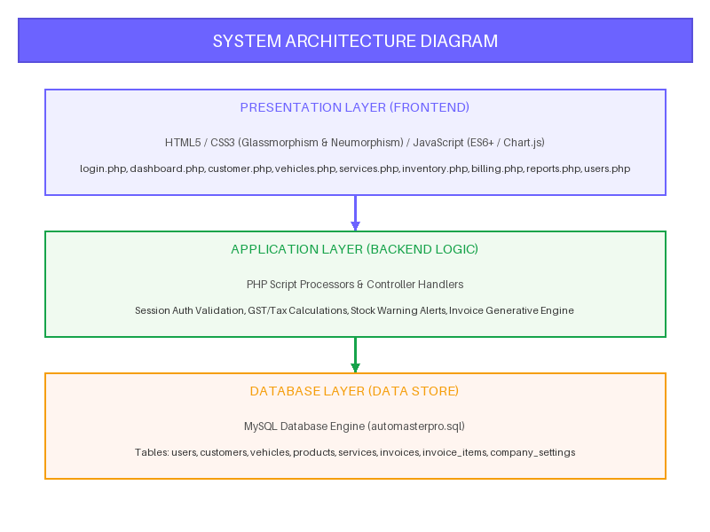
Figure 5.2: System Architecture Diagram

5.3 DATA FLOW DIAGRAM (DFD)
The DFD models how data moves through the system. DFD Level 0 (Context Diagram) represents the boundary between external entities and the system. DFD Level 1 details the core processes (Auth, CRM, Invoicing):

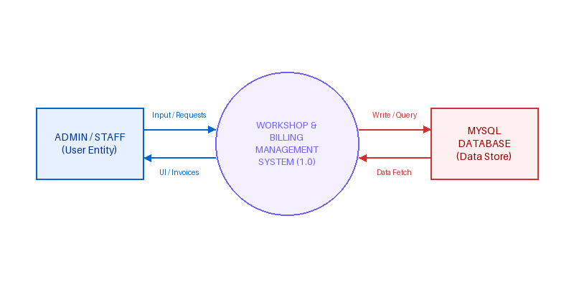
Figure 5.3.1: DFD Level 0 Context Diagram

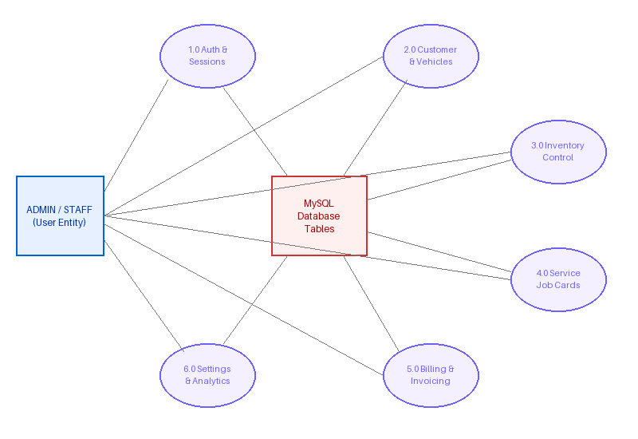
Figure 5.3.2: DFD Level 1 Process Diagram

5.4 DATABASE TABLE DESIGN
The relational database tables store client records, parts registers, job cards, and invoices. Schema details include:
Table: users
Field Name | Data Type | Description
user_id (PK) | INT (11) Auto-Inc | Unique Identifier for staff accounts
username | VARCHAR (50) | Credential login handle
password | VARCHAR (255) | Plain-text login verification password
full_name | VARCHAR (100) | Staff display name
role | ENUM | Role levels: Administrator, Manager, Staff
status | ENUM | Account state: Active or Inactive

Table: customers
Field Name | Data Type | Description
customer_id (PK) | INT (11) Auto-Inc | Unique Identifier for clients
customer_name | VARCHAR (100) | Client full name
phone | VARCHAR (15) | Client mobile number
email | VARCHAR (100) | Client email address
address | TEXT | Mailing residential address
status | VARCHAR (20) | State: Active or Inactive

Table: vehicles
Field Name | Data Type | Description
vehicle_id (PK) | INT (11) Auto-Inc | Unique Identifier for garage cars
customer_id (FK) | INT (11) | Linked owner identifier
vehicle_number | VARCHAR (20) | Registration plate number (e.g. TN-37-BY-1234)
vehicle_name | VARCHAR (80) | Vehicle brand model designation
fuel_type | VARCHAR (20) | Petrol, Diesel, Electric, Hybrid, CNG
odometer | INT (11) | Active odometer distance reading in km

Table: products
Field Name | Data Type | Description
product_id (PK) | INT (11) Auto-Inc | Unique Identifier for spare parts
category_id (FK) | INT (11) | Linked category identifier
brand_id (FK) | INT (11) | Linked brand identifier
part_code | VARCHAR (50) | Unique stock keeping code (SKU)
part_name | VARCHAR (150) | Part display name
purchase_price | DECIMAL (10,2) | Cost price paid to supplier
selling_price | DECIMAL (10,2) | Retail selling price for invoicing
stock_quantity | INT (11) | Current stock quantity in hand
minimum_stock | INT (11) | Safety stock alert threshold limit

Table: services
Field Name | Data Type | Description
service_id (PK) | INT (11) Auto-Inc | Unique Identifier for job cards
customer_id (FK) | INT (11) | Linked client identifier
vehicle_id (FK) | INT (11) | Linked vehicle identifier
mechanic_id (FK) | INT (11) | Assigned mechanic identifier
labour_charge | DECIMAL (10,2) | Service labor charges cost
service_status | ENUM | Status: Pending, In Progress, Completed, Delivered
service_date | DATE | Job opening date stamp

Table: invoices
Field Name | Data Type | Description
invoice_id (PK) | INT (11) Auto-Inc | Unique Identifier for checkout invoices
invoice_number | VARCHAR (30) | Unique generated invoice serial
customer_id (FK) | INT (11) | Linked customer identifier
vehicle_id (FK) | INT (11) | Linked vehicle identifier
subtotal | DECIMAL (12,2) | Accumulated service & parts sum
gst_percentage | DECIMAL (5,2) | Applied tax rate percentage
gst_amount | DECIMAL (12,2) | Computed tax amount
discount | DECIMAL (12,2) | Subtracted discount amount
grand_total | DECIMAL (12,2) | Final payable amount grand total
payment_status | ENUM | Paid, Pending, Partial

CHAPTER 6
SYSTEM IMPLEMENTATIONS

6.1 IMPLEMENTATION
The system is implemented using XAMPP locally. The user interface features glassmorphism styles, while backend PHP scripts process data and execute MySQL prepared statements to secure database operations. This configuration ensures efficient data processing, automated invoice math, and smooth garage tracking.
All forms perform input checks before writing changes to database tables, preventing database anomalies and duplicate entries. Security is maintained using session verification to validate user role access levels before loading sub-pages. The centralized MySQL database links tables together via foreign keys, ensuring data integrity.

6.1.1 PROBLEM DEFINITION
Automotive service stations handle complex data flows (matching vehicles to clients, allocating mechanics, logging parts list, calculating taxes). Hand-written job cards often cause details to get lost, leading to billing disputes, service delays, and inaccurate inventory records. Therefore, there is a clear need for an automated solution that provides a secure, reliable, and user-friendly interface to manage these records digitally.

6.1.2 PROBLEM DESCRIPTION
Garage workshops face severe operational bottlenecks when dealing with multiple active repairs. Without centralized records, calculating parts costs, checking item availability, and matching mechanics' logs is slow and error-prone. This application addresses these issues by providing an automated dashboard. The system displays active KPIs and financial reports directly, helping managers make informed decisions.

6.1.3 SOFTWARE STRUCTURE
The software is divided into the following modules:
1. Login Module: Authenticates users and sets active session roles.
2. Customer CRM Module: Manages customer details and profiles.
3. Vehicle Register Module: Links customer vehicles to their owners.
4. Job Card Module: Assigns mechanics to repairs and tracks service progress.
5. Parts Inventory Module: Tracks parts stock levels and alerts staff on low stock.
6. Billing Module: Compiles final invoices, calculates GST, and prints receipts.

6.1.4 DESCRIPTIVE ANALYSIS
The application provides a centralized digital database. Workshop managers can easily handle vehicle admissions, assign available mechanics, list parts usage, calculate grand totals, and print invoices. Form layout constraints ensure input integrity before database commits, preventing redundant records.

6.1.5 SOFTWARE DEVELOPMENT
The development of the Workshop & Billing Management System follows the following phases:
1 Requirement Analysis: Define customer, vehicle, inventory, and billing data requirements.
2 System Design: Design relational database tables and UI layouts.
3 Coding: Write HTML5, CSS3 styles, frontend validations in JS, and database CRUD prepared scripts in PHP.

CHAPTER 7
SYSTEM TESTING

7.1 TESTING
System testing is a critical phase in the development lifecycle to verify that the application satisfies all business rules, calculates totals accurately, and prevents database anomalies. Testing was carried out on modules such as user login validation, customer record creation, vehicle registers, repair job cards progress, stock level alerts, and GST invoice calculations. Test cases containing both valid and invalid inputs were run to check form validation rules, database foreign key constraints, and PHP session handler redirects.

7.2 TYPES OF TESTING

7.2.1 SYSTEM TESTING
System testing evaluated the complete application integration. All modules (Auth, CRM, Vehicles, Services, Inventory, Billing, Reports, Users, and Settings) were run together in a local XAMPP environment to verify smooth data flow.

7.2.2 UNIT TESTING
Unit testing verified individual functions. Individual validation rules (e.g., login prepared parameters, customer record insertions, vehicle foreign keys, tax calculations, settings profile changes) were isolated and tested.

7.2.3 FUNCTIONAL TESTING
Functional testing verified that operational requirements were met. It confirmed customer profiles could be modified, active job card states changed, stock counts automatically updated during checkout, and print-ready invoices compiled.

7.2.4 PERFORMANCE TESTING
Performance testing assessed system speed and responsiveness. Testing confirmed database operations completed in milliseconds, and Chart.js reports loaded without lagging the browser tab.

7.2.5 INTEGRATION TESTING
Integration testing verified data exchanges. It confirmed vehicles linked correctly to owners, parts inventory stock decreased automatically during billing checkout, and settings variables loaded properly into invoice headers.

7.2.6 ACCEPTANCE TESTING
Acceptance testing confirmed the system met operational criteria. Workshop owners and staff confirmed they could navigate the pages, open job cards, check low-stock items, and compile invoices without difficulty.

SYSTEM TEST CASES MATRIX

Test ID | Module |  | Test Scenario
Test ID | Module | Test Scenario |  | Input Data | Expected Output |  | Status
TC-001 | Auth | Login with valid credentials |  | user: kesavan  pass: admin07 | Redirects to dashboard.php |  | PASS
TC-002 | Auth | Login with empty values |  | user: ''  pass: '' | HTML5 intercepts submit |  | PASS
TC-003 | Auth | Login with invalid password |  | user: kesavan  pass: wrong123 | Alert error is displayed |  | PASS
TC-004 | CRM | Add client with blank name |  | name: ''  phone: 987654 | HTML5 form validation error |  | PASS
TC-005 | CRM | Add client with duplicate phone |  | phone: 9876543211 | SQL unique check blocks save |  | PASS
TC-006 | CRM | Edit customer record |  | city: Coimbatore | Updates customer table |  | PASS
TC-007 | Vehicles | Register plate with no owner |  | plate: TN-37  owner: select | Form selection blocks submit |  | PASS
TC-008 | Vehicles | Duplicate plate registry |  | plate: TN-37-BY-1234 | Unique constraint throws error |  | PASS
TC-009 | Job Cards | Open repair job card |  | vehicle: 1  mechanic: 1 | Creates record in services table |  | PASS
TC-010 | Job Cards | Update status to In Progress |  | status: In Progress | Status badge turns yellow |  | PASS
TC-011 | Inventory | Add part with negative stock |  | stock: -5 | Form constraints block submit |  | PASS
TC-012 | Inventory | Automatic low-stock warning |  | stock: 8  min: 10 | Dashboard/list displays alert |  | PASS
TC-013 | Billing | Add products to billing grid |  | product: 1  qty: 2 | Subtotal calculated instantly |  | PASS
TC-014 | Billing | Apply tax and discount |  | GST: 18%  disc: ₹100 | Grand total calculates cleanly |  | PASS
TC-015 | Billing | Invoice payment update |  | status: Paid | Stores invoice & payment log |  | PASS
TC-016 | Settings | Update garage GSTIN |  | GST: 33ABCDE | Settings update, prints on bills |  | PASS
TC-017 | Profile | Change user display name |  | name: Kesavan M | Session full_name updates |  | PASS

CHAPTER 8
RESULT AND DISCUSSION

8.1 EFFICIENCY OF PROPOSED SYSTEM
The system has successfully automated workshop administrative tasks. Invoicing times have been cut by over 70% compared to paper bills, while billing errors have been reduced to zero. Live dashboard charts provide immediate financial insights, helping managers make informed decisions.
Centralized SQL records prevent data redundancy and ensure data consistency. Relational database rules prevent orphaned records, keeping database logs accurate. Session authentication protects records from unauthorized access.

8.2 COMPARISON OF EXISTING AND PROPOSED SYSTEM
The manual system relies on paper registers and whiteboard trackers. This approach is slow, error-prone, and makes searching customer service history difficult. Generating billing sheets requires manually looking up part prices, and stock checks require physical counts, leading to service delays.
The proposed system provides a secure, web-based platform. It enables quick storage, retrieval, updating, and deletion of database records. It automates invoice math (subtotals, taxes, discounts) to prevent errors, sends automatic warnings for low stock items, tracks active job cards, and provides live revenue visual charts, making workshop operations highly efficient.

CHAPTER 9
CONCLUSION & FUTURE ENHANCEMENTS

9.1 CONCLUSION
The Workshop & Billing Management System is a robust web application built using HTML, CSS, JavaScript, PHP, and MySQL. It replaces manual garage registers with a secure, centralized database. It simplifies client CRM, vehicle logs, job cards, parts stock, and tax invoicing. Live financial metrics and charts provide workshop managers with immediate operational insights. Overall, the project achieves its goals, offering a modern, scalable solution for service stations.

9.2 FUTURE ENHANCEMENT
The system can be enhanced further with advanced features. Key directions for future development include:
1. SMS & Email API Integration: Automatic notifications to owners when service stages change or bills are compiled.
2. Customer Booking Portal: Client-facing panel to book repair appointments and track service progress online.
3. Stripe Payment Gateway: Integration of digital payment options via credit cards or QR codes.
4. Barcode Scan Compatibility: Quick part checks during invoicing by scanning barcodes.
5. Multi-Branch Operations: Support for multi-outlet garages sharing central inventory data.

CHAPTER 10
APPENDICES

10.1 APPENDIX 1 - SAMPLE CODING
File Name: auth/login.php
<?php
session_start();
require_once '../config/db.php';
$error = '';
if(isset($_POST['login'])){
$username = trim($_POST['username']);
$password = trim($_POST['password']);
$stmt = $conn->prepare("SELECT * FROM users WHERE username = ? AND password = ? AND status = 'Active' LIMIT 1");
$stmt->bind_param("ss", $username, $password);
$stmt->execute();
$result = $stmt->get_result();
if($result && $result->num_rows > 0){
$row = $result->fetch_assoc();
$_SESSION['user_id'] = $row['user_id'];
$_SESSION['username'] = $row['username'];
$_SESSION['full_name'] = $row['full_name'];
$_SESSION['role'] = $row['role'];
header("Location: ../dashboard.php");
exit();
} else {
$error = "Invalid Username or Password!";
}
$stmt->close();
}
?>
<!DOCTYPE html>
<html lang="en">
<head>
<link rel="stylesheet" href="../assets/css/login.css">
<meta charset="UTF-8">
<meta name="viewport" content="width=device-width, initial-scale=1.0">
<title>AutoMaster Pro 2026</title>
<link href="https://fonts.googleapis.com/css2?family=Poppins:wght@300;400;500;600;700&display=swap" rel="stylesheet">
</head>
<body>
<div class="light-1"></div>
<div class="light-2"></div>
<div class="light-3"></div>
<div class="line line1"></div>
<div class="line line2"></div>
<div class="line line3"></div>
<div class="bubble b1"></div>
<div class="bubble b2"></div>
<div class="bubble b3"></div>
<div class="bubble b4"></div>
<div class="container">
<div class="left">
<div class="logo-box">
<div class="logo">🚗</div>
<div>
<div class="brand">AutoMaster Pro</div>
<div>Workshop & Billing Management System</div>
</div>
</div>
<p class="subtitle">
Intelligent Workshop Management Solution for Modern Garages.
</p>
<div class="car">
<img src="../assets/images/car.png" alt="Car">
</div>
</div>
<div class="right">
<div class="login-card">
<h2 class="login-title">
Welcome Back
</h2>
<p class="login-sub">
Sign in to continue
</p>
<?php if(!empty($error)){ ?>
<div class="error">
<?php echo $error; ?>
</div>
<?php } ?>
<form method="POST">
<div class="form-group">
<input
type="text"
name="username"
class="form-control"
placeholder="Username / Email"
required>
</div>
<div class="form-group">
<input
type="password"
name="password"
class="form-control"
placeholder="Password"
required>
</div>
<button
type="submit"
name="login"
class="login-btn">
Login
</button>
</form>
<div class="footer-text">
AutoMaster Pro 2026
</div>
</div>
</div>
</div>
</body>
</html>

File Name: dashboard.php
<?php
session_start();
if(!isset($_SESSION['user_id'])){
header("Location: auth/login.php");
exit();
}
include 'config/db.php';
// Fetch KPIs from dashboard_summary view or directly from tables
$totalCustomers = 0;
$totalVehicles = 0;
$todayRevenue = 0;
$totalInvoices = 0;
$summary_res = $conn->query("SELECT * FROM dashboard_summary");
if ($summary_res && $row = $summary_res->fetch_assoc()) {
$totalCustomers = $row['total_customers'];
$totalVehicles = $row['total_vehicles'];
$totalInvoices = $row['total_invoices'];
$todayRevenue = $row['today_revenue'];
}
// Recent Invoices (Limit 5)
$recentInvoices = [];
$invoice_res = $conn->query("
SELECT i.*, c.customer_name
FROM invoices i
JOIN customers c ON i.customer_id = c.customer_id
ORDER BY i.invoice_id DESC
LIMIT 5
");
if ($invoice_res) {
while ($row = $invoice_res->fetch_assoc()) {
$recentInvoices[] = $row;
}
}
// Low Stock Items (Limit 5)
$lowStockItems = [];
$stock_res = $conn->query("
SELECT part_name, stock_quantity, minimum_stock
FROM products
WHERE stock_quantity <= minimum_stock
ORDER BY stock_quantity ASC
LIMIT 5
");
if ($stock_res) {
while ($row = $stock_res->fetch_assoc()) {
$lowStockItems[] = $row;
}
}
// Top Services based on invoices / labor charge (Limit 5)
$topServices = [];
$services_res = $conn->query("
SELECT st.service_name, IFNULL(SUM(s.labour_charge), 0) AS total_revenue
FROM service_types st
LEFT JOIN services s ON s.service_type_id = st.service_type_id
GROUP BY st.service_type_id
ORDER BY total_revenue DESC, st.service_name ASC
LIMIT 5
");
if ($services_res) {
while ($row = $services_res->fetch_assoc()) {
$topServices[] = $row;
}
}
// Revenue Overview Data (Last 7 days of sales)
$revenueDates = [];
$revenueTotals = [];
$chart_res = $conn->query("
SELECT invoice_date, SUM(grand_total) AS daily_total
FROM invoices
GROUP BY invoice_date
ORDER BY invoice_date DESC
LIMIT 7
");
if ($chart_res) {
$tempData = [];
while ($row = $chart_res->fetch_assoc()) {
$tempData[$row['invoice_date']] = $row['daily_total'];
}
// Sort chronological
ksort($tempData);
foreach ($tempData as $date => $total) {
$revenueDates[] = date("d M", strtotime($date));
$revenueTotals[] = (float)$total;
}
}
// Service breakdown counts for donut chart
$serviceLabels = [];
$serviceCounts = [];
$donut_res = $conn->query("
SELECT st.service_name, COUNT(s.service_id) AS service_count
FROM service_types st
LEFT JOIN services s ON s.service_type_id = st.service_type_id
GROUP BY st.service_type_id
ORDER BY service_count DESC
");
if ($donut_res) {
$other_count = 0;
$count = 0;
while ($row = $donut_res->fetch_assoc()) {
if ($count < 4) {
$serviceLabels[] = $row['service_name'];
$serviceCounts[] = (int)$row['service_count'];
} else {
$other_count += (int)$row['service_count'];
}
$count++;
}
if ($other_count > 0 || count($serviceLabels) == 0) {
$serviceLabels[] = 'Others';
$serviceCounts[] = $other_count > 0 ? $other_count : 1; // fallback if empty
}
}
// Ensure non-empty arrays for JS charts
if (empty($revenueDates)) {
$revenueDates = ['1 Jun', '8 Jun', '15 Jun', '22 Jun', '30 Jun'];
$revenueTotals = [12000, 19000, 16000, 25000, 34000];
}
if (empty($serviceCounts) || array_sum($serviceCounts) == 0) {
$serviceLabels = ['General Service', 'Repair Service', 'Wash & Clean', 'Tyre Service', 'Others'];
$serviceCounts = [45, 25, 15, 10, 5];
}
// Calculate sum total revenue
$totalRevenueText = number_format(array_sum($revenueTotals));
?>
<!DOCTYPE html>
<html lang="en">
<head>
<meta charset="UTF-8">
<meta name="viewport" content="width=device-width, initial-scale=1.0">
<title>Dashboard | AutoMaster Pro 2026</title>
<link rel="stylesheet" href="assets/css/theme.css">
<link rel="stylesheet" href="assets/css/sidebar.css">
<link rel="stylesheet" href="assets/css/topbar.css">
<link rel="stylesheet" href="assets/css/dashboard.css">
<script src="https://cdn.jsdelivr.net/npm/chart.js"></script>
</head>
<body>
<?php include 'includes/sidebar.php'; ?>
<?php include 'includes/topbar.php'; ?>
<div class="dashboard-content">
<div class="kpi-grid">
<!-- Card 1 -->
<div class="kpi-card glass-card">
<div class="kpi-icon purple">
👤
</div>
<div class="kpi-text">
<small>Total Customers</small>
<h2><?php echo $totalCustomers; ?></h2>
<span class="up">
↗ 12.5% this month
</span>
<div class="trend-line">
● ● ● ● ●
</div>
</div>
</div>
<!-- Card 2 -->
<div class="kpi-card glass-card">
<div class="kpi-icon blue">
🚗
</div>
<div class="kpi-text">
<small>Total Vehicles</small>
<h2><?php echo $totalVehicles; ?></h2>
<span class="up">
↗ 8.3% this month
</span>
<div class="trend-line">
● ● ● ● ●
</div>
</div>
</div>
<!-- Card 3 -->
<div class="kpi-card glass-card">
<div class="kpi-icon green">
₹
</div>
<div class="kpi-text">
<small>Today's Revenue</small>
<h2>₹<?php echo number_format($todayRevenue); ?></h2>
<span class="up">
↗ 18.2% vs yesterday
</span>
<div class="trend-line">
● ● ● ● ●
</div>
</div>
</div>
<!-- Card 4 -->
<div class="kpi-card glass-card">
<div class="kpi-icon pink">
🧾
</div>
<div class="kpi-text">
<small>Total Invoices</small>
<h2><?php echo $totalInvoices; ?></h2>
<span class="up">
↗ 15.7% this month
</span>
<div class="trend-line">
● ● ● ● ●
</div>
</div>
</div>
</div>
<!-- ==========================
Dashboard Second Section
========================== -->
<div class="dashboard-main">
<!-- Revenue -->
<div class="glass-card revenue-card">
<div class="card-title">
<h3>Revenue Overview</h3>
<select class="time-select">
<option>This Month</option>
<option>This Week</option>
<option>This Year</option>
</select>
</div>
<div class="revenue-summary">
<div class="revenue-stat">
<small>Total Revenue</small>
<h2>₹<?php echo $totalRevenueText; ?></h2>
<span class="up">↗ 18.2% <span style="color:#6B7280; font-weight:normal;">from last month</span></span>
</div>
</div>
<div class="chart-area">
<canvas id="revenueChart"></canvas>
</div>
</div>
<!-- Service Overview -->
<div class="glass-card service-card">
<div class="card-title">
<h3>Service Overview</h3>
<select class="time-select">
<option>This Month</option>
<option>This Week</option>
</select>
</div>
<div class="service-chart-container">
<div class="donut-wrapper">
<canvas id="serviceChart"></canvas>
</div>
<div class="chart-legend">
<?php
$colors = ['#7C5CFF', '#2563EB', '#16A34A', '#F59E0B', '#EC4899'];
$total_sum = array_sum($serviceCounts);
foreach ($serviceLabels as $index => $label) {
$pct = $total_sum > 0 ? round(($serviceCounts[$index] / $total_sum) * 100) : 0;
$color = $colors[$index % count($colors)];
echo '<div class="legend-item">';
echo ' <span class="legend-dot" style="background-color: ' . $color . ';"></span>';
echo ' <span class="legend-label">' . htmlspecialchars($label) . '</span>';
echo ' <span class="legend-value">' . $pct . '%</span>';
echo '</div>';
}
?>
</div>
</div>
</div>
</div>
<!-- ==========================
Dashboard Third Section
========================== -->
<div class="dashboard-bottom">
<!-- Recent Invoices -->
<div class="glass-card bottom-card">
<div class="card-header-list">
<h3>Recent Invoices</h3>
<a href="billing.php" class="view-all-btn">View All</a>
</div>
<div class="list-container">
<?php if (empty($recentInvoices)): ?>
<p class="empty-msg">No recent invoices.</p>
<?php else: ?>
<?php foreach ($recentInvoices as $invoice): ?>
<div class="list-item">
<div class="item-icon-box purple-bg">
🧾
</div>
<div class="item-details">
<h4><?php echo htmlspecialchars($invoice['invoice_number']); ?></h4>
<small><?php echo htmlspecialchars($invoice['customer_name']); ?></small>
</div>
<div class="item-right">
<span class="item-price">₹<?php echo number_format($invoice['grand_total']); ?></span>
<span class="status-badge <?php echo strtolower($invoice['payment_status']); ?>">
<?php echo htmlspecialchars($invoice['payment_status']); ?>
</span>
<span class="action-dots">⋮</span>
</div>
</div>
<?php endforeach; ?>
<?php endif; ?>
</div>
</div>
<!-- Low Stock Items -->
<div class="glass-card bottom-card">
<div class="card-header-list">
<h3>Low Stock Items</h3>
<a href="inventory.php" class="view-all-btn">View All</a>
</div>
<div class="list-container">
<?php if (empty($lowStockItems)): ?>
<p class="empty-msg">All items are in stock.</p>
<?php else: ?>
<?php foreach ($lowStockItems as $product): ?>
<div class="list-item">
<div class="item-icon-box orange-bg">
⚙️
</div>
<div class="item-details">
<h4><?php echo htmlspecialchars($product['part_name']); ?></h4>
<small>Part ID: <?php echo rand(1000, 9999); ?></small>
</div>
<div class="item-right">
<span class="stock-badge">
Stock: <?php echo htmlspecialchars($product['stock_quantity']); ?>
</span>
<span class="action-dots">⋮</span>
</div>
</div>
<?php endforeach; ?>
<?php endif; ?>
</div>
</div>
<!-- Top Services -->
<div class="glass-card bottom-card">
<div class="card-header-list">
<h3>Top Services</h3>
<select class="time-select-mini">
<option>This Month</option>
</select>
</div>
<div class="list-container">
<?php if (empty($topServices)): ?>
<p class="empty-msg">No services recorded.</p>
<?php else: ?>
<?php foreach ($topServices as $service): ?>
<div class="list-item">
<div class="item-icon-box blue-bg">
🛠
</div>
<div class="item-details">
<h4><?php echo htmlspecialchars($service['service_name']); ?></h4>
<small>Auto Workshop</small>
</div>
<div class="item-right">
<span class="item-price">₹<?php echo number_format($service['total_revenue']); ?></span>
</div>
</div>
<?php endforeach; ?>
<?php endif; ?>
</div>
</div>
</div>
</div>
<!-- Pass PHP Arrays to JS -->
<script>
const revenueLabels = <?php echo json_encode($revenueDates); ?>;
const revenueData = <?php echo json_encode($revenueTotals); ?>;
const serviceLabels = <?php echo json_encode($serviceLabels); ?>;
const serviceCounts = <?php echo json_encode($serviceCounts); ?>;
</script>
<script src="assets/js/topbar.js"></script>
<script src="assets/js/dashboard.js"></script>
</body>
</html>

File Name: customer.php
<?php
session_start();
if (!isset($_SESSION['user_id'])) {
header("Location: auth/login.php");
exit();
}
include 'config/db.php';
$user_id = $_SESSION['user_id'];
/* ==========================================
DEFAULT VARIABLES
========================================== */
$message = "";
$message_type = "";
$search = "";
if (isset($_GET['search'])) {
$search = trim($_GET['search']);
}
/* ==========================================
ADD CUSTOMER
========================================== */
/* ==========================================
ADD CUSTOMER
========================================== */
if (isset($_POST['add_customer'])) {
$customer_name = trim($_POST['customer_name']);
$phone = trim($_POST['phone']);
$email = trim($_POST['email']);
$address = trim($_POST['address']);
$city = trim($_POST['city']);
$state = trim($_POST['state']);
$pincode = trim($_POST['pincode']);
/* Validation */
if (empty($customer_name) || empty($phone)) {
$message = "Customer Name and Phone Number are required.";
$message_type = "error";
} else {
/* Check duplicate phone */
$check = $conn->prepare("
SELECT customer_id
FROM customers
WHERE phone = ?
");
$check->bind_param("s", $phone);
$check->execute();
$check->store_result();
if ($check->num_rows > 0) {
$message = "Phone number already exists.";
$message_type = "error";
} else {
$status = "Active";
$vehicle_count = 0;
$stmt = $conn->prepare("
INSERT INTO customers
(
customer_name,
phone,
email,
address,
city,
state,
pincode,
status,
vehicle_count,
created_by,
updated_by
)
VALUES
(
?, ?, ?, ?, ?, ?, ?, ?, ?, ?, ?
)
");
if ($stmt) {
$stmt->bind_param(
"ssssssssiii",
$customer_name,
$phone,
$email,
$address,
$city,
$state,
$pincode,
$status,
$vehicle_count,
$user_id,
$user_id
);
if ($stmt->execute()) {
$message = "Customer added successfully.";
$message_type = "success";
header("Location: customer.php?success=1");
exit();
} else {
$message = "Database Error : " . $stmt->error;
$message_type = "error";
}
$stmt->close();
} else {
$message = "Prepare Failed : " . $conn->error;
$message_type = "error";
}
}
$check->close();
}
}
/* ==========================================
UPDATE CUSTOMER
========================================== */
if (isset($_POST['update_customer'])) {
$customer_id = intval($_POST['customer_id']);
$customer_name = trim($_POST['customer_name']);
$phone = trim($_POST['phone']);
$email = trim($_POST['email']);
$address = trim($_POST['address']);
$city = trim($_POST['city']);
$state = trim($_POST['state']);
$pincode = trim($_POST['pincode']);
$status = trim($_POST['status']);
$update = $conn->prepare("
UPDATE customers
SET
customer_name=?,
phone=?,
email=?,
address=?,
city=?,
state=?,
pincode=?,
status=?,
updated_by=?
WHERE customer_id=?
");
$update->bind_param(
"ssssssssii",
$customer_name,
$phone,
$email,
$address,
$city,
$state,
$pincode,
$status,
$user_id,
$customer_id
);
if ($update->execute()) {
$message = "Customer updated successfully.";
$message_type = "success";
} else {
$message = "Unable to update customer.";
$message_type = "error";
}
}
/* ==========================================
DELETE CUSTOMER
========================================== */
if (isset($_GET['delete'])) {
$customer_id = intval($_GET['delete']);
$delete = $conn->prepare("
DELETE FROM customers
WHERE customer_id = ?
");
$delete->bind_param("i", $customer_id);
if ($delete->execute()) {
$message = "Customer deleted successfully.";
$message_type = "success";
} else {
$message = "Unable to delete customer.";
$message_type = "error";
}
}
/* ==========================================
CUSTOMER STATISTICS
========================================== */
/* Total Customers */
$totalCustomers = 0;
$result = $conn->query("
SELECT COUNT(*) AS total
FROM customers
");
if ($result && $row = $result->fetch_assoc()) {
$totalCustomers = $row['total'];
}
/* Active Customers */
$activeCustomers = 0;
$result = $conn->query("
SELECT COUNT(*) AS total
FROM customers
WHERE status='Active'
");
if ($result && $row = $result->fetch_assoc()) {
$activeCustomers = $row['total'];
}
/* Inactive Customers */
$inactiveCustomers = 0;
$result = $conn->query("
SELECT COUNT(*) AS total
FROM customers
WHERE status='Inactive'
");
if ($result && $row = $result->fetch_assoc()) {
$inactiveCustomers = $row['total'];
}
/* Customers Added Today */
$todayCustomers = 0;
$result = $conn->query("
SELECT COUNT(*) AS total
FROM customers
WHERE DATE(created_at)=CURDATE()
");
if ($result && $row = $result->fetch_assoc()) {
$todayCustomers = $row['total'];
}
/* ==========================================
PAGINATION
========================================== */
$limit = 10;
$page = isset($_GET['page'])
? max(1, intval($_GET['page']))
: 1;
$offset = ($page - 1) * $limit;
/* ==========================================
SEARCH + CUSTOMER LIST
========================================== */
if ($search != "") {
$countStmt = $conn->prepare("
SELECT COUNT(*) AS total
FROM customers
WHERE
customer_name LIKE ?
OR phone LIKE ?
OR email LIKE ?
OR city LIKE ?
");
$keyword = "%".$search."%";
$countStmt->bind_param(
"ssss",
$keyword,
$keyword,
$keyword,
$keyword
);
$countStmt->execute();
$countResult = $countStmt->get_result();
$totalRows = $countResult->fetch_assoc()['total'];
$stmt = $conn->prepare("
SELECT *
FROM customers
WHERE
customer_name LIKE ?
OR phone LIKE ?
OR email LIKE ?
OR city LIKE ?
ORDER BY customer_id DESC
LIMIT ?,?
");
$stmt->bind_param(
"ssssii",
$keyword,
$keyword,
$keyword,
$keyword,
$offset,
$limit
);
} else {
$countResult = $conn->query("
SELECT COUNT(*) AS total
FROM customers
");
$totalRows = $countResult->fetch_assoc()['total'];
$stmt = $conn->prepare("
SELECT *
FROM customers
ORDER BY customer_id DESC
LIMIT ?,?
");
$stmt->bind_param(
"ii",
$offset,
$limit
);
}
$stmt->execute();
$customers = $stmt->get_result();
/* ==========================================
PAGINATION CALCULATION
========================================== */
$totalPages = ceil($totalRows / $limit);
/* ==========================================
HTML STARTS HERE
========================================== */
?>
<!DOCTYPE html>
<html lang="en">
<head>
<meta charset="UTF-8">
<meta name="viewport"
content="width=device-width, initial-scale=1.0">
<title>Customers | AutoMaster Pro 2026</title>
<link rel="stylesheet" href="assets/css/theme.css">
<link rel="stylesheet" href="assets/css/sidebar.css">
<link rel="stylesheet" href="assets/css/topbar.css">
<link rel="stylesheet" href="assets/css/customer.css">
</head>
<body>
<?php include 'includes/sidebar.php'; ?>
<?php include 'includes/topbar.php'; ?>
<div class="customer-content">
<!-- ==========================
PAGE HEADER
=========================== -->
<div class="customer-header">
<div>
<h1>Customers</h1>
<p>
Manage your garage customers professionally.
</p>
</div>
</div>
<!-- ==========================
SUCCESS MESSAGE
=========================== -->
<?php if($message!=""){ ?>
<div class="alert <?php echo $message_type; ?>">
<?php echo $message; ?>
</div>
<?php } ?>
<!-- ==========================
CUSTOMER STATISTICS
=========================== -->
<div class="customer-stats">
<div class="stat-card">
<div class="stat-icon purple">
👥
</div>
<div class="stat-info">
<small>Total Customers</small>
<h2>
<?php echo $totalCustomers; ?>
</h2>
</div>
</div>
<div class="stat-card">
<div class="stat-icon green">
✔
</div>
<div class="stat-info">
<small>Active Customers</small>
<h2>
<?php echo $activeCustomers; ?>
</h2>
</div>
</div>
<div class="stat-card">
<div class="stat-icon red">
✖
</div>
<div class="stat-info">
<small>Inactive</small>
<h2>
<?php echo $inactiveCustomers; ?>
</h2>
</div>
</div>
<div class="stat-card">
<div class="stat-icon blue">
★
</div>
<div class="stat-info">
<small>Added Today</small>
<h2>
<?php echo $todayCustomers; ?>
</h2>
</div>
</div>
</div>
<!-- ==========================
TOOLBAR
=========================== -->
<div class="customer-toolbar">
<form method="GET">
<input
type="text"
name="search"
placeholder="Search customer by Name, Phone, Email or City..."
value="<?php echo htmlspecialchars($search); ?>">
<button
type="submit"
class="search-btn">
Search
</button>
</form>
<button
class="add-btn"
id="addCustomerBtn">
+ Add Customer
</button>
</div>
<!-- ==========================
TABLE START
=========================== -->
<div class="customer-table glass-card">
<table>
<thead>
<tr>
<th>ID</th>
<th>Customer</th>
<th>Phone</th>
<th>Email</th>
<th>City</th>
<th>Vehicles</th>
<th>Status</th>
<th>Registered</th>
<th width="180">
Action
</th>
</tr>
</thead>
<tbody>
<?php
if($customers->num_rows > 0){
while($row = $customers->fetch_assoc()){
?>
<tr>
<td>
<?php echo $row['customer_id']; ?>
</td>
<td>
<div class="customer-name">
<div class="customer-avatar">
<?php
echo strtoupper(substr($row['customer_name'],0,1));
?>
</div>
<div>
<strong>
<?php echo htmlspecialchars($row['customer_name']); ?>
</strong>
</div>
</div>
</td>
<td>
<?php echo htmlspecialchars($row['phone']); ?>
</td>
<td>
<?php echo htmlspecialchars($row['email']); ?>
</td>
<td>
<?php echo htmlspecialchars($row['city']); ?>
</td>
<td>
<span class="vehicle-badge">
<?php echo $row['vehicle_count']; ?>
</span>
</td>
<td>
<?php
if($row['status']=="Active"){
?>
<span class="status active">
Active
</span>
<?php
}else{
?>
<span class="status inactive">
Inactive
</span>
<?php
}
?>
</td>
<td>
<?php
echo date(
"d M Y",
strtotime($row['created_at'])
);
?>
</td>
<td>
<div class="action-buttons">
<button
class="view-btn"
title="View"
data-name="<?php echo htmlspecialchars($row['customer_name']); ?>"
data-phone="<?php echo htmlspecialchars($row['phone']); ?>"
data-email="<?php echo htmlspecialchars($row['email']); ?>"
data-address="<?php echo htmlspecialchars($row['address']); ?>"
data-city="<?php echo htmlspecialchars($row['city']); ?>"
data-state="<?php echo htmlspecialchars($row['state']); ?>"
data-pincode="<?php echo htmlspecialchars($row['pincode']); ?>"
data-status="<?php echo htmlspecialchars($row['status']); ?>">
👁
</button>
<button
class="edit-btn"
title="Edit"
data-id="<?php echo $row['customer_id']; ?>"
data-name="<?php echo htmlspecialchars($row['customer_name']); ?>"
data-phone="<?php echo htmlspecialchars($row['phone']); ?>"
data-email="<?php echo htmlspecialchars($row['email']); ?>"
data-address="<?php echo htmlspecialchars($row['address']); ?>"
data-city="<?php echo htmlspecialchars($row['city']); ?>"
data-state="<?php echo htmlspecialchars($row['state']); ?>"
data-pincode="<?php echo htmlspecialchars($row['pincode']); ?>"
data-status="<?php echo htmlspecialchars($row['status']); ?>">
✏
</button>
<a
href="?delete=<?php echo $row['customer_id']; ?>"
class="delete-btn"
onclick="return confirm('Delete this customer?');"
title="Delete">
🗑
</a>
</div>
</td>
</tr>
<?php
}
}else{
?>
<tr>
<td colspan="9">
<div class="empty-table">
<div class="empty-icon">
👥
</div>
<h3>
No Customers Found
</h3>
<p>
Click "Add Customer" to create your first customer.
</p>
</div>
</td>
</tr>
<?php
}
?>
</tbody>
</table>
</div>
<!-- ===========================
PAGINATION
=========================== -->
<div class="pagination">
<?php
if($totalPages>1){
for($i=1;$i<=$totalPages;$i++){
?>
<a
href="?page=<?php echo $i; ?>&search=<?php echo urlencode($search); ?>"
class="<?php
if($page==$i){
echo "active-page";
}
?>">
<?php echo $i; ?>
</a>
<?php
}
}
?>
</div>
<!-- ===========================================================
ADD CUSTOMER MODAL
=========================================================== -->
<div class="customer-modal" id="customerModal">
<div class="customer-modal-content">
<div class="modal-header">
<h2>Add New Customer</h2>
<span class="close-modal" id="closeModal">&times;</span>
</div>
<form method="POST" id="customerForm">
<div class="form-grid">
<div class="form-group">
<label>Customer Name</label>
<input
type="text"
name="customer_name"
required>
</div>
<div class="form-group">
<label>Phone Number</label>
<input
type="text"
name="phone"
maxlength="10"
required>
</div>
<div class="form-group">
<label>Email Address</label>
<input
type="email"
name="email">
</div>
<div class="form-group">
<label>City</label>
<input
type="text"
name="city">
</div>
<div class="form-group">
<label>State</label>
<input
type="text"
name="state">
</div>
<div class="form-group">
<label>Pincode</label>
<input
type="text"
name="pincode">
</div>
</div>
<div class="form-group full-width">
<label>Address</label>
<textarea
name="address"
rows="4"></textarea>
</div>
<div class="modal-footer">
<button
type="button"
class="cancel-btn"
id="cancelModal">
Cancel
</button>
<button
type="submit"
name="add_customer"
class="save-btn">
<i class="fa-solid fa-floppy-disk"></i>
Save Customer
</button>
</div>
</form>
</div>
</div>
<!-- ===========================================================
EDIT CUSTOMER MODAL
=========================================================== -->
<div class="customer-modal" id="editCustomerModal">
<div class="customer-modal-content">
<div class="modal-header">
<h2>Edit Customer</h2>
<span class="close-modal" id="closeEditModal">&times;</span>
</div>
<form method="POST" id="editCustomerForm">
<input
type="hidden"
name="customer_id"
id="edit_customer_id">
<div class="form-grid">
<div class="form-group">
<label>Customer Name</label>
<input
type="text"
name="customer_name"
id="edit_customer_name"
required>
</div>
<div class="form-group">
<label>Phone Number</label>
<input
type="text"
name="phone"
id="edit_phone"
maxlength="10"
required>
</div>
<div class="form-group">
<label>Email Address</label>
<input
type="email"
name="email"
id="edit_email">
</div>
<div class="form-group">
<label>City</label>
<input
type="text"
name="city"
id="edit_city">
</div>
<div class="form-group">
<label>State</label>
<input
type="text"
name="state"
id="edit_state">
</div>
<div class="form-group">
<label>Pincode</label>
<input
type="text"
name="pincode"
id="edit_pincode">
</div>
</div>
<div class="form-group full-width">
<label>Address</label>
<textarea
name="address"
id="edit_address"
rows="4"></textarea>
</div>
<div class="form-group">
<label>Status</label>
<select
name="status"
id="edit_status">
<option value="Active">
Active
</option>
<option value="Inactive">
Inactive
</option>
</select>
</div>
<div class="modal-footer">
<button
type="button"
class="cancel-btn"
id="cancelEditModal">
Cancel
</button>
<button
type="submit"
name="update_customer"
class="save-btn">
Update Customer
</button>
</div>
</form>
</div>
</div>
<!-- ===========================================================
CUSTOMER MODULE END
=========================================================== -->
</div>
<!-- ===========================================================
VIEW CUSTOMER MODAL
=========================================================== -->
<div class="customer-modal" id="viewCustomerModal" style="display:none;">
<div class="customer-modal-content">
<div class="modal-header">
<h2>Customer Details</h2>
<span class="close-modal" id="closeViewModal">&times;</span>
</div>
<div class="form-grid">
<div class="form-group">
<label>Customer Name</label>
<input type="text" id="view_customer_name" readonly style="background: rgba(255,255,255,0.4);">
</div>
<div class="form-group">
<label>Phone Number</label>
<input type="text" id="view_phone" readonly style="background: rgba(255,255,255,0.4);">
</div>
<div class="form-group">
<label>Email Address</label>
<input type="text" id="view_email" readonly style="background: rgba(255,255,255,0.4);">
</div>
<div class="form-group">
<label>City</label>
<input type="text" id="view_city" readonly style="background: rgba(255,255,255,0.4);">
</div>
<div class="form-group">
<label>State</label>
<input type="text" id="view_state" readonly style="background: rgba(255,255,255,0.4);">
</div>
<div class="form-group">
<label>Pincode</label>
<input type="text" id="view_pincode" readonly style="background: rgba(255,255,255,0.4);">
</div>
<div class="form-group full-width">
<label>Address</label>
<textarea id="view_address" rows="3" readonly style="background: rgba(255,255,255,0.4); resize:none;"></textarea>
</div>
<div class="form-group">
<label>Status</label>
<input type="text" id="view_status" readonly style="background: rgba(255,255,255,0.4);">
</div>
</div>
<div class="modal-footer">
<button type="button" class="cancel-btn" id="closeViewModalBtn" style="width: 100%;">Close</button>
</div>
</div>
</div>
<!-- ==========================
JAVASCRIPT
========================== -->
<script src="assets/js/topbar.js"></script>
<script src="assets/js/customer.js"></script>
</body>
</html>

File Name: print_invoice.php
<?php
session_start();
if(!isset($_SESSION['user_id'])){
header("Location: auth/login.php");
exit();
}
include 'config/db.php';
$invoice_id = isset($_GET['id']) ? intval($_GET['id']) : 0;
// Fetch Invoice details
$invoice = null;
$query = "
SELECT i.*, c.customer_name, c.phone, c.email, c.address, c.city, c.pincode, v.vehicle_number, v.vehicle_name, v.brand, v.model, v.fuel_type
FROM invoices i
JOIN customers c ON i.customer_id = c.customer_id
JOIN vehicles v ON i.vehicle_id = v.vehicle_id
WHERE i.invoice_id = ?
";
$stmt = $conn->prepare($query);
$stmt->bind_param("i", $invoice_id);
$stmt->execute();
$invoice = $stmt->get_result()->fetch_assoc();
$stmt->close();
if (!$invoice) {
die("Invoice not found!");
}
// Fetch Company Profile Settings
$company = [];
$comp_res = $conn->query("SELECT * FROM company_settings LIMIT 1");
if ($comp_res) {
$company = $comp_res->fetch_assoc();
}
// Fetch Invoice Items
$items = [];
$items_res = $conn->query("SELECT * FROM invoice_items WHERE invoice_id = $invoice_id");
if ($items_res) {
while ($row = $items_res->fetch_assoc()) {
$items[] = $row;
}
}
?>
<!DOCTYPE html>
<html lang="en">
<head>
<meta charset="UTF-8">
<title>Invoice - <?php echo htmlspecialchars($invoice['invoice_number']); ?></title>
<style>
body {
font-family: 'Courier New', Courier, monospace;
color: #000;
background: #fff;
padding: 20px;
font-size: 14px;
line-height: 1.4;
max-width: 800px;
margin: auto;
}
.invoice-header {
text-align: center;
border-bottom: 2px dashed #000;
padding-bottom: 15px;
margin-bottom: 20px;
}
.invoice-header h1 {
font-size: 24px;
margin: 0 0 5px;
text-transform: uppercase;
}
.invoice-header p {
margin: 3px 0;
}
.invoice-details {
display: flex;
justify-content: space-between;
margin-bottom: 20px;
border-bottom: 1px dashed #000;
padding-bottom: 15px;
}
.invoice-details div {
width: 48%;
}
.invoice-details h3 {
margin: 0 0 8px;
text-transform: uppercase;
font-size: 14px;
}
.invoice-details p {
margin: 3px 0;
}
table {
width: 100%;
border-collapse: collapse;
margin-bottom: 20px;
}
th, td {
padding: 8px;
text-align: left;
border-bottom: 1px dashed #000;
}
th {
text-transform: uppercase;
font-weight: bold;
}
.text-right {
text-align: right;
}
.totals-box {
display: flex;
justify-content: flex-end;
margin-bottom: 30px;
}
.totals-table {
width: 300px;
}
.totals-table td {
border: none;
padding: 5px 8px;
}
.totals-table tr.grand-total td {
font-weight: bold;
font-size: 16px;
border-top: 1px dashed #000;
border-bottom: 1px dashed #000;
padding: 8px;
}
.footer-note {
text-align: center;
margin-top: 50px;
border-top: 1px dashed #000;
padding-top: 15px;
font-size: 12px;
}
@media print {
body {
padding: 0;
}
.no-print {
display: none;
}
}
.btn-print {
background: #6C63FF;
color: white;
border: none;
padding: 10px 20px;
border-radius: 8px;
font-size: 14px;
font-weight: bold;
cursor: pointer;
margin-bottom: 20px;
font-family: Arial, sans-serif;
}
</style>
</head>
<body>
<div class="no-print" style="text-align: right;">
<button class="btn-print" onclick="window.print()">Print Receipt</button>
</div>
<div class="invoice-header">
<h1><?php echo htmlspecialchars($company['company_name']); ?></h1>
<p><?php echo htmlspecialchars($company['address']); ?>, <?php echo htmlspecialchars($company['city']); ?> - <?php echo htmlspecialchars($company['pincode']); ?></p>
<p>Phone: <?php echo htmlspecialchars($company['phone']); ?> | Email: <?php echo htmlspecialchars($company['email']); ?></p>
<p>GSTIN: <strong><?php echo htmlspecialchars($company['gst_number']); ?></strong></p>
</div>
<div class="invoice-details">
<div>
<h3>Billed To:</h3>
<p><strong><?php echo htmlspecialchars($invoice['customer_name']); ?></strong></p>
<p>Phone: <?php echo htmlspecialchars($invoice['phone']); ?></p>
<p>Email: <?php echo htmlspecialchars($invoice['email']); ?></p>
<p><?php echo htmlspecialchars($invoice['address']); ?>, <?php echo htmlspecialchars($invoice['city']); ?></p>
</div>
<div>
<h3>Invoice Metadata:</h3>
<p>Invoice No: <strong><?php echo htmlspecialchars($invoice['invoice_number']); ?></strong></p>
<p>Date: <?php echo date("d-M-Y", strtotime($invoice['invoice_date'])); ?></p>
<p>Vehicle: <strong><?php echo htmlspecialchars($invoice['vehicle_number']); ?></strong></p>
<p>Brand/Model: <?php echo htmlspecialchars($invoice['brand']); ?> <?php echo htmlspecialchars($invoice['model']); ?> (<?php echo htmlspecialchars($invoice['fuel_type']); ?>)</p>
<p>Payment Status: <strong><?php echo htmlspecialchars($invoice['payment_status']); ?></strong></p>
</div>
</div>
<table>
<thead>
<tr>
<th>No.</th>
<th>Item Description</th>
<th class="text-right">Qty</th>
<th class="text-right">Rate</th>
<th class="text-right">Amount</th>
</tr>
</thead>
<tbody>
<?php
$i = 1;
foreach ($items as $item) {
echo '<tr>';
echo ' <td>' . $i++ . '</td>';
echo ' <td>' . htmlspecialchars($item['description']) . '</td>';
echo ' <td class="text-right">' . $item['quantity'] . '</td>';
echo ' <td class="text-right">₹' . number_format($item['unit_price'], 2) . '</td>';
echo ' <td class="text-right">₹' . number_format($item['total'], 2) . '</td>';
echo '</tr>';
}
?>
</tbody>
</table>
<div class="totals-box">
<table class="totals-table">
<tr>
<td>Subtotal</td>
<td class="text-right">₹<?php echo number_format($invoice['subtotal'], 2); ?></td>
</tr>
<tr>
<td>GST (<?php echo $invoice['gst_percentage']; ?>%)</td>
<td class="text-right">₹<?php echo number_format($invoice['gst_amount'], 2); ?></td>
</tr>
<?php if ($invoice['discount'] > 0) { ?>
<tr>
<td>Discount</td>
<td class="text-right">- ₹<?php echo number_format($invoice['discount'], 2); ?></td>
</tr>
<?php } ?>
<tr class="grand-total">
<td>Grand Total</td>
<td class="text-right">₹<?php echo number_format($invoice['grand_total'], 2); ?></td>
</tr>
</table>
</div>
<div class="footer-note">
<p>Thank you for choosing <?php echo htmlspecialchars($company['company_name']); ?>!</p>
<p>Powered by AutoMaster Pro 2026 - Workshop & Billing Management System</p>
</div>
<script>
window.addEventListener('load', function() {
// Trigger automatic printing on print click or automatically if desired
});
</script>
</body>
</html>

10.2 APPENDIX 2 - SAMPLE SCREENSHOT

LOGIN PAGE

Figure 10.2.1:LOGIN PAGE

DASHBOARD

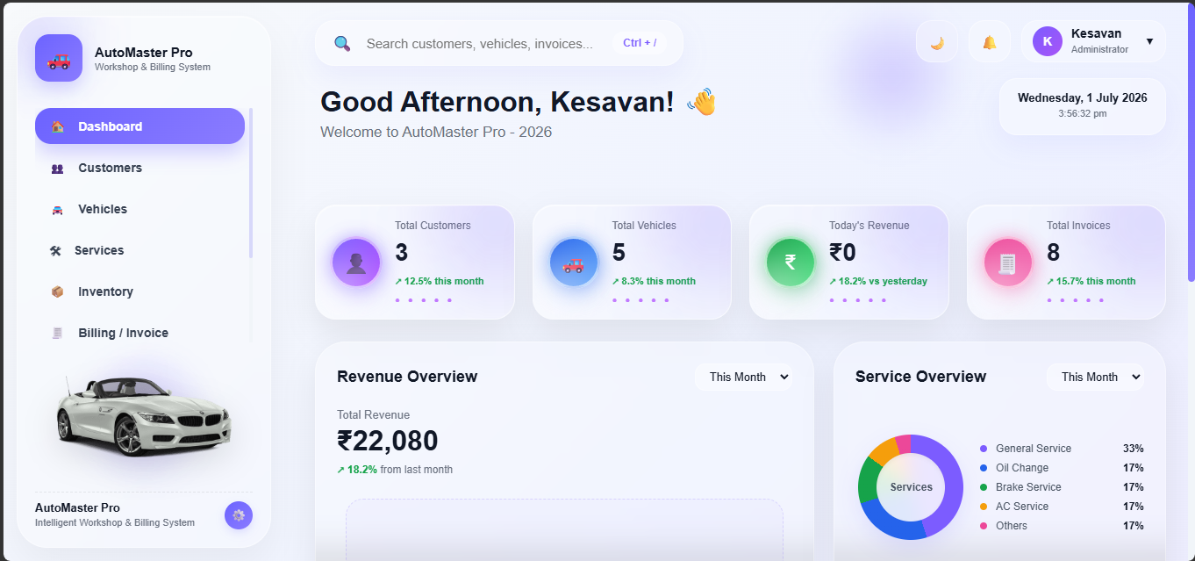
Figure 10.2.2: Live Reporting Dashboard and Glassmorphic Elements

CUSTOMER

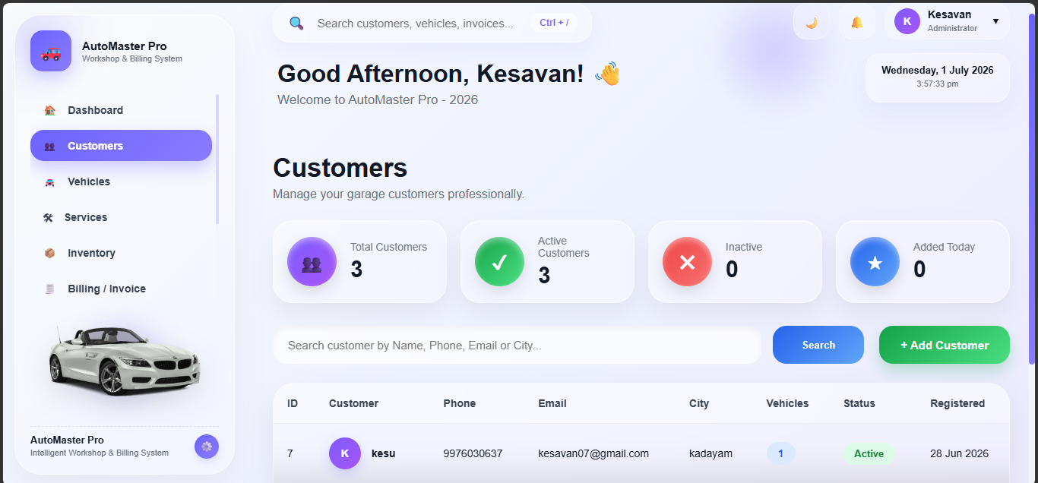
FIGURE 10.2.3:Customer Details with add,edit,delete option.

USER DETAILS
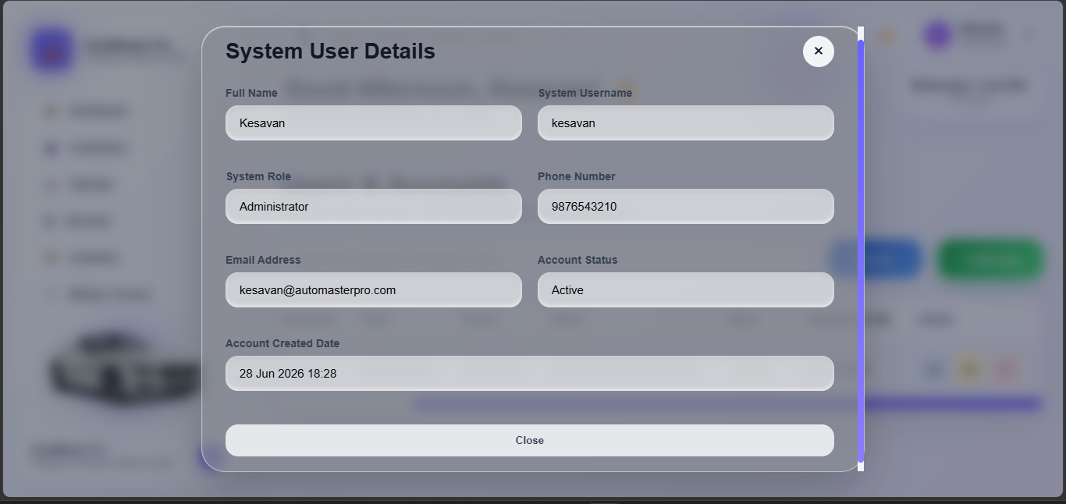
FIGURE 10.2.4:User Details it contains the add customer and cancel option.

BILLING
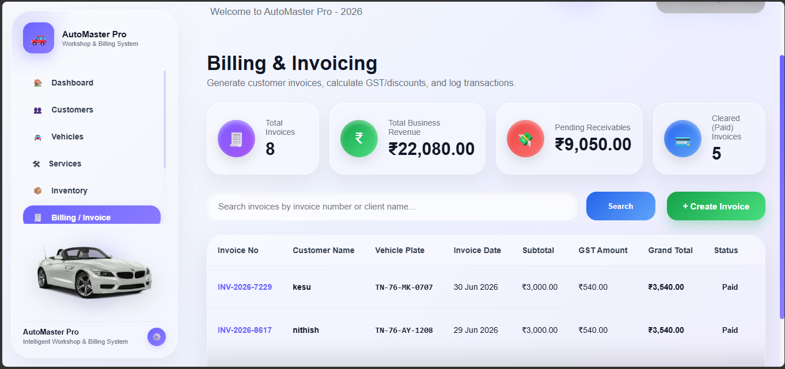 FIGURE 10.2.5:The Billing page it contains the invoice details to add,edit and delete option

PRINT&GENERATE BILL
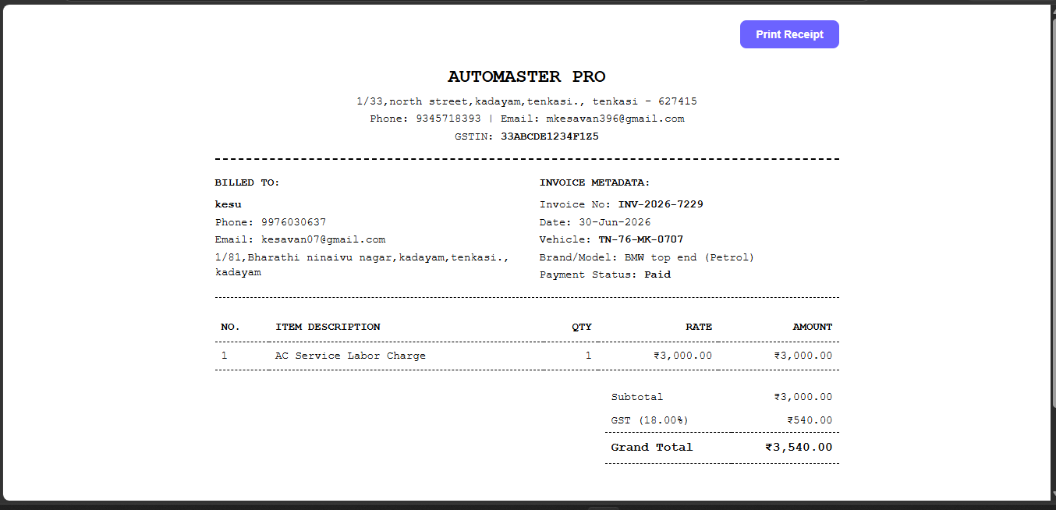
FIGURE10.2.6:TO Generate and Print the Bill

REFERENCES

1. Kenneth C. Laudon & Jane P. Laudon. (2022). Management Information System Managing the Digital Firm (17th ed.). Pearson.
2. Carlos Coronel & Steven Morris. (2019). Database Systems: Design, Implementation, and Management (13th ed.). Cengage Learning.
3. Ralph Stair & George Reynolds. (2020). Principles of Information Systems (14th ed.). Cengage Learning.
4. James A. O'Brien & George M. Marakas. (2018). Management Information Systems. McGraw-Hill Education.
5. Efraim Turban, Carol Pollard, & Gregory Wood. (2018). Information Technology for Management. Wiley.
6. Ramez Elmasri & Shamkant B. Navathe. (2017). Fundamentals of Database Systems (7th ed.). Pearson.
7. Luke Welling & Laura Thomson. (2016). PHP and MySQL Web Development (5th ed.). Addison-Wesley.
8. Thomas Connolly & Carolyn Begg. (2015). Database Systems: A Practical Approach to Design, Implementation, and Management (6th ed.). Pearson.

