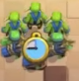
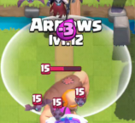
Standard troops: Use clock detection

Spells with radius: Use ellipse detection + elixir display inside

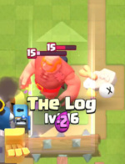

Spells with width:

Troops with no clock:

