13

1. Use this link <https://cryptii.com/pipes/rot13-decoder> to convert the ciphertext to plaintext with **ROT13** decoder.

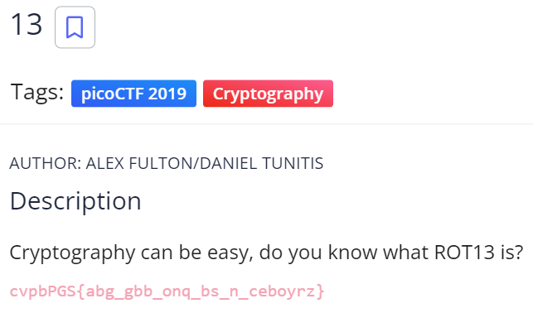

**ROT 13**

* ***unbale*** to ***encrypt*** the ***special character*** like **{ }_**
* ciphertext and plaintext are the ***same length***
* ***alphabet capital*** in ciphertext is ***same*** with plaintext

|  |
| --- |
|  |