**CAR RECOMMENDATION SYSTEM**



Expert System Report

***by***

**Chandi Charan Prajapati**

**Keshav Kumar**

**Dasari Venkatesh**

**Akshat Srivastava**

**(Section: K1637, K1637, K1637, K1637)**

**Department of Intelligent System**

**School of Computer Science Engineering**

**Lovely Professional University, Jalandhar**

**April-2020**

**Student Declaration**

This is to declare that this report has been written by us. No part of the report is copied from other sources. All information included from other sources have been duly acknowledged. We aver that if any part of the report is found to be copied, we are shall take full responsibility for it.

Chandi Charan Prajapati Roll number: 07

Keshav Kumar Roll number: 27

Dasari Venkatesh Roll number: 03

Akshat Srivastava Roll number: 31

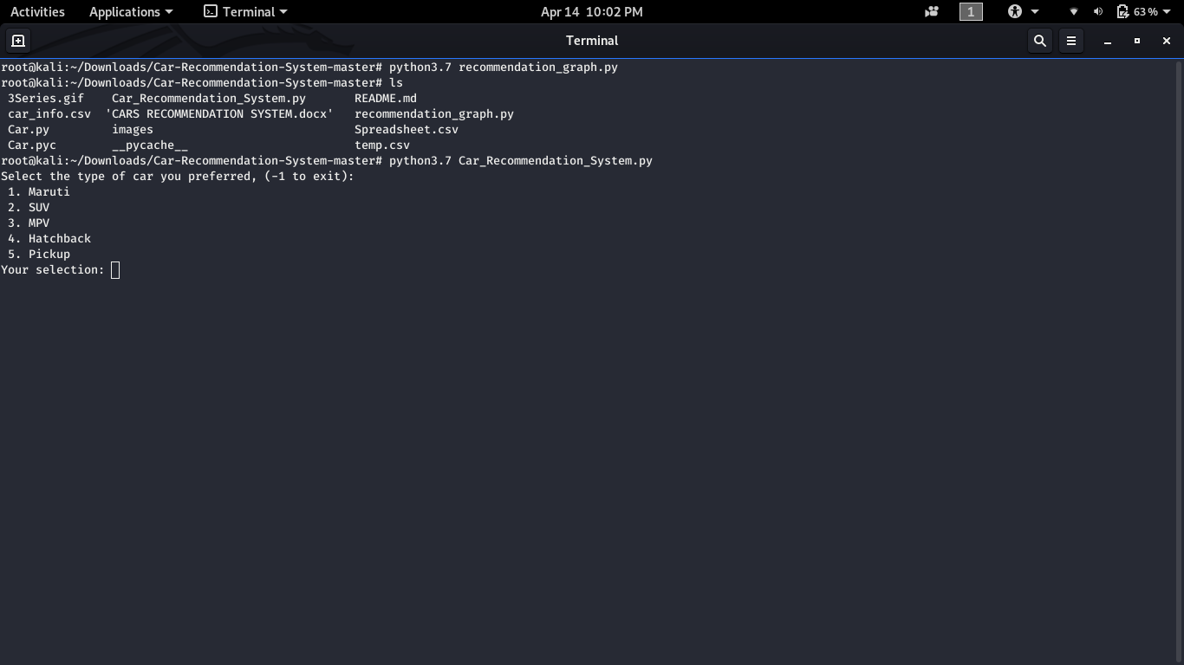

**GitHub Repository Link:**

https://github.com/aks1998/Four_wheel_rec_Sys.git

https://github.com/chandicharan5983/Four_wheel_recommendation

https://github.com/venky2719/4_W_recommendation.git

https://github.com/keshkumar/car_recom_sys.git

**Recommender system**

A recommender system filters data on the basis of the various ratings/preferences a consumer assigns with an object. For instance, when you watch a particular movie having a specific genre or belonging to a particular language, any app such as Netflix or Hotstar performs information filtering and presents you more such choices of movies. Often there are several factors based on which recommender systems work and filter data. There are two techniques on which these recommender systems work- Content based filtering and collaborative filtering.

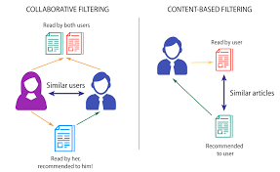

**APPROACHES**

There are three major approaches in Recommendation System. These are:

* **Collaborative Filtering:** The approach utilized for Recommending applications is mutual screening. There are two senses, a specific one and a more common, for collaborative filtering. collaborative filtration includes the filtering process for information or trends, using techniques which require collaboration between multiple officers, points of view, sources of evidence, and so on. Different forms of data, such as: knowledge gathering and monitoring, such as geological mining, environmental sensing on broad areas or multi-sensor data, financial based data, such as financial linked service organizations which combine various finance services and online transactions and web technologies, where consumer details become a priority etc., have been collaborated through filtering techniques. The remainder of this article centers on shared user-data filtering, while many large systems may still be subject to such strategies and approaches.
* **Content Based Filtering:**Content Based Filtering, also known as semantic filtration, proposes products based on a similarity of the quality of the things with the customer profile. The contents of each object are seen as a series of definitions or phrases, usually the words in a text. The consumer profile is shown on the same terms and is generated by the review of the nature of the things the customer has viewed.Text records are the most important type of knowledge utilized by content-based filtering systems. A common term sorting technique extracts specific terms from records. The vector spaced model and latented semantine indexing-method describe documents in a multi-dimensional space by the two approaches used in these words.
* **Knowledge Based Recommendation System:** Knowledge Based Recommendation System (expertise-driven advisory programs) are a specific form of guidance program focused on clear knowledge on the topics, customer needs and suggestion requirements. Both mechanisms are relevant in situations that do not implement alternate solutions like shared filters or content-driven filters.The non-existenceof cold start (ramp-up), a big strength in knowledge-based suggestion systems. A similar drawback is the possible shortage in information gained by the need to specifically identify suggestion awareness.Know-how-based suggestion mechanisms are also conversational.

**Four Wheel-Recommendation system**

This project is a recommendation system for cars. There are mainly Three modules in this project:

1. Data Analysis and Recommendation
2. Take input and show graphical Representation
3. Filtering of information

**Dataset:** The dataset chosen has 30 fields and 454 tuples, namely, ID, brand, Type, Engine-size, transmission, fuel, mileage, price.

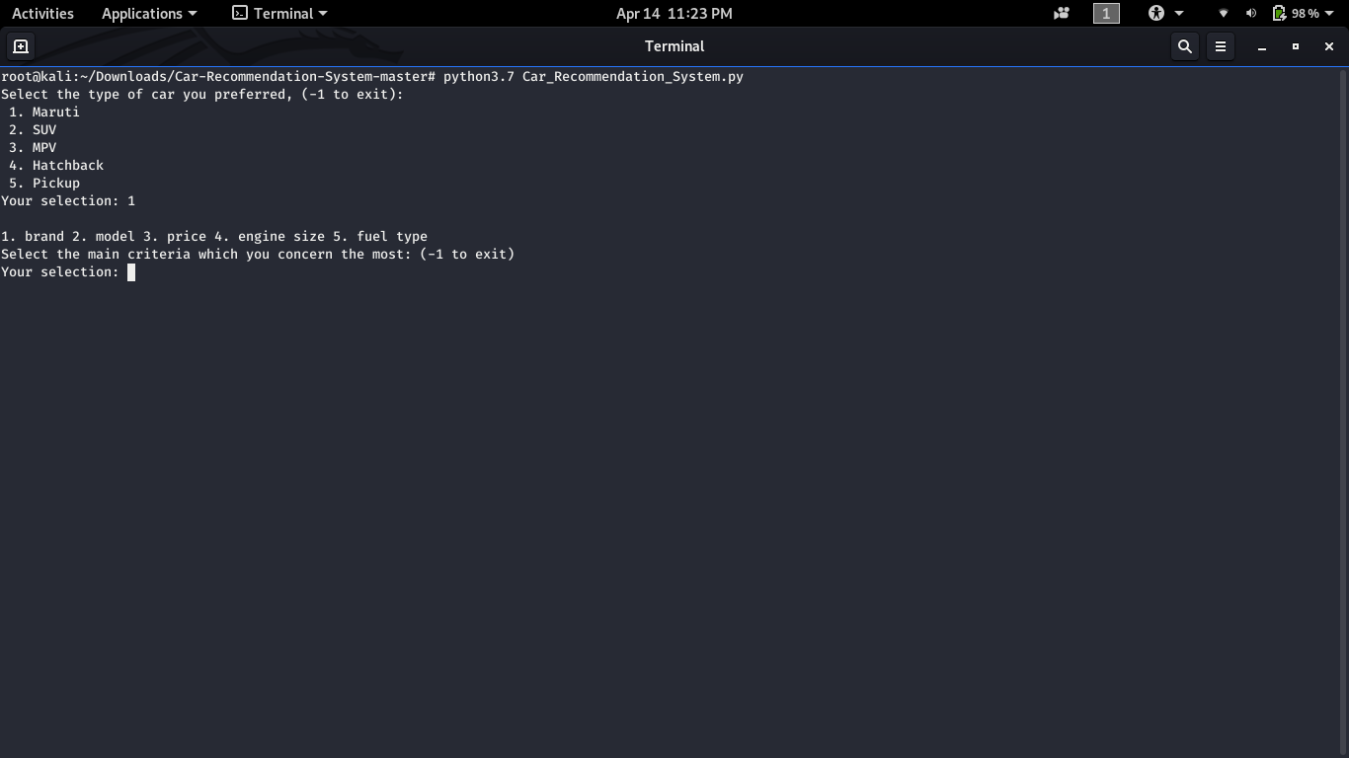

While Selecting number the system ask for different choice to select 1. Brand 2. Model if the User choose Brand the data will save at the background for analysis depend upon the user input.

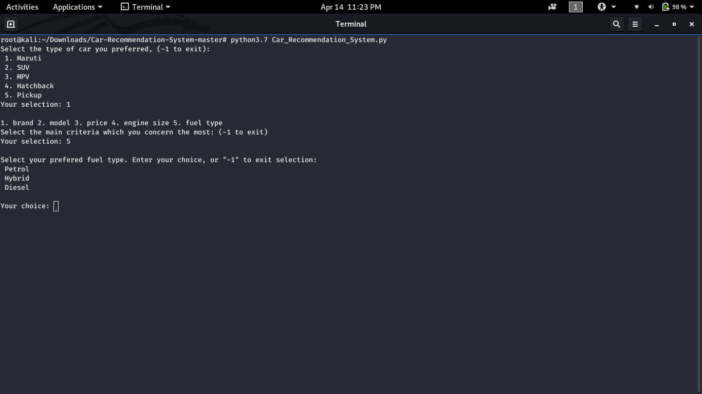

Further there is a feature of graphical visualisation with three dimensions namely, mileage, car type and car price.

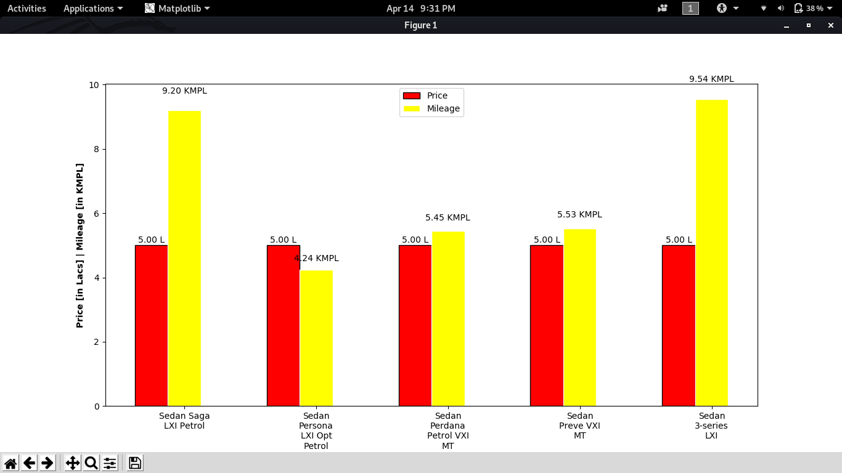

**Work distribution**

|  |  |
| --- | --- |
| **Module** | **Member** |
| Chandi Charan | Dataset analysis |
| Dasari Venkatesh | filtering |
| Keshav Kumar | Graphical Representation |
| Akshat Srivastava | Module design, Documentation |

**Future Scope**

This system can be further improved by adding features such as filtering by availability of seats , Fuel Capacity and extra functionality available in the Cars.