**Bank_loan report**

create database bank

use bank

select* from bank_loan

Key Performance Indicators (KPIs) Requirements:

Total Loan Applications:

select count(id)total_loan_count from bank_loan



The Month-to-Date (MTD) Loan Applications

select count(id)MTD_total_loan_count from bank_loan

where month(issue_date)=12 and year(issue_date)=2021



PMTD Loan Applications

select count(id)PMTD_total_loan_count from bank_loan

where month(issue_date)=11 and year(issue_date)=2021



Total Funded Amount:

SELECT SUM(loan_amount) Total_Funded_Amnt FROM bank_loan



MTD Total Funded Amount

SELECT SUM(loan_amount) AS Total_Funded_Amount FROM bank_loan

WHERE MONTH(issue_date) = 12 and YEAR(issue_date)=2021



PMTD Total Funded Amount

SELECT SUM(loan_amount) AS Total_Funded_Amount FROM bank_loan

WHERE MONTH(issue_date) = 11 and YEAR(issue_date)=2021



Total Amount Received

SELECT SUM(total_payment)Total_Amount_Collection FROM bank_loan



Average Interest Rate

SELECT AVG(int_rate)*100 as Avg_Int_Rate FROM bank_loan



Average Debt-to-Income Ratio (DTI):

SELECT AVG(dti)*100 as DTI_avg FROM bank_loan



**Good Loan KPIs:**

Good Loan Application Percentage:

SELECT

(COUNT(CASE WHEN loan_status = 'Fully Paid' OR loan_status = 'Current' THEN id END) * 100.0) /

COUNT(id) AS Good_Loan_app_Percentage

FROM bank_loan



-Good Loan Applications:

SELECT COUNT(id) AS Good_Loan_Applications FROM bank_loan

WHERE loan_status = 'Fully Paid' OR loan_status = 'Current'



Good Loan Funded Amount:

SELECT SUM(loan_amount) AS Good_Loan_Funded_amount FROM bank_loan

WHERE loan_status = 'Fully Paid' OR loan_status = 'Current'



Good Loan Total Received Amount:

SELECT SUM(total_payment) AS Good_Loan_amount_received FROM bank_loan

WHERE loan_status = 'Fully Paid' OR loan_status = 'Current'



Bad Loan Percentage

SELECT (COUNT(CASE WHEN loan_status = 'Charged Off' THEN id END) * 100.0) /

COUNT(id) Bad_Loan_Percent

FROM bank_loan



Bad Loan Applications

SELECT COUNT(id) BadLoan_Applications FROM bank_loan

WHERE loan_status = 'Charged Off'



-- Bad Loan Funded Amount

SELECT SUM(loan_amount) Bad_Loan_Fund_amnt FROM bank_loan

WHERE loan_status = 'Charged Off'



-- Bad Loan Amount Received

SELECT SUM(total_payment)BadLoan_amnt_received FROM bank_loan

WHERE loan_status = 'Charged Off'



-- LOAN STATUS

SELECT loan_status, COUNT(id)LoanCount, SUM(total_payment)Total_Amount_Received,

SUM(loan_amount)Total_Funded_Amount, AVG( int_rate * 100)Interest_Rate,

AVG(dti * 100) DTI

FROM bank_loan

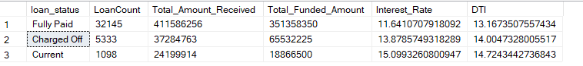 GROUP BY loan_status

-- 'Month-to-Date (MTD) Funded Amount,' 'MTD Amount Received,'

SELECT loan_status, SUM(total_payment)MTD_Total_Received_Amnt, SUM(loan_amount)MTD_Total_Amount_Funded

FROM bank_loan

WHERE MONTH(issue_date) = 12

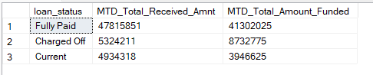GROUP BY loan_status

-- BANK LOAN REPORT | MONTH

SELECT MONTH(issue_date)Month_Munber, DATENAME(MONTH, issue_date)Month_name, COUNT(id)Total_Loan_Applications, SUM(loan_amount) AS Total_Funded_Amount, SUM(total_payment) AS Total_Amount_Received

FROM bank_loan

GROUP BY MONTH(issue_date), DATENAME(MONTH, issue_date)

ORDER BY MONTH(issue_date)

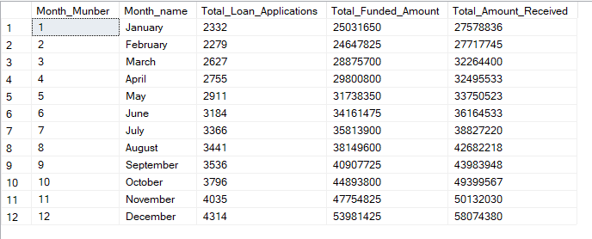

--STATE

SELECT address_state as State, COUNT(id)Total_Loan_Applications, SUM(loan_amount) Total_Funded_Amount, SUM(total_payment) AS Total_Amount_Received

FROM bank_loan

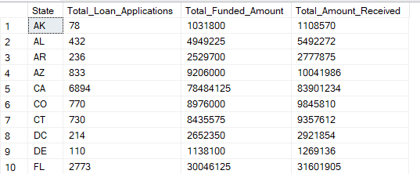GROUP BY address_state

ORDER BY address_state

-- TERM

SELECT term AS Term, COUNT(id)Total_Loan_Applications, SUM(loan_amount)Total_Funded_Amount,

SUM(total_payment)Total_Amount_Received

FROM bank_loan

GROUP BY term

ORDER BY term

-- EMPLOYEE LENGTH

SELECT emp_length as Employee_Length, COUNT(id)Total_Loan_Applications, SUM(loan_amount)Total_Funded_Amount,

SUM(total_payment)Total_Amount_Received

FROM bank_loan

GROUP BY emp_length

ORDER BY emp_length

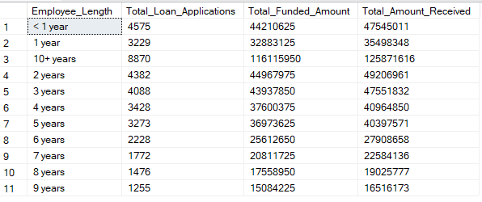

-- PURPOSE

SELECT purpose AS PURPOSE, COUNT(id)Total_Loan_Applications, SUM(loan_amount)Total_Funded_Amount,

SUM(total_payment)Total_Amount_Received

FROM bank_loan

GROUP BY purpose

ORDER BY purpose

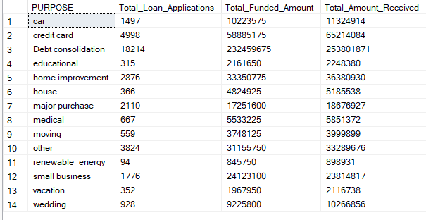

-- HOME OWNERSHIP

SELECT home_ownership AS Home_Ownership, COUNT(id) AS Total_Loan_Applications, SUM(loan_amount) AS Total_Funded_Amount,

SUM(total_payment) AS Total_Amount_Received

FROM bank_loan

GROUP BY home_ownership

ORDER BY home_ownership

