1. **StatelessWidget**

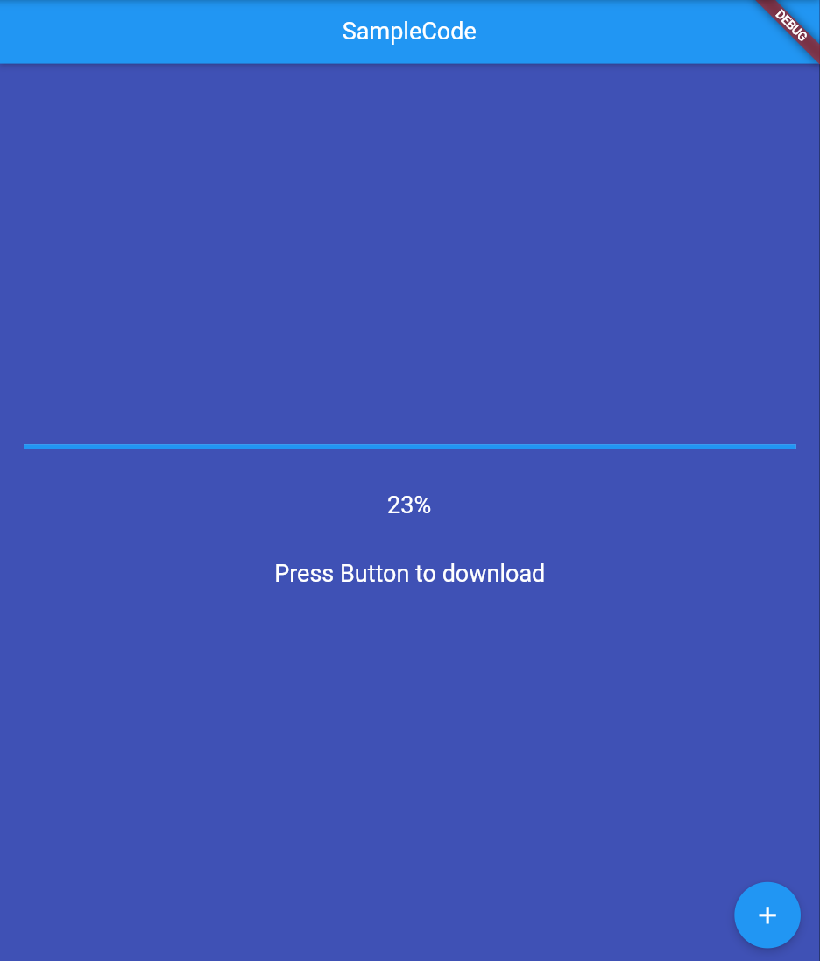

//Беспалова Ксения ИП-19-3

import 'dart:html';

import 'package:flutter/material.dart';

void main() {

runApp(

MyApp(),

);

}

class MyApp extends StatelessWidget {

const MyApp({Key? key}) : super(key: key);

@override

Widget build(BuildContext context) {

return MaterialApp(

home: Scaffold(

backgroundColor: Colors.indigo,

appBar: AppBar(

title: Text('SampleCode'),

centerTitle: true,

),

body: Center(

child: Container(

padding: EdgeInsets.all(20),

child: Column(

mainAxisAlignment: MainAxisAlignment.center,

children: [

LinearProgressIndicator(

value: 23,

),

SizedBox(height: 35),

Text(

'23%',

style: TextStyle(

color: Colors.white,

fontSize: 20,

),

),

SizedBox(height: 35),

Text(

'Press Button to download',

style: TextStyle(

color: Colors.white,

fontSize: 20,

),

),

],

),

),

),

floatingActionButton: FloatingActionButton(

child: Icon(Icons.add),

onPressed: () {},

),

),

);

}

}

1. **StatefulWidget**

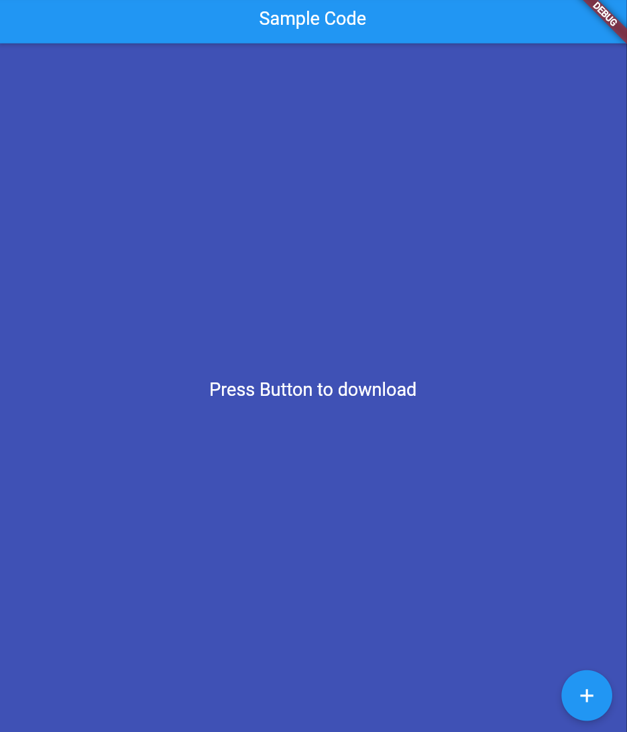

//Беспалова Ксения ИП-19-3

import 'dart:async';

import 'package:flutter/material.dart';

void main() {

runApp(

MyApp(),

);

}

class MyApp extends StatefulWidget {

const MyApp({Key? key}) : super(key: key);

@override

State<StatefulWidget> createState() {

return _MyAppState();

}

}

class _MyAppState extends State<MyApp> {

late bool _loading;

late double _progressValue;

@override

void initState() {

_loading = false;

_progressValue = 0.0;

super.initState();

}

@override

Widget build(BuildContext context) {

return MaterialApp(

home: Scaffold(

backgroundColor: Colors.indigo,

appBar: AppBar(

title: Text('Sample Code'),

centerTitle: true,

),

body: Center(

child: Container(

padding: EdgeInsets.all(20),

child: _loading

? Column(

mainAxisAlignment: MainAxisAlignment.center,

children: [

LinearProgressIndicator(

value: _progressValue,

),

SizedBox(height: 35),

Text(

'${(_progressValue * 100).round()}%',

style: TextStyle(

color: Colors.white,

fontSize: 20,

),

),

SizedBox(height: 35),

],

)

: Text(

'Press Button to download',

style: TextStyle(

color: Colors.white,

fontSize: 20,

),

),

),

),

floatingActionButton: FloatingActionButton(

child: Icon(Icons.add),

onPressed: () {

setState(() {

_loading = !_loading;

_updateProgress();

});

},

),

),

);

}

void _updateProgress() {

const oneSec = Duration(seconds: 1);

Timer.periodic(

oneSec,

(Timer t) {

setState(

() {

_progressValue += 0.2;

if (_progressValue.toStringAsFixed(1) == '1.0') {

_loading = false;

t.cancel();

_progressValue = 0.0;

return;

}

},

);

},

);

}

}