## Education

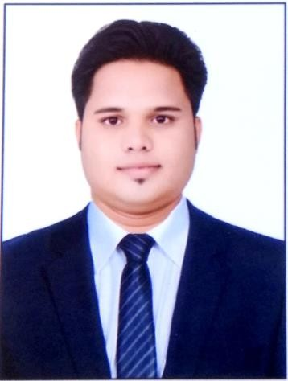

### HSS: General

Government High School Ishurwara Sagar, Madhya Pradesh 2015(June)-2016(May) **CGPA 71.58**

### Diploma: Computer Science and Engineering

S.R. Govt. Polytechnic College Sagar, Madhya Pradesh 2016(August)-2019(June) **CGPA 70.94**

# KESHRIBHAN SURYVANSHI

LINUX SYSTEM ADMINISTRATOR

OBJECTIVEI have completed six months postgraduate **diploma in High Performance Computing System Administration** from ACTS C-DAC Pashan, Pune. I have hands on experience in **cloud computing, linux** and **VMware virtualization** in **cloud computing.** I am looking forward to kick-start my career.

# SKILLS & ABILITIES

## Linux, cloud computing, Python and HPC System, Bash scripting, Shell Scripting.

Technologies: (High performance Computing) | Linux| Python | Cloud | AWS | DevOps | Docker | Kubernetes | Jenkins | Networking | Perl | Hadoop | Storage.

## Tools: xCAT, Nagios, LVM, RAID, Lustre, Slurm.

Hinjewadi Phase I Pune, Maharashtra Mob no: 8719933560

## Email : [keshari0921@gmail.com](mailto:keshari0921@gmail.com)

LinkedIn: https://[www.linkedin.com/in/keshribhan-](http://www.linkedin.com/in/keshribhan-) suryavanshi-740990199/

### Bachelor of Technology: Information Technology

Indira Gandhi Engineering College Sagar Madhya Pradesh 2019(August)-2022(June) **CGPA 77.79**

### PG-DHPCSA: Diploma in High Performance Computing System Administration

C-DAC’s Advanced Computing Training School Pune Maharashtra

2022(Sep)-2023(March) **CGPA 63.65**

## Academic Projects

**Title: Intelligent Threat Detection and Real-Time Prevention Platform:** AWS Cloud, Python, Linux

**Description:** Identify threats using GuardDuty on your Aws Infrastructure and have an automated prevention mechanism using AWS Lambda functions

### Title: Tourist Guide System

**Platform:** HTML, CSS, Bootstrap, JS, Node.JS, Reat.JS, Mongo dB

**Description:** A Tourist Guide System is a software application that provides information and guidance to tourists visiting a particular location or destination. This system can be accessed through a website, mobile application, or other digital platforms.

## Declaration

I hereby confirm that all the details mentioned above are authentic and accurate to the best of my belief.

## Date: Keshribhan Surayavnshi

Place: Hinjewadi Pune, Maharashtra Signature